**Institute of System Science, National University of Singapore**

**Submitted to:** Brandon Ng& Tian Jing

**Report Prepared By:**

Tan Chee Wei (A0179723U)

Ramasamy Muthuraman (A0179756H)

Laxman Singh (A0178223E)

**KE5106 CA1 – INSUREU**

**Deployment Guide**

**Protection gap in Mortality and Critical illness**

**Submitted to:** Brandon Ng& Tian Jing

**Report Prepared By:**

Tan Chee Wei (A0179723U)

Ramasamy Muthuraman (A0179756H)

Laxman Singh (A0178223E)

**Table of Contents**

1. Introduction 3

2. Pre-requisites of Application or Components 3

3. Sequence of Deployment 3

3.1 Copy SQL server dump and Tableau file to target directory 4

3.2 Deploy SQL server Database (DB) dump in SQL server management studio(SSMS). 4

3.3 Open Tableau file. 10

# **Introduction**

This document guides to deploy application such as database, dashboard etc., to new environment.

We included screen shot and instructions to ease the deployment process. If there is any issues please contact any one of us.

# **Pre-requisites of Application or Components**

The following applications are required,

1. SQL server 2017 (Express edition)
2. SQL server Management studio 2017
3. Tableau Desktop edition Version 10.5

# **Sequence of Deployment**

Kindly follow the following sequence to deploy our application,

1. Copy SQL server dump and Tableau file to your destination folder.
2. Deploy SQL server Database (DB) dump using SQL server management studio.
3. Open Tableau file and map SQL Server connection details

## Copy SQL server dump and Tableau file to target directory

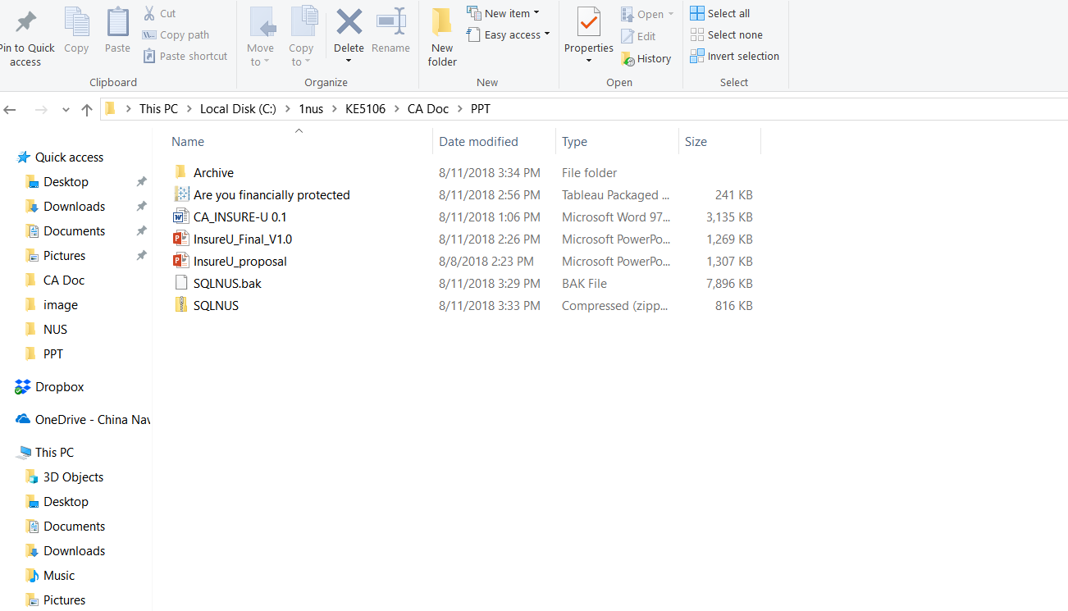

## Deploy SQL server Database (DB) dump in SQL server management studio(SSMS).

1. Open SSMS and connect to SQL server.

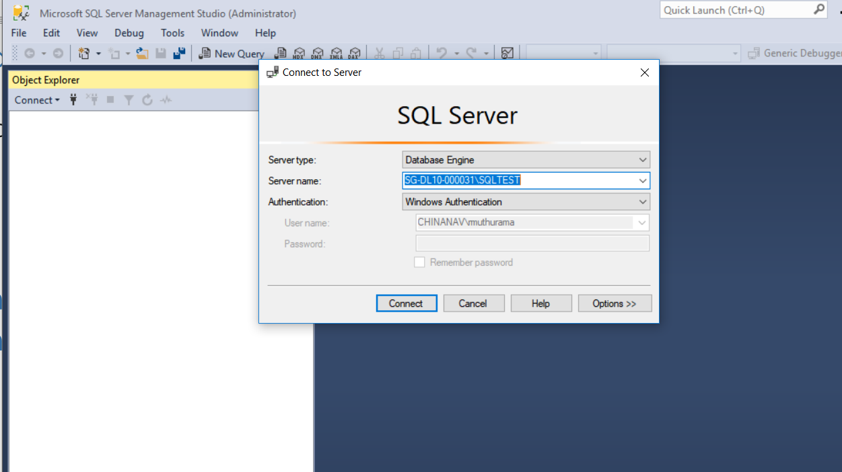

1. Deploy SQL server Database (DB) dump using restore database in SQL server management studio.

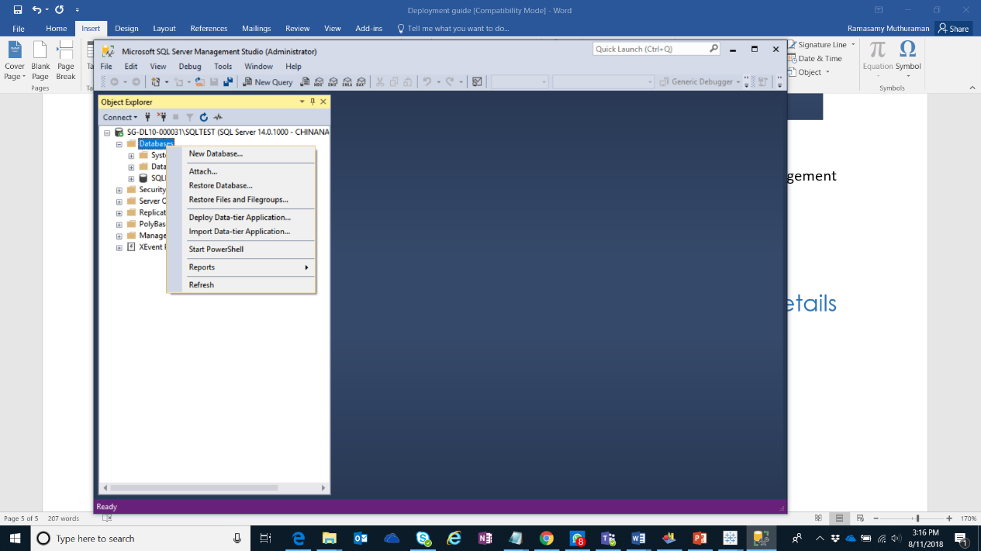

3. Select Device option and select the folder.

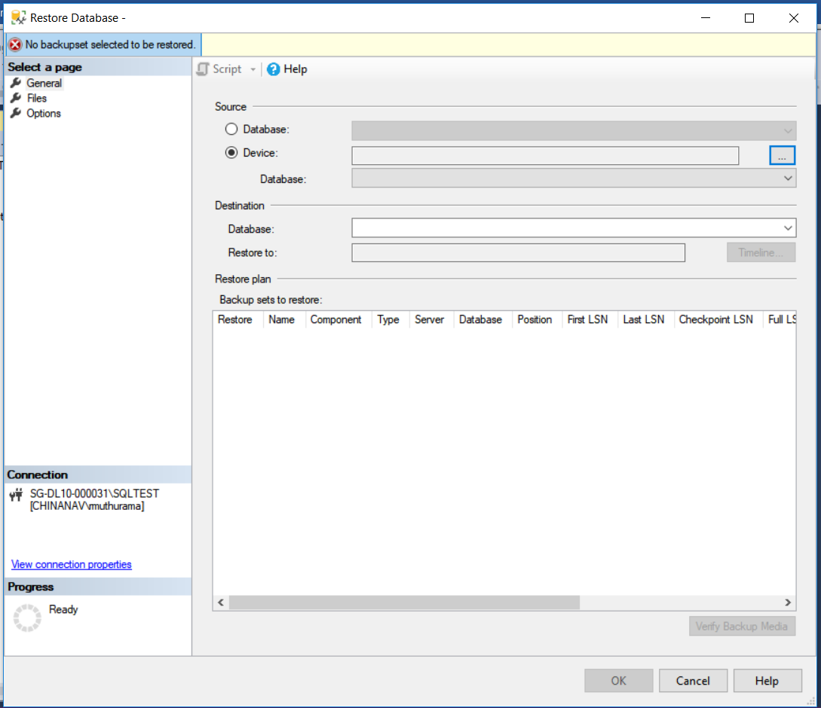

Click Add button

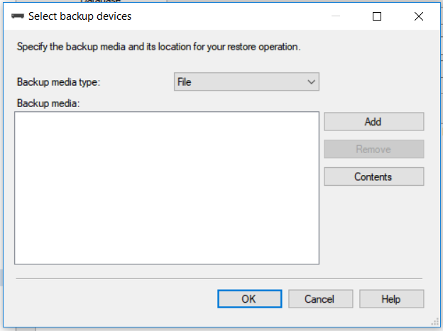

Select the SQL server dump file (back up) file where you copied earlier

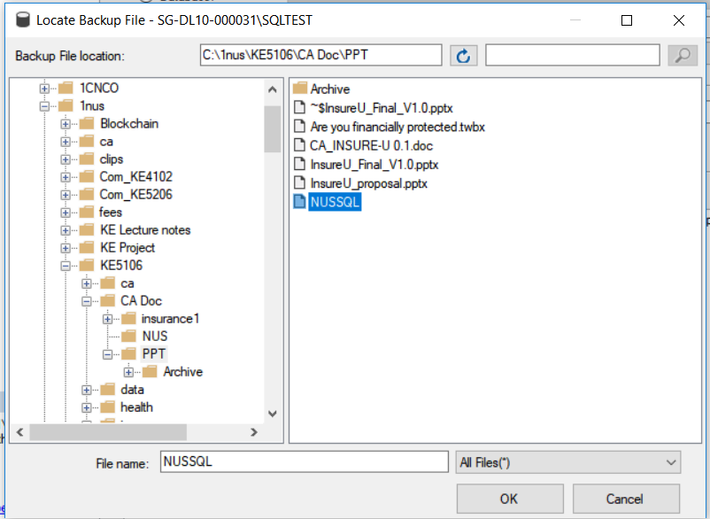

Press ok to load database dump files.

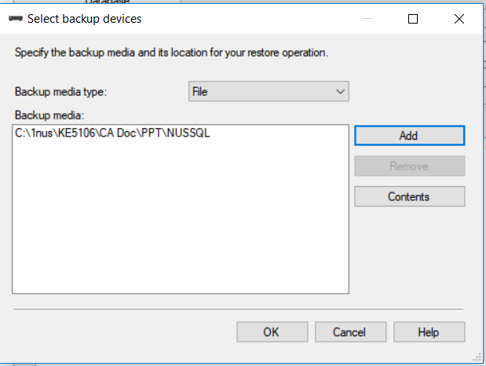

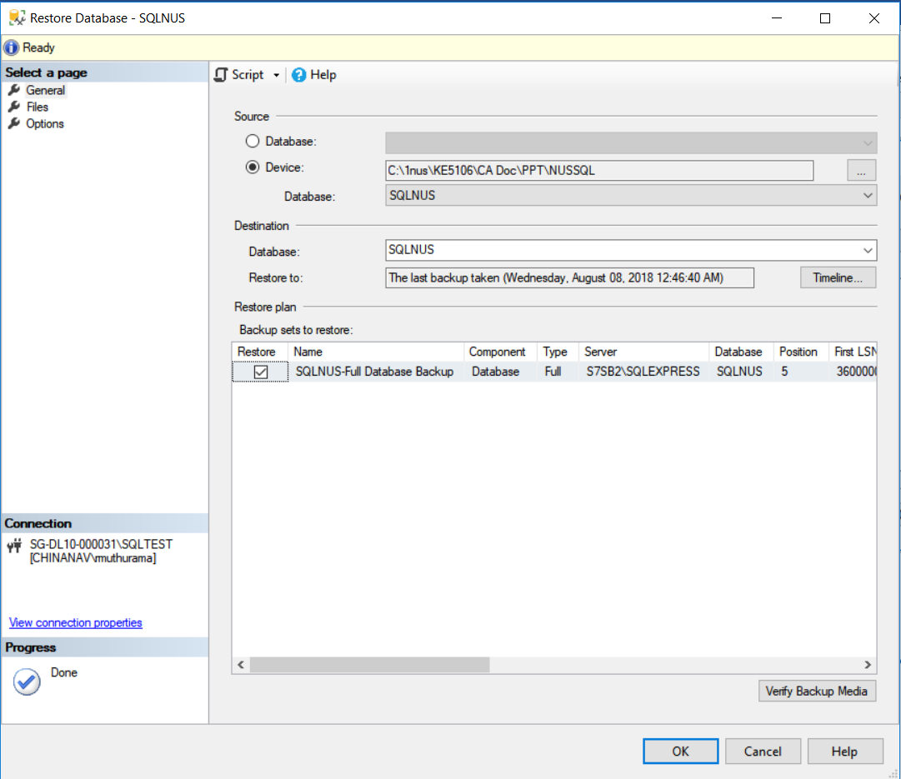

Once database dump loaded, you will see the successful message as per the following screen.

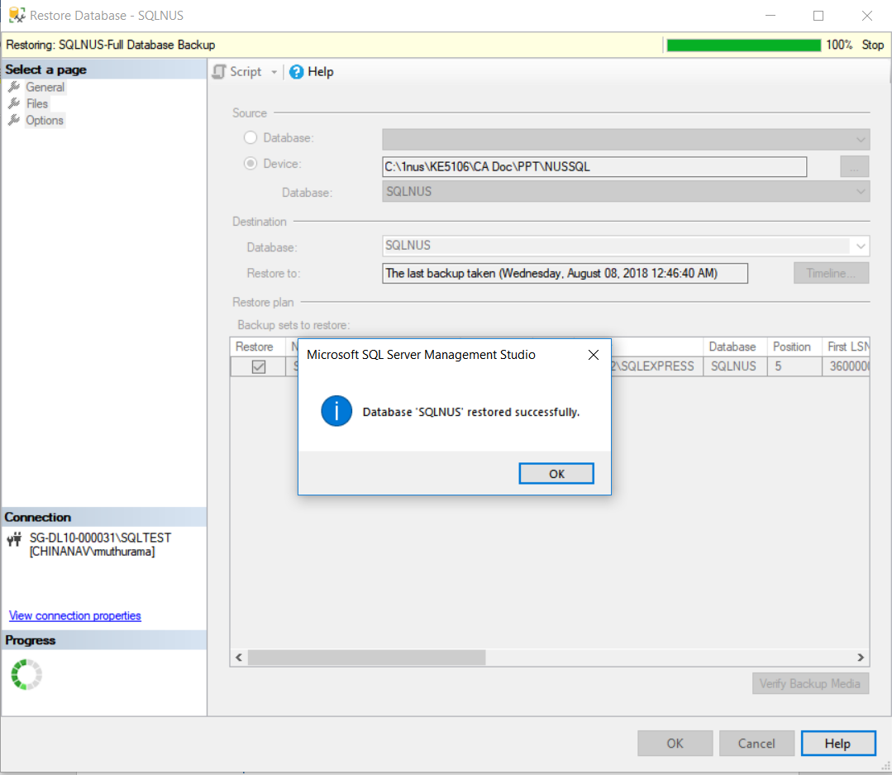

## Open Tableau file.

Double click the tableau file “Are you financially protected.tbwx” file, this will open tableau application and it will execute the query. This may take few minutes, kindly wait patiently. Since tableau created with SQL server express edition where the instance is tied with local server name and this message will appear when the server name is different from original tableau dashboard creation..

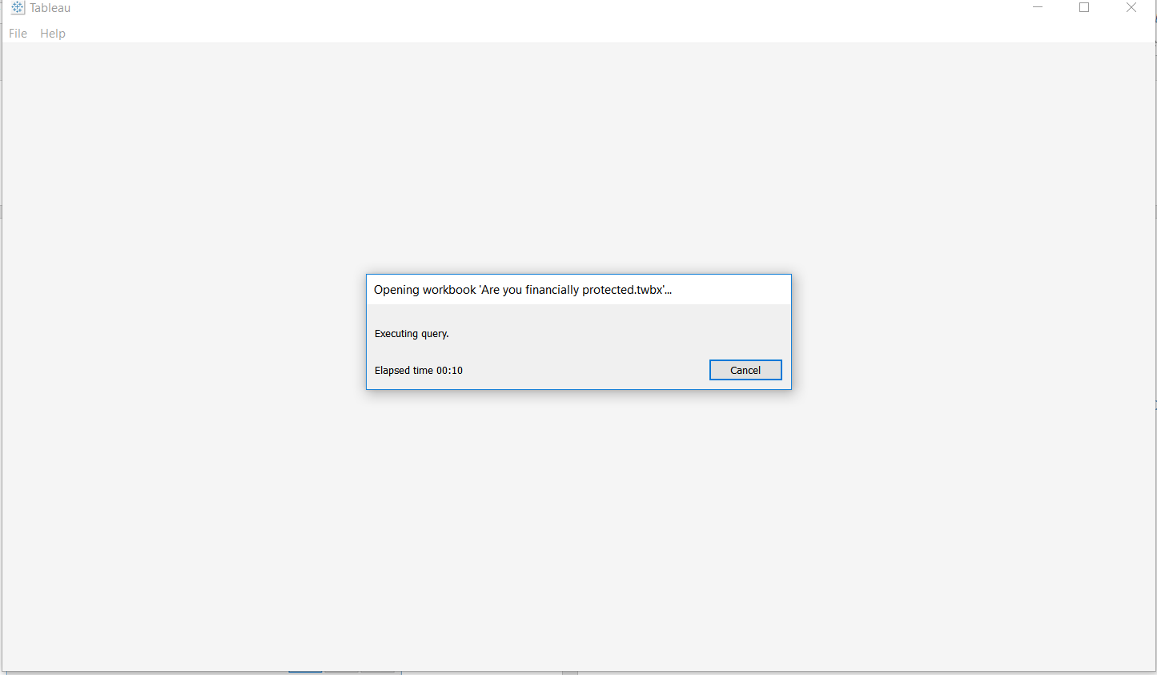

Change connection by selecting “edit connection”.

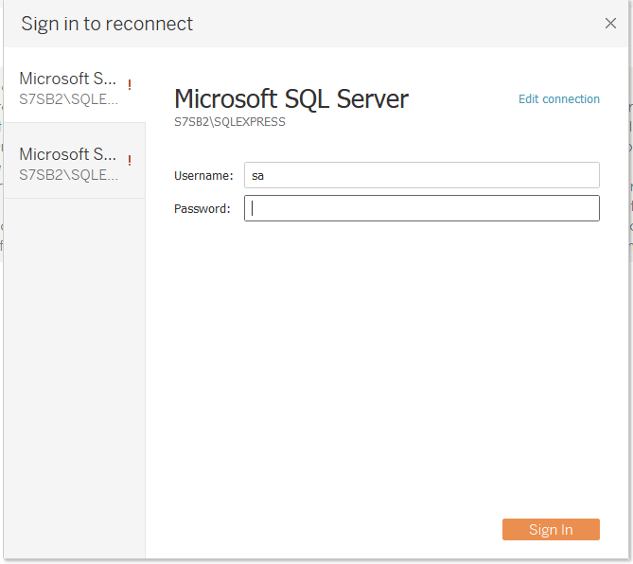

Enter the server name, instance name and database name

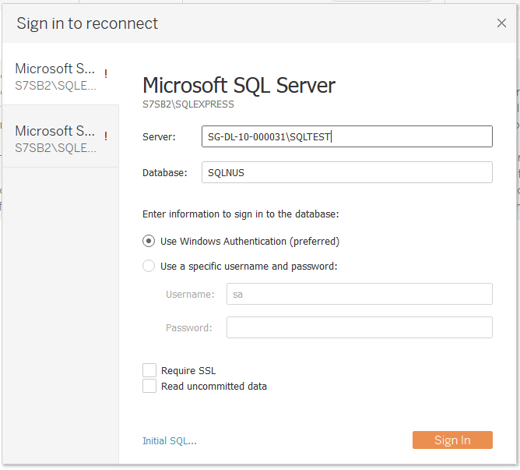

Repeat the above process until the connection issue resolved. We need to perform this because the tableau dash board was created with SQL server express edition, so Tableau will try for every object connectivity and displays for new connection.

After successful change, Tableau will connect to local SQLserver express edition sucessfully. You will notice the following screen.

