Institute of System Science, National University of Singapore
KE5106 CA1 – INSUREU

Report: Protection gap in Mortality and Critical illness

Submitted to: Brandon Ng & Tian Jing

Report Prepared By:
Tan Chee Wei (A0179723U)
Ramasamy Muthuraman (A0179756H)
Laxman Singh (A0178223E)

Table of Contents
Abstract 4
1. Introduction 5
2. Objective of study 6
3. Executive summary 6
3.1. Mortality Protection Gap 6
3.2. Critical illness Protection Gap 6
4. Definition 7
4.1. Mortality Protection Gap 8
4.2. Critical illness Protection Gap 9
4.3. Family Profiles 9
5. Solution Overview 10
5.1. Protection needs and Gap 10
5.2. Protection Needs 11
5.2.1. Expenses 11
5.2.2. Loans 11
5.2.3. Ongoing Expenses 12
5.3. EA Adults income 12
5.3.1. Spouse Income 12
5.3.2. Effect of Zeroisation 12
5.4. Resource Available 13
5.4.1. CPF savings 13
5.4.2. Other Savings 13
5.4.3. Life Insurance Coverage 13
6. Assumptions 13
7. Conclusions 15
8. Action Items 16
9. References 17
10. Appendix 17

Abstract

Many of the Singaporeans and Permanent residents are having protection gap and at the same time life expectancy rate is increasing to widen this gap further. This report highlights the protection gap in terms of the Mortality protection and Critical illness protection needs of economically active Singaporeans and Permanent residents of Singapore. This report is based on the two sets of data collected from year 2012 and 2017.

Currently, mortality protection and critical illness protection needs of an individual in Singapore has reached to 9 times and 3.9 times of average income respectively. It was observed that overall mortality and critical illness protection gap reached $355 billion and $538 billion respectively.

Mortality protection gap study performed in the year 2012 and Critical illness protection gap study performed in the year 2016. These reports effectively analyzed the mortality and critical illness protection gap for an individual in Singapore. This report also highlights the increasing life expectancy rate in Singapore. Singapore has the third highest life expectancy 82 years around the world. Impact of better life expectancy on protection gap is also one of the obvious areas of this report.

This report collects the data of expenses incurred by an individual in different category and impact of that on their protection requirements. Some of the expenses like funeral expenses and unseen medical expenses etc are generally not considered by an individual. Impact of those expenses in country like Singapore is also capable of increase the protection gap for an individual.

Overall, this report and dashboard as output highlights the protection gap by age group and average life expectancy in Singapore. Dashboard contains Mortality protection gap and Critical illness protection gap by age group. It also shows the different types of expenses and charges incurred for the same. These results are unexpectedly surprising and going to be one of the challenges for every Singaporeans and Permanent residents.

Introduction

This report “Protection Gap Study” (PGS) provides information from the analysis done by one of the renowned organization to judge the protection gap in different age groups covering both Mortality and Critical illness (CI). This report particularly pays attention to the earning capacity of an individual verses saving and insurance taken. It summarizes the results and approach for PGS. It includes methodology used for the calculation of PGS, breakdown of gaps in appropriate segments, source of data used and analysis of insurance industry data. It will also comment on the protection gap through which various age groups are going through due to various reasons like increase life expectancy etc.

Three worst case scenarios are:
- Death: Individual died and left with dependents to pay his/her debts, loans. Dependents lost a source of income too.
- Terminal Illness: Source of income is lost and expenses of medical increased
- Accident: Individual meet with an accident results in expensive hospital bills and loss of pay

These uncertainties make it difficult to choose the best suitable insurance. In reality, insurance should be focused on sufficient coverage for the right reasons at the lowest cost.

In a survey, over 200 people participated in the community in Singapore and voted five most important types of insurance. They are: Health, Term life, Whole life, Critical illness, Personal accident and others. Over 185 voted for health insurance as the most important insurance type.
Sufficient Coverage
Lowest Cost
Right Reasons

Objective of study

Protection Gap is metric to estimate the lack of protection against the financial consequences of specific events such as death or Critical illness (CI). Protection gap study is done to address and evaluate the protection needs of Singapore. It has following objectives:
- To identify the protection needs of Singaporeans and how they can be protected in light of their evolving protection needs.
- To evaluate how the protection gap and needs of Singaporean have changed during the last 5 years.
- To educate and increase significance of CI coverage in addition to the mortality coverage.

Executive summary

This report summarizes the protection gap in two categories: Mortality Protection and Critical illness protection.

Mortality Protection Gap

As of 31st December 2016, the Mortality Protection Needs of Economically Active Singaporeans and Permanent Residents is S$1,547 billion which translated to an overall Protection Need of 9.0x average income. However, it is to be noted that the factor of annual salary to Protection Need varies significantly between the different household profiles and income levels.

The mortality Protection Gap of working adults is S$355 billion or 2.1x annual income after allowing for insurance and savings. Insurance has played a key role with overall mortality insurance coverage per economically active person of 4.2x annual salary. A further 1.2x annual income to meet the mortality Protection Need was met by existing CPF Savings and another 1.6x annual income by other savings.

Compared to the previous LIA study conducted at 31st December 2011, there has been an increase in the absolute amount of Protection Needs and Gap. However, the Protection Gap, as a ratio of Average Income has stayed constant, reflecting corresponding increases in wages, savings and insurance coverage. It is important for individuals to continue to review and update their financial planning to reflect changes in insurance needs.

Critical illness Protection Gap

In the 2017 Protection Gap Study, the Critical Illness (CI) Protection Gap has been newly added to the analysis. An approach similar to the mortality protection gap has been used to calculate the CI gap for economically active Singaporeans and Permanent residents at 31st December 2016, by assuming a five-year CI recovery period.

The overall CI Protection Needs is S$663 billion which translates to overall Protection Needs of 3.9x average income. This amount represents the financial needs of household expenses, outstanding debt payments and lifestyle maintenance during the period of recovery. Immediate medical expenses are assumed to be covered by Medishield or an Integrated Plan.

The CI Protection Gap amounts to S$538 billion or 3.1x average income after allowing for CI insurance coverage of S$125 billion or 0.7x annual income.

Since the CI Protection Gap has been calculated for the first time as at 31st December 2016, no comparison is available against the 2012 position.

The reader is advised to be aware of key limitations arising from the assumptions and data sources used in the calculation of the Mortality and CI Protection Gaps. Furthermore, these results reflect the average across Singapore, whereas each individual’s circumstances will be different and specific to the individual. As such, individual protection needs should be analyzed separately and professional advice obtained where necessary.

Definition

The protection gap is a metric to estimate the lack of protection against the financial consequences of specific events such as death or CI.

In this report, the protection gap has been calculated as the difference between the protection needs (resources required) and the resources available. Protection needs include multiplication of expenses such as loans, daily expenses etc with number of economically active adults. Resource available is comprised of monthly saving and existing insurance coverage. Total protection gap can be calculated by deducting Resource available from Protection needs. If the protection gap calculated using above formula is less than equal to 0, then the individually considered fully protected. In case this protection gap is positive and more than 0, this is alarming signal for individual as there is protection gap in life to cope up with uncertainties.

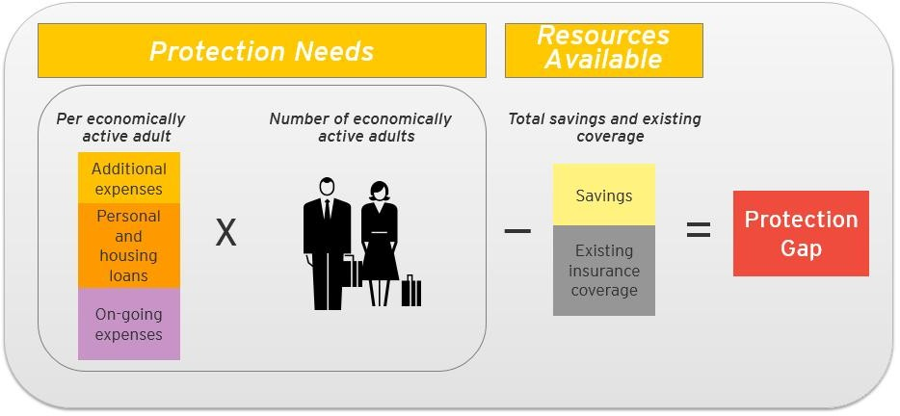
The protection needs include:
- Additional expenses: funeral costs and unpaid services
- Personal and housing loans
- Ongoing expenses for dependents: needs of the children, needs of elderly parents, rent and future household expenses, after deduction of the remaining income of spouse
The resources available include:
- Saving: CPF and Other Savings (cash and deposits)
- Insurance coverage: Group and Individual insurance

Mortality Protection Gap

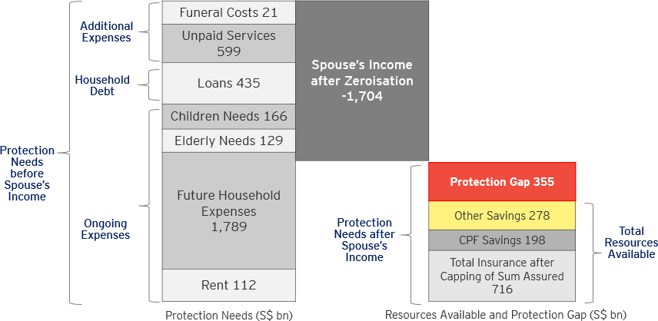
The mortality protection gap represents the financial gap to cover needs of dependents over a defined period in the event of death. It is the amount of money required by dependents to cover expenses, clear outstanding debt and maintain a reasonable lifestyle less existing savings and insurance coverage for mortality, following the death of a member of the household. Approximately, 9-10 times of annual income average mortality protection coverage amount required for an economically active (EA) adult in Singapore. Assuming that EA is an employed individual and contributing to the production and distribution of goods and services, between the ages of 20-69 years with at least one dependent.

Critical illness Protection Gap

The CI protection gap represents the financial gap to cover family needs during the assumed CI recovery period of 5 years, until the insured is able to return to work, or to adjust his or her lifestyle needs. These needs include expenses, outstanding debt payments and lifestyle maintenance less existing insurance coverage for CI. Approximately, CI is 3-4 times of annual income is the average CI protection coverage amount required for an economically active adult in Singapore.

It is assumed that the direct medical costs for the CI treatments are met by the patients existing Medishield Life or Integrated Shield plans, and CPF Medisave Accounts, reflecting the health financing landscape of Singapore.

It did not count CPF or other savings as available resources to meet the CI Protection Needs, as we have assumed that those savings are required for retirement needs.
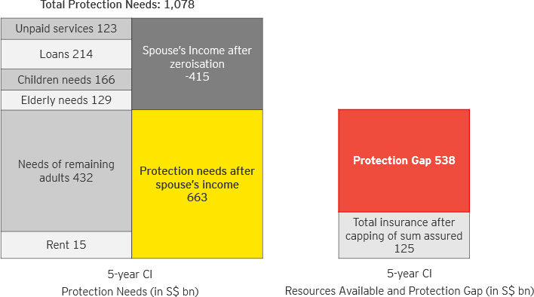

Family Profiles

This report considered family groups such that better insights can be formed regarding protection gap. Family groups are divided as below:
- Male Single with Elderly Parent
- Female Single with Elderly Parent
- Male Married with Economically Active Spouse
- Male Married with Economically Inactive Spouse
- Female Married with Economically Active Spouse
- Female Married with Economically Inactive Spouse

Five income quintiles and 10 age bands starting from 20 ending at 69 are considered to have better inputs to the report. Total numbers of EA in year 2016 were 2,093,567 persons. There is increase of 10 percent in the working population from the year 2011. This report did not consider economically inactive adults. Therefore this study and report considers only EA adults.

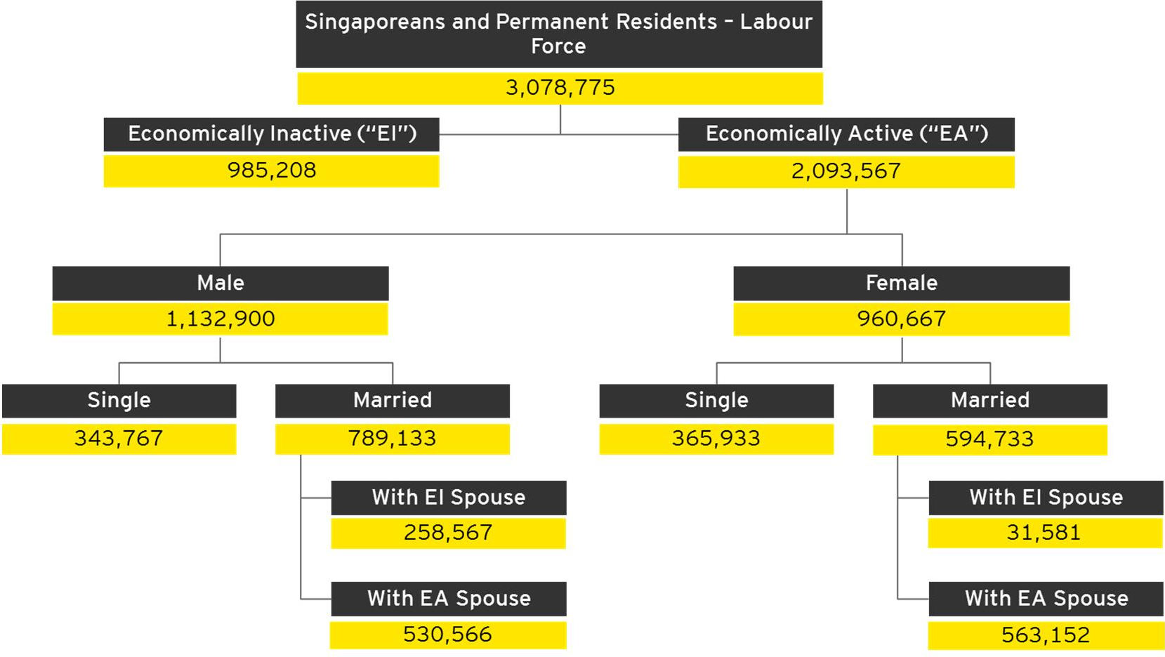

Solution Overview

Data is collected from the analysis report 2012 and 2017 for mortality protection gap and critical illness protection gap respectively. Data is received in the form of Excel, PDF, JSON and .csv files. In the next step, data will be transformed and loaded into SQL server. Using Tableau, data received from connecting Tableau to SQL server, is presented in the Dashboard reports. End users can view the report.

Protection needs and Gap

Singapore’s overall protection needs and gap as per year 2017 (below amounts are in billions)
Insurance Category | Protection needs | Resources Available | Protection Gap
Mortality | $1547 | $1192 | $355
Critical illness | $663 | $125 | $538

Above table is based on assumption of average income of EA is 81k approximately. As per the data, let us consider protection needs as 100 percent. In case of mortality, 80 percent resources are available to cover protection. For critical illness, 20 percent resources are available. So, there is visible protection gap of 20 and 80 percent for mortality and CI protection respectively.

The protection gap per Economically Active Adult can be broken down as below.

Protection Need after Zeroisation | 738,783
Less: CPF Savings | 94,566
Less: Other Savings | 132,566
Less: Existing Insurance Coverage | 341,988
Protection Gap | 169,673
Average Annual Income | 81,663
Multiple of Annual income
Protection Need after Zeroisation | 9.0x
CPF Savings | 1.2x
Other Savings | 1.6x
Existing Insurance Coverage | 4.2x
Protection Gap | 2.1x

Protection Needs

Expenses

- Funeral Cost: This includes the cost incurred on holding a funeral and post funeral costs i.e, purchasing a niche to store the ashes
Total funeral cost
Items | Cost in SGD
Funeral Cost per EA Adult (S$) | 10,000
Number of EA Adults | 2,093,567
Total funeral expenses(S$ billion) | 20.9

- Unpaid Services: These are the services provided by every member of the household to maintain the living standards of household. It includes carrying out day to day activities and it involves cost.
Items | Cost in SGD
Present value of unpaid services per EA adult (S$) | 285,922
Number of EA Adults | 2,093,567
Total unpaid services (S$ billion) | 598.6

Loans
Personal and housing Loans considered as liabilities. This will become burden for the repayment by the dependent after the death of EA.
Personal and housing loans are 70 k approx and 230 k approx respectively as per the below table:

Mortgage Loans | 233.2
Financial Institutions | 194.2
Housing Development Board | 39.0
Personal Loans | 75.9
Motor Vehicle Loans | 9.7
Credit / Charge Cards | 10.8
Others | 55.3
Total Loans | 309.1

Ongoing Expenses

- Needs of Children: This is one of the ongoing expenses considered in the report. It includes school fees, tuitions and other enrichment class fees etc. The needs of children are considered in the reports till the children are below 20 years.

- Needs of Elderly Parents: This is also one of the ongoing expenses categories. It involves expenses made by an EA for their elderly parents who are not living with them. In this report only the elderly parents who are financially dependent upon EA are considered.

- Needs of Surviving Adults: This category contains two types of expenses in major i.e, rent and future household expenses. Rent is based on actual rent amount over age group and income quintiles. Future rent is considered for single EA living with elderly parents. Future rent covers the remaining life time of spouse for married EA.

- Future Household Expenses: This report considers future household expenses as expenses incurred on the dependents. It does not include expenses on study, elderly parents etc. It is derived based on the average household expenses allowing for inflation. It also analyzed that on an average 0.3 dependents are supported by an EA.

EA Adults income

Spouse Income

Spouse income is considered to be zero in the following cases:
- Housewife
- EA is not married

For married people, spouse is assumed to work after EA’s death. Spouse’s income will be able to offset some of the protection needs of the household. Spouse income will be derived by adjusting the average household income. This adjustment is based on the profile of an individual.

Effect of Zeroisation

Zeroisation is the term used for the household where spouse’s income is capable of covering the protection needs of household. In other words, it means protection gap of the family is 0 or negative. In case of negative protection gap, this report converts the negatives to 0. This situation generally occurs in higher income quintiles with two EA adults.

Resource Available

Resource available in Singapore are available insurance, CPF saving and their personal savings.

CPF savings
CPF savings are extracted from the CPF annual report 2017. It is more than 94 k for EA aged above 20.
Average CPF Savings per EA (S$) | 94,566
Number of EA Adults | 2,093,567

Other Savings
Other savings include currency and deposits account. This report is unable to get the saving of foreigners. For that case, it is adjusted based on the savings proportionate to the savings of Singaporeans and PRs amongst the total population of Singapore.

Life Insurance Coverage
Life insurance coverage stands for the insurance coverage already taken by EA as an individual or whole group. This report also considered the total sum of amount assured for the insurance taken.

This report capped the assured per person at the maximum Protection Need assessed for each age band and gender to remove potential cross-subsidy from those who are over-insured. The maximum sum assured capped for individual private insurance individuals are detailed in the table below:
Age Band | Male | Female
20 - 24 | 3.7 | 3.0
25 - 29 | 3.8 | 3.4
30 - 34 | 3.8 | 3.5
35 - 39 | 3.6 | 3.3
40 - 44 | 3.1 | 2.8
45 - 49 | 2.7 | 2.4
50 - 54 | 1.9 | 1.8
55 - 59 | 1.8 | 1.7
60 - 64 | 1.4 | 1.4
65 - 69 | 1.0 | 1.0

Assumptions

- Retirement age is assumed to be 65 in the calculation of spouse’s income.
- Elderly parents are assumed to be the higher of age 65 or 25 years older than the economically active adult, used in calculation of elderly needs and rent.
- The life expectancy is assumed to be to 87.4 years for all the individuals, in line with the life expectancy of a female in Singapore at 31 st December 2016.
- Future income and expenses are inflated using prospective rates specified in Appendix D, Assumptions and Data Sources. Future income and expenses are discounted at a rate that is based on the yield on the 15 year Singapore Government Bond of 2.74%.
- The CI recovery period is assumed to be 5 years, and no distinction is made between early and advanced CI coverage.
- CPF or other savings are not available as resources to meet the CI Protection Needs, as we have assumed that those savings are required for retirement needs.
- Reports at dashboard are based on the aggregated data from LIA. We are unable to get the detailed data due to data privacy. Refer to appendix 10.1
- Till today, only two analyses done i.e., in the year 2012 and 2017. Data refresh is not going to happen frequently. In case of new report, data will be extracted and uploaded manually in Database.

Conclusions

Insurance type and reasons to take particular type of insurance helps to reduce the protection gap for an individual. Top 5 insurance types with reasons to take and recommended coverage are as below:

Rank | Type | Reasons | Recommendation | Analysis
1 | Health (H&S) | High cost of Hospital and Surgical bills & outpatient care | Private hospital and Public A | Singaporeans / PRs are covered for this. No study is done on this further.
2  | Term/Whole life | Death of an individual assure amount to the family members or dependent | Five times of your yearly income or based on your liabilities | Dashboard covers representation for this.
3   | Critical illness (CI) | Sum assured to meet huge cost of medical expenses with the discovery of CI. | Payout tied to life insurance | Dashboard covers representation for this.
4   | Disability | Monthly sum payout to meet your minimum expenses in case of loss of pay | It should be greater than 3000 SGD or depends upon your current income and minimum monthly expenses | This is not in scope of the report
5   | Personal Accident | Huge cost of outpatient medical expenses | Totally payout linked to insurance and paid by them based on expenses incurred | This is not in scope of the report.

In real, individual should not mix insurance with investments. One of the reasons is most of the investments can be done online by saving the cost of middlemen as insurance agent. When individual keep the investment component separate, there will be following major positives:
- Fully controlled finances: Financial investment controlled by you means you can do what you want and at the same time, you know what is happening.
- You need not to pay fees or extra charges for being a middlemen in your each transaction
- You have more flexibility in withdrawing and relocation your funds with much lesser fee.
- Individually managed finances will not have any limitations of lock-in period

However the learning to self-invest requires lot of study, more patience in learning, hard work and risk factor as most of the people will not be able to wholly commit them.

Action Items

Every individual should review their monthly expenses and insurance taken to meet up with any uncertainties. This should be iterative process and should be performed after an interval. In case any protection gap, need to fill it with proper care.

- Call Agent: Meeting with Insurance agent is always the first option to review your insurance policies.
Online calculator is also available to calculate protection gap. (Link: http://www.lia.org.sg/pgc)
- Review Insurance policies: Review your policies so that there will be no protection gap. At least, look for these 2 key essential type of policies: A Health policy (hospitalization & surgical, private hospital cover) and A Life policy (Understand if it’s a term or life)
Policies can be reviewed by self review with the help of internet search.
- Review Gap: Discuss your policies with others, insurance agents and go for the best which suites your requirements. Feel free to post your queries in community and get some initial idea. Many a times, fancy policy names are misunderstood and cause problems.

Find Insurance gap: Most importantly, an individual should always look for any insurance gap. Insurance gap could be dangerous to dependents and other family members.

References

- https://public.tableau.com/profile/rahul5357#!/vizhome/InsuranceDashboardExamples/LifeInsuranceDashboard
- http://libguides.nus.edu.sg/singaporestatistics
- http://www.lia.org.sg/system/files/news/2018/04/2017_Protection_Gap_Report_v20180426.pdf
- https://economictimes.indiatimes.com/wealth/insure/are-you-underinsured/articleshow/50997638.cms
- https://www.straitstimes.com/singapore/look-out-for-gaps-in-insurance-coverage
- https://www.todayonline.com/singapore/singaporeans-lack-80-critical-illness-protection-needs-life-insurance-association
- https://www.clearlysurely.com/blog/technical-smechnical/singapores-protection-gap-2017-report-card-just-came-out-we-erm-need-to-talk/
- National healthcare challenge - https://ihis.spigit.com/nhtchallenge/Page/ViewIdeas
- https://dollarsandsense.sg/glaring-protection-gap-among-young-adults-singapore/

Appendix

No | Document Description | Attached Document
1 | Mail conversation with LIA for collecting data | 
2 | Initial discussions | 
3 | Discussion output with SME | 

