A regulatory-grade river water-quality record in a few satellite messages a day
Kofi Sarpong Adu-Manu^{a,∗}, Stephen Kwaku Azongoª
ªDepartment of Computer Science, University of Ghana, Legon, Accra, Ghana
Abstract
Many polluted rivers, such as those affected by illegal gold mining in Ghana, lie beyond terrestrial network coverage, and satellite Internet of Things services that reach them sell a small number of short, one-way messages per day. This study asked how much data a regulatory-grade water-quality record requires, and how such a record can be delivered over these links. A record was taken as guaranteed when every reconstructed value stayed within the United States Geological Survey (USGS) accuracy rating of an excellent record. On 39 USGS river sites, the fewest values that guaranteed a day of temperature, conductance, dissolved oxygen, and pH needed a median of 15 bytes, or 1.8% of the raw readings, and at most 10 messages of 23 bytes. Because the satellite link returns no acknowledgements, the design that protected this minimal record with an erasure code across messages was compared with current practice in a pre-registered study: designs were tuned on 2023 data and confirmed on a sealed 2024 year. At six messages a day with 30% message loss, the proposed design guaranteed 89% of site-days, against 34% for the same record sent without protection and 43% for the scheme used by satellite-linked animal tags; repetition of the record performed similarly to the code. With a buffer, six messages a day kept 90% of days guaranteed within a week at 35 of 39 sites, and a 28-day pilot selected an adequate message plan for 85% of sites. All seven pre-registered hypotheses held.
Keywords: water-quality monitoring, satellite Internet of Things, error-bounded compression, erasure coding, USGS accuracy ratings, pre-registered evaluation
1. Introduction
Continuous water-quality monitoring underpins the regulation of rivers that supply drinking water and receive pollution. Wireless sensor networks have made it possible to measure temperature, specific conductance, dissolved oxygen, and pH every few minutes at low cost (Adu-Manu et al., 2017). Deployments in Ghana and Kosovo have shown that such systems work in practice, but they relied on cellular backhaul (Adu-Manu et al., 2020; Ahmedi and Ahmedi, 2022). The rivers under the greatest pressure are often the furthest from that infrastructure. In Ghana, illegal small-scale gold mining has degraded rivers in forested catchments where terrestrial coverage is sparse (Duncan, 2020).
Satellite Internet of Things (IoT) services now reach such sites with small, low-power terminals (Centenaro et al., 2021). Their capacity, however, is sold in messages, not bandwidth. A typical module transmits one-way messages with a payload of 23 bytes at 400 bit/s and receives no acknowledgement (Kinéis, 2023), and service plans offer a few to a few dozen messages per day. A four-parameter sensor sampling every 10 minutes produces approximately 1,296 bytes per day, which would require approximately 62 such messages. The question for a monitoring agency is therefore not how to stream every reading, but what a credible record of the river costs, and how to deliver that record when messages are scarce and may be lost without notice.
This study addressed that question with a definition of credibility taken from regulatory practice. The USGS rates the accuracy of continuous water-quality records, and an excellent record keeps temperature within 0.2 °C, specific conductance within 3%, dissolved oxygen within 0.3 mg/L or 5%, and pH within 0.2 units (Wagner et al., 2006). A day’s record was called guaranteed when every value reconstructed at the server stayed within these limits. The study then asked four research questions:
- RQ1: How many bytes per day does a guaranteed record require, and how does that need vary across sites, seasons, and parameters?
- RQ2: Which satellite message plans can carry the record when a node buffers data across days, and with what delay?
- RQ3: Which delivery design maximises the share of guaranteed days over a one-way link that loses an unknown share of messages, compared with the designs used in practice?
- RQ4: Can an adequate message plan be chosen from a short pilot record?
Each element of the answer has antecedents. Minimum-size piecewise-linear approximations with a maximum-error bound are classical (Imai and Iri, 1988) and have online versions for sensor streams (Soroush et al., 2008). Compressing buffered sensor history to a bandwidth budget, including a group leader that allocates more bandwidth to the node with the largest error, was proposed for multi-hop sensor networks (Deligiannakis et al., 2007). Erasure codes and unequal protection of compressed data are standard tools (Albanese et al., 1996; Reed and Solomon, 1960). Satellite-linked animal tags have long compressed ocean profiles into a few broken-stick points and resent them pseudo-randomly over the one-way Argos system (Boehme et al., 2009; Photopoulou et al., 2015). What has not been established is how these elements perform together for regulatory-grade environmental records on byte-priced, one-way satellite links, and what such a record costs on real rivers. The contributions of this study are the following:
- A measurement of the cost of a USGS-excellent water-quality record on 39 rivers over two years: a median of 15 bytes per day (1.8% of the raw readings), with its variation across sites, months, and parameters.
- A delivery design for one-way links that sends the minimum guaranteed set of values protected by an erasure code across messages, together with a server-side certification of which parts of the record are guaranteed, obtained without any feedback.
- A pre-registered comparison with current practice, tuned on 2023 and confirmed on a sealed 2024 year and on two low-cost deployments, in which all seven hypotheses held.
- Design guidance for agencies: the message plan that suffices under independent and bursty loss, and a pilot-based rule that selects it.
Section 2 reviews related work. Section 3 defines the record, the link, and the designs. Section 4 describes the data and the pre-registered study. Section 5 reports the results, Section 6 discusses their implications and limits, and Section 7 concludes.
2. Related work
2.1. Error-bounded reduction of sensor records
Sensor data reduction with guaranteed accuracy has two classical formulations. The first fixes a precision and minimises communication: Olston et al. (2003) adapted per-source filter widths so that continuous queries met their precision constraints with the fewest updates, and Deligiannakis et al. (2004) redistributed error thresholds within aggregation trees. The second fixes a budget and minimises error. Self-based regression (SBR) compresses the buffered multi-signal history of a sensor node to a bandwidth budget and supports a maximum-absolute-error objective; in its localised mode, a group leader repeatedly allocates residual bandwidth to the member with the largest error (Deligiannakis et al., 2007). For a single signal, the fewest vertices of a piecewise-linear approximation within a maximum error can be found in linear time (Imai and Iri, 1988), also online (Soroush et al., 2008), and many signals can be archived jointly under one maximum error (Gandhi et al., 2009). Storage-side work has produced multi-resolution summaries for drill-down queries (Ganesan et al., 2003), predictive archival with on-demand retrieval (Desnoyers et al., 2005), and layered time-series encodings that decode at several error levels (Barbarioli et al., 2023). This study used the minimum-size approximation as its node encoder. It did not propose a new compression algorithm; it measured what that encoder costs for regulatory tolerances on rivers, and how its output survives a link without acknowledgements, which these works assume to be reliable.
2.2. Satellite IoT and one-way delivery
Direct-to-satellite IoT has been studied mainly at the medium-access layer: constellation design for revisit time (Capez et al., 2022), slotted ALOHA with erasures at several satellites (Tondo et al., 2021), uplink transmission policies (Alvarez et al., 2022), scheduling of LoRa uplinks to passing satellites (Afhamisis and Palattella, 2022), and message replication for reliability (Rathi and Borkotoky, 2025). These works treat packets as interchangeable and do not address what the packets should contain. Terrestrial schemes for bulk transfer of buffered data aim to deliver every byte (Abdelfadeel et al., 2020). The closest practice to this study comes from animal telemetry. Conductivity–temperature–depth satellite relay data loggers abstract each ocean profile to a fixed number of points, store the resulting messages in a buffer, and send them pseudo-randomly through the one-way Argos system so that losses are spread over an unbiased sample (Boehme et al., 2009; Photopoulou et al., 2015). That practice fixes the number of points, not the accuracy, and it was included in this study as a baseline.
2.3. Freshness and value of information
A large literature optimises the age or value of the information held about the current state of a source (Yates et al., 2021), including over random-access and satellite links (Chen et al., 2021; Ramachandran and Banerjee, 2026; Talli et al., 2026). These models keep only the newest sample of a synthetic process; Chen et al. (2021), for example, assumed a one-packet buffer in which new packets replace older ones. Environmental regulation needs the whole record, not only its latest value, which is why this study used a record-wide maximum error as its objective. A record within tolerance everywhere also holds the latest value within tolerance.
3. System model
Fig. 1 summarises the system. A sensor node at a remote river site samples several water-quality parameters, stores them, and once a day encodes the day’s record into a small number of satellite messages. The link delivers each message or loses it, and the node never learns which. The server reconstructs the record from the values that arrive and states which parts of it are guaranteed.
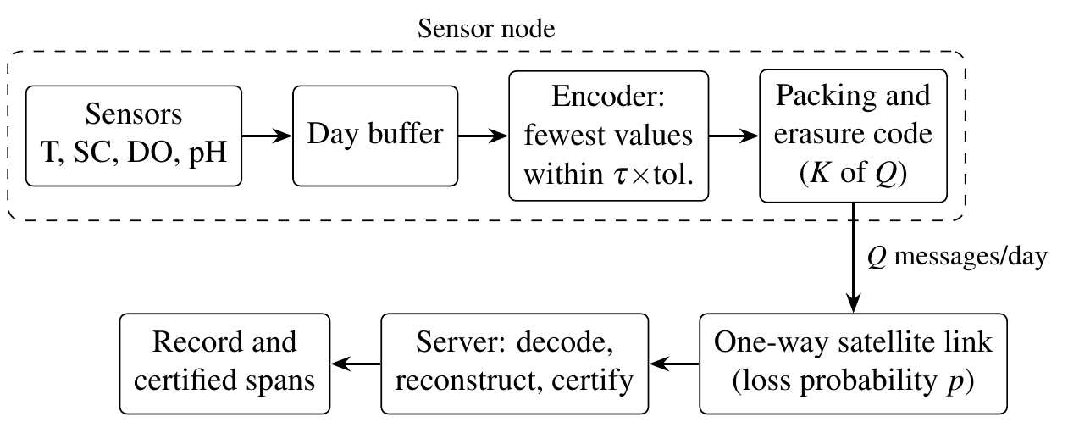
Figure 1: System overview. The node encodes each day’s record into at most $Q$ messages; no acknowledgement returns over the link.
3.1. Record and tolerance
For parameter $j$ of a site, let $x_{j}(t)$, $t=1,…,n$, be the day’s readings and $x_{j}(0)$ the last reading of the previous day, which the server is assumed to hold. The server reconstructs ${\hat{x}}_{j}(t)$ by linear interpolation between the values it received, starting from $x_{j}(0)$, and holds the last received value to the end of the day. The tolerance of each reading follows the USGS rating of an excellent record (Wagner et al., 2006): 0.2 °C for temperature, 3% of the value for specific conductance, the greater of 0.3 mg/L and 5% of the value for dissolved oxygen, and 0.2 units for pH. With $δ_{j}(t)$ the tolerance of reading $x_{j}(t)$, the normalised error is
 | $$e_{j}(t)=\frac{|x_{j}(t)−{\hat{x}}_{j}(t)|}{δ_{j}(t)}$$ | (1)
and a day is guaranteed when the error in Eq. (1) satisfies $e_{j}(t)≤1$ for every parameter and reading. Because the newest reading is part of the record, a guaranteed day also guarantees the current value.
3.2. Node encoder
For a level $τ$, the encoder selects for each parameter the fewest readings $S_{j}(τ)$ such that interpolation through them keeps every $e_{j}(t)≤τ$. This is the minimum-number (min-#) problem of polygonal approximation, which has an exact solution in time linear in $n$ for functions of one variable (Imai and Iri, 1988); the implementation used an equivalent quadratic dynamic program. Given a budget of $k$ values, the encoder uses one level $τ$ for all parameters, the smallest for which j​|Sj(τ)|≤k. The guaranteed record of a day is the set at $τ=1$, and its size is the day’s need (RQ1).
3.3. Messages and link
Each message carries 23 bytes (Kinéis, 2023): a one-byte header with a three-bit day index and a five-bit sequence number, followed by seven values of three bytes each. A value uses two bits for the parameter, nine bits for its time slot (up to 512 slots per day, which covers 5-minute sampling), and 13 bits for the reading. Readings are quantised linearly for temperature ($−5$ to 40 °C), dissolved oxygen (0 to 25 mg/L), and pH (0 to 14), and logarithmically for specific conductance (1 to 100,000 µS/cm). The largest quantisation error is 2.3% of the conductance tolerance and below 1.4% of the others; an encoder that targets 0.975 times the tolerance therefore keeps every transmitted value within it, and Section 5.5 reports what this margin costs. A plan allows $Q$ messages per day. Plans of 1, 6, 12, 24, and 96 messages per day were evaluated as illustrative tiers of commercial offers. The five-bit sequence number indexes up to 32 messages per day; the 96-message tier, which appears only in the buffered analysis, would need a two-byte header and six values per message, which cannot change its result because the largest daily need observed was 67 values.
The link is one-way. Two loss models were used, because no measured loss rate was available for the target service: independent loss with probability $p$, and a two-state Gilbert channel (Elliott, 1963; Gilbert, 1960) that loses every message in its bad state, with mean burst length three messages and the same mean loss $p$. The values $p∈\{0.1,0.3,0.5\}$ lie within the range of erasure probabilities, 0.01 to 0.9, studied for direct-to-satellite links (Tondo et al., 2021).
3.4. Delivery designs
Table 1 lists the five designs compared. All of them use at most $Q$ messages per day.
Table 1: Delivery designs compared.
Design | Content and transmission
Every $k$-th reading | Every $k$-th reading of every parameter, newest reading included, $k$ set to fill the plan; no guarantee.
Tag practice | A fixed number of broken-stick points per parameter, chosen by largest absolute deviation, packed into $D$ messages; the $Q$ transmissions pick among them pseudo-randomly, as satellite-linked animal tags do (Boehme et al., 2009; Photopoulou et al., 2015); a single-day model of the tags’ buffer rotation.
Reliable-link design | The guaranteed set at the smallest $τ$ that fills $7Q$ values, each message sent once; the design that is optimal when no message is lost, as in budget-constrained compression of sensor history (Deligiannakis et al., 2007).
Repetition | The guaranteed set at the smallest $τ$ that fills $7⌊Q/r⌋$ values; every message sent $r$ times, copies interleaved.
Erasure code (proposed) | The guaranteed set at the smallest $τ$ that fills $7K$ values in $K$ data messages, plus $Q−K$ parity messages of a systematic Reed–Solomon code over GF($2^{8}$) (Reed and Solomon, 1960); any $K$ arriving messages recover all data, otherwise the arriving data messages are used.
3.5. Decoding and certification
The server decodes what arrived and reconstructs each parameter as described above. Because sequence numbers identify which planned values arrived, the server can certify, without feedback, every span between two consecutive planned values that both arrived: the encoder guaranteed every reading inside it within $τ$ times its tolerance. The certified share is the share of readings inside such spans.
3.6. Buffering across days
Because the need of a day varies (Section 5), a node can carry the guaranteed sets of demanding days into the spare capacity of quiet days. In the buffered model, each day’s guaranteed set joins a first-in, first-out backlog at the end of the day. Every day the node sends one coded block of $K$ data and $Q−K$ parity messages, filled from the oldest backlog first; $K$ follows the development tuning, and the 96-message tier reuses the ratio $K/Q$ tuned at 24 messages. A day is guaranteed if every block that carried its values decoded, and its delay is the number of days until its last block was sent. Because the link is one-way, a lost block is not resent.
4. Data and study design
4.1. Data
The main data were approved instantaneous values from 39 USGS river sites in New Jersey, Pennsylvania, Illinois, and Oregon (U.S. Geological Survey, 2016), recorded every 15 minutes at 28 sites, every 30 minutes at 9 sites, and every 5 minutes and every hour at one site each. Dissolved oxygen was used in mg/L, the unit of the accuracy rating. A site-day was used when every gap within it spanned at most two readings; such gaps were bridged linearly. The year 2023 (10,978 site-days) served for development and 2024 (12,221 site-days, 10,164 with all four parameters) for confirmation. Two low-cost deployments were added: node 1 of the InWaterSense network on the Sitnica River, Kosovo (Ahmedi and Ahmedi, 2022; Ahmedi, 2021), and the Weija intake deployment in Ghana (Adu-Manu et al., 2020). InWaterSense reports dissolved oxygen in percent saturation, which was converted to mg/L with the freshwater solubility of Benson and Krause (1984) at the measured temperature. Readings flagged as implausible by earlier cleaning were removed. For Weija, only temperature and conductivity were used, because its pH record was not physically plausible. Both low-cost records contain many gaps, which left 22 and 49 complete site-days.
4.2. Pre-registered study
The study followed a written plan. All design choices were made on the 2023 data: the repetition count $r$, the code dimension $K$, and the share of messages used by tag practice were tuned for each plan, loss model, and loss probability on half of a stratified sample of 780 site-days, and reported on the other half. The plan, the tuned parameters, and the code were then frozen and checksummed, and the hypotheses in Table 2 were fixed. Only then were the 2024 data opened, once, after their checksums had been verified; the low-cost deployments had not been used for any choice either. The confirmatory runs applied the frozen parameters without change.
4.3. Metrics
The following metrics were used:
- Guaranteed share $G$: the share of site-days whose whole record was within tolerance, averaged over 30 random loss realisations per site-day.
- Certified share: the share of readings that the server could certify (Section 3).
- Buffered target: for RQ2, the share of a site’s days that were guaranteed within seven days; a site met the target when this share reached 90%.
- Plan choice: for RQ4, the plan selected from the first 28 days of a year as the smallest plan that met the buffered target there under independent loss with $p=0.3$, compared with the smallest plan that met it over the rest of the year. A safety factor on the pilot needs was tuned on 2023 and came out at 1.0, which means no inflation.
Because site-days of one site are not independent, uncertainty was estimated with a site-clustered bootstrap: the 39 sites were resampled with replacement 2,000 times, and 95% percentile intervals are reported for the headline statistics.
4.4. Sensitivity analyses
The plan also listed sensitivity analyses, which were run after confirmation and are exploratory. They covered the USGS rating of a good record (temperature 0.5 °C, specific conductance 10%, dissolved oxygen 0.5 mg/L or 10%, pH 0.5) (Wagner et al., 2006), 19-byte messages with six values, and coarser sampling, obtained by keeping every second or fourth reading. Two tolerance margins were added: 0.975 times the tolerance, which absorbs the quantiser, and half the tolerance, which leaves the other half of the error budget to the sensor. Two simpler encoders, of the kind used in process data historians and supervisory control systems, were also measured: greedy online segmentation, which extends each segment as far as the tolerance allows before keeping its last reading, and deadband reporting, which sends a reading whenever it leaves the tolerance band around the last value sent.
Table 2: Pre-registered hypotheses and their outcome on the 2024 confirmation data.
 | Hypothesis | Result | Outcome
H1 | Median daily need at most 5% of the raw readings | 1.8% | Passed
H2 | Sites with at least 90% of days guaranteed within 7 d (6 msg/d, independent loss, $p=0.3$): at least 75% | 35/39 | Passed
H2b | Same at 12 msg/d under bursty loss: at least 85% | 35/39 | Passed
H3 | Median $G$, code over reliable-link design: at least $2×$ | 3.5$×$ | Passed
H4 | Median $G$, code minus tag practice: at least 0.25 | 0.33 | Passed
H5 | Code and repetition each exceed the reliable-link design by at least 0.2 in 12 settings | 12/12 (min. 0.34) | Passed
H6 | Pilot-based tier sufficient at least 80%; at most one tier too large at least 80% | 85%; 100% | Passed
H7 | InWaterSense median need at least $3×$ the USGS median | 3.9$×$ | Passed
5. Results
All seven pre-registered hypotheses held on the 2024 confirmation data (Table 2). This section reports the results by research question; unless stated otherwise, numbers refer to the 2024 data.
5.1. Cost of a guaranteed record (RQ1)
Fig. 2 illustrates the encoder on a summer day of dissolved oxygen. Six values chosen by the encoder kept the whole day within tolerance, whereas six evenly spaced readings missed the steep afternoon rise and exceeded the tolerance by a factor of more than two.
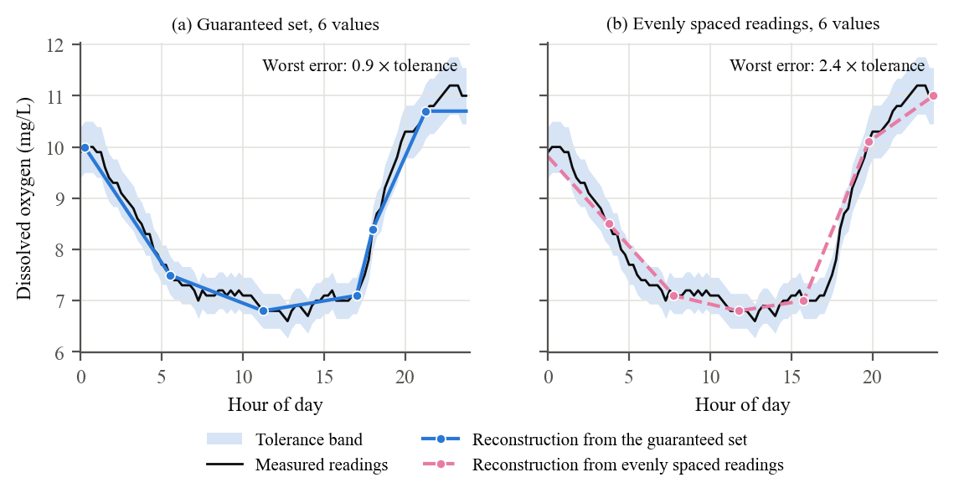
Figure 2: Dissolved oxygen on one day of 2023 at a development site. (a) The fewest values that keep every reading within tolerance. (b) The same number of evenly spaced readings. The shaded band is the USGS excellent-record tolerance.
Across all site-days, the guaranteed record was small (Fig. 3). Its median size was 15 bytes per day (95% interval 12–21 bytes), 1.8% of the raw readings; the 90th percentile was 45 bytes, the 99th percentile 108 bytes, and the largest day needed 201 bytes, or 10 messages. The record fitted into a single 23-byte message on 63% of site-days. The development year gave almost the same distribution (median 18 bytes, 99th percentile 111 bytes).
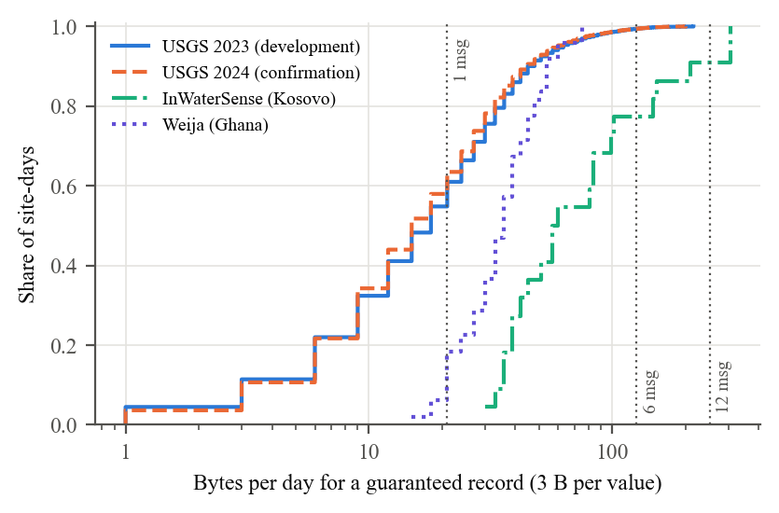
Figure 3: Cumulative distribution of the bytes per day needed for a guaranteed record. Vertical lines mark the value capacity of 1, 6, and 12 messages per day. Days that needed no value are drawn at 1 byte.
The need varied with the site and the season. Site medians ranged from 3 to 57 bytes per day, and within a site the 99th percentile was typically 3.3 times the median. The median need rose from 6 bytes per day in January to 24 bytes per day in June (Fig. 4); the highest needs occurred from June to August. At sites that measured all four parameters, temperature accounted for 41% of the values in the guaranteed records, dissolved oxygen for 26%, specific conductance for 23%, and pH for 10%. Temperature, often treated as a slowly varying baseline, was therefore the most expensive parameter to keep within its tight tolerance.
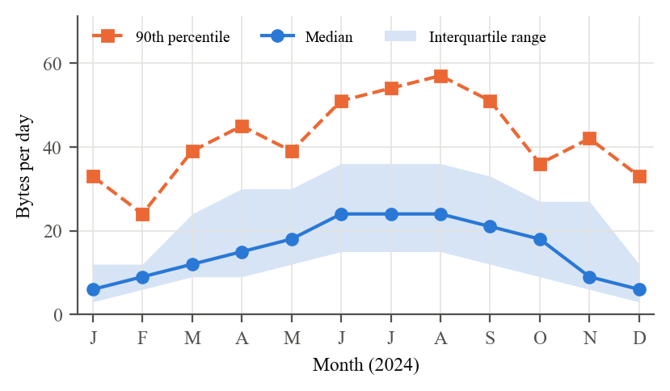
Figure 4: Bytes per day needed for a guaranteed record by month, over all 2024 site-days.
The low-cost deployments were more expensive. InWaterSense needed a median of 58.5 bytes per day, 3.9 times the USGS median, which confirmed hypothesis H7. The cause was not isolated in this study; candidate causes include sensor noise and fouling, and the few complete days available. Weija, with two parameters, needed 36 bytes per day.
5.2. Delivery over a one-way link (RQ3)
Table 3 and Fig. 5 compare the designs. At six messages per day and an independent loss probability of 0.3, the erasure-code design guaranteed 89% of site-days (95% interval 86%–92%). The reliable-link design, which sends the tighter record without protection, guaranteed 34% (30%–40%); tag practice guaranteed 43% (35%–51%); and evenly spaced readings guaranteed 28% (22%–35%). By median over site-days, the code reached 3.5 times the guaranteed share of the reliable-link design (hypothesis H3; 95% interval 3.1–4.0) and exceeded tag practice by 0.33 (H4). The code was better than the reliable-link design on 91% of site-days and better than tag practice on 87%. The development data had given 0.90 and 0.34 for the code and the reliable-link design; thus, the gap carried over to the new year.
Table 3: Mean guaranteed share $G$ at six messages per day. USGS 2024 confirmation data unless stated.
 | Independent loss |  |  | Bursty loss | Low-cost sites
Design | $p=0.1$​ | $p=0.3$​ | $p=0.5$​ | $p=0.3$​ | $p=0.3$​
Guaranteed set + erasure code (proposed) | 0.96 | 0.89 | 0.80 | 0.81 | 0.77
Guaranteed set + repetition | 0.93 | 0.85 | 0.71 | 0.81 | 0.58
Fixed points + random resending (tag practice) | 0.55 | 0.43 | 0.29 | 0.41 | 0.20
Guaranteed set, sent once (reliable-link design) | 0.70 | 0.34 | 0.18 | 0.47 | 0.17
Every $k$-th reading | 0.47 | 0.28 | 0.17 | 0.33 | 0.01
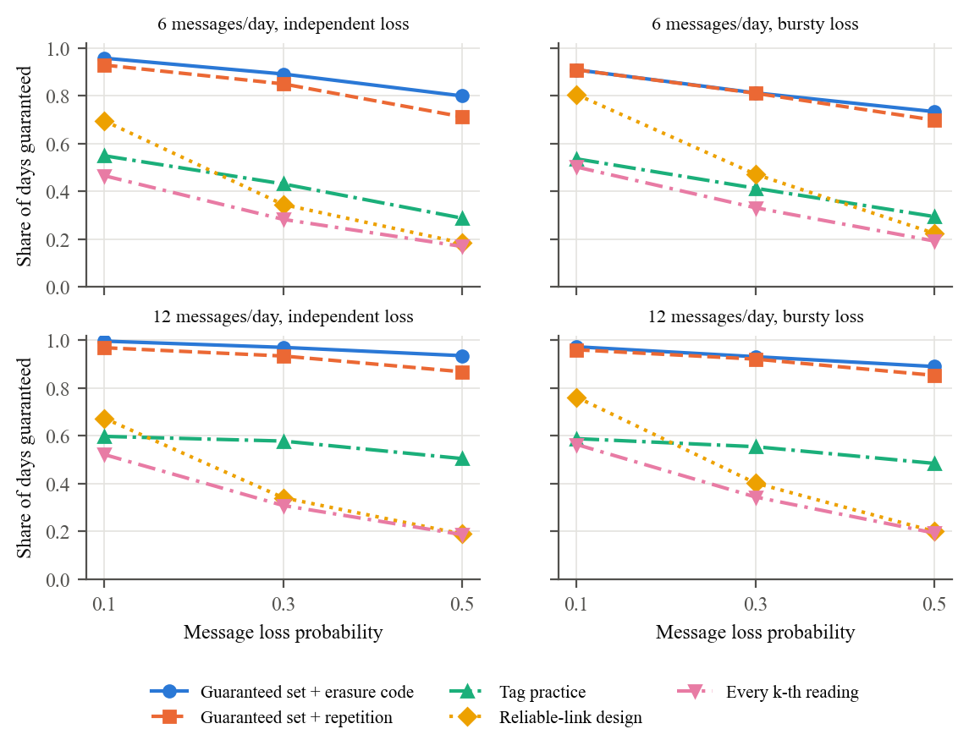
Figure 5: Guaranteed share of site-days by design, plan size, loss model, and loss probability (USGS 2024).
Repetition of the guaranteed record performed close to the code. Its mean was 85% against 89% under independent loss, a small but consistent difference (0.04, 95% interval 0.01–0.07), and equal under bursty loss (81% and 81%); its median was slightly higher than that of the code. Both exceeded the reliable-link design by at least 0.34 in every setting of six, 12, and 24 messages per day with loss probabilities of 0.3 and 0.5 (H5). The difference between them appeared on the low-cost records, whose larger guaranteed sets left less room for copies: there, the code guaranteed 77% of site-days and repetition 58%.
Two further results bound these conclusions:
- Capacity alone did not help: at 24 messages per day and $p=0.3$, the reliable-link design still guaranteed only 38% of site-days, because a single lost message removes values from a record that has no redundancy.
- One message per day was too few: no design reached more than 55%, since a single message cannot carry both a record and protection.
The server could certify 91% of readings with the code, against 70% with the reliable-link design.
5.3. Buffering across days (RQ2)
Fig. 6 shows the share of sites that met the buffered target. Under independent loss with $p=0.3$, six messages per day met it at 35 of 39 sites (hypothesis H2), with guaranteed days typically delivered on the following day (median delay 1 day in development). Under bursty loss, six messages per day met the target at only 17 sites, because one burst can erase a whole day’s block; 12 messages per day restored it at 35 sites (H2b). One message per day met the target at no site.
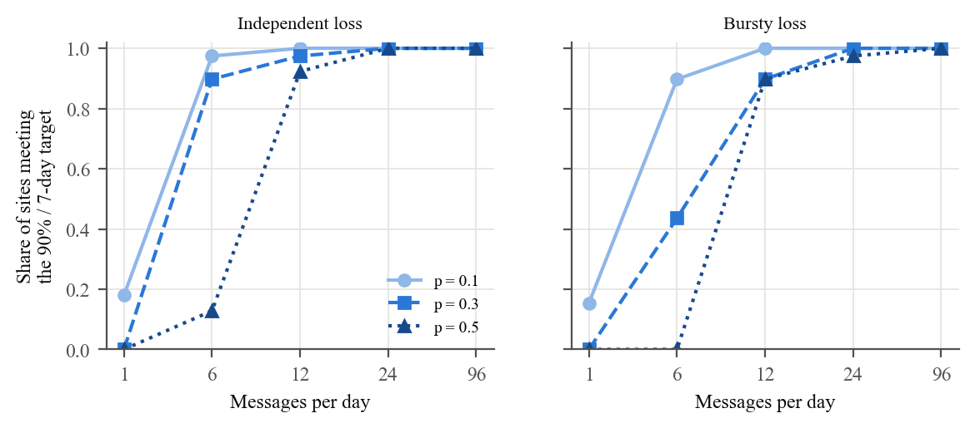
Figure 6: Share of sites with at least 90% of days guaranteed within seven days, by plan size and loss probability, with buffering and the erasure code (USGS 2024).
5.4. Choosing a plan from a pilot (RQ4)
The plan chosen from the first 28 days of 2024 was sufficient for the rest of the year at 85% of sites, and it was never more than one tier larger than necessary (100% of sites; hypothesis H6). At five of the six sites whose pilot underestimated the need, the median need during the pilot was lower than over the rest of the year, which is consistent with the seasonal rise in Fig. 4.
5.5. Sensitivity analyses
Table 4 summarises the exploratory sensitivity analyses of the daily need. The results above used exact readings; an encoder that targets 0.975 times the tolerance, which keeps the transmitted 13-bit values within it too, needed a median of 18 bytes per day and 13% more values in total, which is less than one message on the most demanding days. Reserving half of the error budget for the sensor raised the median need to 33 bytes, 2.2 times the main result, whereas the USGS rating of a good record needed only 6 bytes. The two simpler encoders were more expensive: greedy online segmentation needed 25% more values than the fewest-values encoder, and deadband reporting 1.9 times as many. Coarser sampling did not reduce the need: at the sites sampled every 15 minutes, the median was 18 bytes per day, and it stayed at 18 and 18 bytes when only every second or fourth reading was kept, because the need reflects the variation of the river rather than the number of readings.
Table 4: Bytes per day needed under the sensitivity analyses: median, 99th percentile, and maximum over the USGS 2024 site-days, and the median over the InWaterSense days.
Record and encoder | Median | P99 | Max. | InWaterSense
Main result: excellent record, fewest values | 15 | 108 | 201 | 58.5
Excellent record within 0.975 of the tolerance (quantiser margin) | 18 | 117 | 219 | 63.0
Excellent record within half the tolerance (sensor margin) | 33 | 207 | 366 | 139.5
Good record, fewest values | 6 | 39 | 123 | 21.0
Excellent record, greedy online segmentation | 18 | 138 | 255 | 84.0
Excellent record, deadband reporting | 30 | 176 | 270 | 133.5
With 19-byte messages, which carry six values instead of seven, the ranking of the delivery designs was unchanged. At six messages per day and $p=0.3$, the code guaranteed 88% of site-days, repetition 81%, tag practice 36%, the reliable-link design 35%, and evenly spaced readings 28%; under bursty loss, the code and repetition guaranteed 78% and 77%.
6. Discussion
6.1. Guidance for monitoring agencies
The results translate into five recommendations for remote river monitoring over satellite IoT:
- Send the guaranteed record, not the readings. A day within the USGS excellent-record tolerance needed a median of 15 bytes, which is approximately one fiftieth of the raw readings. Evenly spaced readings at the same size violated the tolerance on most days at every loss probability tested (Table 3).
- Protect the record against loss. The design that is optimal on a reliable link guaranteed only 34% of days at a loss probability of 0.3, and more capacity did not repair it. At that loss probability, repetition and an erasure code both raised the guaranteed share above 80%. The code is preferable where records are larger, as at the low-cost sites, and repetition is a simpler choice where they are small.
- Size the plan for the loss process. With buffering, six messages per day sufficed at 90% of sites under independent loss, but bursty loss required 12. A single message per day was insufficient at almost every site.
- Choose the plan from a pilot, with a margin for season. A 28-day pilot selected an adequate plan at 85% of sites. Most shortfalls occurred where the pilot fell in a low-need period; therefore, a pilot in the season of greatest variation, or one tier of margin, is advisable.
- Do not rank parameters by assumed stability. Temperature consumed the largest share of the guaranteed record (41%); thus, fixed priority classes that treat it as a baseline would degrade the record where it is most demanding.
Neither satellite contact time nor energy was the binding constraint. An orbit propagation of the Kinéis constellation over the Weija site gave approximately 40 passes per day above 25° elevation, each lasting a median of 4.5 minutes. The module draws 500 mA at 5 V while transmitting a message for less than one second (Kinéis, 2023); therefore, six messages per day cost at most 15 J. The constraint was the message quota, which is the quantity this study optimised. Where a terrestrial community LoRaWAN network is available, its fair-use limit of 30 seconds of airtime per day (The Things Network, 2026) allows approximately 510 bytes per day even at the slowest data rate, more than the largest daily need observed; the scarcity addressed here is therefore specific to satellite plans.
6.2. Relation to earlier work
The encoder and the code are established techniques (Imai and Iri, 1988; Reed and Solomon, 1960; Soroush et al., 2008), and budgeted compression of sensor history, including allocation of bandwidth towards the node with the largest error, was proposed for multi-hop sensor networks (Deligiannakis et al., 2007). The findings of this study qualify that line of work for one-way links: the design that is best when every message arrives was the worst of the guaranteed-record designs once messages could be lost. They also qualify current satellite-tag practice (Boehme et al., 2009; Photopoulou et al., 2015), which fixes the number of points rather than the accuracy; by construction, such a scheme spends capacity on quiet days and cannot guarantee the tolerance on active ones. Freshness-oriented scheduling (Talli et al., 2026; Yates et al., 2021) addresses a different objective, the latest value, which a guaranteed record covers as a special case.
6.3. Limitations
The results carry the following limitations:
- Message plans: the tiers of 1 to 96 messages per day were illustrative; the message size and the one-way link followed the module datasheet (Kinéis, 2023), but commercial plans differ between providers and change over time.
- Loss: no measured loss rate was available for the service; therefore, loss probabilities and burstiness were swept. Field measurements could narrow the plan recommendation.
- Hardware: the study was trace-driven. The encoder has an exact algorithm in time linear in the number of readings (Imai and Iri, 1988), a day of four parameters at 10-minute sampling occupies approximately 1.2 kB, and a Reed–Solomon code over GF($2^{8}$) needs only table look-ups (Reed and Solomon, 1960); all of this suits a microcontroller, but neither was run on a node.
- Sensor error: the guarantee bounds the error added by the encoder, not the error of the sensor. A sensor that already uses part of the USGS error budget leaves less for the encoder; reserving half of the budget for the sensor raised the median need to 33 bytes per day (Section 5.5).
- Tag practice: the baseline modelled the pseudo-random resending of satellite-linked tags within one day. Real tags rotate a buffer over several days, which adds a form of repetition across days that was not modelled.
- Tolerances: the USGS rating defines accuracy relative to the measured record. Other agencies use other limits, and the guarantee refers to the sensor readings, not to the river itself; sensor errors are outside its scope.
- Low-cost deployments: both records had many gaps, which left 22 and 49 complete days. Their results are indicative.
- Day boundaries: the reconstruction of a day starts from the previous day’s last value. A lost anchor weakens the guarantee of the following day until a new value arrives.
7. Conclusions
This study measured what a regulatory-grade water-quality record costs and how it can be delivered over the one-way, message-limited satellite links that reach remote rivers. On 39 USGS sites over two years, a record within the USGS excellent-record tolerance needed a median of 15 bytes per day and at most 10 messages of 23 bytes. Delivered without protection, such a record was guaranteed on only 34% of days at a message loss of 30%. Protected by an erasure code or by repetition, it was guaranteed on more than 80% of days at the same loss with six messages per day, and on most sites within a week when a node buffered its data. A 28-day pilot was sufficient to choose the plan at 85% of sites. All seven pre-registered hypotheses held on a sealed confirmation year.
For agencies monitoring rivers such as those affected by illegal mining in Ghana, the result means that a credible continuous record does not require a high-capacity link. It requires the right bytes, protected against loss, on a plan sized from local data. Future work should measure message loss on operational satellite services, run the encoder on field hardware, and extend the guarantee to the event alarms that operators need in real time.
Software and data availability
The software that produced every result is described below:
- Name of software: guaranteed-record toolkit (encoder, Reed–Solomon code, loss channels, delivery designs, buffered simulation, analysis scripts, and unit tests).
- Developers: Stephen Kwaku Azongo and Kofi Sarpong Adu-Manu.
- Contact: Kofi Sarpong Adu-Manu, Department of Computer Science, University of Ghana.
- Year first available: 2026.
- Hardware required: a standard desktop computer.
- Software required: Python 3.13 with NumPy, pandas, and Matplotlib.
- Program language: Python.
- Program size: approximately 2,400 lines.
- Availability and cost: free, under a CC BY 4.0 licence; archived on Zenodo (Azongo, 2026) and developed at https://github.com/steveAzo/river-wq-satellite-records.
The archive also holds the USGS and InWaterSense data as used, the frozen study plan with the checksums of the frozen code, and every result file from which the numbers, tables, and figures of this paper are generated. The USGS data are public (U.S. Geological Survey, 2016). The InWaterSense data are available under a CC BY 4.0 licence (Ahmedi, 2021). The Weija data belong to the deployment team and are available from the corresponding author on reasonable request.
CRediT authorship contribution statement
Kofi Sarpong Adu-Manu: Conceptualization, Supervision, Resources, Writing – review & editing. Stephen Kwaku Azongo: Methodology, Software, Formal analysis, Investigation, Data curation, Visualization, Writing – original draft.
Declaration of competing interest
The authors declare that they have no known competing financial interests or personal relationships that could have appeared to influence the work reported in this paper.
Funding
This research did not receive any specific grant from funding agencies in the public, commercial, or not-for-profit sectors.
Acknowledgements
The authors thank the operators of the USGS National Water Information System, the InWaterSense project, and the Weija deployment team for making their data available.

References
Abdelfadeel, K.Q., Zorbas, D., Cionca, V., Pesch, D., 2020. FREE: Fine-grained scheduling for reliable and energy-efficient data collection in LoRaWAN. IEEE Internet of Things Journal 7, 669–683. https://doi.org/10.1109/jiot.2019.2949918
Adu-Manu, K.S., Katsriku, F.A., Abdulai, J.-D., Engmann, F., 2020. Smart river monitoring using wireless sensor networks. Wireless Communications and Mobile Computing 2020, 1–19. https://doi.org/10.1155/2020/8897126
Adu-Manu, K.S., Tapparello, C., Heinzelman, W., Katsriku, F.A., Abdulai, J.-D., 2017. Water quality monitoring using wireless sensor networks: Current trends and future research directions. ACM Transactions on Sensor Networks 13, 1–41. https://doi.org/10.1145/3005719
Afhamisis, M., Palattella, M.R., 2022. SALSA: A scheduling algorithm for LoRa to LEO satellites. IEEE Access 10, 11608–11615. https://doi.org/10.1109/access.2022.3146021
Ahmedi, F., Ahmedi, L., 2022. Dataset on water quality monitoring from a wireless sensor network in a river in Kosovo. Data in Brief 44, 108486. https://doi.org/10.1016/j.dib.2022.108486
Ahmedi, L., 2021. InWaterSense dataset: Data from a wireless sensor network on water quality monitoring in a river in Kosovo. https://doi.org/10.17632/KRZV3G6D5F.1
Albanese, A., Blomer, J., Edmonds, J., Luby, M., Sudan, M., 1996. Priority encoding transmission. IEEE Transactions on Information Theory 42, 1737–1744. https://doi.org/10.1109/18.556670
Alvarez, G., Fraire, J.A., Hassan, K.A., Cespedes, S., Pesch, D., 2022. Uplink transmission policies for LoRa-based direct-to-satellite IoT. IEEE Access 10, 72687–72701. https://doi.org/10.1109/access.2022.3189647
Azongo, S.K., 2026. River-wq-satellite-records, version v1.0.0: Code, data, and results. https://doi.org/10.5281/zenodo.23617665
Barbarioli, B., Mersy, G., Sintos, S., Krishnan, S., 2023. Hierarchical residual encoding for multiresolution time series compression. Proceedings of the ACM on Management of Data 1, 1–26. https://doi.org/10.1145/3588953
Benson, B.B., Krause, D., 1984. The concentration and isotopic fractionation of oxygen dissolved in freshwater and seawater in equilibrium with the atmosphere. Limnology and Oceanography 29, 620–632. https://doi.org/10.4319/lo.1984.29.3.0620
Boehme, L., Lovell, P., Biuw, M., Roquet, F., Nicholson, J., Thorpe, S.E., Meredith, M.P., Fedak, M., 2009. Technical note: Animal-borne CTD-satellite relay data loggers for real-time oceanographic data collection. Ocean Science 5, 685–695. https://doi.org/10.5194/os-5-685-2009
Capez, G.M., Henn, S., Fraire, J.A., Garello, R., 2022. Sparse satellite constellation design for global and regional direct-to-satellite IoT services. IEEE Transactions on Aerospace and Electronic Systems 58, 3786–3801. https://doi.org/10.1109/taes.2022.3185970
Centenaro, M., Costa, C.E., Granelli, F., Sacchi, C., Vangelista, L., 2021. A survey on technologies, standards and open challenges in satellite IoT. IEEE Communications Surveys & Tutorials 23, 1693–1720. https://doi.org/10.1109/comst.2021.3078433
Chen, X., Liao, X., Bidokhti, S.S., 2021. Real-time sampling and estimation on random access channels: Age of information and beyond, in: IEEE INFOCOM 2021 - IEEE Conference on Computer Communications. IEEE, pp. 1–10. https://doi.org/10.1109/infocom42981.2021.9488702
Deligiannakis, A., Kotidis, Y., Roussopoulos, N., 2007. Dissemination of compressed historical information in sensor networks. The VLDB Journal 16, 439–461. https://doi.org/10.1007/s00778-005-0173-5
Deligiannakis, A., Kotidis, Y., Roussopoulos, N., 2004. Hierarchical in-network data aggregation with quality guarantees, in: Advances in Database Technology - EDBT 2004, Lecture Notes in Computer Science. Springer Berlin Heidelberg, Berlin, Heidelberg, pp. 658–675. https://doi.org/10.1007/978-3-540-24741-8_38
Desnoyers, P., Ganesan, D., Li, H., Li, M., Shenoy, P., 2005. PRESTO: A predictive storage architecture for sensor networks, in: Proceedings of the 10th Workshop on Hot Topics in Operating Systems (HotOS x). Santa Fe, NM, USA.
Duncan, A.E., 2020. The dangerous couple: Illegal mining and water pollution—a case study in Fena river in the Ashanti region of Ghana. Journal of Chemistry 2020, 1–9. https://doi.org/10.1155/2020/2378560
Elliott, E.O., 1963. Estimates of error rates for codes on burst-noise channels. Bell System Technical Journal 42, 1977–1997. https://doi.org/10.1002/j.1538-7305.1963.tb00955.x
Gandhi, S., Nath, S., Suri, S., Liu, J., 2009. GAMPS: Compressing multi sensor data by grouping and amplitude scaling, in: Proceedings of the 2009 ACM SIGMOD International Conference on Management of Data, SIGMOD/PODS ’09. ACM, pp. 771–784. https://doi.org/10.1145/1559845.1559926
Ganesan, D., Greenstein, B., Perelyubskiy, D., Estrin, D., Heidemann, J., 2003. An evaluation of multi-resolution storage for sensor networks, in: Proceedings of the 1st International Conference on Embedded Networked Sensor Systems, SenSys03. ACM, pp. 89–102. https://doi.org/10.1145/958491.958502
Gilbert, E.N., 1960. Capacity of a burst-noise channel. Bell System Technical Journal 39, 1253–1265. https://doi.org/10.1002/j.1538-7305.1960.tb03959.x
Imai, H., Iri, M., 1988. Polygonal approximations of a curve: Formulations and algorithms, in: Toussaint, G.T. (Ed.), Computational Morphology. North-Holland, Amsterdam, pp. 71–86.
Kinéis, 2023. KIM1 Kinéis module: Product datasheet (KINEIS-MU-22-0032).
Olston, C., Jiang, J., Widom, J., 2003. Adaptive filters for continuous queries over distributed data streams, in: Proceedings of the 2003 ACM SIGMOD International Conference on Management of Data, SIGMOD/PODS03. ACM, pp. 563–574. https://doi.org/10.1145/872757.872825
Photopoulou, T., Fedak, M.A., Matthiopoulos, J., McConnell, B., Lovell, P., 2015. The generalized data management and collection protocol for conductivity-temperature-depth satellite relay data loggers. Animal Biotelemetry 3, 21. https://doi.org/10.1186/s40317-015-0053-8
Ramachandran, R., Banerjee, S., 2026. Pricing IoT data delivered via LEO satellites. https://doi.org/10.48550/ARXIV.2609.37995
Rathi, S., Borkotoky, S.S., 2025. Message replication for improving reliability of LR-FHSS direct-to-satellite IoT. https://doi.org/10.48550/ARXIV.2501.11984
Reed, I.S., Solomon, G., 1960. Polynomial codes over certain finite fields. Journal of the Society for Industrial and Applied Mathematics 8, 300–304. https://doi.org/10.1137/0108018
Soroush, E., Wu, K., Pei, J., 2008. Fast and quality-guaranteed data streaming in resource-constrained sensor networks, in: Proceedings of the 9th ACM International Symposium on Mobile Ad Hoc Networking and Computing, MobiHoc08. ACM, pp. 391–400. https://doi.org/10.1145/1374618.1374670
Talli, P., Munari, A., Mason, F., Chiariotti, F., Zanella, A., 2026. Value-based massive access through goal-oriented irregular repetition slotted ALOHA. https://doi.org/10.48550/ARXIV.2609.20569
The Things Network, 2026. Duty cycle and fair use policy.
Tondo, F.A., Montejo-Sánchez, S., Pellenz, M.E., Céspedes, S., Souza, R.D., 2021. Direct-to-satellite IoT slotted Aloha systems with multiple satellites and unequal erasure probabilities. Sensors 21, 7099. https://doi.org/10.3390/s21217099
U.S. Geological Survey, 2016. National water information system data available on the world wide web (USGS water data for the nation). https://doi.org/10.5066/F7P55KJN
Wagner, R.J., Boulger, R.W., Jr., Oblinger, C.J., Smith, B.A., 2006. Guidelines and standard procedures for continuous water-quality monitors: Station operation, record computation, and data reporting (Techniques and Methods No. 1-D3). U.S. Geological Survey, Reston, VA, USA. https://doi.org/10.3133/tm1D3
Yates, R.D., Sun, Y., Brown, D.R., Kaul, S.K., Modiano, E., Ulukus, S., 2021. Age of information: An introduction and survey. IEEE Journal on Selected Areas in Communications 39, 1183–1210. https://doi.org/10.1109/jsac.2021.3065072

∗ Corresponding author.

