**-**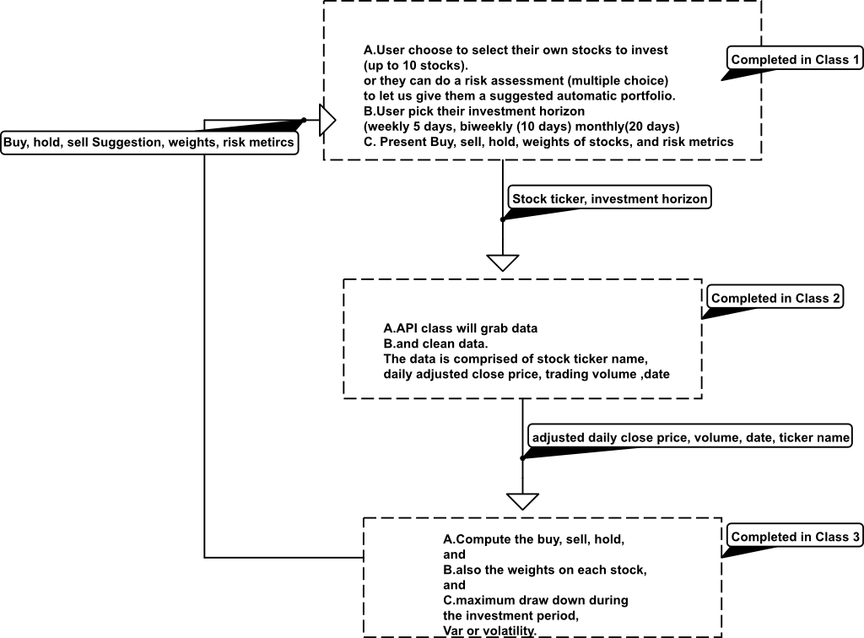

**---------Main function**

Show stock price to users according to their input. Maybe do some customized suggestions based on the user’s interests.

**Basic Workflow**

1. Class 1 get the stock name from user, and pass it to Class 2

2. Class 2 take the input from Step1, communicate with stock website with public API, extract price data, and pass it to Class 3

3. Class 3 analyze the data, produce graphs, and pass back to Class 1

4. Class 1 show the graphs to the user

This is really a very brief and basic workflow. We can come up with more functions later on.

Zeneng: if we are allowed to use python instead of java, then this project would be easier. Since there are many great packages presenting data and building GUI.

**Design Classes**

Class 1 is a user interface. The main function is to interact with user, get input and show output in a nice way. （Steve?）

Class 2 is a communicator. The main function is to get data from the stock website. Maybe do some data cleaning to provide clean data to Class 3 （Xi?）

Class 3 is an analyzer. The main function is to analyze the price data (Zeneng?) Zeneng: Analyzing data is not the essential part or difficult part of this project, maybe I can offer some help on API part.

Class 1, 2, 3 are just a general classification. More classes are good to perform the function and show good design.

**JAVA Packages**

1. For user interface, do we need graphic user interface? Is console good enough? How to present statistic graphs made by Class 3? What packages are helpful? (Steve?) Zeneng:

2. Available APIs for stock market (Xi?) Zeneng: I find Interactive broker is good to use since it has both JAVA and Python api, if you find any other API let me know.

3. Packages to handle certain data type: JASON/XML (Xi?)

3. Packages for data analysis and visualization, like Numpy and Pandas in Python? Do we must use Java package for this part? (Zeneng?) Zeneng: Let me ask our project supporter.

This is just an initial thought. Feel free to make changes and add your ideas. Let me know if everyone agrees with the work breakdown. It would great if we set up a meeting next week to discuss everything.

We can start by thinking about the design of classes, and searching for packages. I also created two google sheets. One is to collect and share information about the Packages, so each of us can just search for part of them and share with each other. The other one is CRC cards which is almost empty. We can fill it out during our meeting.

* Question? Do you guys want to use machine learning for any part of this project ? If so I’ve done some stuff in R before using neural networks to predict stock market data

Zeneng: If time allows, we can try.

* I can definitely work on “class 1”, I think it would be really interesting and cool to have to make a GUI ---Also correct me if I’m wrong, but it seems that you are interested in making something similar to a dashboard that could be found in something like Tableau for presenting the data we get from class 3
* I’ve actually been working on making android apps (which is an example of a gui), but I think making all of this in an app would be a bit challenging and potentially take more time than we have for this project (although it would be cool)
* Zeneng: I think we can make an easy GUI, it doesn’t take much time to build.