First plot. C = 0.1. 30 Support Vectors. 8 Misclassifications. 1 Misclassification that is outside of the margins (the top red data point).

Second plot. C = 100. 30 Support Vectors. 8 Misclassifications. Thinner margin, 1 less misclassification. Visually looks like it’s probably a better fit actually despite higher C usually leading towards higher overfitting.

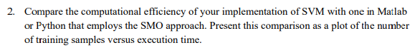

Plot of number of samples versus time to execute each method in seconds. I did 10 iterations at 100,200,300,…,1000 samples each. The quad prog implementation grows almost exponentially. The other method I used is Scikit-Learn’s SVM package that uses the SMO algorithm. It looks like a flat line on this scale but it’s actually growing almost linearly. Much faster than my implementation (by a couple orders of magnitude).