Student: Steve Gillet
Course: Algorithmic Motion Planning – ASEN 52540-001 – Fall 2024
Instructor: Morteza Lahijanian
Teaching Assistant: Yusif Razzaq
Date: September 13, 2024

Homework 2 Assignment Submission

Exercise 1.
Define appropriate sets that describe the following shapes:
(a) Hat in Figure 1a,
(b) Pacman in Figure 1b,
(c) Birthday Pacman in Figure 1c, where point v = (xv, yv). (hint: use the results in parts (a) and
(b))

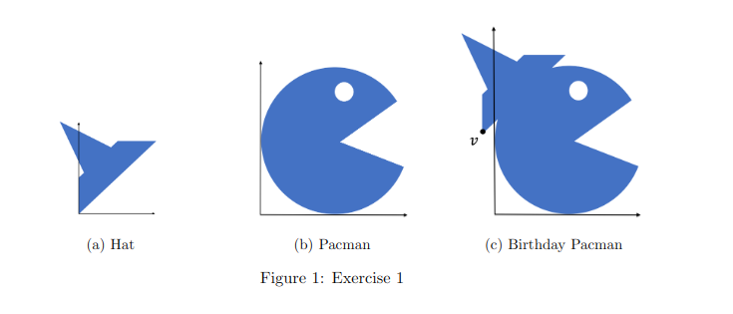

(a) Hat:

The hat appears to be a triangular shape. This can be defined as a subset of R2 using inequalities. Let’s denote the hat as H, and we can define the region bounded by three lines:
- One line that represents the base of the triangle.
- Two other lines representing the two other sides.
H={(x,y)∣ax+by≤c,dx+ey≤f,gx+hy≤i

(b) Pacman:
Pacman can be defined as a circle with a triangular sector removed. Assume the center of the circle is at (xc​,yc​) and radius r, and the wedge is formed between angles θ1​ and θ2​ from the positive x-axis.
- Circle: The set of all points within radius r of (xc​,yc​) is:
P={(x,y)∣(x−xc​)2+(y−yc​)2≤r2}
- Wedge (Triangle sector): A wedge cut from angle θ1​ to θ2​. This can be defined using polar coordinates or angular conditions:
W={(x,y)∣θ1​≤arg((x−xc​)+i(y−yc​))≤θ2​}
- The Pacman shape is then:
P={(x,y)∈R2∣(x−xc​)2+(y−yc​)2≤r2}∖W

(c) Birthday Pacman:
The birthday Pacman is the Pacman with the hat positioned at a specific point v=(xv​,yv​).
- Translated Hat: Translate H to v:
H′={(x+xv​,y+yv​)∣(x,y)∈H}
- Birthday Pacman: Combine the translated hat with Pacman:
B=P∪H′
In these definitions:
- (xc​,yc​),r describe the circle.
- θ1​,θ2​ describe the angular range of the missing wedge.
- xv​,yv​ is the translation vector for placing the hat.

Exercise 2.
Implement BUG 1 and BUG 2 algorithms for a left-turning robot using AMP-tools.
Consider the two workspaces W1 and W2 as specified below.
• W1 = [−1, 14] × [−1, 14], qstart = (0, 0), qgoal = (10, 10), and obstacles W O1 and W O2, where
W O1 is a rectangle and W O2 is the union of four rectangles, i.e., W O2 = ⋃5
i=2 W Oi. The vertices of the rectangles are:
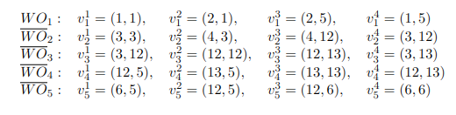
• W2 = [−7, 36] × [−7, 7], qstart = (0, 0), qgoal = (35, 0), and obstacle W O = ⋃9
i=1 W Oi, where each W Oi is a rectangle with vertices:
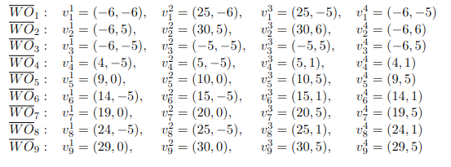
(a) Plot the paths generated by Bug 1 and Bug 2 algorithms.
(b) What are the lengths of the paths generated by Bug 1 and Bug 2 algorithms?
(c) Would you expect the same path lengths if the robot were right turning?
(d) Ensure your implementation passes the benchmark HW2::grade(). Note that this benchmark
randomly generates multiple environments with (possibly overlapping) obstacles. Each environ-
ment is guaranteed to have a path to goal.
Submit the report card.dat file along with your code (ws/). Detailed instructions can be found
on GitHub: https://github.com/peteramorese/AMP-Tools-public

(a) Plot Paths:
Bug 1 Random Obstacles:

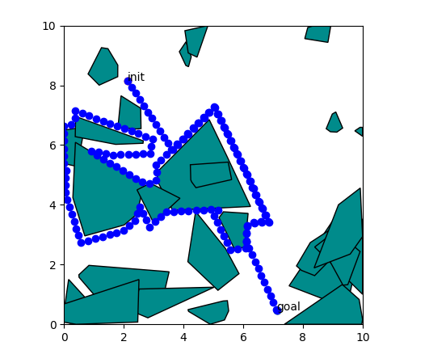
Bug 1 Workspace 1:
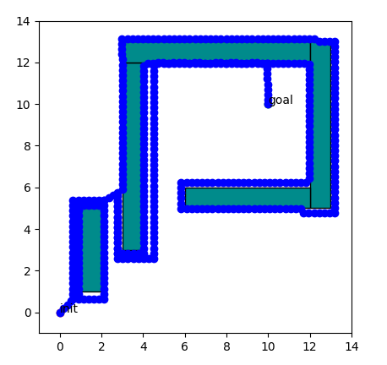

Bug 2 Random Obstacles:
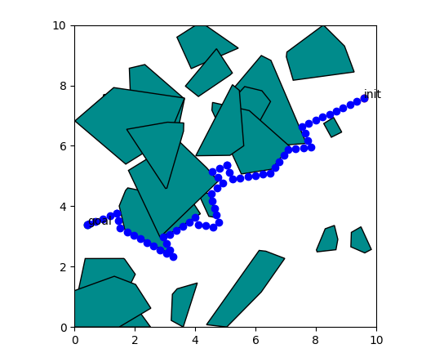
Bug 2 Workspace 1:
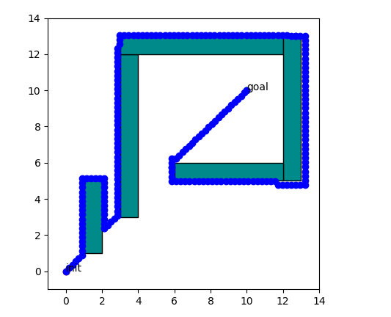

(b) Path Lengths:
Bug 1 had a path length of 42.0338 (Random Obstacles) and Bug 2 had a path length of 15.5369 (Random Obstacles).

(c) Right Path Lengths:
The path length is only different for Bug 2 depending on whether it is right turning or left turning. A clear example is in this Bug 2 Random Obstacle run where the bug goes around the left side of the obstacle where much less of the perimeter is. If there is more perimeter on a certain side of the m-line for Bug 2 then turning that direction is going to increase the path length more.
Bug 1 has to completely circumnavigate the obstacle it hits no matter which direction it turns and when it goes back to the leave point it goes by the shortest route so it doesn’t matter in terms of path length which way it turns.

