Student: Steve Gillet
Course: Linear Control Design – ASEN 5014-001 – Fall 2024
Instructor: Dale Lawrence
Teaching Assistant: Karan Muvvala
Date: September 9, 2024

Homework 1 Assignment Submission

Question 1:
1). Find two different state space realizations for Example 1 in class. Hint, consider the case of an output sensor converting velocity to voltage. How may other realizations can you find?

Voltage Output:
For the first state space realization I would like to address the case suggested in the question (converting velocity to voltage). The state space realization would actually be pretty similar to the example done in class:
v’(t) =1/m f(t) x=v u=f y=v
x’(t) = [v’] = [0]x(t) + [1/m]u(t)
y(t) = [ ] = [1]x(t) + [0]u(t)
In both examples you are only concerned with the velocity in terms of force input into the system, however in the voltage output sensor case you are scaling that velocity by some constant that relates the velocity to the output voltage. Therefore the state space realization will look very similar with that constant (represented by k) and the output being V voltage.
v’(t) =1/m f(t) x=v u=f y=V
x’(t) = [v’] = [0]x(t) + [1/m]u(t)
y(t)=[ ] = [k]x(t) + [0]u(t)

Position and Velocity States:
The second state space realization is the case where we keep track of two states, the position and the velocity. The change in position is equal to the velocity and the change in velocity is equal to the force divided by the mass. The output is not dependent on the input or the position.
v’(t)=1/m f(t) x’=v u=f y=v
x’(t)= = + u(t)
y(t)= [ ] = [0 1] + [0]u(t)

Other Realizations:
It occurs to me that you could also do a realization with position and velocity and the sensor and varying what the sensor reads or outputs. You could add damping or external disturbances. I would imagine that you could have an infinite number of realizations since you could relate just about any other process to this system and vary it in any little way.

Question 2:
2). Find a state space realization for Example 3 in class.

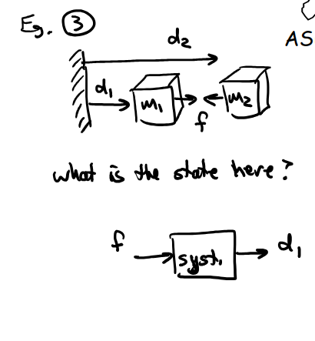Figure 1: Example 3

Two Mass State Realization:
The state variables for this system are the position and velocity of the two masses. I don’t believe that the two masses have any effect on each other in terms of velocity or acceleration unless they bump into each other, perhaps if displacement 1 becomes equal to displacement 2 and I’m not really sure how to model that. There is no spring or gravity in between them so the acceleration of one does not effect the other, so I made the state space realization so that the velocity and acceleration only depends on the mass of the individual block and the force applied. The output is the displacement d1.
x= u=f y=d1
x’(t)==+ u(t)
y(t) = [ ] = + 0 u(t)

Question 3:
3). Work problem 3.1 in the Textbook, using the controllable canonical form approach discussed in class.
Also construct corresponding simulation diagrams for each.
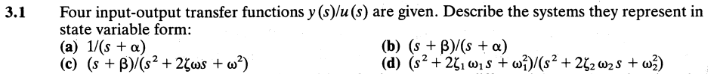

(a) 1/(s + a)
Transfer function in time-domain form:
y’+ay=u y=x
x’(t) = [-a]x(t) + [1]u(t)
y(t) = [1]x(t) + [0]u(t)
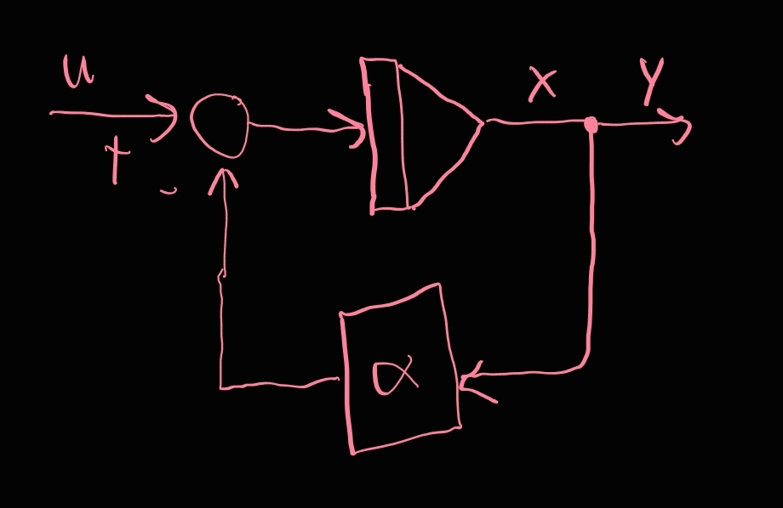

(b) (s + B)/(s + a)
y’ + ay = Bu + u’
x1=y x’ = -ax1 +Bx2 + x2’
x’(t)==+u(t)
y(t) = [1 0]+ [0]u(t)
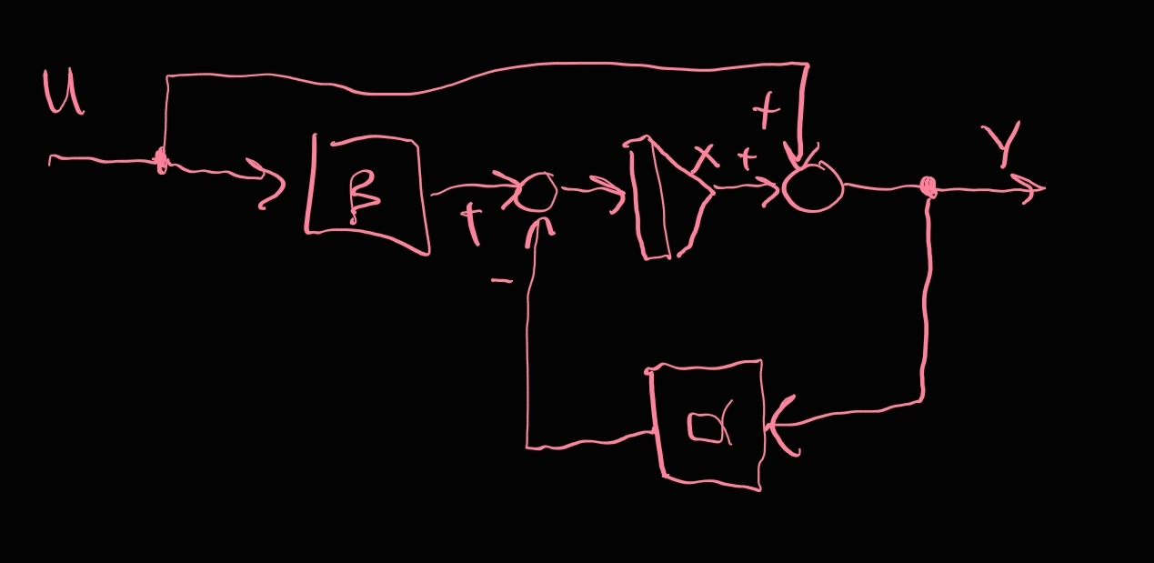

(c) (s + B)/(s^2 +2fws+w^2)
y’’ + 2fwy’ + w^2y = u’ + Bu
x1=y x2=y’
x1’=x2 x2’=-w^2x1-2fwx2+Bu+u’
x3=u x3’=u’
x’(t)==+u(t)
y(t) = [1 0]+[0]u(t)
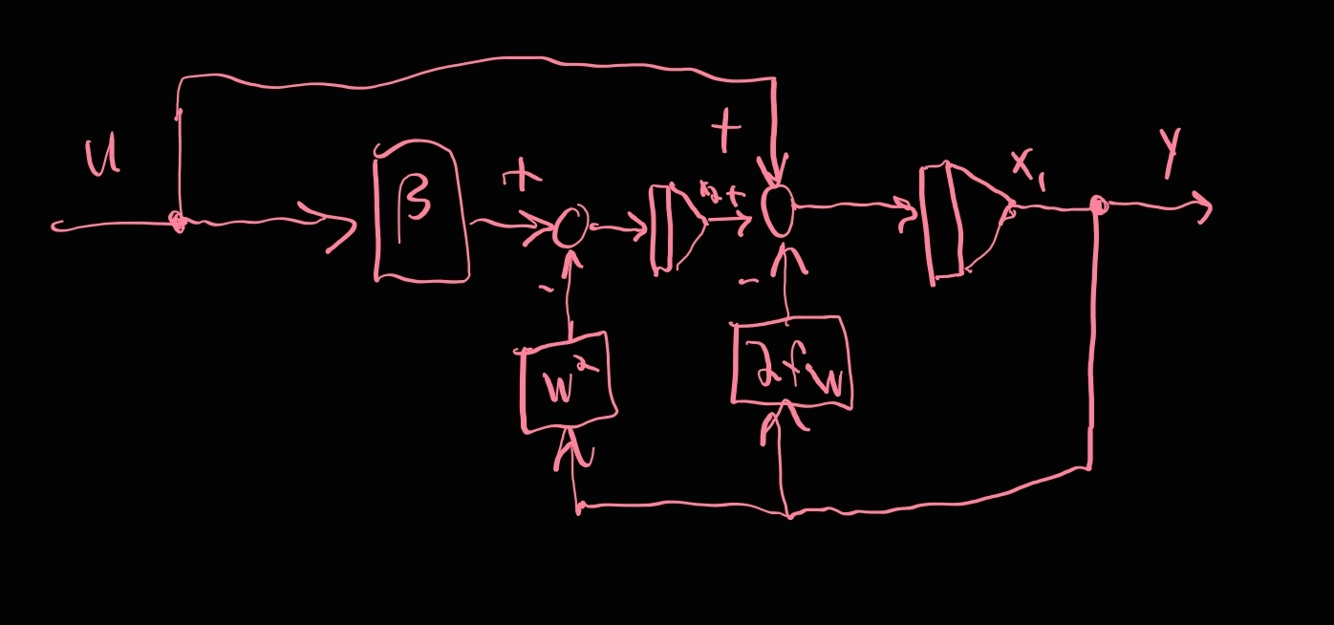

(d) (s^2 + 2f1w1s + w1^2)/(s^2 + 2f2w2s + w2^2)
x’(t)==+u(t)
y(t) = [w1^2 2f1w1]+[1]u(t)
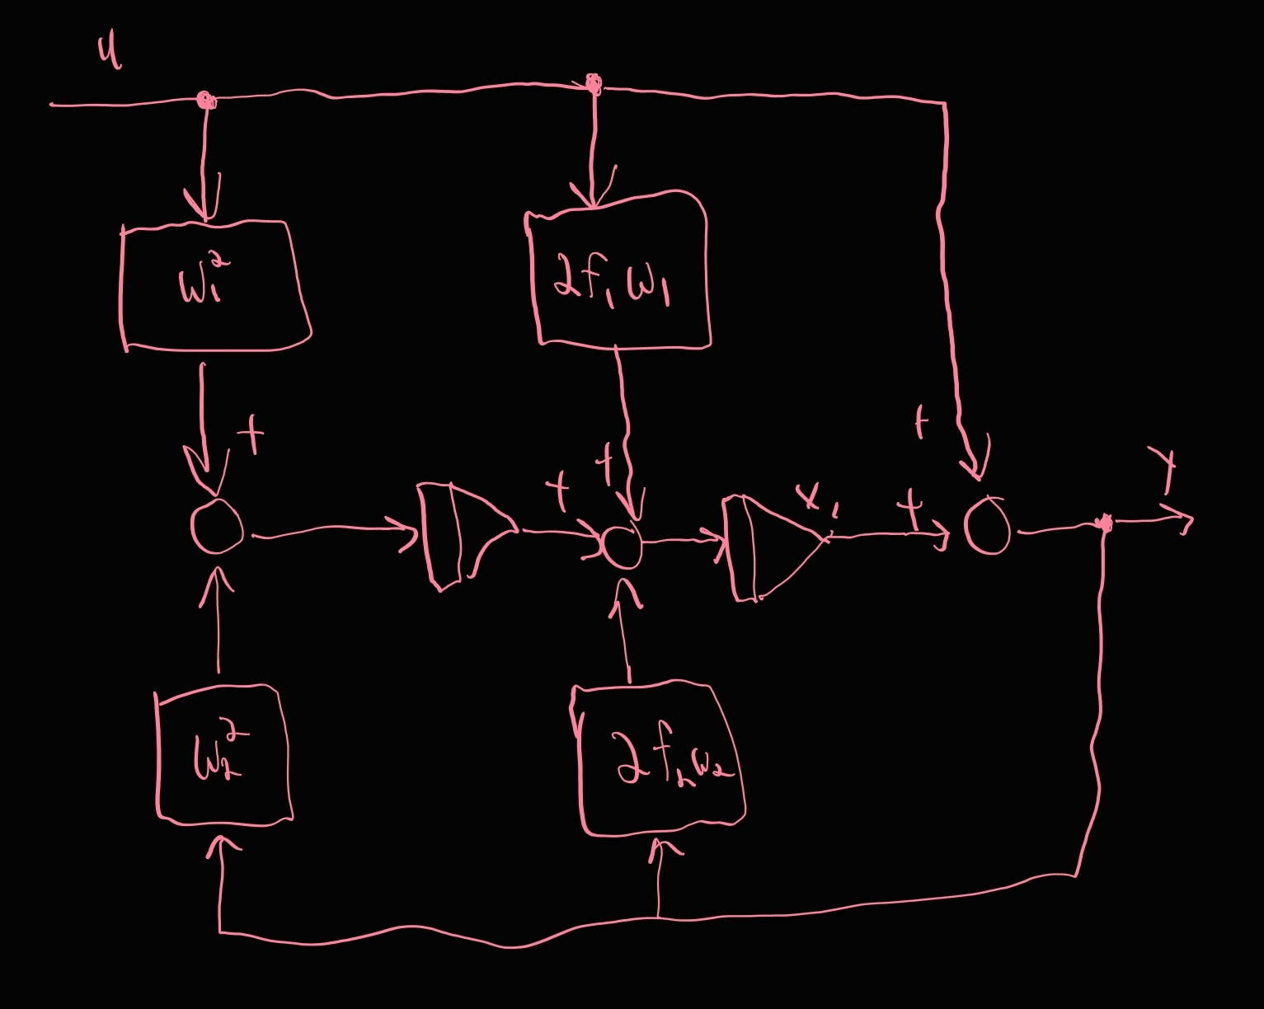

Question 4:
4). Work problem 3.20 in the Textbook.

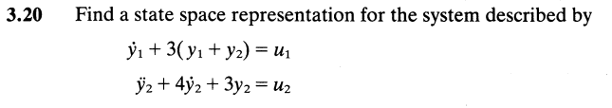
State Representation:
State variables:
x1=y1 x2=y2 x3=y2’
x1’=y1’ x2’=y2’=x3 x3’=y2’’
x1’ = -3x1 -3x2 + u1
x2’ = x3
x3’ = - 3x2 - 4x3 + u2

State Space Representation (Controllable Canonical Form):
=+

y = +u

