1. **Github Link:**

<https://github.com/steveantony5/AESD_Assignments/tree/master/Assignment_5>

1. **Oscilloscope screenshot:**

**LED toggling verification**

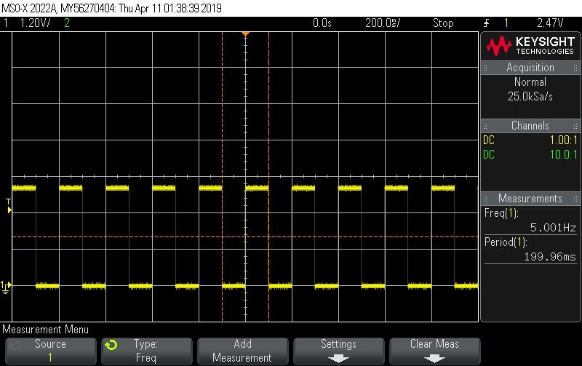

The toggling happens at 10 Hz ( 100ms)

The period of the waveform is 199.96 ms (5.001 Hz) , ie 2 toggles constitute one cycle.

1. **Oscilloscope screenshot:**

Screenshot of log output from tasks

1. **Notification when temperature cross the threshold (upper threshold is set as 28 C, lower threshold 23C )**

