Should I enter alteration counts in Corrections Review or Proof Revisions?
Article workflows
For some ARTEMIS workflows, you can enter your correction counts in Corrections Review (after Author Corrections and/or Editorial Office Corrections tasks) or at Proof Revisions. Do not put counts in both tasks. Our preference is to put them in at the Proof Revisions task. If you entered the counts in both tasks when sending one round of corrections to TNQ, please email Susan Clark for assistance.
Issue, PAP, FMBM, ELD workflows
Enter the correction counts once with each revision you send back to TNQ.
Alteration Counts
You will need to enter the counts for VEs, EAs, AAs, and PEs. Remarks can't be counted.
You enter the tasks in the Additional Information section.
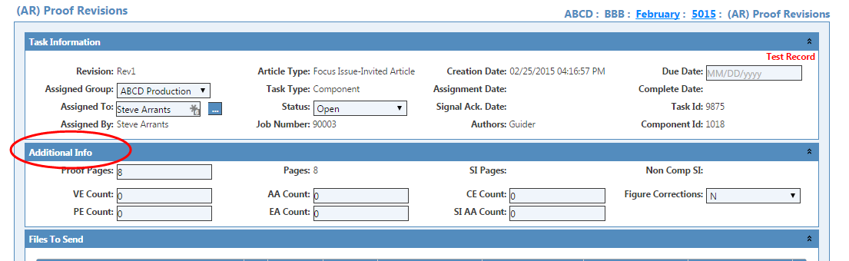
Enter each count. If there are Figure Corrections, select Y, N, or R.
How do I enter Additional Charges?
You must edit the task to enter Additional Charges.
What are Additional Charges?
Additional Charges can include reshoots for cover mockup, re-folioing the issue, PAP resupplies, supplemental pages processing, creating issue CDs for the customer, merging two articles to create a third article, color or B/W figure changes, etc.
To add Additional Charges
- Click the Additional Charges bar to open this section.
- Click Add. ARTEMIS opens the New Additional Charge dialog box.
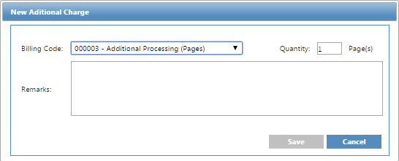
- Select a Billing Code from the drop-down list.
- Type a Quantity for the selected code.
- Type any Remarks.
- Click Save. ARTEMIS saves the entry.
Note: Once saved, you cannot delete or edit an entry. Instead, add a Remark.

