(AD) Record Created
{b}Note: {/b} Refer to your specific Workflow and process documentation for account-specific information.
One time ads vs. reusable ads
One-time ads are for use in a single issue. Reusable ads can be used in any issue. You can create either of them in the Title Record or in an unassigned issue record.
Summary
Initial step needed to add an Ad to ARTEMIS.
Full Description
- Click Production>Issues.
- Select your journal from the Issues list and click View. ARTEMIS displays the Issue Details screen.
- In the Ads section, click Add.
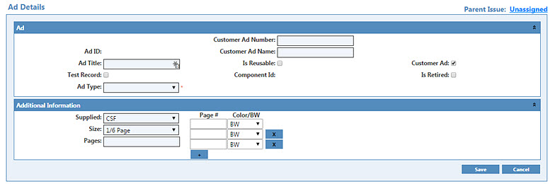
- If this is a reusable ad, select the Is Reusable check box. If this is a one-time ad, make sure this check box is cleared.
{b}Note: {/b} Currently, the Is Reusable option 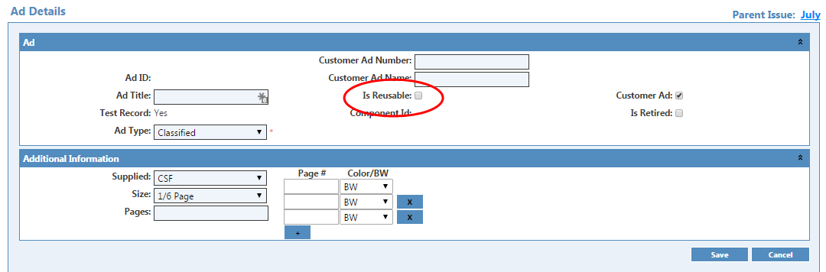is not operational. Until it is, see FAQ entry Is an ad reusable in different issues of the same journal?
- Fill out the Additional Information section.
  - If a new ad, choose CSF in the Supplied dropdown.
  - If TNQ has processed the ad, choose PU from the Supplied dropdown and enter the ad number on the Closing Memo to TNQ when you request print files.
- Type the page number and select Color or BW, and then click Save. ARTEMIS displays the Ad Details screen in the (AD) Ad Processing task.
{b}Note: {/b} Make a note of the Ad ID.
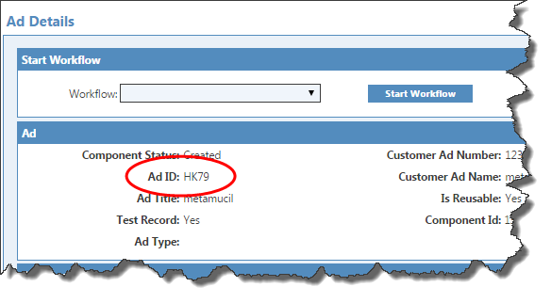
Related Tasks
- (AD) Ad Processing
- (AD) Ad QC
- (AD) Approval
FAQ Topics
- How do I use ads from FMP in ARTEMIS without reprocessing by TNQ?
- Can I use the same ad in two journals for the same customer without creating two ad records?
- Is an ad reusable in different issues of the same journal?
- How do I manage the same ad running in FMP and ARTEMIS?
(AD) Ad Processing
{b}Note: {/b} Refer to your specific Workflow and process documentation for account-specific information.
Summary
In this task, you upload files for processing by a vendor.
Full Description
To complete Ad Processing
- Edit the task.
- In the File Manager section, upload the files and select Include in Files to Send.
- In the Additional Info section, make any changes to the information and in the Remarks box, type any instructions for processing and for the ad.
- Click Submit. ARTEMIS submits the files to the vendor and changes the task status to AwaitingVendor. When the vendor completes the task, the ad's task changes to (AD) Ad QC.
Related Tasks
- (AD) Record Created
- (AD) Ad QC
- (AD) Approval
FAQ Topics
- How do I use ads from FMP in ARTEMIS without reprocessing by TNQ?
- Can I use the same ad in two journals for the same customer without creating two ad records?
- Is an ad reusable in different issues of the same journal?
- How do I manage the same ad running in FMP and ARTEMIS?
(AD) Ad QC
{b}Note: {/b} Refer to your specific Workflow and process documentation for account-specific information.
Summary
This task become available after the vendor processes the ad after submitting the (AD) Ad Processing task.
Full Description
This task is a production review of vendor-processed ads.
To complete Ad QC
- Edit the task.
- View the files listed in File Manager under (AD) Ad Processing:Orig. If there are any corrections, annotate the PDF and go to Step 5.
- Check the Remarks.
- If there are no errors, click Approve. This task closes and the workflow ends.
- If there is a Preflight failure, refer to the PDF checklist.
  - Review the checklist in the File Manager.
  - Click Alteration if the ad needs changes.
  - Go back to Ad Processing and resend the ad to TNQ.
{b}Note: {/b} If your title-specific workflow needs ads approved by the ME or agency, these tasks are set up in ARTEMIS and come before you click Approve.
Related Tasks
- (AD) Record Created
- (AD) Ad Processing
- (AD) Approval
FAQ Topics
- How do I use ads from FMP in ARTEMIS without reprocessing by TNQ?
- Can I use the same ad in two journals for the same customer without creating two ad records?
- Is an ad reusable in different issues of the same journal?
- How do I manage the same ad running in FMP and ARTEMIS?
(AD) Approval
{b}Note: {/b} Refer to your specific Workflow and process documentation for account-specific information.
Summary
The final step in adding an ad to an issue.
Full Description
This is a System task. There is no user action.
Related Tasks:
- (AD) Record Created
- (AD) Ad Processing
- (AD) Ad QC
FAQ Topics
- How do I use ads from FMP in ARTEMIS without reprocessing by TNQ?
- Can I use the same ad in two journals for the same customer without creating two ad records?
- Is an ad reusable in different issues of the same journal?
- How do I manage the same ad running in FMP and ARTEMIS?
How do I use ads from FMP in ARTEMIS without reprocessing by TNQ?
Occasionally, you need to use an ad existing in FMP in an ARTEMIS workflow. You don't want TNQ to process the ad again and you need to make it clear in ARTEMIS Sequencing and in the Closing Memo the new ARTEMIS ad ID and the old FMP ad ID are.
- Add the old FMP ads into ARTEMIS, preferably in the Unassigned issue.
- During ad set-up in ARTEMIS, choose PU in the Supplied drop-down and select Is Reusable.
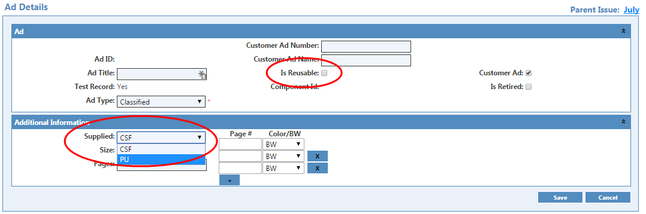
- Include the old FMP ad number as part of the Ad Title when you set up the ad in ARTEMIS. For example, and ad title might beJASN- Updated Web site (old ad ID: AC237). This helps you select the correct ad during Sequencing.
- In the Remarks section, choose Closing Memo and include the following text: This ad was previously processed by TNQ. It is a Pick-up ad... The old ad number is... and include the ad number.
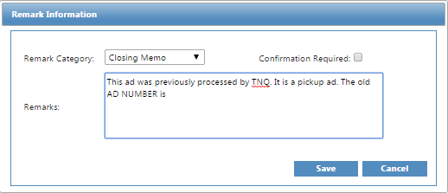
This message appears in the RemarksForPlanner column on the Closing Memo which will help TNQ pick the correct ad.
Now in the Ad workflow, do one of the following:
If the Ad workflow doesn't start
- Upload the original file submitted by the customer and the files returned by TNQ from the old ad folders on Dickens into ARTEMIS. You have completed the tasks for this ad. Stop here.
If the Ad workflow starts
- In Ad Processing, open the task and send email to TNQ to not process the ad. You then must upload the old FMP ad files from TNQ into ARTEMIS.
- Complete the workflow tasks until you see Approval and the task is closed.
If there are any corrections, you can make them during issue production.
Can I use the same ad in two journals for the same customer without creating two ad records?
At present, you must create an ad record for each account/journal where the ad runs. Make sure, however, that TNQ processes the ad only once. When adding the add after it was previously processed by TNQ for the other journal, do the following.
- In the Remarks section, choose Closing Memo and include the following: This ad was previously processed by TNQ. It is a Pick-up ad. The old ad number is ... and include the ad number.
This message appears in the RemarksForPlanner column on the Closing Memo which will help TNQ pick the correct ad.
- In Ad Processing, open the task and send email to TNQ to not process the ad. Since the ad files are already in ARTEMIS, there is no need to re-upload them into ARTEMIS.
- Complete the workflow tasks until you see Approval and the task is closed.
If there are any corrections, you can make them during issue production.
Is an ad reusable in different issues of the same journal?
{b}Note: {/b} Currently, the Is Reusable option is not operational. Until it is, here are the procedures you must use.
If the ad was already sequenced in a previous issue and that issue is not past Files to Printer
- Use the procedures in Can I use the same ad in two journals for the same customer without creating two ad records?
If the issue is past Files to Printer
- Unassign the ad from the old issue.
- Select it from the unassigned issue when you Add items during sequencing of the new issue.
How do I manage the same ad running in FMP and ARTEMIS?
Until all of your journals are in ARTEMIS, we recommend that you process the ads in FMP and then complete the steps in How do I use ADS from FMP in ARTEMIS without reprocessing by TNQ? to get the ad into ARTEMIS. Use a spreadsheet to keep track of the ARTEMIS ad IDs for each of the ads in the journals in ARTEMIS and the FMP ID.

