Table of Contents
Table of Contents 1
ARTEMIS Dashboard Help 2
Using Online Help 2
Navigation and Finding Topics 2
Searching 2
Interface and Commands 3
Dashboard Commands 3
Dashboard Interface 4
Filtering and Searching 5
Using Filters 5
Adding to Filters 6
Clearing Filters 6
The Article Dashboard 7
Workflow Tasks 7
Workflow Stage 7
Action(s) 7
Article Workflow Tasks 9
To use View Task 9
View Files 10
File Columns 10
Launch PFX 11
Web Service Calls 12
To view WS Calls 12
View Call 14
Get Package 15
To download data with Get Package 15
copyright, trademarks, and Terms of Use 16
Glossary 17
Index 19

ARTEMIS Dashboard Help
ARTEMIS Dashboard gives you a view into the state of the articles being processed by ARTEMIS. You can search for specific articles, see which tasks are in progress or complete, and look at Web Service calls sent and received.
Using Online Help
The Online Help system is easy to use. If you've used a website, you can navigate Help with ease.
Navigation and Finding Topics
The Contents and Index tabs help you find topics. The Glossary tab contains definitions of terms we use in ARTEMIS Dashboard.
Searching
The Help system features a full-text search. That means that while we've added keywords to topics, you can also use other terms to search.
The Help system highlights each term producing a hit in the topic, making it easy to find. Use the Remove all Search highlighting button (see below) to view without highlights.
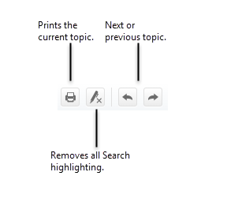
Interface and Commands
When you log into ARTEMIS Dashboard, the first screen you see is the Article Dashboard. Search filters are at the top and the ArticleDashboard showing matching results is underneath.
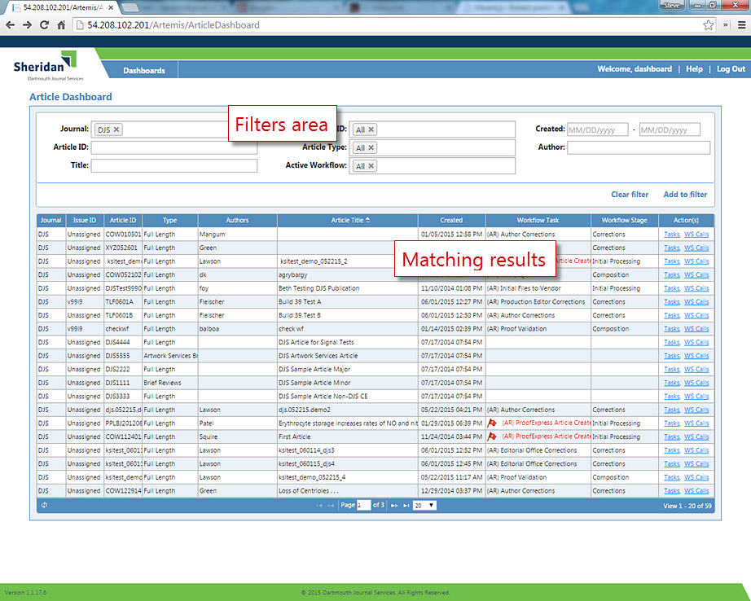
Dashboard Commands
When finished with your work, click Log Out, in the upper-right corner of your screen.
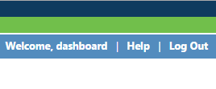
Dashboard Interface
The Page arrows at the bottom of the Article Dashboard allow you to move from one page to the other. Click the right or left arrows to move forward or back through the list of tasks. Click the down arrow to adjust the number of results ARTEMIS Dashboard displays on the Tasks screen.
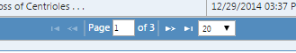
Filtering and Searching
To search for articles, use the filters at the top of ARTEMIS Dashboard.
Using Filters
You can perform basic searches use the Journal, Article ID, Title, Issue ID, Article Type, Active Workflow, Created Date, and Author filters. Select the drop-down list next to each or type in the text boxes.
- Journal is the journal ID; an acronym such as JLR, JI, JCB, etc.
- Article ID is a short identifier for the article, corresponding the ARTEMIS Record ID. You can search on partial IDs.
- Title is the full article title. You can search on partial titles.
- Issue ID is the ARTEMIS Issue ID for the article formed from the volume and issue number, for example, v023i119. If you select multiple Journal entries, the journal acronym appears in the Issue ID drop down, e.g., DJS - Editorial.
- Article Type is the customer/journal-specific article type. If you select multiple Journal entries, the journal acronym appears in the Article Type drop down, e.g., DJS-v99i121.
- Active Workflow values are All, Active, or Inactive. Inactive means the article has completed or has been stopped. This occurs when an article is withdrawn, for example.
- Created Date is the date of article creation. If you enter only a beginning date, ARTEMIS Dashboard displays only those articles created on that date. If you enter a date range, articles created within that range are shown.
- Author displays the authors' names. You can search on partial names.
You can sort on all columns except Issue ID, Workflow Task, Workflow Stage, and Action(s). Click inside the column header cell to sort.
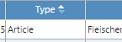
ARTEMIS Dashboard displays results as soon as you choose a drop-down item or when you finish typing text and press Enter. Searches do not accept wildcard characters, but will match partial entries. That is, ARTEMIS Dashboard returns Goodman, Goodall, and Osgoode if you enter Good in the Author box. ARTEMIS Dashboard only displays articles that meet all filter criteria.
Adding to Filters
If you need a more complex filter, use the Add to filter command. This command does three things:
- Moves currently entered criteria to a summary line.
- Displays a new blank form you use to enter additional filter criteria.
- Aggregates the filter, acting as a logical 'OR' and combining the results of each filter.
Here we've created a filter to find articles with the Article ID of 051415 OR TLF2727.
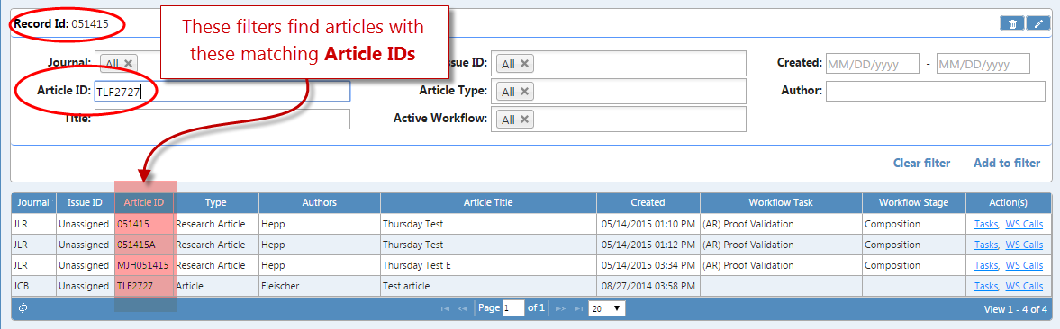
ARTEMIS Dashboard immediately displays your results in the Article Dashboard. Please see the Article Dashboard topic for more information.
Clearing Filters
To quickly reset the filters to default values, click Clear filter.
The Article Dashboard
In the Article Dashboard, click items in the Action(s) column to view and work with Tasks and WS Calls.
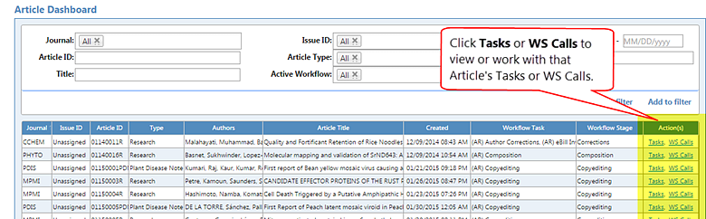
Workflow Tasks
Workflow Tasks shows you the current in-progress ARTEMIS Task, such as (AR) Comp QC or (AR) Author Corrections. If the text is in red with a red flag, , then the article is in an error state. ARTEMIS informs Technical Support in the logs.
Other entries in this column include:
- Blank—The workflow hasn't started.
- Failed—Something has gone wrong and the workflow failed. Technical support is needed.
- Completed—The workflow is complete and there are no remaining article tasks.
- User Terminated—The user cancelled the task.
Workflow Stage
Workflow Stage shows where the article is in the workflow, such as Initial processing, Composition, Corrections, Composition, Approval, etc. Each stage can involve multiple Workflow Tasks.
Action(s)
The last column, Action(s), may be blank, or may contain links to view the Tasks and WS Calls. Tasks include all of the ARTEMIS workflow tasks associated with the selected article. WS Calls displays incoming and outgoing web service calls for the selected article. Your user permissions determine whether you can view these web service calls.
Article Workflow Tasks
You use Tasks in the Action(s) column to view all tasks created for the article, view files, and launch ProofExpress.
To use View Task
- Search for an article.
- Click Tasks under Action(s). ARTEMIS Dashboard displays the Article Workflow Tasks form.
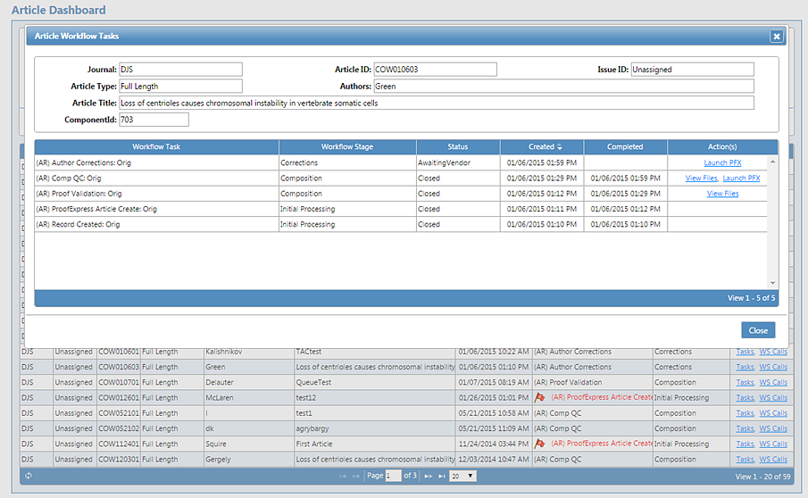
The Article Workflow Tasks form lists information about the article, its Journal, Article ID, Issue ID, Article Type, Article Title, and ComponentId.
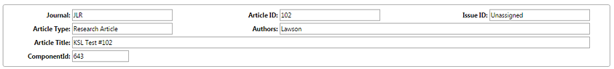
Following this, ARTEMIS Dashboard displays the article's Workflow Task, Workflow Stage, Status, Created date and Completed date, and available Action(s). Each line in the form tells you about the workflow steps completed or in process.
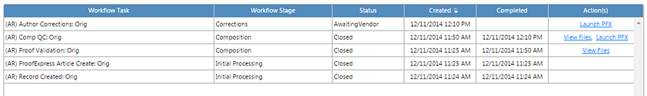
You can sort on all columns except Action(s). If available, you can View Files and Launch PFX for an article.
View Files
- Click View Files to see a list of files organized by Attached Files and Files Sent.
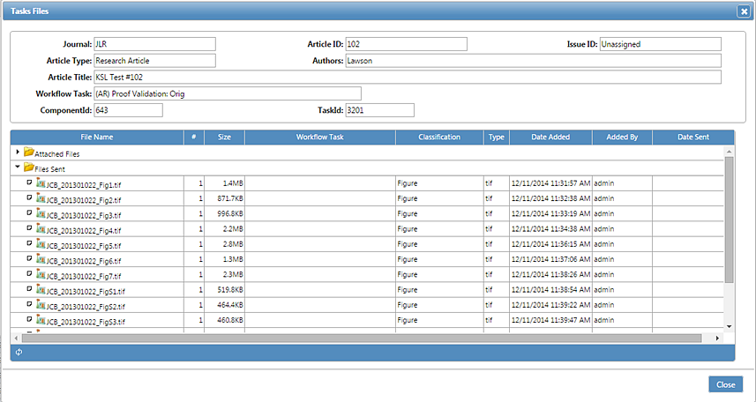
File Columns
Each file has the following information listed:
- File Name—The name and file extension, e.g., DJS_02114.indd.
- #—The version of the file. ARTEMIS can store files with the sane name, but gives each new copy a new version number. If ARTEMIS Dashboard displays the file information in gray text, this means it is not the most recent version. The most recent version is displayed with black text.
- Size—File size in bytes, KB, or MB.
- Workflow Task—The ARTEMIS workflow task and version where the files was added to ARTEMIS. This is always the current task for Attached Files. For Files Sent, this can be any task in the workflow.
- Classification—How the file is classified or grouped within ARTEMIS. Currently, ARTEMIS uses these classifications:
Not Defined | Vendor Report | Accepted | Video
Equation | InDesign | Manifest | Final
Manuscript Text | Data | Image Forensic | Typeset
Proof | Table | Figure | Copyright Form
- Type— File type, indicated by its extension.
- Date Added—The date and time the file was added to the ARTEMIS task.
- Added By—The user or system (JPS, ProofExpress, etc.) that added the file.
- Date Sent—The date and time ARTEMIS transferred this file to an external system.
Launch PFX
Click Launch PFX to open the article in ProofExpress in a new browser tab. For information on using ProofExpress, please see its online Help.
Web Service Calls
ARTEMIS communicates with different systems to perform its tasks. To help with troubleshooting and tracing tasks, you can view Web Service Calls, or WS Calls.
To view WS Calls
- Search for an article.
- Click WS Calls under Action(s). ARTEMIS Dashboard displays the Article Web Service Calls form.
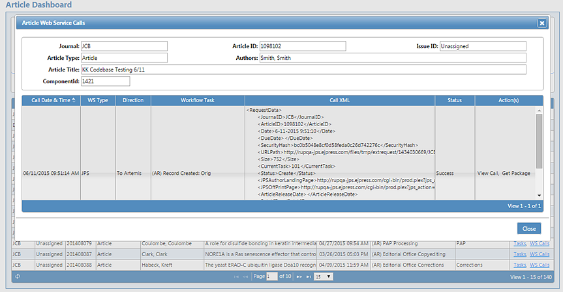
You can view this information or you can click View Call or Get Package.

The Article Web Service Calls form lists information about the article, its Journal, Article ID, Issue ID, Article Type, Article Title, and ComponentId.
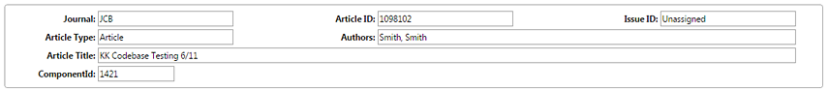
Underneath, ARTEMIS Dashboard displays the Call Date & Time, WS Type, Workflow Task, the Call XML code, Status, and available Action(s).
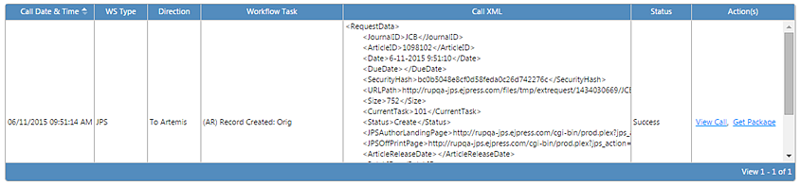
You can sort on all columns except Action(s).
- Call Date & Time—The date and time the web service call occurred.
- WS Type—The type of Web Service call, which can be
Unknown | TAC
FreeStyle | eBill
ProofExpress | PageExpress
JPS | MathMI
- Direction—If From Artemis, the call is out to an external system. If To Artemis, the call is into ARTEMIS from an external system.
- Workflow Task—The specific task where this call occurred.
- Call XML—The XML sent with the call. The XML may have been encoded within the URL or included as a POST parameter to the web service call, depending on the type of call made. ARTEMIS Dashboard displays the XML in decoded format for readability.
- Status—The status of the call. This can be:
Accepted | ArticleNotFound | InternalServerError
InvalidRequestXML | MissingAttribute_Request_ID | MissingElement_PageCount
OK | Success | TaskNotFound
TitleNotFound | UnexpectedException | UrlDownloadFailed
This is not a complete list. An external system may return additional status codes.
- Actions—Links to the View Call or Get Package tasks, if available.
View Call
The View Call command displays the raw details of the call as stored in ARTEMIS. This information is helpful if you want to verify that the call is formatted properly.
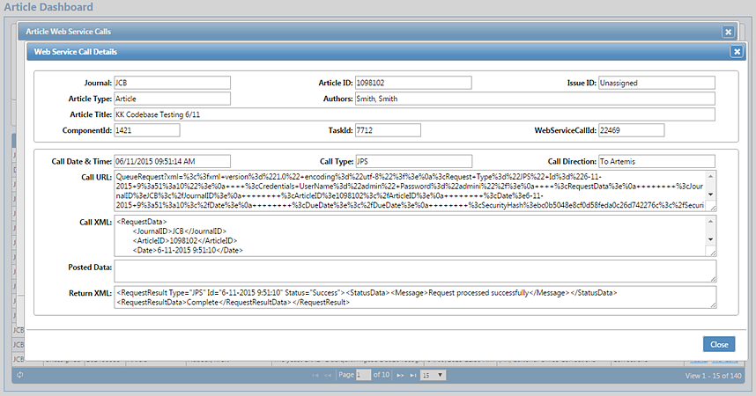
Fields here include:
- Call Date & Time—The date and time the web service call occurred.
- Call Type—The type of call, which can be:
Unknown | TAC
FreeStyle | eBill
ProofExpress | PageExpress
JPS | MathMI
- Call Direction—If From Artemis, the call is out to an external system. If To Artemis, the call is into ARTEMIS from an external system.
- Call URL—The URL used to make the call. ARTEMIS Dashboard displays encoded XML in the encoded format.
- Call XML—The decoded view of the URL used to make the call.
- Posted Data—XML content sent as a POST data block of the call.
- Return XML—Raw XML returned from the call.
Get Package
You use the Get Package command to download the call data. This command is only available if the XML specifies the <URLPath> element.
To download data with Get Package
- In the Action(s) column, click Get Package. ARTEMIS Dashboard displays the Save As dialog box with the file name formatted as <Journal>_<Article ID>.zip for example, DJS_10019.zip.
- Click Save.
The downloaded ZIP file contains the Web Service Call data in XML format.
copyright, trademarks, and Terms of Use
Copyright © 2015 by Dartmouth Journal Services. All rights reserved.
Information in this document is subject to change without notice. No warranties of any nature are extended by the document. Any product and related material disclosed herein are only furnished pursuant and subject to the terms and conditions contained in the duly executed Software License Agreement signed between you and Dartmouth Journal Services. The only warranties made by Dartmouth Journal Services, if any, with respect to the products described in this document, are set forth in such Software License Agreement. Dartmouth Journal Services cannot accept any financial or other responsibility that may be the result of your use of the information in this document or software material, including direct, indirect, special, or consequential damages. The software may be used or copied only in accordance with the terms of those agreements. No part of this publication may be reproduced, stored in a retrieval system, or transmitted in any form or any means electronic or mechanical, including photocopying and recording for any purpose other than the purchaser's personal use without the written permission of Dartmouth Journal Services.

ArticleExpress, the ArticleExpress Workflow, EditExpress, ARTEMIS, ePAGE, eBill, and The Author Center are trademarks or registered trademarks of Dartmouth Journal Services.
MathFlow is a trademark of Design Science.
eXtyles and edifix are registered trademarks of Inera Incorporated.
ORCID is a registered trademark of ORCID, Inc.

Dartmouth Journal Services
5 Pilgrim Park Road, Suite 5
Waterbury, VT 05676
802-244-1547

This Help built on 28 July 2015 at 11:11:AM.
Glossary
A
Active
The workflow is still running for the article.
Article ID
The article identifier provided by the customer.
Attached Files
Files attached or uploaded to this task through an ARTEMIS production task. It also includes files attached to this task through an external system such as ProofExpress, JPS, etc.
Awaiting Vendor
ARTEMIS is waiting for a signal and/or files from another system.
B
Blank
A blank Workflow Task means the workflow has not started.
C
Closed
Task has been completed or closed.
Completed Date
The date and time an ARTEMIS workflow closed the task because there are no remaining tasks. It is sometimes triggered by an outside system.
Created Date
The date and time the article record was created in ARTEMIS.
E
Error
The task has an error associated with it and must be handled by Technical Support.
F
Failed
Something has gone wrong and the workflow failed. Technical Support is needed to correct this state.
Files Sent
Files transferred from the ARTEMIS production system to an external system. The Workflow Task column shows the task that originated each file before it was sent.
I
Inactive
The workflow is no longer running for the article.
Issue ID
The column and issue combination ARTEMIS uses to identify a specific issue.
O
Open
The task is open and in progress.
T
Tasks
In the ARTEMIS Dashboard Action(s) column, Tasks displays all tasks created for an Article. If a specific task is expected but isn't in the list, the activity that creates the task hasn't occurred.
W
WS Calls
In the ARTEMIS Dashboard Action(s) column, you use the WS Calls link to see an Article's web service calls between two systems.
Index

A
Active Workflow, 5
Article ID, 5
Article Type, 5
Author, 5
C
Call Date & Time, 14
Call Direction, 14
Call Type, 14
Call URL, 14
Call XML, 13, 14
Commands, 3
Created Date, 5
D
Download files, 15
F
Filtering, 5
Filters
adding, 6
clearing, 6
I
Interface, 4
Issue ID, 5
J
Journal, 5
L
Launch PFX, 11
P
Posted Data, 14
ProofExpress, 11
R
Return XML, 14
S
Searching, 5
T
Title, 5
V
View Call, 14
View Files, 10
W
Web Service Calls, 12
Get Package, 15
View Calls, 14
WS Calls, 12
Get Package, 15
View Call, 14
WS Type, 13

