JIRA Service Desk
  - Internal Customer Guide



JIRA Service Desk - Internal Customer Guide

Dartmouth Journal Services, Inc. Pilgrim 5, Suite 5
5 Pilgrim Park Road
Waterbury, VT 05676

Written by
Kevin Lawson, Mike Hepp, Tina Fleischer, and Antony Gnanapiragasam

No part of this book, including interior design and icons, may be reproduced or transmitted in any form, by any means, without the prior written permission of Dartmouth Journal Services, Inc.

August 2015 (version 1.0)

Service Desk Introduction

Product Details
JIRA Service Desk (JSD) by Atlassian is bug/issue-tracking software designed, along with JIRA, as
a contact center and help desk. It fits within their suite of products (JIRA, Confluence, etc.), which allows information and functions to be shared across products. For instance, a bug submitted by a customer in Service Desk may end up linked to a ticket created in JIRA for the development team. DJS is migrating toward increased use of these products to improve efficiency.

Definitions

Roles: Customers and Agents
In JIRA Service Desk, a “customer” can mean an external customer of DJS (e.g., Rockefeller Uni- versity Press), an author, or a person within DJS who is requesting support (considered an internal customer).
An Agent is a user who works out of the preconfigured service desk projects and resolves customer requests. The Agents at DJS are primarily the Technical Support team.
The main functions of the Agent are:
- Access the internal service desk interface
- View the Customer Portal, queues, reports and
- Service Level Agreement (SLA) metrics of assigned service desk projects
- Troubleshoot and resolve tickets
- Manage knowledge base content (to come)

Customer Portal
The Customer Portal is a web-based area with links and form fields that allows the various customers to input information to support ticket creation in Service Desk. To access the Customer Portal, an account is first configured with privileges in JIRA Service Desk and then the internal customer navigates through a screen to create their own login and password.

The User Experience
You will be emailed an invitation to create a JIRA Service Desk account for the product. In our example it is the ARTEMIS JIRA Service Desk.
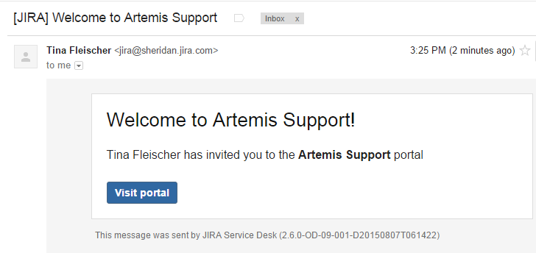
Click on Visit Portal. You will be taken to the account creation page.
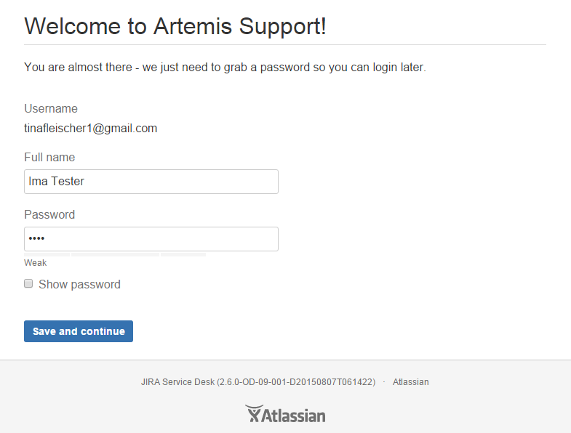
Once your account has been created, you can submit a support request through the Customer Portal.
- Click Get Support to open the form.
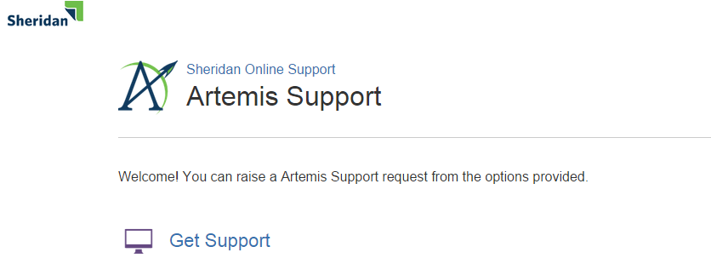
- Fill out the form fields (example shown below). Attach any relevant files or screen captures, and select the component that best applies to your problem. If you are unsure, select Not Sure.
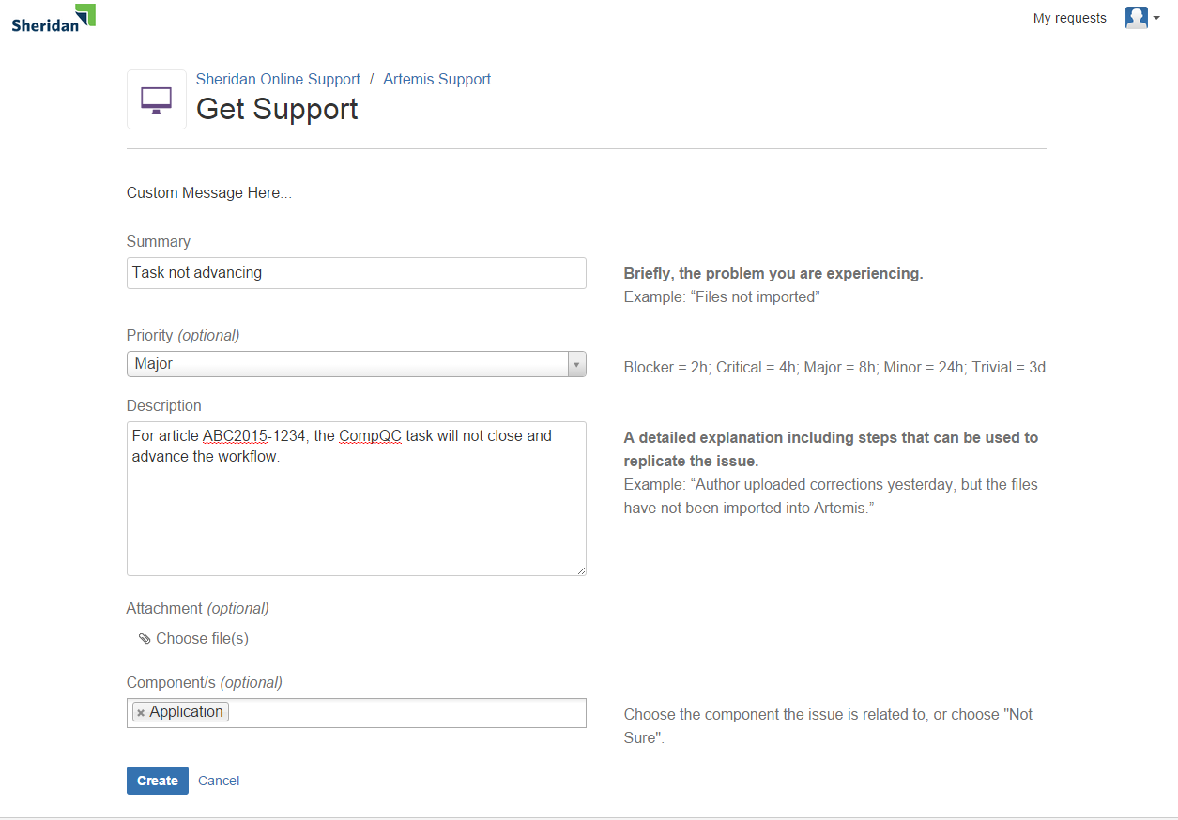
NOTE: At any time you can access “My Requests” to see your open tickets and their status.
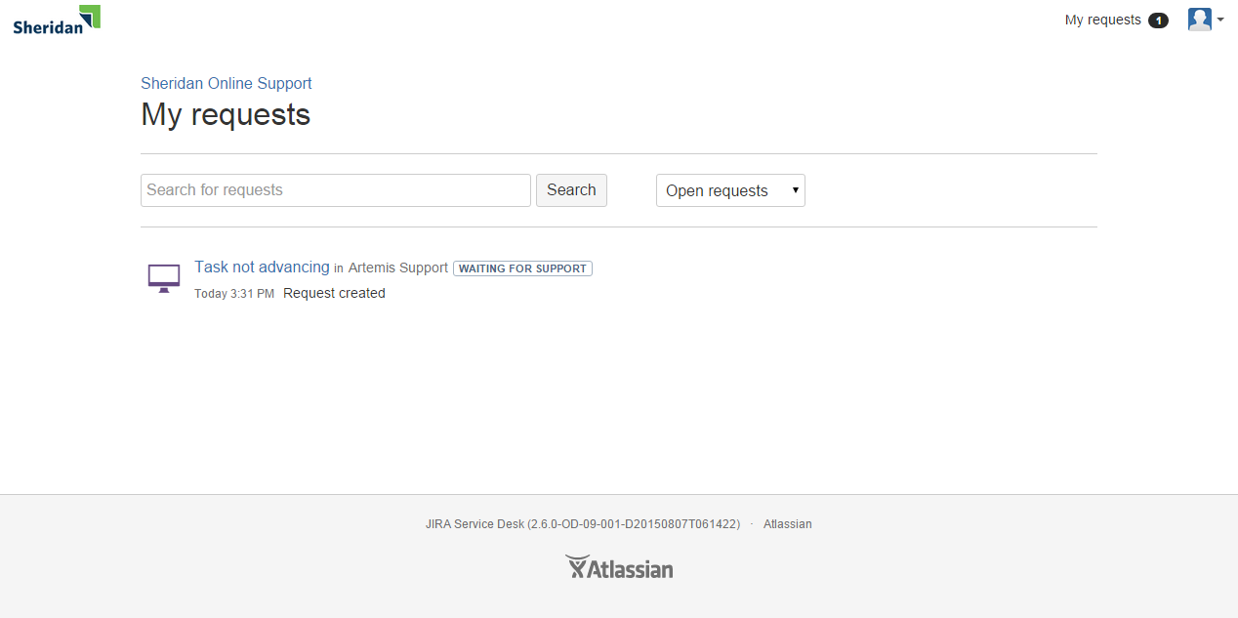
You will receive an email when your ticket has been assigned to a Technical Support Specialist and when work has begun. Email will also alert you to workflow status changes and requests to you for more information. DO NOT REPLY TO THE EMAIL. Instead, click the link in the email to take you directly to the open ticket and add your comments. Alternatively, you can log into the portal and navigate to the ticket. Finally, you will be notified when the ticket has been resolved.
IMPORTANT NOTES:
- You will no longer be able to enter support tickets for a given software into Track-It! once it has a JIRA Service Desk.
- Any filetype can be attached to a ticket.
- You are the Customer. If the ticket status is Waiting for Customer, the ticket needs your attention and the “clock is stopped” until the Agent hears back from you.
- It may be most efficient for you to autofile emails from JIRA Service Desk and keep your Customer Portal open. It will automatically refresh every 15 minutes. You can also refresh the browser view manually at any time. Instructions for how to autofile are located with the rest of the customer documentation at
J:\Procedures - Production Dept\____GENERAL PROCEDURES\JIRA Service Desk
- You can add watchers to a ticket, for example, teammates or Group Leaders. These individuals must have already created a JSD account in order to appear as customers.
- Your JIRA Service Desk password should never expire.
- JIRA Service Desk appends an “s” (for support) to the software product’s name. ARTEMIS support tickets, therefore, become ARTEMISS support tickets.

