JIRA Service Desk
  - Internal Customer Guide



JIRA Service Desk - Internal Customer Guide

Dartmouth Journal Services, Inc. Pilgrim 5, Suite 5
5 Pilgrim Park Road
Waterbury, VT 05676

Written by
Kevin Lawson, Mike Hepp, Tina Fleischer, and Antony Gnanapiragasam

No part of this book, including interior design and icons, may be reproduced or transmitted in any form, by any means, without the prior written permission of Dartmouth Journal Services, Inc.

August 2015 (version 1.0)

Service Desk Introduction

Product Details
JIRA Service Desk (JSD) by Atlassian is bug/issue-tracking software designed, along with JIRA, as
a contact center and help desk. It fits within their suite of products (JIRA, Confluence, etc.), which allows information and functions to be shared across products. For instance, a bug submitted by a customer in Service Desk may end up linked to a ticket created in JIRA for the development team. DJS is migrating toward increased use of these products to improve efficiency.

Definitions

Roles: Customers and Agents
In JIRA Service Desk, a customer is external customer of DJS (e.g., Rockefeller University Press), an author, or a person within DJS requesting support (an internal customer).
An Agent is a user who resolves customer requests. The Agents at DJS are primarily the Technical Support team.
Agents can:
- Access the internal service desk interface
- View the Customer Portal, queues, reports and
- Service Level Agreement (SLA) metrics of assigned service desk projects
- Troubleshoot and resolve tickets
- Manage knowledge base content (to come)

Customer Portal
The Customer Portal is a web-based form you use to create a support ticket in Service Desk. We create your account in JIRA service desk, but you create your own login and password.

The User Experience
We will email you an invitation to create a JIRA Service Desk account for the product. In our example it is the ARTEMIS JIRA Service Desk.
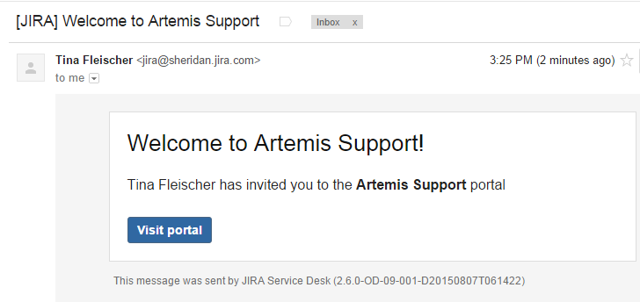
Click Visit Portal. JIRA Service Desk displays the account creation page.
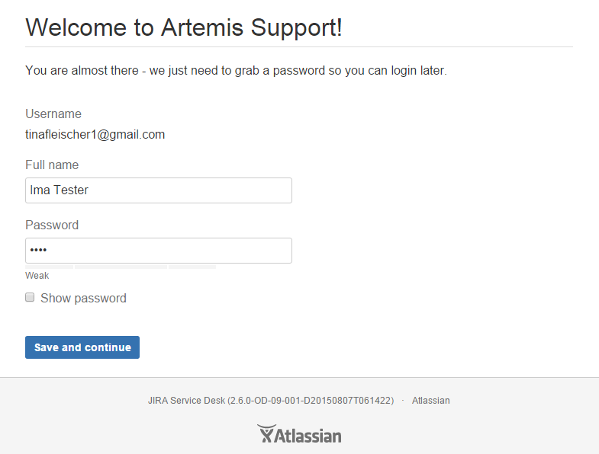
Once your account is created, you can submit a support request through the Customer Portal.
- Click Get Support to open the form.
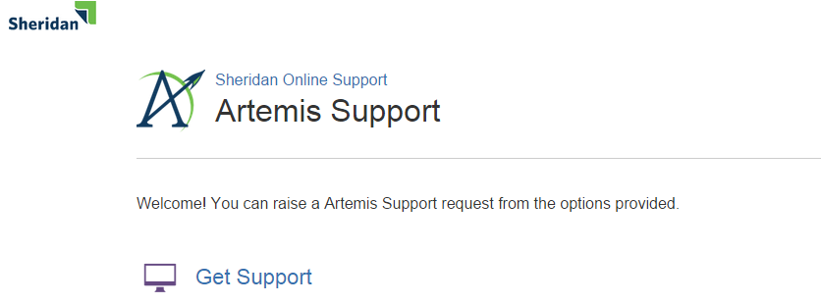
- Fill out the form fields (example shown below). Attach any files or screen captures, and select the component that best applies to your problem. If you are unsure, choose Not Sure.
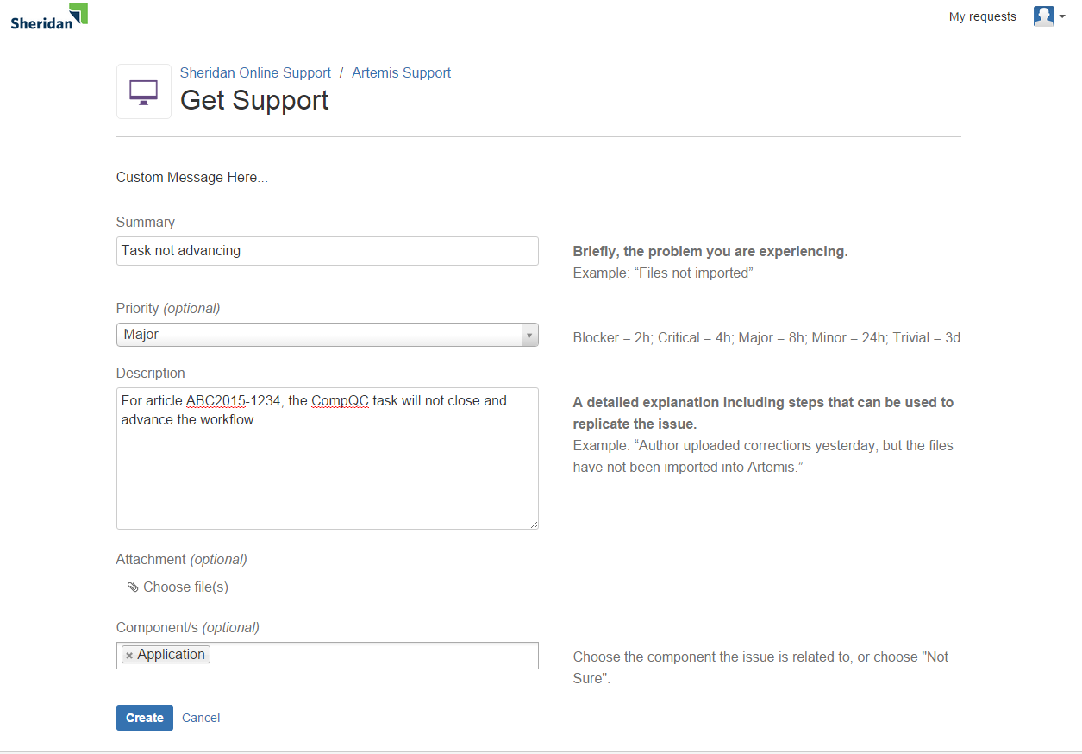
NOTE: At any time, you can click My Requests to see your open tickets and their status.
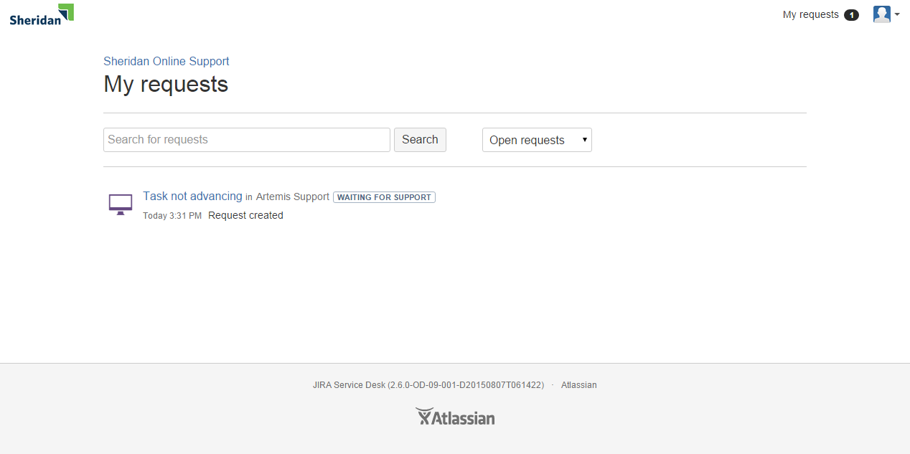
JIRA Service desk sends you an email when your ticket is to a Technical Support Specialist and when work starts. Email also alerts you to workflow status changes and requests for more information. DO NOT REPLY TO THE EMAIL. Instead, click the link in the email to take you directly to the open ticket and add your comments. You can also log into the portal and navigate to the ticket. When the ticket has been resolved, JIRA Service Desk notifies you.
IMPORTANT NOTES:
- You will no longer be able to enter support tickets for a given software into Track-It! once it has a JIRA Service Desk.
- You can attach any filetype to a ticket.
- You are the Customer. If the ticket status is Waiting for Customer, the ticket needs your attention and the clock stops until the Agent hears back from you.
- It may be most efficient for you to autofile emails from JIRA Service Desk and keep your Customer Portal open. It automatically refreshes every 15 minutes. You can also manually refresh your browser at any time. Instructions for how to autofile are located with the rest of the customer documentation at
J:\Procedures - Production Dept\____GENERAL PROCEDURES\JIRA Service Desk
- You can add watchers to a ticket, such as, teammates or Group Leaders, if they have a JIRA Service Desk account.
- Your JIRA Service Desk password should never expire.
- JIRA Service Desk appends an S (for support) to the software product’s name. ARTEMIS support tickets, for example, become ARTEMISS support tickets.

