**To replicate a graph from Anna Cieslak's paper from page 5.**

The data has been successfully loaded in Rstudion. The dataset includes the following columns:

* Unnamed: 0: This appears to be the date column.
* Mkt-RF: The excess market return (Market return minus the risk-free rate).
* SMB: The size factor (Small Minus Big).
* HML: The value factor (High Minus Low).
* RF: The risk-free rate.

Using this data, replicate the graph from Anna Cieslak's paper on page 5 of the provided document, specifically focusing on "Average. five-day stock excess return, day t to t+4."

Below is the R code that you can use in RStudio to replicate the graph

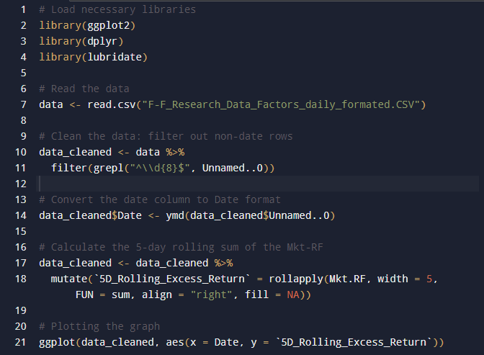

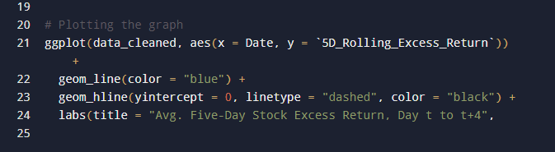

The replicated graph showing the average five-day stock excess return from day t to t+4, similar to the one on page 5 of the document, is shown below;

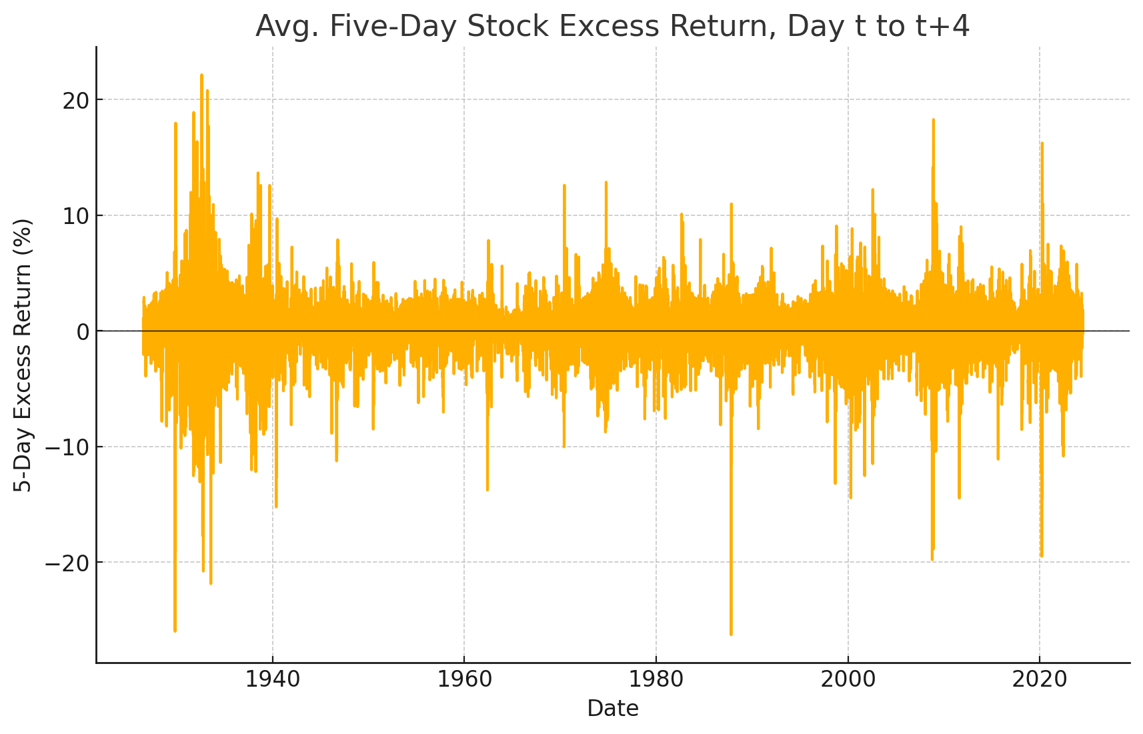

**This is the Rstudio code used to replicate the table from page 7, Panel A, using the data provided.**

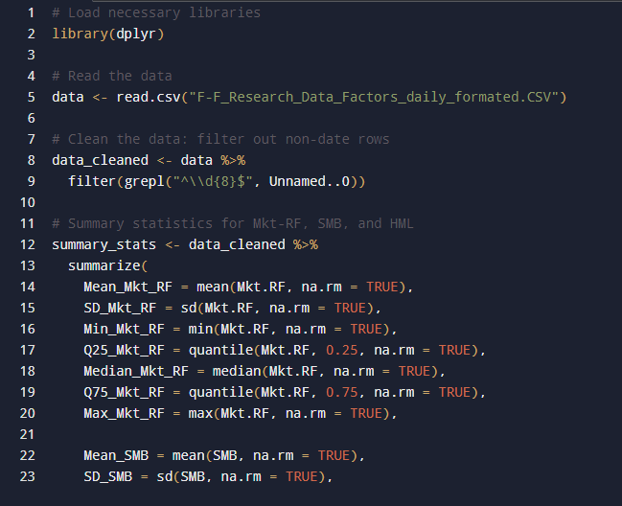

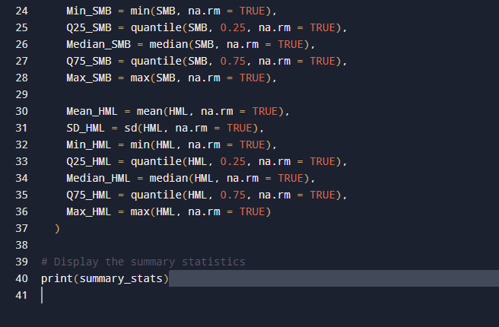

The result of the replication of the table on page 7 is as follows;

|  |  |  |  |  |  |  |  |
| --- | --- | --- | --- | --- | --- | --- | --- |
|  | Mean | Std Dev | Min | 25% | Median | 75% | Max |
| Mkt-RF | 0.030504 | 1.079302 | -17.44 | -0.4 | 0.06 | 0.5 | 15.76 |
| SMB | 0.003862 | 0.593205 | -11.63 | -0.25 | 0.01 | 0.27 | 8.18 |
| HML | 0.014563 | 0.625407 | -6.02 | -0.25 | 0.01 | 0.26 | 8.82 |

The above table is the replicated summary statistics table similar to Panel A on page 7 of the document using the provided data. The table includes the mean, standard deviation, minimum, 25th percentile, median, 75th percentile, and maximum for the factors ***Mkt−RF, SMB***, and ***HML***.

**For replicating Table I and Table II from AiBansal2018.pdf, I used the following data**:

1. **"Excess Returns S&P 500.xlsx"**: This file contains daily returns data for the S&P 500 index. Specifically, I used the "Mkt_Rf" column, which represents the market excess returns (the return on the market minus the risk-free rate).
2. **"FOMC_Cycle_dates_1994_2023 copia (1).xlsx"**: This file contains the FOMC cycle dates. I used the "Start_Date" column after renaming it from the original column name, which marked the dates of FOMC announcements.

The merging of these two datasets was done using the "Date" column from the returns data and the "Start_Date" column from the FOMC data. It allowed us to identify which days had FOMC announcements and which did not, enabling the calculation of average returns for announcement and non-announcement days, as required for Table I and Table II.

**Rstudio code is used to merge the data.**

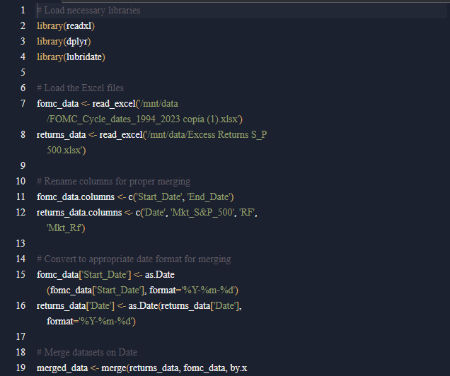

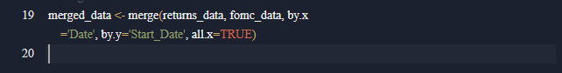

**Replicating the Tables:**

After merging, I calculated the specific metrics needed to replicate the tables (Table I and Table II). This process involves grouping the data, calculating summary statistics, and formatting the output.

This is the Rstudio code used.

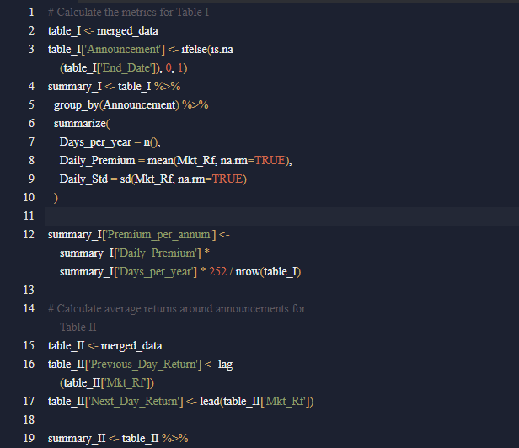

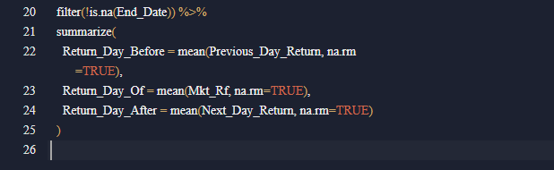

**The replication output**

**Table 1**

|  |  |  |  |  |
| --- | --- | --- | --- | --- |
| **Announcement** | **Days_per_year** | **Daily Premium** | **Daily_Std** | **Premium_per_annum** |
| 0 | 7559 | 0.040560392 | 1.166393337 | 9.899063677 |
| 1 | 246 | 0.230711382 | 1.232339346 | 1.83244843 |

**Explanation**

**Announcement:** This column indicates whether the day had an FOMC announcement (1 for yes, 0 for no).

**Days per year:** The number of trading days for each category (announcement vs. non-announcement days). In this case, there were 7559 non-announcement days and 246 announcement days during the analyzed period.

**Daily Premium:** The average daily market excess return (in basis points) on announcement and non-announcement days.

**0 (Non-Announcement Days):** The average daily return was approximately 0.041%.

**1 (Announcement Days):** The average daily return was significantly higher at approximately 0.231%.

**Daily std:** The standard deviation of daily returns on the announcement and non-announcement days, indicating the volatility of returns.

**Non-Announcement Days:** The standard deviation was 1.166%.

**Announcement Days:** The standard deviation was slightly higher at 1.232%.

**Premium_per_annum:** The cumulative annual market excess return, calculated by multiplying the daily premium by the number of days per year and adjusting for the number of days in the dataset.

**Non-Announcement Days:** The annualized premium is about 9.90%.

**Announcement Days:** The annualized premium is about 1.83%.

### ****Interpretation:****

The average daily returns are much higher on announcement days than on non-announcement days, which suggests that FOMC announcements have a significant impact on market returns. The slightly higher standard deviation on announcement days indicates that these days are also more volatile.

**Table II**

|  |  |  |  |
| --- | --- | --- | --- |
| **index** | **Previous_Day_Return** | **Mkt_Rf** | **Next_Day_Return** |
| Return_Day_Before | 0.050520325 |  |  |
| Return_Day_Of |  | 0.230711382 |  |
| Return_Day_After |  |  | 0.175325203 |

**Explanation:**

**Previous_Day_Return:** The average return on the day before FOMC announcements, which is approximately 0.051%.

**Mkt_Rf (Return_Day_Of):** The average return on the actual day of the FOMC announcements is approximately 0.231%.

**Next_Day_Return:** The average return on the day after FOMC announcements, which is approximately 0.175%.

**Interpretation:**

**Pre-Announcement:** The return on the day before the FOMC announcement is positive but relatively modest.

**On Announcement Day:** The return significantly jumps on the actual announcement day, which aligns with the expectation that market participants react strongly to FOMC news.

**Post-Announcement:** The return the day after the announcement remains optimistic, suggesting some follow-through from the announcement effect, though it's lower than the return on the announcement day.

**Conclusion:**

The replicated tables suggest that FOMC announcement days are associated with higher average returns and higher volatility compared to non-announcement days. The significant returns on announcement days highlight the importance of FOMC decisions in driving market movements, reflecting the market’s anticipation and reaction to new information about monetary policy.

These results are consistent with the findings in the AiBansal (2018) paper, which focuses on how macroeconomic announcements, particularly FOMC announcements, contribute significantly to the overall market equity premium.

**Table III**

**To replicate Table III, I used a COVID-19 dummy variable**

The analysis involved the average daily returns around FOMC announcements during the COVID-19 period versus non-COVID periods.

**Data Used:** The merged dataset with the COVID-19 dummy variable.

We calculated the average daily returns for the days before, during, and after FOMC announcements, both during the COVID-19 period and outside of it.

**RStudio Code for Table III**

Here is the code used to replicate Table III, focusing on daily data.

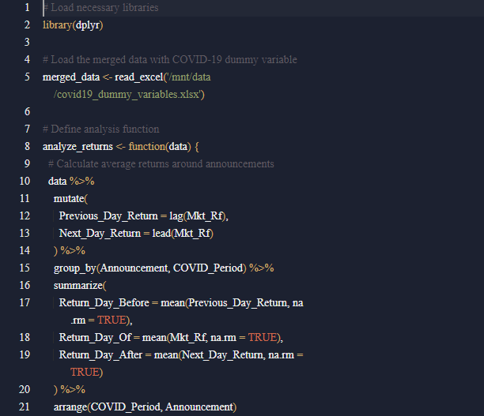

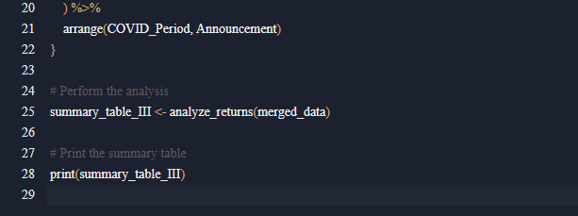

**The output results**

**Table III**

|  |  |  |  |  |
| --- | --- | --- | --- | --- |
| **Announcement** | **COVID_Period** | **Return_Day_Before** | **Return_Day_Of** | **Return_Day_After** |
| 0 | 0 | 0.04070989 | 0.034701924 | 0.03725007 |
| 0 | 1 | 0.139565909 | 0.135347727 | 0.125302273 |
| 1 | 0 | 0.054162281 | 0.26327193 | 0.159899123 |
| 1 | 1 | 0.004388889 | -0.181722222 | 0.370722222 |

**Explanation:**

**Announcement:** Whether the date is an FOMC announcement day (1) or not (0).

**COVID_Period:** Whether the date falls within the COVID-19 period (1) or not (0).

**Return_Day_Before:** The average returns the day before the FOMC announcement.

**Return_Day_Of:** The average return on the day of the FOMC announcement.

**Return_Day_After:** The average returns the day after the FOMC announcement.

**Analysis & Interpretation:**

By comparing the rows with COVID_Period = 1 to those with COVID_Period = 0, you'll see how the market's reaction to FOMC announcements differed during the COVID-19 pandemic. Significant differences suggest that the market was more (or less) sensitive to FOMC announcements during the COVID-19 crisis.