**Applying the Trapezoidal Rule and Geometric Decomposition to Determine the Volume of an Irregular Sculpture**

**1. Introduction and Rationale**

For as long as I can remember, I have been fascinated by the intersection of creativity and logic, particularly in mathematics and art. This fascination came to life in a recent project where I decided to explore the volume of a handmade sculpture designed in the shape of a rabbit, inspired by the Mid-Autumn Festival, a traditional celebration in Chinese culture. This sculpture is more than just a piece of art. It's a meaningful blend of tradition, design, and mathematics. I wanted to create a physical object that could be scaled accurately and reproduced. To do that, I needed to determine how much material (specifically clay) would be required. Calculating the volume of such an irregular, non-standard 3D shape is not straightforward. That challenge is what made this an ideal topic for my mathematical exploration. My objective is to estimate the volume of the sculpture as accurately as possible by applying two mathematical approaches: the trapezoidal rule and geometric decomposition. The trapezoidal rule allows me to numerically approximate the area under the curve of the sculpture’s profile when revolved around an axis, turning it into a solid. On the other hand, geometric decomposition involves breaking the sculpture into basic 3D shapes like ellipsoids, cylinders, cones, and hemispheres, each with a known volume formula.

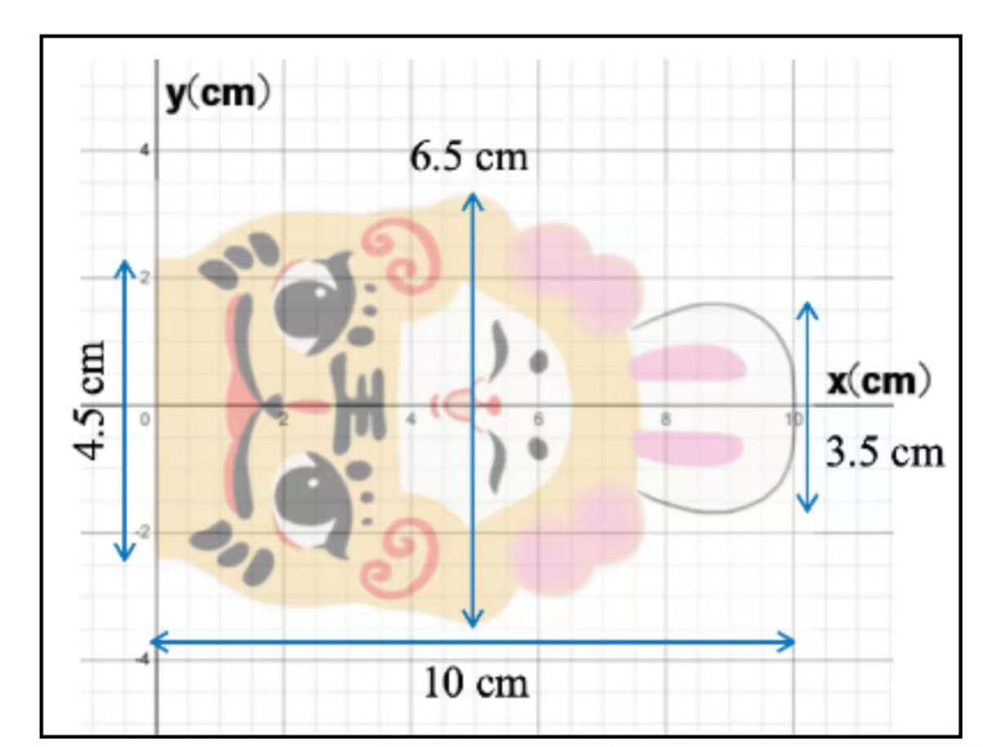

Figure 1. The clay rabbit sculpture was used for volume analysis, showing key dimensions

**1.1 Mathematical Aim and Strategy Overview**

This exploration aims to estimate the volume of an irregular sculpture by applying the trapezoidal rule and decomposing it into geometric solids. The sculpture I chose has a complex, curved shape inspired by a Mid-Autumn Festival rabbit figure. Since it doesn’t correspond to a single standard solid, a combination of mathematical methods is necessary to calculate its volume accurately.

To begin, I traced the 2D outline of the sculpture and placed it on a coordinate grid, treating one side of the profile as a curve. By revolving this curve around the x-axis, I was able to generate a 3D solid, which is known as forming a solid of revolution. With this setup, the volume can be approximated by integrating the square of the function values, where the trapezoidal rule comes into play.

Additionally, I divided the sculpture into logical geometric sections based on its shape, such as a semi-ellipsoid for the head, a cylinder for the body, a cone for the base, and a hemisphere for the ear. Each section was analyzed and modeled using its respective volume formula, forming the second method of calculation: geometric decomposition.

**2. Measurement and Graphing Setup**

To begin estimating the sculpture's volume, I first placed an image of it onto a coordinate grid. I ensured the base of the sculpture was aligned with the x-axis, while the vertical height was aligned with the y-axis. It allowed me to treat the sculpture's profile as a 2D curve that could later be rotated around the x-axis to generate a solid revolution.

From the image, I identified key landmarks along the sculpture's outline and measured its height and width at fixed intervals. I used a ruler tool within a digital image editor to measure every 1 cm along the x-axis, recording the corresponding height (y-value) at each point. These measurements were scaled proportionally to match the sculpture's actual dimensions, ensuring that the curve represented the true profile.

I noticed that the sculpture was symmetric about the y-axis, but since I measured only one side of the outline, I will rotate it around the x-axis to form the full three-dimensional shape. This approach simplifies the volume calculation by leveraging the Disk Method and the Trapezoidal Rule over a known function or discrete dataset. Below is the table of coordinates (x, y) I extracted from the image. Each point represents a vertical slice along the profile curve:

|  |  |
| --- | --- |
| **x​ (cm)** | **y(cm)** |
| 0.0 | 0.0 |
| 1.0 | 1.3 |
| 2.0 | 2.8 |
| 3.0 | 3.5 |
| 4.0 | 3.1 |
| 5.0 | 2.2 |
| 6.0 | 1.0 |
| 7.0 | 0.0 |

These coordinates will form the foundation for my trapezoidal estimation and function modeling.

**3. Trapezoidal Rule Application**

After extracting the coordinates from the sculpture's side profile, I estimated its volume using the trapezoidal rule combined with the solids of the revolution method this idea is also supported by (Abdulhameed and Memon; Zul Afiq Sazeli et al.). Since I was revolving the curve around the x-axis, I used the disk method to compute the volume.

The formula I used is a combination of the disk method and the trapezoidal rule:

Here's what each term represents:

* : estimated volume of the sculpture
* : constant (approximately 3.1416 )
* : spacing between the x -values (distance between slices)
* : height of the profile at each point , i.e., the function values

Here's what each term represents:

* : estimated volume of the sculpture
* : constant (approximately 3.1416 )
* : spacing between the x -values (distance between slices)
* : height of the profile at each point , i.e., the function values

From my measurements, I selected 8 data points at 1 cm intervals:

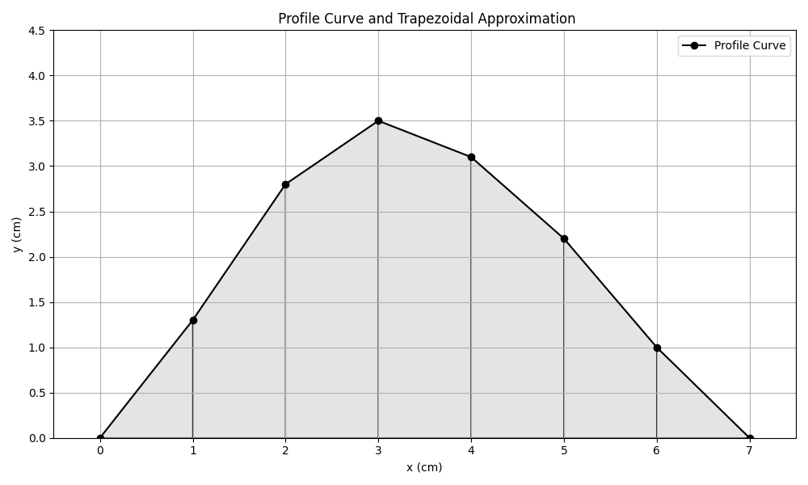

|  |  |
| --- | --- |
|  |  |
| 0.0 | 0.0 |
| 1.0 | 1.3 |
| 2.0 | 2.8 |
| 3.0 | 3.5 |
| 4.0 | 3.1 |
| 5.0 | 2.2 |
| 6.0 | 1.0 |
| 7.0 | 0.0 |

In this case:

* (constant spacing between points)
* intervals (8 points)

I substituted these values into the formula:

Calculating each squared term:

Now summing:

This volume represents an estimate of the sculpture’s total volume if the profile is rotated 360 degrees about the x-axis.

### ****4. Geometric Decomposition Method****

I applied a geometric decomposition method to obtain a more intuitive and segmented estimate of the sculpture's volume. According to (Cheng et al.; Xin et al.), it involved visually analyzing the shape and breaking it into standard 3D solids whose volumes can be calculated using known formulas. The sculpture consists of organic curves, but I could derive an accurate and understandable estimate by approximating different sections with close-fitting solids like **cylinders, cones,** and **ellipsoids**.

After studying the profile of the sculpture and its overall structure, I divided it into **four main parts**:

1. A **semi-ellipsoid** head
2. A **cylindrical body**
3. A **conical base**
4. A small **hemispherical ear**

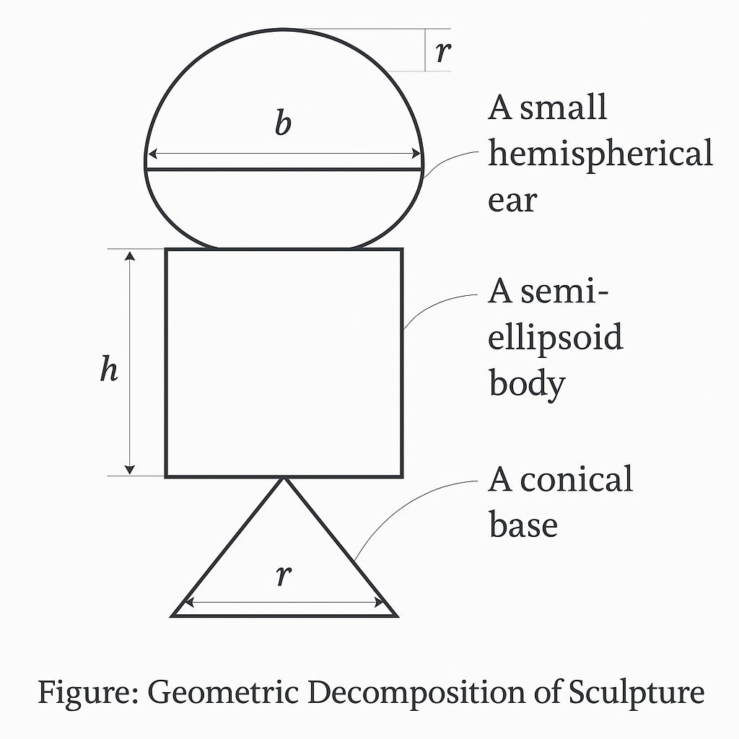

# ****Part 1: Head Semi-Ellipsoid****

The top portion of the sculpture appeared smooth and rounded, much like a half-ellipsoid. Based on the image, I estimated the dimensions of this section as:

* Horizontal radius (a) = 2.5 cm
* Side radius (b) = 2.5 cm (symmetrical side)
* Vertical radius (c) = 3.0 cm

The formula for the volume of a **half ellipsoid** is:

Substituting the values:

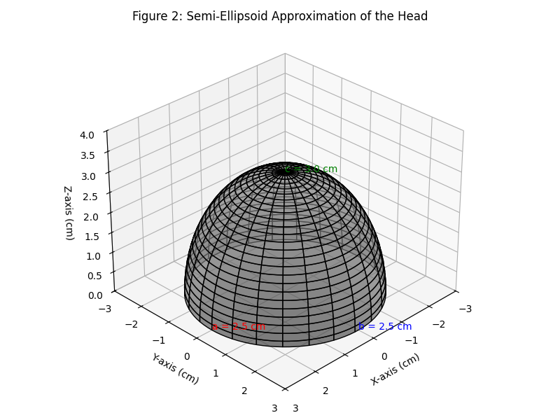

# ****Part 2: Body – Cylinder****

The central portion of the sculpture, from the neck to the midsection, closely resembled a straight column, making it ideal to model as a **cylinder**. From the profile image, I estimated:

* Radius (r) = 2.0 cm
* Height (h) = 4.5 cm

The volume of a cylinder is:

Substituting:

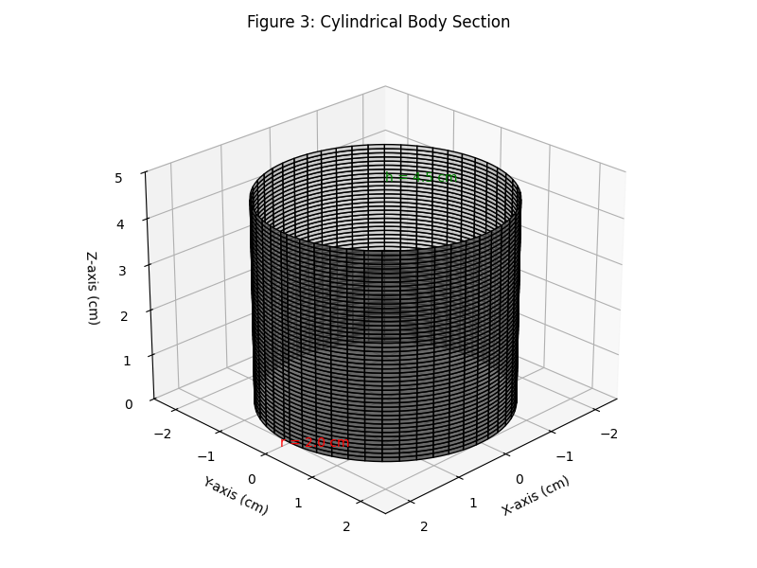

# ****Part 3: Base – Cone****

The lower part of the sculpture appeared to taper downwards, resembling a cone. For this section, I measured:

* Radius (r) = 2.2 cm
* Height (h) = 3.0 cm

The volume of a cone is given by:

Substituting:

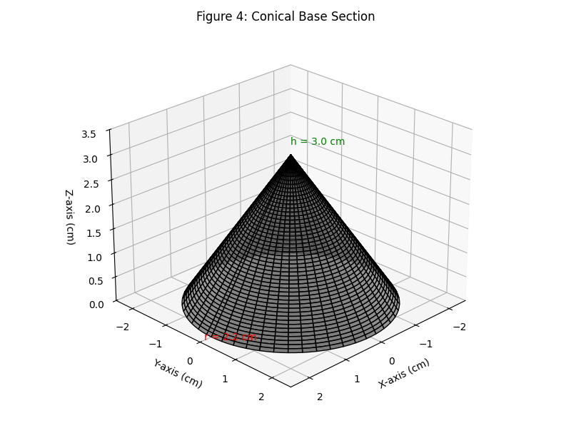

# ****Part 4: Ear – Hemisphere****

A rounded protrusion at the top resembling an ear, modeled as a hemisphere. I estimated:

* Radius (r) = 1.0 cm

The volume of a hemisphere is:

Substituting:

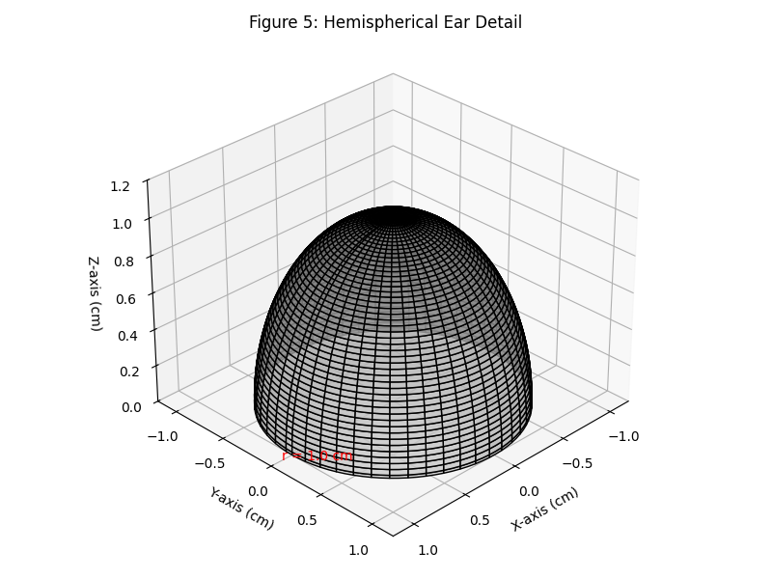

1. **Total Volume from Geometric Decomposition**

Now, I summed up all the calculated volumes:

|  |  |
| --- | --- |
| **Component** | **Volume (cm³)** |
| Head (ellipsoid) | 39.27 |
| Body (cylinder) | 56.55 |
| Base (cone) | 15.20 |
| Ear (hemisphere) | 2.09 |
| **Total Volume** | **113.11** |

**5.1 Comparison with Trapezoidal Rule**

In the previous section, I estimated the sculpture's volume to be approximately 116.96 cm³ using the trapezoidal rule. My geometric decomposition estimate, on the other hand, resulted in 113.11 cm³. The small difference of about 3.85 cm³ (roughly 3.3%) between the two values is acceptable, given the assumptions and approximations made during modeling. Interestingly, the trapezoidal rule relied purely on numerical data and rotation. At the same time, the geometric method involved analytical reasoning and visual estimation to match parts of the sculpture with geometric solids. Both approaches are valid, but their differences highlight how the structure of a shape can influence volume calculations. Geometric decomposition also makes it easier to communicate and visualize how much clay is needed for each part.

**5.2 Reflections on Accuracy**

The decomposition method was helpful for visual learners like me. It allowed me to break down a complex object into manageable pieces and use formulas I was already comfortable with. However, it also introduced room for estimation errors in selecting dimensions for each section. For more precision, 3D scanning or mathematical modeling software could provide even better segmentation and volume calculation. Still, this method effectively bridges visual design and mathematical analysis Kus and Cakiroglu.

1. **Comparison of Methods and Discussion**

After applying both the trapezoidal rule and the geometric decomposition method to estimate the volume of my sculpture, I could compare their results and their respective advantages and limitations. The trapezoidal rule yielded an estimated volume of approximately 116.96 cm³, while the geometric decomposition method gave a slightly lower estimate of 113.11 cm³. The difference between the two results was about 3.85 cm³, roughly 3.3%. Given the assumptions made in both methods, I found this level of consistency quite reassuring.

Regarding which method gave a better estimate, it’s difficult to say with certainty without access to the true volume. However, the trapezoidal rule may provide a slightly more accurate result because it directly integrates the area under the curve defined by measured points (Kumar and Kumar). It doesn’t rely on manually approximating parts of the sculpture as standard shapes, which can introduce errors when the form doesn’t exactly match a known solid. On the other hand, the geometric decomposition method was easier to understand and visualize. It allowed me to break the sculpture into familiar 3D solids like ellipsoids, cylinders, and cones. It made the volume calculation more structured and allowed me to interpret the contribution of each part of the sculpture individually. However, the downside of this method is that it assumes idealized shapes, which may not precisely reflect the organic contours of a handmade object.

Several sources of error affected both methods. First, I relied on pixel-based measurements from an image, which could introduce slight inaccuracies, especially if the image wasn’t perfectly scaled. Second, in the decomposition method, I had to approximate complex curves using ideal geometric solids, which simplifies the sculpture but may overlook smaller features. Lastly, in the trapezoidal rule, the accuracy depends on the number and spacing of data points. Fewer points or uneven intervals would reduce the precision of the volume estimate.

Overall, I appreciated how both approaches complemented each other. While the trapezoidal rule offered numerical rigor, geometric decomposition helped me conceptually engage with the sculpture's form. Combining both methods could lead to better estimation and design precision in a real-world scenario.

# Works Cited

Abdulhameed, A. F., and Q. A. Memon. “An Improved Trapezoidal Rule for Numerical Integration.” *Journal of Physics: Conference Series*, vol. 2090, no. 1, Nov. 2021, p. 012104, <https://doi.org/10.1088/1742-6596/2090/1/012104>.

Cheng, Jian, et al. “A Noise Reduction Method Based on Adaptive Weighted Symplectic Geometry Decomposition and Its Application in Early Gear Fault Diagnosis.” *Mechanical Systems and Signal Processing*, vol. 149, Feb. 2021, p. 107351, <https://doi.org/10.1016/j.ymssp.2020.107351>. Accessed 9 Sept. 2021.

Kumar, Krishan, and Neeraj Kumar. “Region Coverage-Aware Path Planning for Unmanned Aerial Vehicles: A Systematic Review.” *Physical Communication*, vol. 59, Elsevier BV, Aug. 2023, pp. 102073–73, <https://doi.org/10.1016/j.phycom.2023.102073>. Accessed 1 Apr. 2024.

Kus, Mehtap, and Erdinc Cakiroglu. “Mathematics in the Informal Setting of an Art Studio: Students’ Visuospatial Thinking Processes in a Studio Thinking-Based Environment.” *Educational Studies in Mathematics*, vol. 110, no. 3, Mar. 2022, pp. 545–71, <https://doi.org/10.1007/s10649-022-10142-8>. Accessed 15 Sept. 2022.

Xin, Ge, et al. “Complex Symplectic Geometry Mode Decomposition and a Novel Time–Frequency Fault Feature Extraction Method.” *IEEE Transactions on Instrumentation and Measurement*, vol. 74, Institute of Electrical and Electronics Engineers (IEEE), 2025, pp. 1–10, <https://doi.org/10.1109/tim.2024.3522417>. Accessed 7 Apr. 2025.

Zul Afiq Sazeli, et al. “Comparison of the Trapezoidal Rule and Simpson’s Rule.” *Multidisciplinary Applied Research and Innovation*, vol. 5, no. 2, 2024, pp. 118–23, penerbit.uthm.edu.my/periodicals/index.php/mari/article/view/13828.