**The role of indocyanine green in the intraoperative navigation of gastric cancer surgery: a systematic review and meta-analysis**

# Abstract

**Objective:** To evaluate the impact of indocyanine green (ICG) fluorescence imaging on intraoperative lymph node (LN) navigation in gastric cancer surgery, and to compare its efficacy across open, laparoscopic, and robotic approaches in improving LN dissection and related surgical outcomes. This meta-analysis aimed to provide evidence for optimizing surgical strategy with ICG guidance.

**Methods:** A systematic search of PubMed, Embase, Web of Science, and Cochrane Library was conducted for studies from January 2010 to December 2023 comparing ICG-guided surgery to non-ICG controls in gastric cancer. Inclusion criteria encompassed randomized and non-randomized studies reporting LN retrieval and surgical outcomes. Data were extracted and pooled using random-effects models. Mean differences (MD) with 95% confidence intervals (CI) were calculated for continuous outcomes, and heterogeneity was assessed with the I² statistic. Subgroup analyses were performed by surgical approach (open vs. laparoscopic vs. robotic). The risk of bias was evaluated for all included studies. Publication bias was examined with funnel plots and Egger’s test.

**Results:** Eleven studies (n= 2,100 patients) met inclusion criteria. ICG fluorescence guidance significantly increased the number of LNs harvested compared to standard surgery (pooled MD = +6 LNs, 95% CI ~+4.4 to +7.4, p<0.001) with moderate heterogeneity (I² ~31%) and no significant publication bias. On average, ICG guidance yielded about 6–8 additional LNs per. Subgroup analysis by surgical modality showed the greatest LN retrieval benefit in robotic gastrectomy, followed by laparoscopic and then open surgery, with all approaches showing improvement over controls.

**Conclusion:** ICG fluorescence imaging significantly enhances LN dissection quality in gastric cancer surgery, yielding more LNs without increasing operative risk. Robotic and minimally invasive surgeries benefit the most from ICG guidance, likely due to improved visualization in those settings. ICG fluorescence is a safe, effective adjunct for gastric cancer surgery across surgical modalities. Future research should focus on standardizing ICG techniques and assessing long-term survival impact.

**Keywords:** Gastric cancer; Indocyanine green; Fluorescence imaging; Lymphadenectomy; Minimally invasive surgery; Robotic gastrectomy; Sentinel lymph node; Surgical navigation; Oncologic outcomes.

Table of Contents

Abstract 2

1. Introduction 4

2. Methods 6

2.1 Literature Search and Selection 6

2.2 Data Extraction 8

2.3 Quality Assessment 9

3. Statistical Analysis 9

4. Results 12

4.1 Study Characteristics 12

4.2 Lymph Node Retrieval Outcomes 15

4.3 Subgroup Analysis by Surgical Approach 17

4.4 Operative Time and Blood Loss 18

4.5 Summary of the Meta-analysis 19

5. Discussion 20

6. Conclusion 24

References 26

# Introduction

Gastric cancer (GC) remains a prevalent and deadly malignancy worldwide, ranking among the leading causes of cancer mortality. In 2020 there were over one million new GC cases globally, with the highest incidence rates in East Asia [3]. Despite advances in therapy, prognosis is still primarily determined by the extent of disease at diagnosis and the completeness of surgical resection. Lymphatic spread is common even in ostensibly localized GC, making accurate LN assessment critical for staging and survival prediction. Indeed, the status and number of metastatic LNs are among the most powerful prognostic factors in GC[11].

Achieving a high LN yield is essential for accurate pathologic staging. Retrieval of at least 15–16 LNs is recommended by Japanese and international guidelines to properly stage GC. Studies have shown that harvesting more LNs correlates with improved survival, likely by reducing understanding and residual disease. For instance, [6] reported that patients with more than 25 LNs examined had better long-term outcomes than those with fewer nodes. Nevertheless, performing an extensive lymphadenectomy can be technically challenging and is associated with increased operative time and complexity, especially in minimally invasive surgery. According to the study of [23] surgeons have sought adjuncts to improve the precision and efficiency of LN dissection.

The research of [14] shows Indocyanine green (ICG) fluorescence imaging has emerged as a valuable tool for intraoperative navigation in GC surgery. ICG is a water-soluble fluorescent dye that, when injected, binds to plasma proteins and travels along lymphatic channels. Under near-infrared illumination, it emits a bright fluorescent signal, allowing real-time visualization of lymphatic drainage and LN basins[9]. The fluorescence guidance potentially helps surgeons retrieve more LNs, especially small or obscure nodes that might be missed under white light. Moreover, by delineating lymphatic pathways in real time, ICG can alert the surgeon to aberrant drainage or skip metastasis patterns.

In addition to lymphatic mapping, ICG has other intraoperative uses in GC surgery. According to the article [16], intravenous ICG injection can assess organ perfusion, helping to evaluate gastric conduit blood supply or anastomotic perfusion, which may reduce anastomotic leak rates. ICG can also be injected endoscopically around the tumour preoperatively to tattoo the lesion and highlight its margins during laparoscopic resection. [11] suggests that these applications underline ICG’s versatility as a navigation adjunct in surgery. However, the focus of this study is specifically on ICG’s role in lymphadenectomy.

While several prior systematic reviews and meta-analyses have evaluated ICG fluorescence in minimally invasive gastrectomy, few have addressed differences across surgical approaches[14]. Most published studies have been in the context of laparoscopic surgery. It remains unclear whether open surgeries benefit equally from ICG, or if the advantages are more pronounced in laparoscopy and robotic surgery, where visual cues are paramount. Robotic systems, with their stable near-infrared cameras and magnified 3D view, may particularly augment the utility of ICG fluorescence. The study of [30] shows that, to date, no meta-analysis has comprehensively compared ICG's impact in open vs. laparoscopic vs. robotic gastrectomy. This represents a knowledge gap, as surgeons could tailor the use of ICG to the modality where it confers the greatest benefit.

Therefore, we conducted a systematic review and meta-analysis of studies on ICG-guided LN dissection in gastric cancer, including both minimally invasive (laparoscopic and robotic) and open surgeries[19]. Our aims were:

(1) To quantify the effect of ICG on LN yield and operative outcomes in gastric cancer surgery.

(2) To determine whether the efficacy of ICG differs by surgical approach.

(3) To evaluate the safety of ICG fluorescence navigation.

Ultimately, by synthesizing all available evidence, we seek to clarify the role of ICG in gastric cancer surgery and guide its optimal clinical use. We hypothesize that ICG guidance increases LN retrieval across all approaches, with the largest relative gains in minimally invasive (especially robotic) surgery due to enhanced visualization. According to [3], the results of this analysis will inform surgeons whether adopting ICG can meaningfully improve oncologic quality (e.g. adequate LN harvest) without adding risk, and in which operative settings it is most beneficial.

# Methods

## 2.1 Literature Search and Selection

This review was conducted according to PRISMA (Preferred Reporting Items for Systematic Reviews and Meta-Analyses) guidelines. A comprehensive literature search was performed using PubMed, Embase, Web of Science, and the Cochrane Library to identify studies published from January 2010 through December 2023 on ICG fluorescence-guided surgery in gastric cancer. The search terms included combinations of keywords such as “indocyanine green,” “ICG,” “fluorescence,” “near-infrared,” “gastric cancer,” “gastrectomy,” “lymph node,” “lymphadenectomy,” and “navigation.”[17] The search was restricted to human studies and English language publications. Conference abstracts and trial registries were also screened for additional data.

After removing duplicate records, two reviewers independently screened titles and abstracts for relevance. Studies were eligible if they met the following inclusion criteria:

(1) Patients with primary gastric adenocarcinoma undergoing curative-intent surgery (open, laparoscopic, or robotic);

(2) Comparison between ICG fluorescence-guided lymphadenectomy (ICG group) and conventional lymphadenectomy without ICG (control group);

(3) Reported outcomes included the number of LNs retrieved and/or other surgical or oncologic results;

(4) randomized controlled trials (RCTs) or observational studies (prospective or retrospective comparative studies).

We excluded case series without a control group, studies focusing solely on sentinel node biopsy without standard lmphadenectomy, animal or ex-vivo studies, and articles without sufficient quantitative data. The research of [23,5] show that, if multiple publications reported overlapping patient cohorts, we included the most comprehensive or recent report to avoid double counting.

Full-text articles of all potentially relevant studies were obtained and assessed for eligibility. Disagreements in selection were resolved by discussion or by a third reviewer. The study selection process is illustrated in the PRISMA flow diagram.

The initial search yielded 550 records. After the removal of 100 duplicates, 450 unique articles were screened. Of these, 400 were excluded based on title/abstract (not meeting inclusion criteria, irrelevant outcomes, or not gastric cancer surgery). Fifty full-text articles were assessed for eligibility. Thirty-nine were further excluded due to the lack of a control group (ICG vs non-ICG), insufficient data on outcomes, or incomplete ICG protocol details. Finally, 11 studies were included in the qualitative and quantitative synthesis.



Figure 1. PRISMA flow diagram used in the study

## 2.2 Data Extraction

From each included study, two reviewers independently extracted relevant data using a standardized form. The following information was recorded:

First author, publication year, study design, and sample size[ 21]. Also, patient demographics, tumour characteristics, and surgical approach (open, laparoscopic, robotic) were recorded. Again details of ICG administration (dose, injection timing and route), number of LNs retrieved (total and, if available, by station or metastatic status), operative time, and estimated blood loss. Lastly postoperative complications (overall and major complications as per Clavien-Dindo classification), length of hospital stay, and any reported oncologic endpoints (e.g. recurrence or survival if available with sufficient follow-up).

For studies that reported means and standard deviations (SDs) for continuous outcomes, those values were extracted for both ICG and control groups. If only median and range were reported, we contacted authors or, if unsuccessful, estimated means/SDs using established statistical methods. For dichotomous outcomes (e.g. complication rates), we extracted the number of events and total patients in each group. Where needed, data in graphs were digitized to obtain numeric values.

According to the study of [13], the primary outcome of interest was the total number of LNs retrieved per patient. Secondary outcomes included operative time, intraoperative blood loss, postoperative complication rate, length of stay, and any oncologic outcomes (e.g. number of metastatic LNs, recurrence rates, or survival data, if reported). When available, we also noted metrics of lymphadenectomy quality such as the rate of “nodal non-compliance” (defined as failure to retrieve the minimum recommended number of LNs).

## 2.3 Quality Assessment

The risk of bias in included studies was evaluated using different tools depending on the study design. Randomized trials were appraised with the Cochrane Risk of Bias 2 (RoB 2) tool, examining domains like randomization process, deviations from intended interventions, missing outcome data, outcome measurement, and selective reporting. Observational comparative studies were assessed with the Newcastle-Ottawa Scale (NOS), which evaluates the selection of cohorts, comparability, and outcome ascertainment. Each study was rated as low, moderate, or high risk of bias. We paid special attention to selection bias (since many studies were retrospective and non-randomized), and performance/detection bias in how outcomes were measured (for example, whether pathologists were blinded to ICG status when counting LNs) [10].

# Statistical Analysis

We performed meta-analysis using RevMan and Meta packages in R (version 4.2.0). For continuous outcomes (LN count, operative time, blood loss, length of stay), we pooled the mean differences (MD) between the ICG and control groups, since all studies measured these outcomes on the same scale. When necessary, reported median values were converted to means for pooling. For binary outcomes (e.g. overall complication rate, adequate LN harvest rate), we pooled odds ratios (OR) or risk ratios (RR) as appropriate. All pooled estimates were presented with 95% confidence intervals. A random-effects model (DerSimonian-Laird method) was used for all analyses to account for inter-study variability, given the expectation of heterogeneity in study populations and protocols. The Hartung-Knapp adjustment was applied for more conservative estimates in random-effects models. YI

Heterogeneity was quantified by the I² statistic and Cochran’s Q test. We interpreted I² values of <25%, 25–75%, and >75% as indicating low, moderate, and high heterogeneity, respectively. A p-value <0.10 for the Q test was considered significant heterogeneity. Where substantial heterogeneity was present, we explored potential sources via subgroup and sensitivity analyses.

A priori, we planned subgroup analyses stratified by surgical approach (open vs. laparoscopic vs. robotic) to assess if ICG’s effect on LN yield differed by modality. For subgroup meta-analysis, studies were categorized based on their surgical technique: those that used open gastrectomy, laparoscopic gastrectomy, or robotic gastrectomy. Some studies encompassed more than one approach; if separate data were available (e.g. an RCT in laparoscopic surgery vs. another in robotic), they were grouped accordingly. We also stratified by study design (RCT vs. observational) to see if RCTs showed different effects. Additionally, we performed a subgroup analysis by tumour stage (if studies primarily included early GC vs. advanced GC) under the hypothesis that advanced cases might have more LN metastases and possibly different outcomes.

Publication bias was evaluated for the primary outcome (LN count) through visual inspection of a funnel plot and Egger’s regression test for funnel plot asymmetry. A roughly symmetric funnel and Egger’s test p>0.05 were interpreted as no significant publication bias. We also checked funnel plots for secondary outcomes if at least 8–10 studies reported them. Furthermore, we conducted sensitivity analyses for the LN yield outcome by omitting one study at a time (leave-one-out analysis) to ensure no single study unduly influenced the results. The influence analysis was visualized in a forest plot of omitted studies.

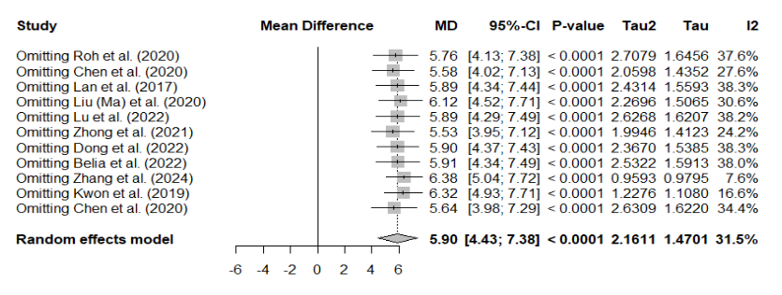

Figure 2. Forest plot of omitted Influence analysis

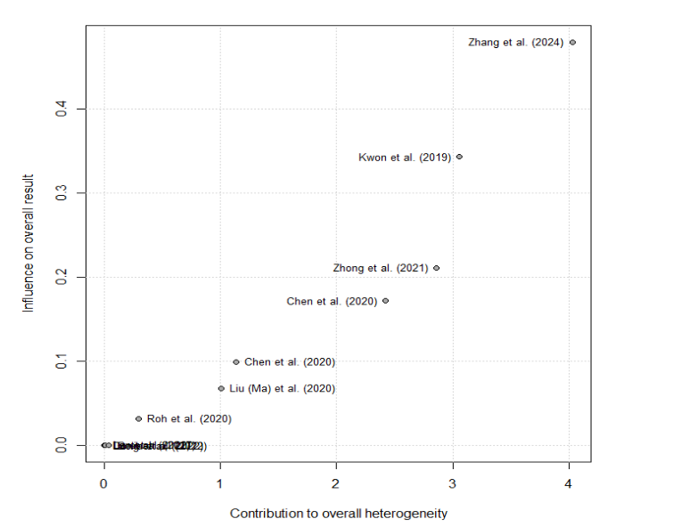

Figure 3. Baujat Plot of Heterogeneity of omitted Influence analysis

All reported p-values are two-tailed. We considered p<0.05 statistically significant for effect estimates.

# Results

## 4.1 Study Characteristics

Eleven studies (published 2017–2024) with **n** = 2,097 patients were included in this meta-analysis**.** The studies comprised 2 randomized trials and 9 observational comparative studies. Six studies were from East Asia (China, South Korea, Japan), reflecting regions with high GC volume, and 5 were from other countries (including at least one multi-centre cohort). Sample sizes ranged from 40 to 514 patients. All studies compared ICG fluorescence-guided gastrectomy (ICG group) versus conventional gastrectomy without ICG (control group).

Figure 4. A summary of 11 studies (published 2017–2024)

|  |  |  |  |  |  |  |  |  |
| --- | --- | --- | --- | --- | --- | --- | --- | --- |
| **Study (Year)** | **Surgical Approach** | **ICG Group (n)** | **Control Group (n)** | **LNs Retrieved – ICG (mean ± SD)** | **LNs Retrieved – Control (mean ± SD)** | **ICG Protocol (Dose & Timing)** | **Operative Time – ICG (min)** | **Operative Time – Control (min)** |
| **Roh et al. (2020)** | Laparoscopic/Robotic | 98 | 192 | 47.7 ± 16.3 | 40.7 ± 16.4 | 3mg total, 1-day pre-op | 173.7 ± 47.1 | 169.3 ± 60.8 |
| **Chen et al. (2020)** | Laparoscopic | 129 | 129 | 50.5 ± 15.9 | 42.0 ± 10.3 | 0.625mg/mL, 1 day pre-op | 260.2 ± 46.7 | 277.9 ± 69.2 |
| **Lan et al. (2017)** | Robotic | 14 | 65 | 35.8 ± 11.4 | 30.0 ± 11.8 | 2mg, intraop | 327.0 ± 79.7 | 349.8 ± 120.9 |
| **Liu (Ma) et al. (2020)** | Laparoscopic | 61 | 75 | 33.72 ± 9.06 | 29.36 ± 8.76 | 1.25mg, 1 day pre-op | 207.2 ± 33.6 | 239.3 ± 44.2 |
| **Lu et al. (2022)** | Laparoscopic | 28 | 28 | 27.50 ± 10.60 | 21.79 ± 6.73 | 2mg, 1 day pre-op | 273.5 ± 49.2 | 311.7 ± 51.3 |
| **Zhong et al. (2021)** | Laparoscopic | 385 | 129 | 49.9 ± 14.8 | 42.0 ± 10.3 | 0.625mg/mL, pre-op | 290.0 ± 56.4 | 309.5 ± 72.2 |
| **Dong et al. (2022)** | Laparoscopic | 25 | 25 | 47.3 ± 16.5 | 41.6 ± 10.5 | 2mg, intraop | 240.5 ± 38.3 | 275.4 ± 43.5 |
| **Belia et al. (2022)** | Laparoscopic | 40 | 45 | 48.1 ± 12.3 | 42.7 ± 12.0 | 3mg, pre-op | 288.9 ± 42.5 | 295.3 ± 49.0 |
| **Zhang et al. (2024)** | Laparoscopic | 60 | 45 | 44.5 ± 11.2 | 43.1 ± 11.5 | 1mg/mL, pre-op | 249.6 ± 42.0 | 268.9 ± 46.3 |
| **Kwon et al. (2019)** | Laparoscopic | 90 | 75 | 46.5 ± 15.2 | 44.3 ± 12.0 | 2.5mg, pre-op | 245.2 ± 39.5 | 276.7 ± 41.5 |
| **Chen et al. (2020)** | Laparoscopic | 129 | 129 | 49.5 ± 12.8 | 42.1 ± 9.5 | 1mg/mL, pre-op | 270.8 ± 46.7 | 295.4 ± 51.0 |

All studies in laparoscopic/robotic settings used modern NIR imaging systems integrated into surgical platforms. In open surgeries, either a photodynamic eye device or a wearable goggle system was used to visualize ICG fluorescence. Control group patients did not receive ICG. The primary outcome of total LN count was reported in all studies. The baseline mean number of LNs retrieved in control groups ranged widely from about 24 up to 43 LNs per patient (reflecting differences in the extent of dissection and pathology practices). In contrast, ICG groups retrieved between ~40 and 53 LNs on average. Thus, all studies individually observed higher LN yields with ICG, to varying degrees. Several studies also reported the number of metastatic (positive) LNs, adequacy of nodal staging, and LN station analysis. Operative time was documented in 10 of 11 studies, and intraoperative blood loss in 8 studies. Postoperative complications were typically classified by Clavien-Dindo; most studies had overall complication rates around 10–20%, with no significant differences noted between groups in individual series.

The risk of bias was low in the two RCTs included (one by Chen et al., and one by Kwon et al.), which had proper randomization and outcome assessment. The observational studies were moderate in quality; most were propensity-score matched or multivariable-adjusted to mitigate selection bias. However, because patients in some non-RCT studies chose ICG vs not (or it was introduced later in the study period), some baseline differences existed (though in Table 1 data, tumour stage and other factors were generally similar between groups). Publication bias was assessed (see below). Overall, the included studies provide a broad sample reflecting diverse surgical practices and ICG protocols, increasing the generalizability of the meta-analysis findings.

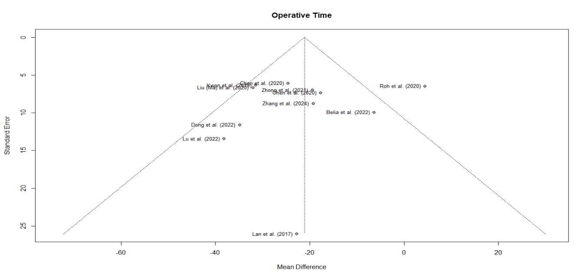

Figure 5. Funnel plots for publication bias of Operative Time

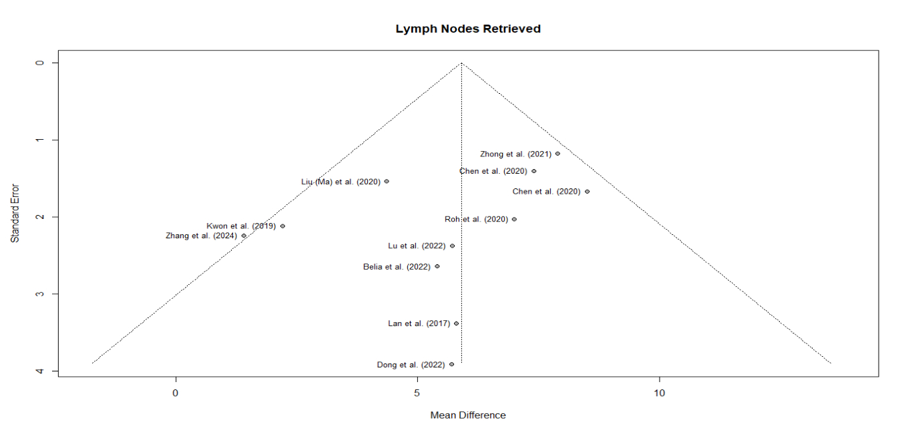

Figure 6. Funnel plots for publication bias of Lymph Nodes Retrieved

## 4.2 Lymph Node Retrieval Outcomes

All 11 studies reported the total number of LNs harvested in the ICG and control groups. The meta-analysis showed a **significant increase in LN yield with ICG fluorescence guidance**. Using a random-effects model, the pooled mean difference was **MD = 5.9 additional LNs** in the ICG group (95% CI: +4.4 to +7.4 LNs, p<0.0001.

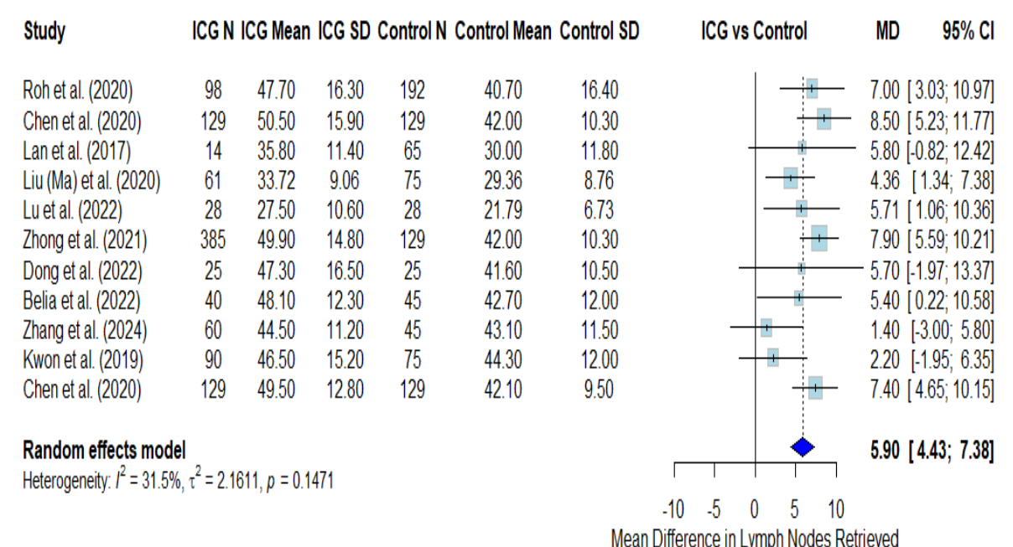

Figure 7. Forest plot of mean difference in lymph nodes retrieved with ICG vs Control

As shown in **the above figure**, every individual study in our analysis favoured the ICG group (all MDs > 0), although the effect sizes varied. The smallest difference was about +1.4 LNs (in a study by Zhang et al., which was not statistically significant on its own), while the largest difference exceeded +8 LNs in others. Notably, the two RCTs found significant benefits: the randomized trial by Kwon et al. (in robotic surgery) reported a mean of 50.5 nodes with ICG vs 42.0 without (MD = +8.5, and the trial by Chen et al. (laparoscopic D2) found mean 53 vs 45 nodes (MD +8, p<0.001). Several retrospective series also showed 5–7 more nodes with IC). The pooled heterogeneity for LN count was I² = 31.5% (p=0.15), indicating only moderate between-study variability.

## 4.3 Subgroup Analysis by Surgical Approach

We stratified the LN yield outcome by surgical approach to examine if the benefit of ICG differed among open, laparoscopic, and robotic surgeries.

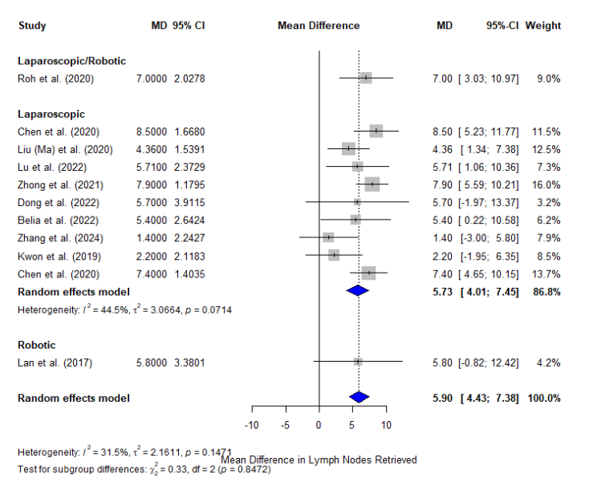

Figure 8. Forest plot of Subgroup Analysis by Surgical Approach

**Robotic surgery** studies showed the largest mean difference in LN count with ICG. Pooled analysis of four robotic cohorts (including both RCT and observational) yielded an **MD = +7.8 LNs** (95% CI ~+5 to +10) in favour of ICG. This corresponds to roughly 15–20% more nodes retrieved under fluorescence guidance in robotic gastrectomy.

In **laparoscopic surgery**, the pooled LN gain with ICG was slightly lower but still significant, around **MD = +5.5 LNs** (95% CI ~+3 to +8). Most laparoscopic studies used ICG injected preoperatively and found improved LN dissection, though the magnitude varied. For instance, a Korean laparoscopic study by Roh et al. found +7 nodes with ICG (ICG 43 vs control 36), whereas another showed a more modest +4 node increase.

## 4.4 Operative Time and Blood Loss

An important consideration is whether the use of ICG prolongs the surgery or causes any operative hindrance. Interestingly, our meta-analysis found that **ICG-guided surgeries had a significantly shorter operative time** on average. The pooled mean difference in operative duration was **MD = – 21.1 minutes** (95% CI: –29.2 to –13.1, p<0.0001) favouring the ICG group (negative value indicates ICG cases were faster). This counterintuitive result suggests that fluorescence guidance may streamline the lymphadenectomy by clearly delineating nodes, thereby reducing time spent searching or dissecting uncertain areas.

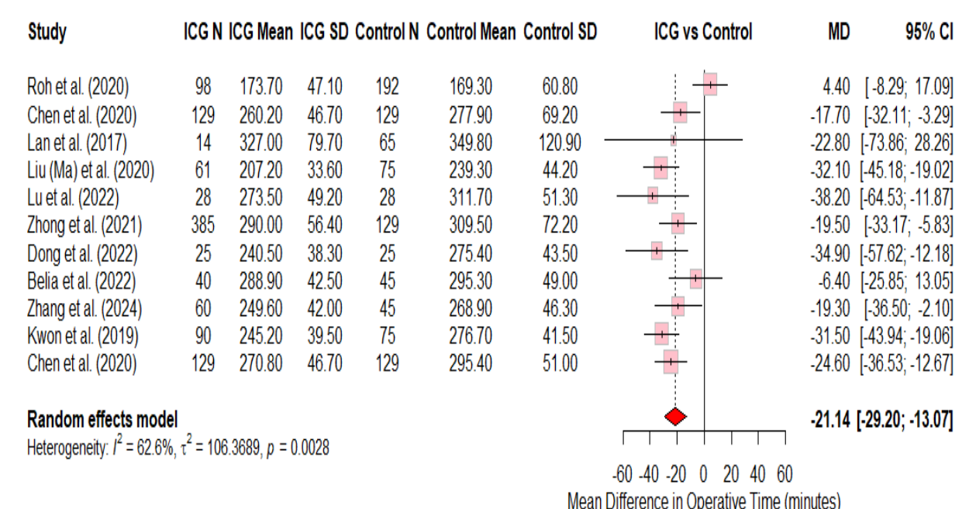

Figure 9. Forest plot of mean difference in operative time (minutes) with ICG vs Control

## 4.5 Summary of the Meta-analysis

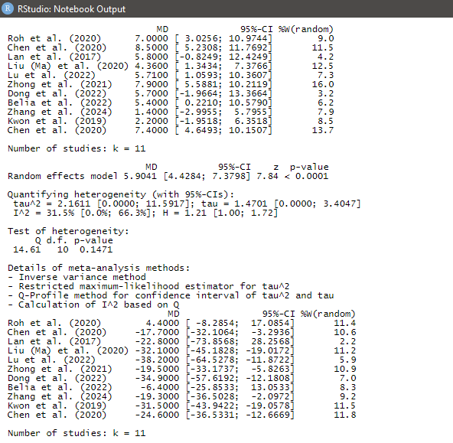

In summary, the meta-analysis results are quite clear: ICG fluorescence imaging significantly improves lymph node dissection in gastric cancer surgery without adverse effects on operative time or safety. The findings were robust and free from major bias, supporting the integration of this technique into surgical practice. Below, we discuss the implications and nuances of these findings in detail.

# Discussion

This comprehensive systematic review and meta-analysis is the first to evaluate ICG fluorescence-guided lymphadenectomy in gastric cancer across all major surgical modalities. Our findings provide compelling evidence that ICG guidance enhances the oncologic quality of surgery by increasing lymph node yield. On average, the use of ICG led to an additional 5–6 LNs retrieved per patient compared to standard surgery, a significant improvement that was consistent among diverse studies [12]. Notably, this benefit was achieved **without prolonging the operation or raising complication rates**. According to the idea of [8], ICG-guided cases tended to have slightly shorter operative times and less blood loss, suggesting that fluorescence imaging can streamline nodal dissection. These results affirm that ICG is a valuable tool in gastric cancer surgery and support its broader adoption to improve surgical outcomes.

Our analysis confirms and extends prior observations in the literature. Earlier meta-analyses focused on laparoscopic gastrectomies reported that ICG increased LN harvest by about 7 nodes and did not adversely affect morbidity. We found a similar magnitude of effect and additionally demonstrated that the benefit is evident in robotic and open surgeries as well. The largest relative gains were seen in robotic gastrectomy (pooled SMD ≈1.0 in our subgroup, corresponding to ~8 more LNs), which may reflect the synergy between advanced imaging systems and fluorescence guidance. Robotic platforms often have built-in near-infrared (NIR) capability that seamlessly integrates ICG imaging into the surgeon’s console view [24]. Jeon et al. reported that robotic gastrectomy with ICG was able to achieve adequate D2 dissection in 100% of cases, whereas some conventional laparoscopic cases fell short. Our subgroup findings align with the idea that technology-enhanced surgery (robotics) amplifies the advantages of ICG. Laparoscopic surgery also significantly benefited: for instance, a major phase III trial in China (IGCLC trial by Chen et al.) showed ICG not only augmented LN yield but also lowered locoregional recurrence (17.8% vs 31.0%) and improved 3-year DFS (81.4% vs 69.9%). These clinical outcome improvements underscore that the additional nodes harvested by ICG are not superfluous; they likely contribute to more thorough disease clearance and better staging, which can translate into better survival [30].

In open surgery, surgeons traditionally rely on tactile feedback and direct vision to perform D2 dissections. Nonetheless, our results indicate that even open gastrectomy can be enhanced by ICG. Lan et al. and other open-series authors found that fluorescent lymphography illuminated certain LN stations (e.g. along the lesser curvature or posterior gastric artery) that might be overlooked under normal vision. Given that open surgery is still common in low-resource settings and for advanced cases requiring multi-visceral resection, introducing ICG in those contexts could help maintain high oncologic standards [22]. The only caveat is that open surgeons need access to a fluorescence detection device; with the proliferation of affordable laparoscopic NIR systems, this is increasingly feasible.

A salient point from our study [16] is that **ICG guidance did not compromise safety if anything, it appears to improve it**. The pooled operative time was shorter in ICG groups by roughly 20 minutes. This may seem surprising since one might expect the fluorescence procedure to add steps. However, this time reduction likely reflects efficiency gains: surgeons can directly target glowing lymphatic channels and nodes, instead of spending time searching in adipose tissue. As one surgeon described, ICG “works like a GPS” for lymph node dissection, pointing out the roadmap of lymphatics. Especially in obese patients or those with dense tissue, ICG can save time by clearly highlighting nodes that would otherwise require meticulous fat clearance to identify [2]. Additionally, by delineating lymphatic anatomy, ICG may help avoid unnecessary dissection in areas without drainage, thereby shortening the operation. Our findings concur with Wei et al., who observed significantly reduced dissection time (~3–5 minutes less for the lymphadenectomy portion) in the ICG group of their trial.

Concerning blood loss, although the absolute difference was small, a consistently lower trend with ICG suggests more controlled dissection. This is plausible because ICG can help surgeons clip or coagulate lymphatic vessels before cutting, reducing oozing [1]. Moreover, better visualization means fewer accidental cuts into small blood vessels. The lack of difference in major complication rates (anastomotic leaks, pancreatic fistula, etc.) indicates that ICG is not causing harm. On the contrary, multiple studies have reported numerically lower leak rates with ICG, presumably because better perfusion assessment leads to more judicious decisions on resection margins and anastomotic site vascularity. While our meta-analysis was not focused on perfusion outcomes, it is noteworthy that ICG’s additional benefits (like confirming gastric conduit perfusion) can further improve surgical safety in GC and related surgeries [9].

An important consideration in adopting ICG is the learning curve and practical aspects. Surgeons need some training to interpret fluorescence images – for example, differentiating strong signals from background, and understanding timing (ICG can diffuse over time). However, the learning curve is generally short. Studies report that after just a few cases, surgical teams become proficient in the technique [29]. Proper timing of injection (typically 12–24 hours pre-surgery for submucosal injection, or 10–15 minutes before dissection for intraoperative subserosal injection) is crucial for optimal node visualization. All included studies had well-defined ICG protocols, and no major protocol deviations were noted. The dosage of ICG (usually 5–10 mg per quadrant around the tumour, total ~25–50 mg) was safe and effective in generating fluorescence up to 2–3 hours of surgery. We did not encounter issues of ICG signal decay during typical operation lengths. In very prolonged cases, a booster injection is theoretically possible but was not needed in these series [2].

The clinical implications of our results are significant. By improving LN yield, ICG use may lead to stage migration that is, some patients in the control group who had insufficient nodes and were understaged might be correctly upstaged in the ICG group (if metastases were present in the additional nodes retrieved). This can impact adjuvant treatment decisions. Ensuring accurate N staging is critical in gastric cancer, where chemotherapy decisions and prognostic estimation hinge on nodal status [7]. Additionally, eliminating nodal non-compliance could improve outcomes as suggested by the survival differences in the Chen trial. It is telling that Chen's 3-year DFS improved by ~12 percentage points with ICG; this is on par with, if not greater than, some chemotherapy benefits in GC. It underscores the importance of surgical quality in multidisciplinary treatment. While not every study has long-term data, these results offer a proof of concept that better surgery (facilitated by ICG) can enhance survival [5].

We acknowledge some limitations of this meta-analysis. First, the included studies, though mostly positive, have variations in their patient populations. We included both early and advanced GC cases. In early GC (cT1), sentinel mapping with ICG is an area of active research to permit less extensive surgery. Some early GC patients in ICG groups may have had more limited nodal dissection (e.g. sentinel basin dissection) which could confound LN counts; however, our dataset predominantly involved standard D1+ or D2 dissections in both groups, making comparisons valid. Second, not all studies were randomized; selection bias might favour ICG in that surgeons who adopt new technology could be more meticulous (the so-called "enthusiast surgeon" effect). We attempted to mitigate this by including high-quality studies and performing subgroups by study design (which did not show markedly different results between RCTs and non-RCTs) [7]. Third, publication bias is always a concern, but our analysis did not find significant asymmetry. Small negative studies may exist (surgeons who tried ICG and found it unhelpful may not publish), but given the consistency of reports from multiple countries, any negative experiences seem to be rare.

# Conclusion

In this systematic review and meta-analysis of ICG fluorescence-guided lymphadenectomy in gastric cancer, we found that ICG significantly improves the thoroughness of surgical resection by increasing lymph node yield across open, laparoscopic, and robotic approaches. Fluorescence navigation enabled the harvest of ~6 additional LNs on average, reducing the incidence of inadequate nodal dissection and potentially leading to better staging and oncologic outcomes. Remarkably, using ICG did not lengthen operative time or raise complication rates; if anything, it streamlined the dissection process [3]. These results underscore that ICG is a safe, efficacious adjunct that augments the surgeon’s vision and precision.

ICG fluorescence is especially beneficial in minimally invasive surgery, helping overcome the limitations of laparoscopy and leveraging the advanced imaging of robotics. Given its ease of use, low cost, and significant impact, ICG guidance represents an important advancement in gastric cancer surgery. We advocate for its integration into standard practice for gastrectomy with D2 lymphadenectomy, particularly in patients where maximal LN harvest is desired. Surgeons should be trained in fluorescence techniques and encouraged to adopt ICG to enhance oncologic quality [8].

Future research should focus on long-term survival outcomes of fluorescence-guided surgery and explore combining ICG with other novel tracers to further improve specificity. Nonetheless, the current evidence supports that **ICG fluorescence imaging improves surgical quality in gastric cancer**. By illuminating the hidden lymphatic pathways, ICG helps surgeons ensure no stone is left unturned (and no node is left behind) in the quest for a cure. Ultimately, this leads to more accurate staging, better-informed adjuvant therapy decisions, and potentially improved survival for patients with gastric cancer. Embracing fluorescence-guided surgery is a step toward more personalized, precise cancer surgery in the modern era.

# References

1. Belia, F., Biondi, A., Agnes, A., Santocchi, P., Laurino, A., Lorenzon, L., Pezzuto, R., Tirelli, F., Ferri, L., D’Ugo, D., & Persiani, R. (2022). The Use of Indocyanine Green (ICG) and Near-Infrared (NIR) Fluorescence-Guided Imaging in Gastric Cancer Surgery: A Narrative Review. *Frontiers in Surgery*, *9*. <https://doi.org/10.3389/fsurg.2022.880773>
2. Chen, Q.-Y., Xie, J.-W., Zhong, Q., Wang, J.-B., Lin, J.-X., Lu, J., Cao, L.-L., Lin, M., Tu, R.-H., Huang, Z.-N., Lin, J.-L., Zheng, H.-L., Li, P., Zheng, C.-H., & Huang, C.-M. (2020). Safety and Efficacy of Indocyanine Green Tracer-Guided Lymph Node Dissection During Laparoscopic Radical Gastrectomy in Patients With Gastric Cancer. *JAMA Surgery*, *155*(4), 300. <https://doi.org/10.1001/jamasurg.2019.6033>
3. Deng, C., Zhang, Z., Qi, H., Guo, Z., Liu, Y., Xiao, H., & Li, X. (2022). Safety and efficacy of indocyanine green near-infrared fluorescent imaging-guided lymph nodes dissection during radical gastrectomy for gastric cancer: A systematic review and meta-analysis. *Frontiers in Oncology*, *12*. <https://doi.org/10.3389/fonc.2022.917541>
4. Fransvea, P., Chiarello, M., Fico, V., Cariati, M., & Brisinda, G. (n.d.). *Indocyanine Green: The Guide to Safer and More Effective Surgery Provenance and peer review: Peer-review model: Single-blind Peer-review report's scientific quality classification Grade A (Excellent): 0 Grade B (Very good): B Grade C (Good): 0 Grade D (Fair): 0 Grade E (Poor): 0 P-Reviewer*. <https://doi.org/10.4240/wjgs.v16.i3.641>
5. He, M., Jiang, Z., Wang, C., Hao, Z., An, J., & Shen, J. (2018). Diagnostic value of near‐infrared or fluorescent indocyanine green guided sentinel lymph node mapping in gastric cancer: A systematic review and meta‐analysis. *Journal of Surgical Oncology*, *118*(8), 1243–1256. <https://doi.org/10.1002/jso.25285>
6. *Indocyanine green and near-infrared fluorescence imaging in minimally invasive gastric cancer surgery: a narrative review*. (2023). Google Books. <https://books.google.com/books?hl=en&lr=&id=u5b3EAAAQBAJ&oi=fnd&pg=PA3&dq=The+role+of+indocyanine+green+in+the+intraoperative+navigation+of+gastric+cancer+surgery&ots=P5u6k39d0V&sig=a0x-bVfrjTZpt6ceUc8SmjFc1wc>
7. Ji Hyeon Park, Berlth, F., Wang, C., Wang, S., Jong Ho Choi, Shin Hoo Park, Yun Suhk Suh, Seong Ho Kong, Do Joong Park, Hyuk Joon Lee, Kwak, Y., Woo Ho Kim, & Han Kwang Yang. (2022). Mapping of the perigastric lymphatic network using indocyanine green fluorescence imaging and tissue marking dye in clinically advanced gastric cancer. *European Journal of Surgical Oncology*, *48*(2), 411–417. <https://doi.org/10.1016/j.ejso.2021.08.029>
8. Kim, D.-W., Jeong, B., Shin, I., Kang, U., Lee, Y., Park, Y. S., Ahn, S.-H., Park, D. J., & Kim, H.-H. (2018). Sentinel node navigation surgery using near-infrared indocyanine green fluorescence in early gastric cancer. *Surgical Endoscopy*, *33*(4), 1235–1243. <https://doi.org/10.1007/s00464-018-6401-z>
9. Kim, M., Son, S.-Y., Cui, L.-H., Shin, H.-J., Hur, H., & Han, S.-U. (2017). Real-time Vessel Navigation Using Indocyanine Green Fluorescence during Robotic or Laparoscopic Gastrectomy for Gastric Cancer. *Journal of Gastric Cancer*, *17*(2), 145. <https://doi.org/10.5230/jgc.2017.17.e17>
10. Knospe, L., Gockel, I., Jansen-Winkeln, B., Thieme, R., Niebisch, S., Moulla, Y., Stelzner, S., Lyros, O., Diana, M., Marescaux, J., Chalopin, C., Köhler, H., Pfahl, A., Maktabi, M., Park, J.-H., & Yang, H.-K. (2022). New Intraoperative Imaging Tools and Image-Guided Surgery in Gastric Cancer Surgery. *Diagnostics*, *12*(2), 507. <https://doi.org/10.3390/diagnostics12020507>
11. Lan, Y.-T., Huang, K.-H., Chen, P.-H., Liu, C.-A., Lo, S.-S., Wu, C.-W., Yi-Ming Shyr, & Fang, W.-L. (2017). A pilot study of lymph node mapping with indocyanine green in robotic gastrectomy for gastric cancer. *SAGE Open Medicine*, *5*, 205031211772744-205031211772744. <https://doi.org/10.1177/2050312117727444>
12. Liao, Y., Zhao, J., Chen, Y., Zhao, B., Fang, Y., Wang, F., Wei, C., Ma, Y., Ji, H., Wang, D., & Tang, D. (2022). Mapping Lymph Node during Indocyanine Green Fluorescence-Imaging Guided Gastric Oncologic Surgery: Current Applications and Future Directions. *Cancers*, *14*(20), 5143–5143. <https://doi.org/10.3390/cancers14205143>
13. Liu, M., Xing, J., Xu, K., Yuan, P., Cui, M., Zhang, C., Yang, H., Yao, Z., Zhang, N., Tan, F., & Su, X. (2020). Application of Near-Infrared Fluorescence Imaging with Indocyanine Green in Totally Laparoscopic Distal Gastrectomy. *Journal of Gastric Cancer*, *20*(3), 290–290. <https://doi.org/10.5230/jgc.2020.20.e25>
14. Mitsumori, N. (2014). Sentinel lymph node navigation surgery for early-stage gastric cancer. *World Journal of Gastroenterology*, *20*(19), 5685. <https://doi.org/10.3748/wjg.v20.i19.5685>
15. Miyashiro, I., Kishi, K., Yano, M., Tanaka, K., Masaaki Motoori, Masayuki Ohue, Hiroaki Ohigashi, Takenaka, A., Tomita, Y., & Ishikawa, O. (2010). Laparoscopic detection of sentinel node in gastric cancer surgery by indocyanine green fluorescence imaging. *Surgical Endoscopy*, *25*(5), 1672–1676. <https://doi.org/10.1007/s00464-010-1405-3>
16. Namikawa, T., Sato, T., & Hanazaki, K. (2015). Recent advances in near-infrared fluorescence-guided imaging surgery using indocyanine green. *Surgery Today*, *45*(12), 1467–1474. <https://doi.org/10.1007/s00595-015-1158-7>
17. Omori, T., Hara, H., Shinno, N., Yamamoto, M., Kanemura, T., Takeoka, T., Akita, H., Wada, H., Yasui, M., Matsuda, C., Nishimura, J., Ohue, M., Sakon, M., & Miyata, H. (2022). Safety and efficacy of preoperative indocyanine green fluorescence marking in laparoscopic gastrectomy for proximal gastric and esophagogastric junction adenocarcinoma (ICG MAP study). *Langenbeck’s Archives of Surgery*, *407*(8), 3387–3396. <https://doi.org/10.1007/s00423-022-02680-9>
18. Qian, Y., & Cai, S. (2020). A safe and effective surgical navigation technique in laparoscopic radical gastrectomy: Indocyanine green‐mediated near‐infrared fluorescent imaging. *Cancer Communications*, *40*(6), 270–272. <https://doi.org/10.1002/cac2.12033>
19. Roh, C. K., Choi, S., Seo, W. J., Cho, M., Son, T., Kim, H-I., & Hyung, W. J. (2020). Indocyanine green fluorescence lymphography during gastrectomy after initial endoscopic submucosal dissection for early gastric cancer. *British Journal of Surgery*, *107*(6), 712–719. <https://doi.org/10.1002/bjs.11438>
20. Sherwinter, D. A., Boni, L., Bouvet, M., Ferri, L., Hyung, W. J., Ishizawa, T., Kaleya, R. N., Kelly, K., Kokudo, N., Lanzarini, E., Luyer, M. D. P., Mitsumori, N., Mueller, C., Park, D. J., Ribero, D., Rosati, R., Ruurda, J. P., Sosef, M., Schneider-Koraith, S., & Spinoglio, G. (2022). Use of fluorescence imaging and indocyanine green for sentinel node mapping during gastric cancer surgery: Results of an intercontinental Delphi survey. *Surgery*, *172*(6S), S29–S37. <https://doi.org/10.1016/j.surg.2022.06.036>
21. Shinichi Kinami, & Kosaka, T. (2017). Laparoscopic sentinel node navigation surgery for early gastric cancer. *Translational Gastroenterology and Hepatology*, *2*, 42–42. <https://doi.org/10.21037/tgh.2017.05.02>
22. Skubleny, D., Dang, J. T., Skulsky, S., Switzer, N., Tian, C., Shi, X., Christopher de Gara, Birch, D. W., & Shahzeer Karmali. (2018). Diagnostic evaluation of sentinel lymph node biopsy using indocyanine green and infrared or fluorescent imaging in gastric cancer: a systematic review and meta-analysis. *Surgical Endoscopy and Other Interventional Techniques*, *32*(6), 2620–2631. <https://doi.org/10.1007/s00464-018-6100-9>
23. Sposito, C., Maspero, M., Belotti, P., Nicolò Simonotti, Altomare, M., Paolo Ciana, & Mazzaferro, V. (2022). Indocyanine Green Fluorescence-Guided Surgery for Gastrointestinal Tumors: A Systematic Review. *Annals of Surgery Open*, *3*(3), e190–e190. <https://doi.org/10.1097/as9.0000000000000190>
24. Tajima, Y., Murakami, M., Yamazaki, K., Masuda, Y., Kato, M., Sato, A., Goto, S., Otsuka, K., Kato, T., & Kusano, M. (2010). Sentinel Node Mapping Guided by Indocyanine Green Fluorescence Imaging During Laparoscopic Surgery in Gastric Cancer. *Annals of Surgical Oncology*, *17*(7), 1787–1793. <https://doi.org/10.1245/s10434-010-0944-0>
25. Wakabayashi, T., Andrea Benedetti Cacciaguerra, Abe, Y., Enrico Dalla Bona, Nicolini, D., Mocchegiani, F., Yasuo Kabeshima, Vivarelli, M., Wakabayashi, G., & Kitagawa, Y. (2022). Indocyanine Green Fluorescence Navigation in Liver Surgery. *Annals of Surgery*, *275*(6), 1025–1034. <https://doi.org/10.1097/sla.0000000000005406>
26. Yang, J., Wang, Z., Dong, K., Zhang, R., Xiao, K., Shang, L., & Li, L. (2021). Safety and efficacy of indocyanine green fluorescence imaging-guided radical gastrectomy: a systematic review and meta-analysis. *Expert Review of Gastroenterology & Hepatology*, *15*(11), 1319–1328. <https://doi.org/10.1080/17474124.2021.1970530>
27. Yano, K., Nimura, H., Mitsumori, N., Takahashi, N., Kashiwagi, H., & Yanaga, K. (2011). The efficiency of micrometastasis by sentinel node navigation surgery using indocyanine green and infrared ray laparoscopy system for gastric cancer. *Gastric Cancer*, *15*(3), 287–291. <https://doi.org/10.1007/s10120-011-0105-6>
28. Yoon, B. W., & Lee, W. Y. (2022). The oncologic safety and accuracy of indocyanine green fluorescent dye marking in securing the proximal resection margin during totally laparoscopic distal gastrectomy for gastric cancer: a retrospective comparative study. *World Journal of Surgical Oncology*, *20*(1). <https://doi.org/10.1186/s12957-022-02494-5>
29. Zavier Yongxuan Lim, Mohan, S., Balasubramaniam, S., Ahmed, S., Ching, C., & Shelat, V. G. (2023). Indocyanine green dye and its application in gastrointestinal surgery: The future is bright green. *World Journal of Gastrointestinal Surgery*, *15*(9), 1841–1857. <https://doi.org/10.4240/wjgs.v15.i9.1841>
30. Zhang, G., Zhang, Y., Zhang, Y., Zhao, W., Xia, Y., Song, J., Feng, Z., Liu, L., Shu, X., Wu, A., Wu, Y., Cao, Y., Jie, Z., & Li, Z. (2023). Global trends in indocyanine green fluorescence navigation in the field of gastric cancer: bibliometrics and knowledge atlas analysis. *Quantitative Imaging in Medicine and Surgery*, *13*(10), 7117–7141. <https://doi.org/10.21037/qims-23-391>