**The Impact of Natural Disasters on Household Savings Rates**

# ****Abstract****

Natural disasters pose serious risks to society, which simultaneously destroy human existence as well as economic stability. The focus of this study is on how the patterns of increasing disaster occurrence impact the patterns of household saving behavior. The research asks if residents living in areas considered to be at high disaster risk save more than those living in less threat zones. The impact of perceived disaster risk and GDP per capita along unemployment rates on savings rate determinants is examined and disaster precautionary saving behaviors are evaluated.

# ****1. Introduction****

The threat of natural disasters to human societies has been long and the potential damage to both lives and economies is great. In the past few decades though, their frequency and intensity has increased and thus there has been interest in investigating how these events affect individual and collective economic behaviour. Household saving is one area where disasters can last. Households may increase their savings when communities are threatened by floods, earthquakes and other catastrophes. These disasters are perceived risk because of the behavior of saving money, especially in disaster prone regions (Cantelmo et al., 2021). In such situations, therefore, households can amass precautionary savings so as to counter future natural disaster related economic shocks.

This paper studies how natural disasters that are frequent (such as floods and earthquakes) impact household's savings rates. The research is focused on the perceived disaster risk and its relation to economic indicators like GDP per capita and unemployment rates. The study will specifically test whether households in high risk disaster areas save more than those in low risk areas.

# ****1.1 Research Question****

The primary research inquiry examines the effect that frequent natural disasters including floods and earthquakes have on household savings rates. The savings behavior of high-risk locations differs substantially from what occurs in low-risk locations. The research expectation demonstrates that people who reside in areas vulnerable to disasters will enact precautionary saving methods that produce greater savings amounts in high-risk locations than in lower-risk locations.

# Hypothesis

* H1: Nations facing higher perceived threats from natural disasters tend to increase their savings because of precautionary saving strategies.
* H2: Savings rates decrease when GDP levels rise because high-income nations supply additional financial security combined with credit options to their citizens.
* H3: Savings rates are associated negatively with unemployment rates because unemployed individuals hold less disposable income.

# ****1.2 Relevance of the Study****

In particular, this study is relevant to policymakers and economists working on financial stability and economic resilience over the long term. By studying the effect of natural disasters on saving behavior, we learn about the techniques that households employ for financial self protection from uncertainty (Lee et al. 2021). Thus, it can be used to design policies that provide better financial safety nets in disaster prone regions. This research can help in making decisions on disaster preparedness, government intervention, and social welfare programs to strengthen savings of households at risk of disasters.

**2. Literature Review**

Far reaching economic consequences of natural disasters are known (Cappelli et al., 2021). Despite the focus of much research on the direct economic costs of disasters such as property losses, lost productivity and disrupted trade, little has been documented about the effect of disasters on individual financial behavior, especially saving (Chang et al., 2022). Previous studies have shown a possible effect of disasters on households’ saving and consumption patterns. Speaking in terms of precautionary savings theory, individuals are assumed to boost their savings as a precautionary measure in case of economic uncertainties. In its application to natural disasters, household in the areas with a high risk of such events may feel that they face an relatively higher risk that they will suffer from damages or lost income will take retaliatory actions by uplifting their saving.

However, studies about savings rates and economy has found that rich countries usually have low savings rate. To illustrate, (Cantelmo et al. 2023) argued that people in richer economies are less willing to save because they have more credit access, social security, as well as other financial systems to support them. In addition, a higher unemployment rate is associated with lower disposable income, and thus lower savings rates (Cantelmo et al., 2023).

These theories do suggest that economic stability influences savings behavior, but also they imply that people in the high risk disaster areas will behave differently. For instance, areas that are perceived to be high risk of disasters could save more since they are more likely to be affected by disasters. For academics, this understanding is important to understand how households prepare for disasters and for policy, how governments can support their financial security.

# ****3. Data Description****

The data used for this study is sourced from multiple authoritative databases, including the World Bank's World Development Indicators, the Emergency Events Database (EM-DAT), and the Organization for Economic Co-operation and Development (OECD). The dataset contains 243 observations covering various countries and years. The variables of interest in the dataset are as follows:



# ****4. Empirical Model****

To examine the relationship between natural disasters and savings behavior, we estimate the following regression model:

SavingsRate $_{i}=β_{0}+β_{1}$ RiskPerceptionIndex $_{i}+β_{2}$ GDPperCapita $_{i}+β_{3}$ UnemploymentRate $_{i}+ϵ_{i}$  
Where:

* SavingsRate_i is the savings rate for country $i$,
* RiskPerceptionIndex_i is the perceived risk index for natural disasters in country $i$,
* GDPperCapita_i controls for the economic development level of the country,
* UnemploymentRate_i controls for the effect of labor market conditions.

# ****5. Empirical Analysis and Results****

### ****Descriptive Statistics****

Before running any regression analysis, we first took a look the summary statistics of the key variables in the dataset:



**Savings Rate**: The mean savings rate is 15.25%, with a standard deviation of 6.23%. The minimum savings rate is 5.02%, and the maximum is 24.93%.

**Risk Perception Index**: The mean value of the risk perception index is 19,603.8, but it varies widely, with a standard deviation of 65,840.5. The range is from -293,415.2 to 377,064.7.

**GDP per Capita**: The average GDP per capita is 36,277.54 USD, with a standard deviation of 19,723.72 USD. The range is from 5,009 USD to 69,803 USD.

**Unemployment Rate**: The average unemployment rate is 9.25%, with a standard deviation of 3.36%. It ranges from 3.00% to 14.99%.

These descriptive statistics help to provide an overview of the data and its variability.

# ****Regression Results****

We begin the analysis with the following regression equation. The regression results indicate the following:



**Risk Perception Index**: The coefficient is 4.14e-06, but the p-value is 0.6, indicating that risk perception has no statistically significant effect on the savings rate.

**GDP per Capita**: The coefficient is -0.0000267, with a p-value of 0.015, suggesting that GDP per capita negatively affects the savings rate. This supports the hypothesis that wealthier countries save less.

**Unemployment Rate**: The coefficient is -0.185, with a p-value of 0.12, which means the unemployment rate does not have a significant impact on savings behavior.

### ****Hypothesis Testing****

Statistics based on the Risk Perception Index show that the two-sample t-test evaluates whether there is a difference in savings rates between high-risk nations and low-risk nations. Savings rates average 15.71% in high-risk nations yet stand at 14.80% in low-risk nations. Although the difference between savings rates is -0.92% the p-value of 0.25 confirms no significant statistical difference exists in these measurements.

# ****Data Visualization****

The analysis included making two visualizations for better risk perception and savings rate understanding: a scatterplot and a boxplot.

A scatterplot represented our investigation of the connection between the Savings Rate and Risk Perception Index.

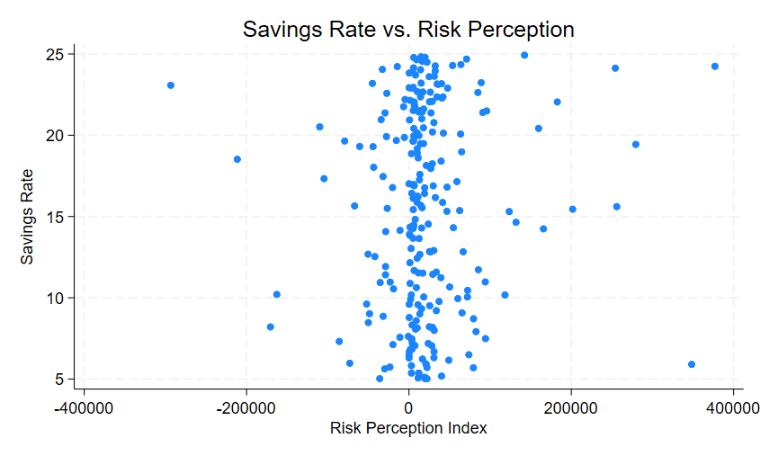

The Risk Perception Index operates is a scaled index. Several disaster-related statistics combine through aggregation to generate a single unified value for assessing perceived risk exposure. The standardized value systems used by countries lead to index measurements yielding extremely high and extremely low numbers based on the dataset that spans from -293,000 to +377,000. The risk perception of people tends to grow in conjunction with increased values in RPI yet declines when RPI demonstrates negative or lower figures. The study used saving trends from the years 2000 to 2020 which revealed broad patterns of savings under differing disaster risk contexts.

**Boxplot**: This boxplot illustrates the distribution of savings rates across the two groups: High Risk and Low Risk based on the Risk Perception Index.

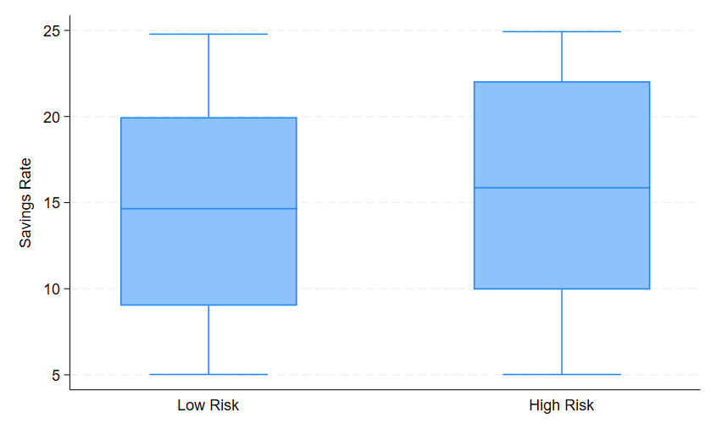

The boxplot shows that the central tendency of savings rates is similar in both high-risk and low-risk regions, although high-risk regions tend to have slightly higher variability in savings rates.

# ****6. Discussion****

### ****Key Findings****

The statistical analysis indicates that perceived disaster risk measured through the Risk Perception Index fails to demonstrate statistical significance regarding savings rates. The main catalyst that impacts savings rates is GDP per capita because it demonstrates a negative relationship with savings behavior. According Mensah & Filipski (2022). the unemployment rate demonstrated no statistical link to variations in savings rates. The findings reveal that people in disaster zones with high risk perception do not save more than those residing in safer areas even though this result seems contrary to logic. The actual savings behavior of households does not show patterns that would support the notion of increased savings because of perceived risk since these areas benefit from government financial safety measures and other factors like income level influence financial choices more strongly (Hong et al., 2021).

# Policy Implications

A strong relationship exists between GDP per capita and household savings so policymakers need to enhance financial stability alongside implementing social security programs in at-risk regions. The implementation of disaster preparedness awareness programs targeting all households in high-risk areas will enhance emergency savings regardless of whether risk perception serves as the main driver (Cappelli et al., 2021).

### ****Limitations****

Data at the country level shows limitations when measuring actual household conduct. Future analyses should use information from individual households to gain a better comprehension of disaster-related impacts on personal savings.

This study utilized the Risk Perception Index as an aggregate measure that fails to show actual individual exposure to risks. More specific measures that identify risks at the local level would reveal a better understanding of situations.

# 7. Conclusion

A research investigation examined how different countries relate natural disaster danger recognition to domestic saving habits. The research results demonstrated GDP per capita as the main factor influencing savings behavior because risk perception did not affect savings rates significantly. Governments should first focus on establishing stable financial structures with social programs that enhance household preparedness for upcoming disasters, particularly in high-risk regions (Hong et al., 2021). Future research needs to examine the relationship between savings behavior and distinct forms of natural disasters including floods and earthquakes. Extending research analysis to the household level rather than at the country scale would yield detailed data about personal behavioral modifications when confronting disaster risks. Local risk data integration would create a more precise understanding of perceived risks among people.

# References

Cantelmo, A., Melina, G., & Papageorgiou, C. (2023). Macroeconomic outcomes in disaster-prone countries. *Journal of Development Economics*, *161*, 103037. https://doi.org/10.1016/j.jdeveco.2022.103037

Cappelli, F., Costantini, V., & Consoli, D. (2021). The trap of climate change-induced “natural” disasters and inequality. *Global Environmental Change*, *70*, 102329. https://doi.org/10.1016/j.gloenvcha.2021.102329

Chang, S. E., Brown, C., Handmer, J., Helgeson, J., Kajitani, Y., Keating, A., Noy, I., Watson, M., Derakhshan, S., Kim, J., & Roa-Henriquez, A. (2022). Business recovery from disasters: Lessons from natural hazards and the COVID-19 pandemic. *International Journal of Disaster Risk Reduction*, *80*, 103191. <https://doi.org/10.1016/j.ijdrr.2022.103191>

Hong, B., Bonczak, B. J., Gupta, A., & Kontokosta, C. E. (2021). Measuring inequality in community resilience to natural disasters using large-scale mobility data. *Nature communications*, *12*(1), 1870.

Lee, C.-C., Wang, C.-W., Ho, S.-J., & Wu, T.-P. (2021). The impact of natural disaster on energy consumption: International evidence. *Energy Economics*, *97*, 105021. <https://doi.org/10.1016/j.eneco.2020.105021>

Mensah, E. R., & Filipski, M. J. (2022). Saving for a rainy day: the impact of natural disasters on savings rates.

# Appendix

* Step 1: Import Data

import excel "new_merged_dataset.xlsx", sheet("Sheet1") first row clear

* Step 2: Declare Panel Data

xtset Country StartYear

* Step 3: Create HighRisk Variable

sum RiskPerceptionIndex, detail

gen HighRisk = (RiskPerceptionIndex > r(p50)) if !missing(RiskPerceptionIndex)

label define risk 0 "Low Risk" 1 "High Risk"

label values HighRisk risk

* Step 4: Descriptive Stats & T-Test

ttest SavingsRate, by(HighRisk)

* Step 5: Fixed Effects Regression

xtreg SavingsRate RiskPerceptionIndex GDPperCapita UnemploymentRate i.StartYear, fe

* Export Results

esttab using "results.rtf", replace