**CSC263 Database Systems**

**Laboratory Assignment #2**

**Goals:** To get started working with MySQL RDBMS by creating a very simple and small relational database.

**Objectives:** After successfully completing the lab, a student should

* have gained initial experiences with remote login to our department MySQL server
* be able to use phpMyAdmin to perform several administrative functions of MySQL
* be able to create and populate a very simple and small relational database by using some basic MySQL SQL (Structured Query Language) commands, specifically CREATE TABLE …; INSERT INTO …; DROP TABLE ….,
* be table to use simple DML to query the small database.

**Lab Report Requirements:**

* Your lab report much include a title, the Goals and Objective of the lab.
* Your lab report should record every task you are about to perform.
* You must take screenshots of every task you are about to perform for this lab and show them in your lab report.

**Lab Requirements:**

Based on the tasks you performed in Lab 1, perform the following tasks. You may need you instructor’s initial help to start.

**Part I (with help of your instructor)**

* Design a small relational database to better model this “small world”. (Lab 1.)

Author as a table, title as a table. Making author and title as entities, with year edition and ISBN as title attributes

* Use any modeling tool to produce an Entity Relational Diagram for this small database. (See Resources page on our class website)

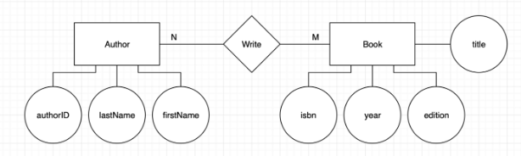

In the following parts of the lab, you need to use the following SQL DDL and DML commands:

* Use MySQL’s SQL command **CREATE TABLE …** to create the necessary tables for the small database.
* Use MySQL’s SQL command **INSERT INTO …** to populate the tables with the information provided.
* Use MySQL’s SQL command **SELECT * FROM *table_name*** to display the complete contents of each table you created and populated.
* Use MySQL’s SQL command **SELECT * FROM *table_name*** **WHERE *condition*** to display the contents of a table that meet specific criteria.

**Part II (to be performed by using remote console to MySQL DBMS)**

* Create the Author table by using remote console (using “putty”) to MySQL DBMS

CREATE TABLE Author

(

A_ID INTEGER UNSIGNED NOT NULL AUTO_INCREMENT,

lastName VARCHAR (25),

firstName VARCHAR (25),

CONSTRAINT PRIMARY KEY (A_ID)

);

* Populate the Author table with at least one author information, for example,

INSERT INTO Author (lastName, firstName) VALUES ("Goldberg", "Andrew");

INSERT INTO Author (lastName, firstName) VALUES ("Choffnes", "David");

* Display the contents of the Author table you have created so far.

SELECT * FROM Author;

* Delete/Remove the Author table from the database.

DROP TABLE Author;

**Part III (to be performed by using phpMyAdmin)**

1. Login to your database server using phpMyAdmin, type and execute the following DDL commands using the SQL build-in editor/executor. After successfully created these tables, show the table structures of all three tables.

CREATE TABLE Book

(

ISBN CHAR (10) NOT NULL,

Title VARCHAR (256) NOT NULL,

Edition INTEGER UNSIGNED NOT NULL,

Year INTEGER UNSIGNED NOT NULL,

CONSTRAINT PK_Book PRIMARY KEY (ISBN)

);

CREATE TABLE A_writes_B

(

A_ID INTEGER UNSIGNED NOT NULL

ISBN varchar(10) NOT NULL,

CONSTRAINT PK_A_writes_B PRIMARY KEY (A_ID, ISBN)

);

1. Populate the tables using the Excel files you created in the previous lab. Make sure that you save those files as .csv format with the corresponding VARCHAR or CHAR field as “text” type not numerical type.
2. Issue the following DML commands (queries) to retrieve information from the database.

* Display information of all authors in the database in the following format.

First Name Last Name

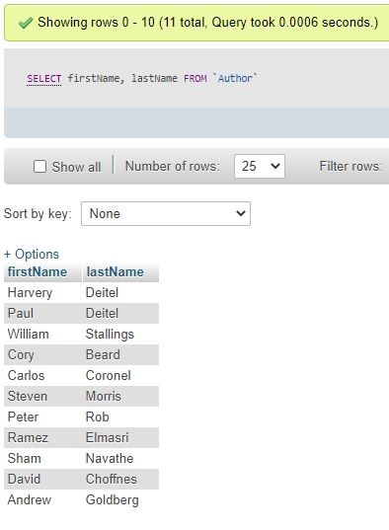

* Display information of all books in the database (just the books without the authors).

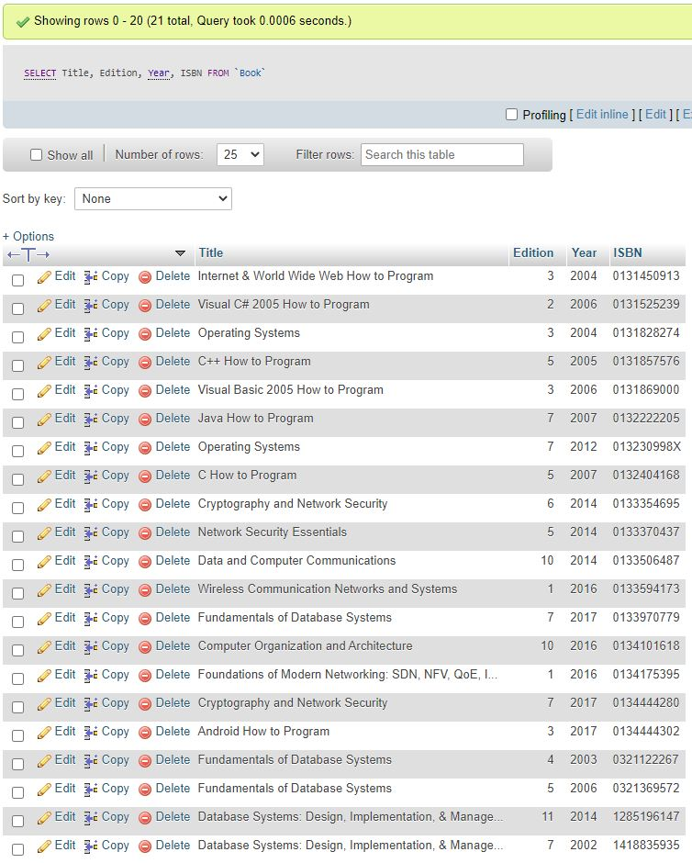Title Edition Year ISBN

* List all authors in the database whose last name is “Deitel”.

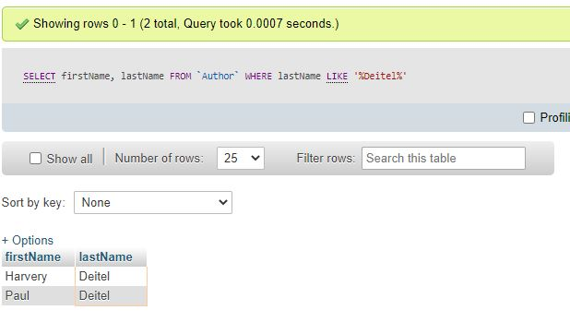First Name Last Name

* List all books in the database that were published since 2006.

Title Year

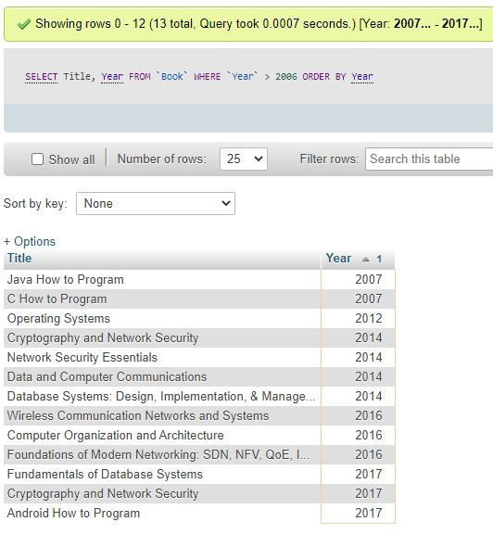

* List all the books published between 2012 and 2017.

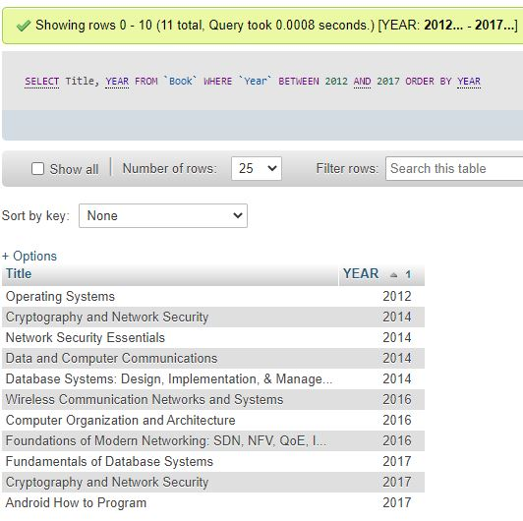Title Year

* List all the books and their authors.

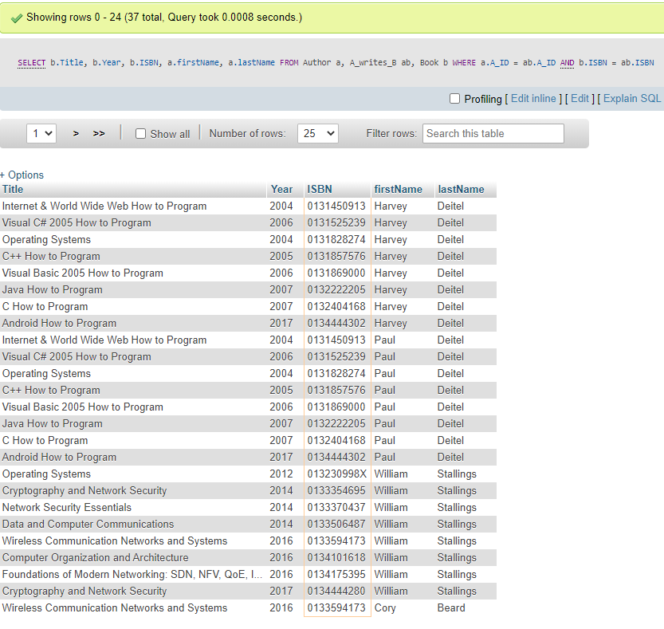Title Year Edition ISBN First Name Last Name

* List all the books authored or co-authored by "Paul Deitel".

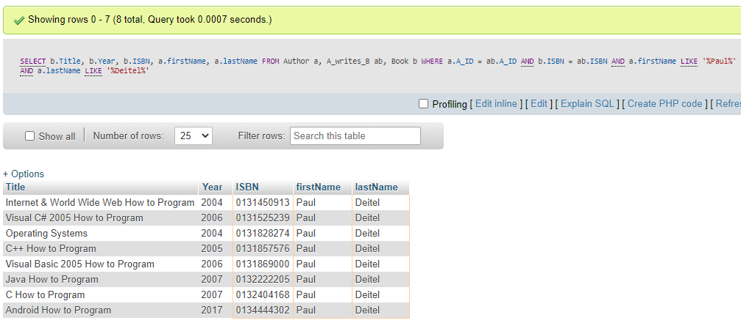Title Year Edition ISBN First Name Last Name

* List all the books authored or co-authored by "David Choffnes".

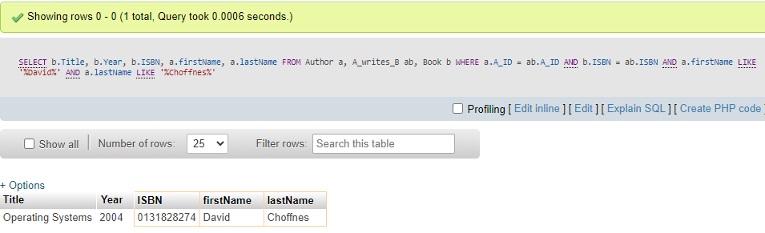Title Year Edition ISBN First Name Last Name

* List all the books authored or co-authored by "Abbey Deitel".

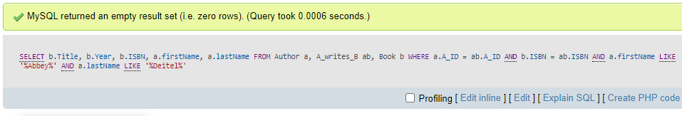Title Year Edition ISBN First Name Last Name

1. Issue the following SQL commands and discuss the result after the query is executed.
2. Add your name into the database as a new author.

I successfully inserted my name into the database as a new Author.

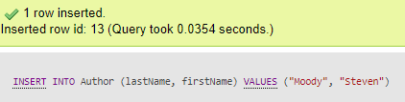

1. Add "Paul Deitel" as an author into the database. Were you able to execute it successfully? If yes, why? If not, what message did you get from MySQL? Why?

It did allow me to insert Deitel, Paul into the database as a new author. This is because even though the name repeats the primary key is set to A_id so both instances of Paul Deitel will always be unique.

1. Issue the following command to add a book into the database. Were you able to execute it successfully? If not, what message did you get from MySQL? Why?

INSERT INTO Book VALUES ("0131869000", "Invitation to Computer Science", 8, 2018);

It did NOT allow me to enter in the book within the above command. The error I got was #1062 - Duplicate entry '0131869000' for key 'PRIMARY'. This is because the Primary Key for the table ‘Book’ is the ISBN so each ISBN must be unique in order to qualify.

1. Issue the following command to add a book into the database. Were you able to execute it successfully? If not, what message did you get from MySQL? Why?

INSERT INTO Book VALUES ("1337561916", "Invitation to Computer Science", 8, 2018);

This did work, because even though it is the same book as the failed command above it now has an ISBN that is unique within the table thus it is not creating any conflict.

1. Issue the following query to the database. Were you able to execute it successfully? Should you be able to run this query? Why? Explain the meaning of this query and reason the problem that this query can cause if it is allowed to be executed.

INSERT INTO A_writes_B VALUES (100, "0137777000");

I was able to run this query. I believe I should have been able to run this query as the tables primary key is the combination of both A-id and ISBN and there were no other instances of this combination within the table. This query is inserting into the table ‘A_write_B’ the A-id value of 100 and the ISBN value of 0137777000, the only logical problem with this query is that there is no A_ID associated with the number 100 and no ISBN of that value and we were allowed to query these values, this allows for major errors being allowed within the query.

**Answer the following questions in your lab report:**

* What did you learn from this lab?

I learned more about DML commands and how SQL can be much faster and more efficient than excel. I learned the importance of having and using Primary_keys and allowing for many queries to be performed.

* What did you learn from Group 4 tasks in Part III of the lab?

Primary_Key is a great constraint however we need a further constraint on this to ensure that primary_Keys cannot be used in other tables without verifying they exist first (Foreign Keys).