**CSC263 Database Systems**

**Laboratory Assignment #3**

**Goals:** To learn the importance of relational database constraints.

**Objectives:** After successfully completing the lab, one should be able to

* use more MySQL SQL commands, such as, ALTER TABLE ADD …; etc.
* correctly set up a database including all necessary constraints

**Requirements:**

Use necessary SQL DDL commands to correct the database structure so that all the problems you experienced in the previous lab can be resolved. Note that you should first get rid of all the anomalies created in the database in the previous lab.

To avoid the anomalies, we need to establish what is called “Referential Integrity” constraints. A Referential Integrity constraint involves two relations. In the “linking table” we need to specify that its ISBN attribute must reference to the ISBN attribute in the “Book” table, and it’s A_ID attribute must reference to the A_ID attribute of the “Author” table.

Use the “ALTER TABLE … ADD …” to add the two Referential Integrity constraints.

Issue the following three queries to the database and discuss the results or messages returned by the DBMS.

1. Insert a tuple in the linking table that contains an existing ISBN and a non-existing Author ID

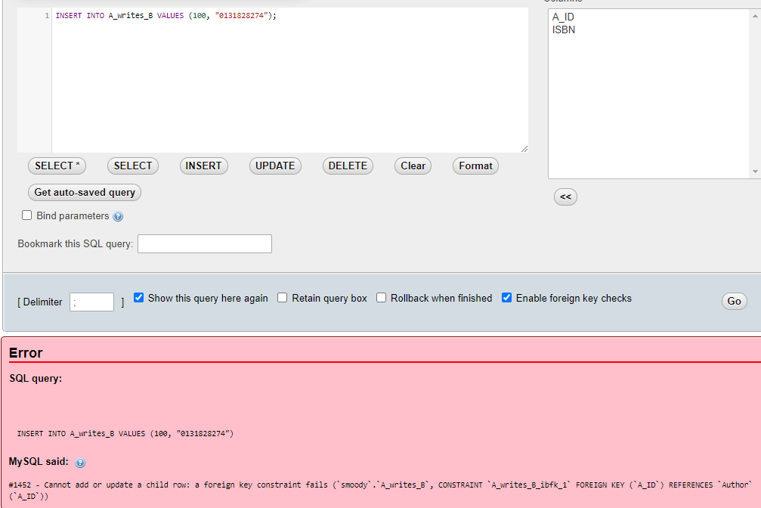

1. **Explanation: Even though the ISBN is known, The Author ID does not exist and due to the foreign key restraints this will not run.**
2. 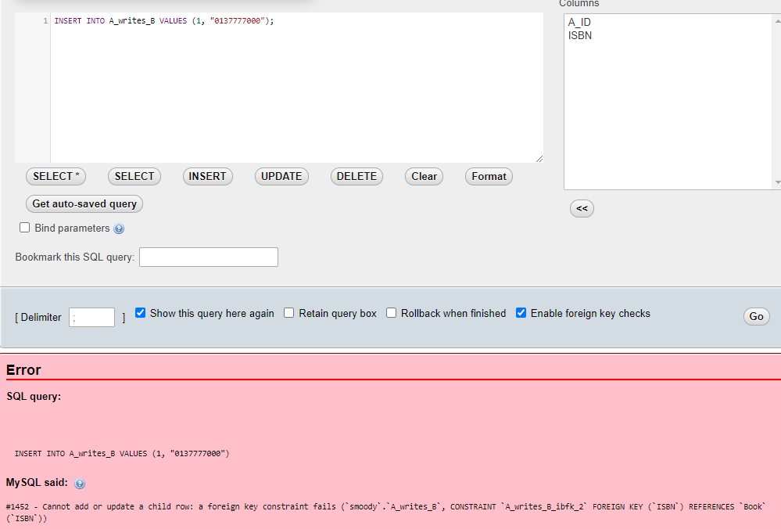Insert a tuple in the linking table that contains a non-exiting ISBN and an existing Author ID
3. **Explanation: Even though the Author ID is known, The ISBN does not exist within any table and due to the foreign key restraints this will not run.**
4. Delete Author table.

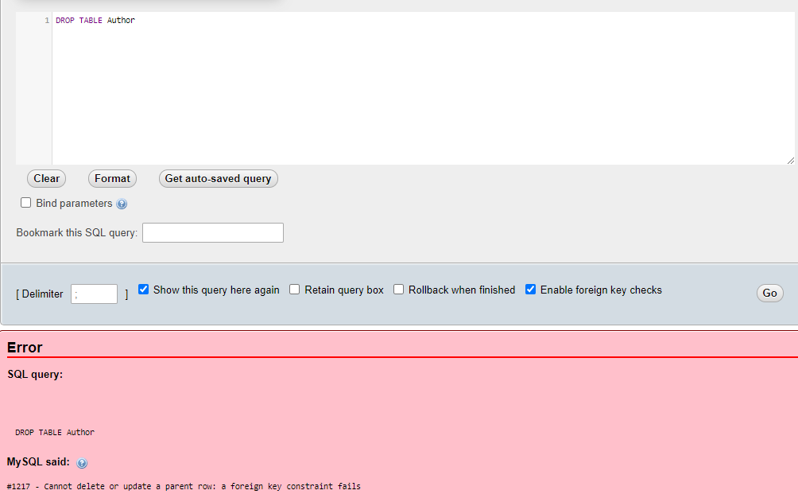

1. **Explanation: We cannot delete the author table because the foreign key constraint calls on an attribute within the Author Entity.**
2. Delete Book table.

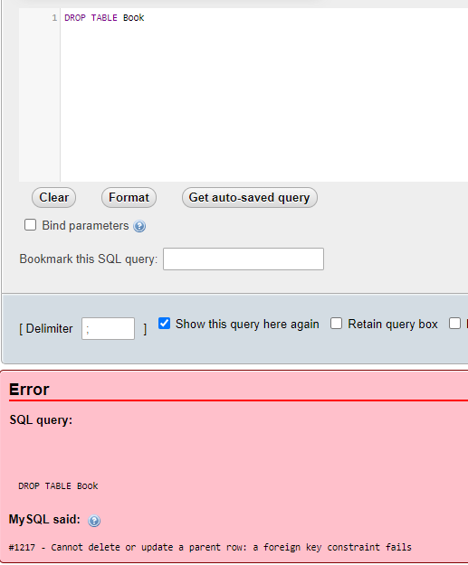

1. **Explanation: We cannot delete the author table because the foreign key constraint calls on an attribute within the Author Entity.**

**Submission Requirements: (submit the required items on class Canvas site)**

* Submit a lab report with all necessary screenshots.
* Write a summary of what you learned in this lab.

In this lab I learned the value of including foreign key constraints as well as the commands necessary to implement them.