**CSC263 Database Systems**

**Laboratory Assignment #5**

**Goals:** To learn and practice writing and executing basic SQL queries in MySQL.

**Objectives:** After successfully completing the lab, a student should be able to become better in writing basic queries in SQL.

**Requirements:**

1. In this lab you will learn to write and execute some basic SQL queries for a new database, “Ski New England”. “Ski New England” is a database that contains stores, manages and allows information retrieval on all New England ski resorts. It has the following schema.

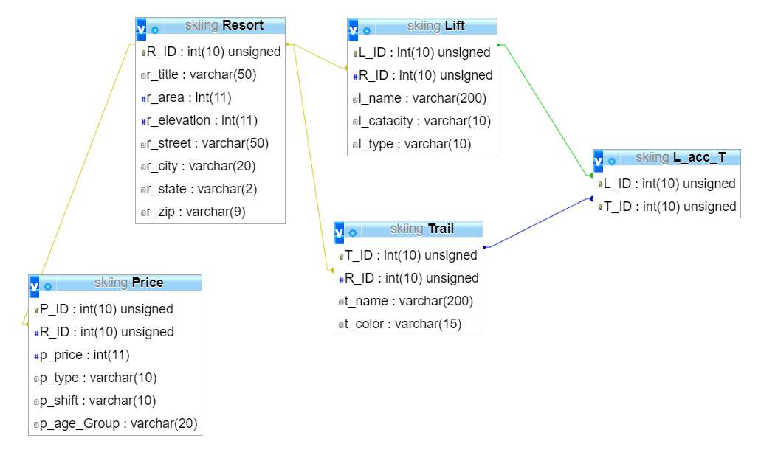

1. Follow the following instructions to establish the database. Take a screenshot of the list of tables after you establish the database in your account.
   1. Use phpMyAdmin to login to your database space.
   2. Establish the database by importing the given “skiNewEngland.sql” script.
   3. Check to make sure that you have the correct number of tuples in each table, i.e., 63 in “Resort”; 331 in “Lift”; 2558 in “Trails”; 252 in “Price”; 747 in “L_acc_T”
2. Write and execute the following queries. Make sure that you write (type out) each query in the lab report, and make sure that you take screenshot of the execution result of each query. The output of each query must follow the display format given, including the title names. When a query returns too many records that it is not practical to show them all, you only need to show the first 25 of them, but you must show the message that shows the total number of resorts returned.

**Query 1. List all ski resorts in New England in ascending order of the resort names (alphabetically).**

**Query Used: “ SELECT r_title As 'Resort Name', r_state As ' StateName' FROM `Resort`ORDER BY r_title ASC “**

|  |  |
| --- | --- |
| Resort Name | State Name |

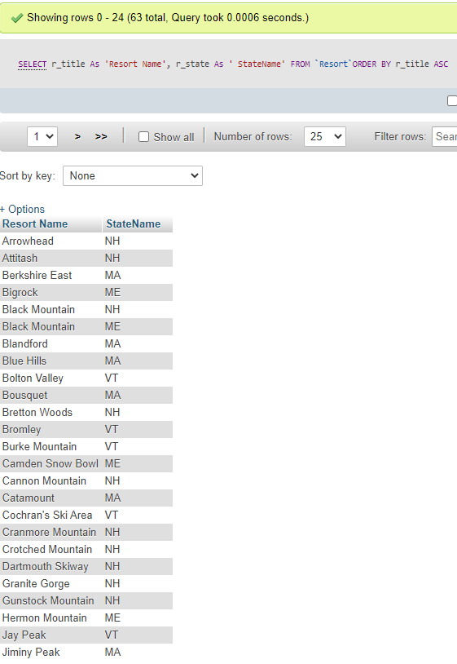

**Query 2. List all ski resort in New Hampshire in the ascending order of the resort names. Q: How many records were returned by this query?**

**Query Used: “ SELECT r_title As 'Resort Name', r_street As 'Street', r_city As 'City', r_zip As 'Zip Code' FROM `Resort` WHERE r_state LIKE '%NH%' ORDER BY r_title ASC ”**

**18 total returned (0-17)**

|  |  |  |  |
| --- | --- | --- | --- |
| Resort Name | Street | City | Zip Code |

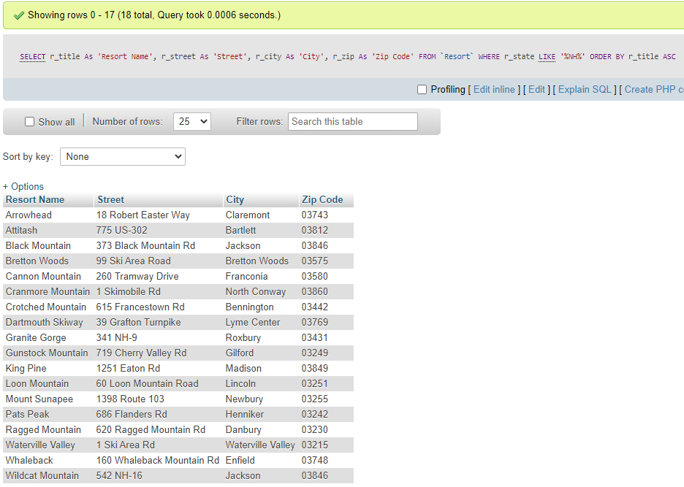

**Query 3. List all ski resorts in New England in the descending order of their elevations.**

**Query Used: “ SELECT r_title As 'Resort Name', r_elevation As 'Elevation' FROM Resort ORDER BY r_elevation DESC”**

|  |  |
| --- | --- |
| Resort Name | Elevation |

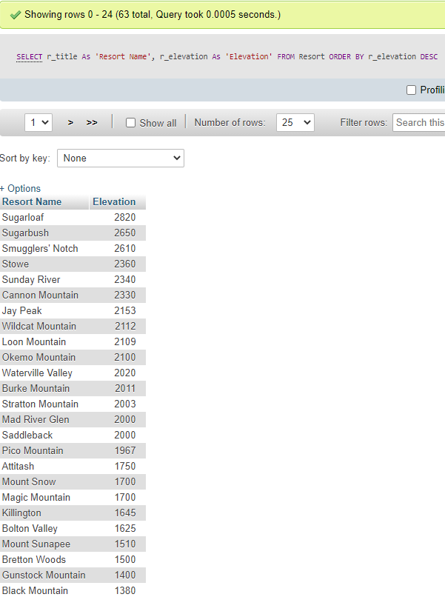

**Query 4. List top 10 largest ski resorts in New England in the descending order of their areas.**

**Query Used: “ SELECT r_title As 'Resort Name', r_area As 'Resort Area' FROM Resort ORDER BY r_area DESC LIMIT 10”**

|  |  |
| --- | --- |
| Resort Name | Resort Area |

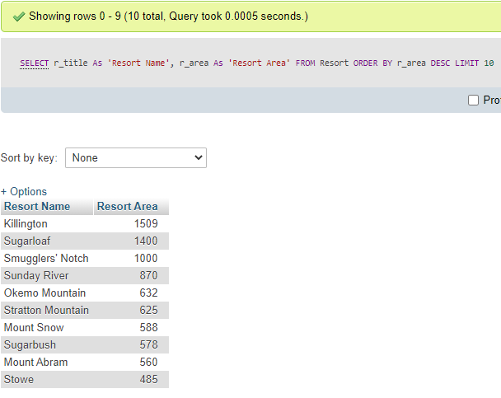

**Query 5. Find the ski resort in New England that has the highest elevation.**

**Query Used: “ SELECT r_title As 'Resort Name' , r_elevation As 'Highest Elevation' FROM Resort ORDER BY r_elevation DESC LIMIT 1”**

|  |  |
| --- | --- |
| Resort Name | Highest Elevation |

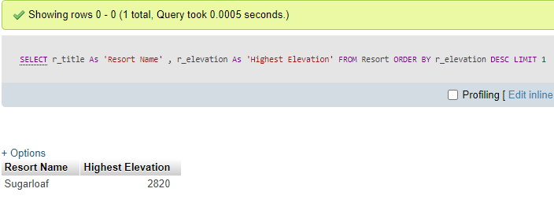

**Query 6. What is the area of the largest ski resort in New England? Output this area as:**

**Query Used: “ SELECT r_area As 'Largest Ski Resort Area in New England' FROM Resort ORDER BY r_area DESC LIMIT 1 ”**

|  |
| --- |
| Largest Ski Resort Area in New England |

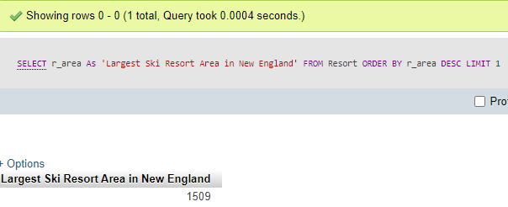

**Query 7. Which is the largest ski resort in New England?**

**Query Used: “SELECT r_title As 'Largest Ski Resort in New England' FROM Resort ORDER BY r_area DESC LIMIT ”**

|  |
| --- |
| Largest Ski Resort in New England |

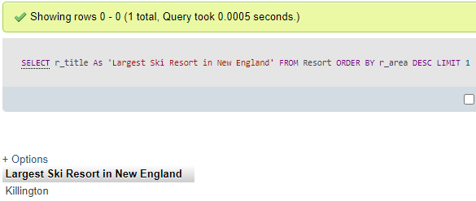

**Query 8. Find the smallest ski resort in New England. Print the ski resort name and its area.**

**Query Used: “SELECT r_title As 'Resort Name', r_area As 'Smallest Area' FROM Resort WHERE r_area IS NOT NULL ORDER BY r_area ASC LIMIT 1 ”**

|  |  |
| --- | --- |
| Resort Name | Smallest Area |

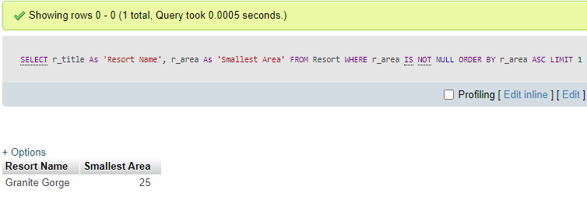

**Query 9. Count and display the number of ski resorts New England.**

**Query Used: “SELECT COUNT(R_ID) As 'Total Number of Ski Resorsts in New England' FROM Resort ”**

|  |
| --- |
| Total Number of Ski Resorts in New England |

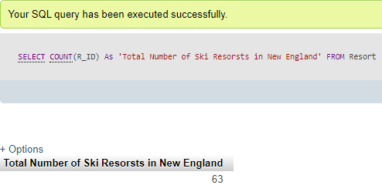

**Query 10. Count and display the number of ski resorts in each state of New England.**

**Query Used: “SELECT r_state As 'State', COUNT(R_ID) As 'Total Number of Ski Resorsts in New England' FROM Resort GROUP BY r_state ORDER BY r_state ASC ”**

|  |  |
| --- | --- |
| State | Total Number of Ski Resorts in State |

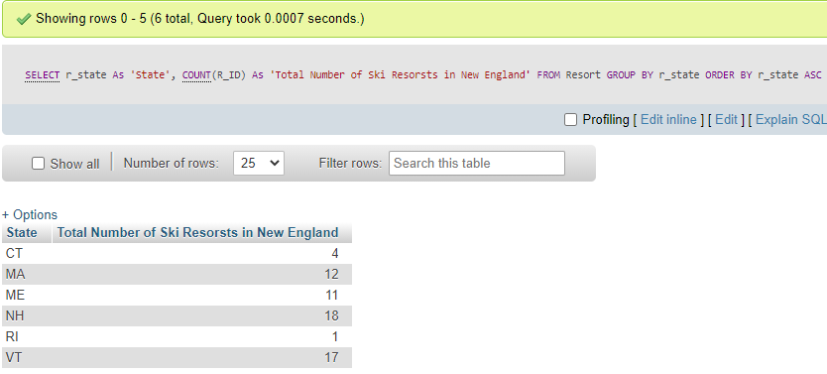

**Query 11. In ascending order of resort names, list all information on prices for all ski resorts in New England. Use the following display format.**

**Query Used: “ SELECT a.r_title As 'Resort Name', b.p_shift As 'Day', b.p_type As 'Type', b.p_age_Group As 'Age Group', b.p_price As '$$$' FROM Resort a, Price b WHERE a.R_ID = b.R_ID ORDER BY a.r_title ASC ”**

|  |  |  |  |  |
| --- | --- | --- | --- | --- |
| Resort Name | Day | Type | Age Group | $$$ |

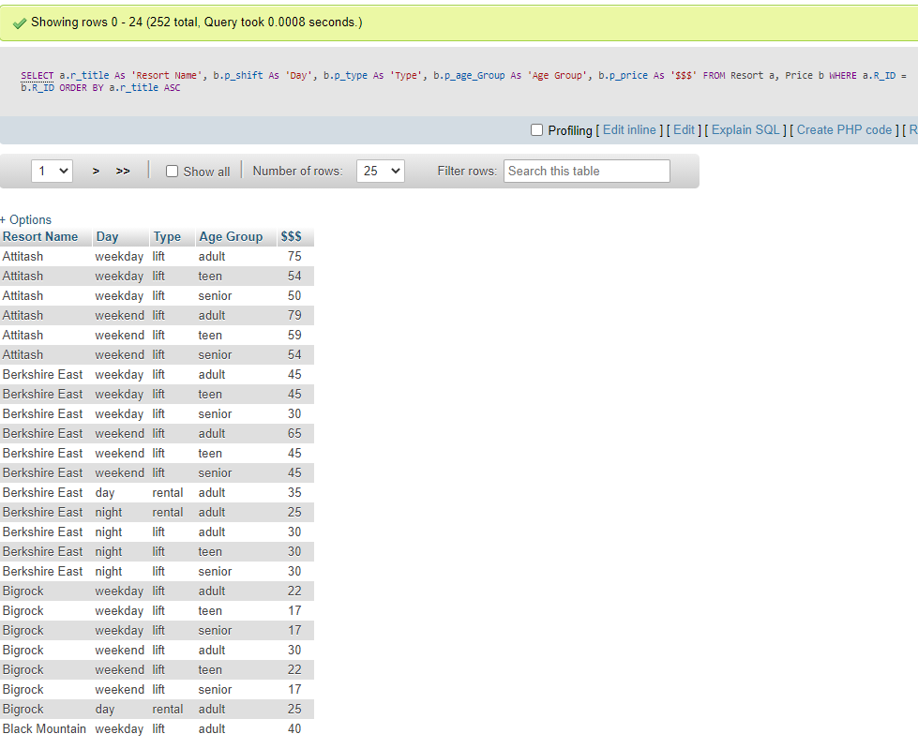

**Query 12. In ascending order of resort names, list the adult day and weekend lift ticket prices for all ski resorts in New England. Use the following display format. How many records were returned by this query?**

**Query Used: “ SELECT a.r_title As 'Resort Name', b.p_shift As 'Day', b.p_price As '$$$' FROM Resort a, Price b WHERE a.R_ID = b.R_ID AND b.p_age_Group LIKE '%adult%' AND b.p_shift LIKE'%day%' OR b.p_shift LIKE '%weekend%' ORDER BY a.r_title ASC ”**

|  |  |  |
| --- | --- | --- |
| Resort Name | Day | $$$ |

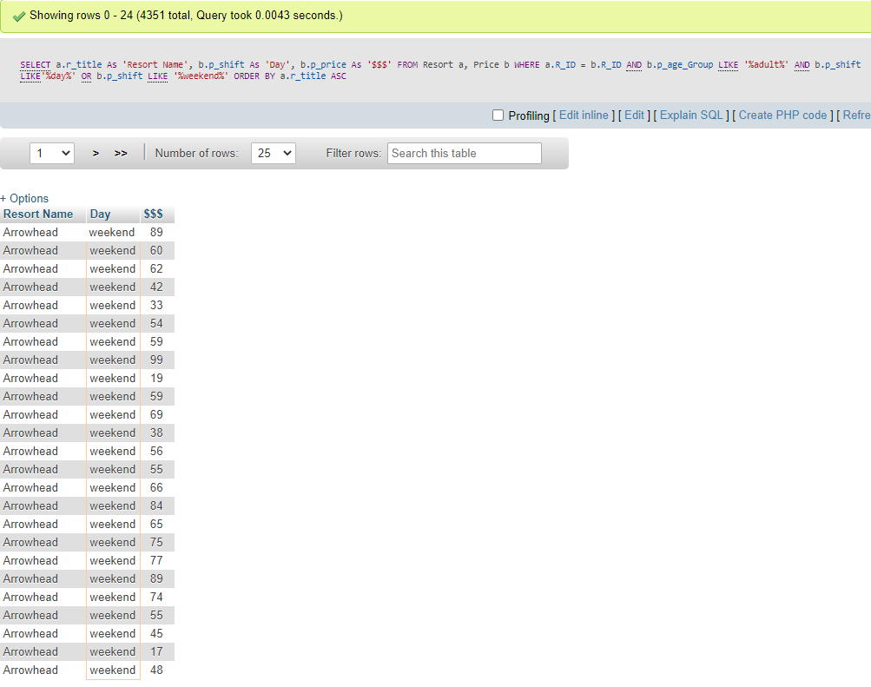

**Query 13. In ascending order of resort names,, list all ski resorts’ weekend lift ticket prices for teenagers.**

**Query Used: “ SELECT a.r_title As 'Resort Name', b.p_price As '$$$' FROM Resort a, Price b WHERE a.R_ID = b.R_ID AND b.p_age_Group LIKE '%teen%' AND b.p_shift LIKE '%weekend%' ORDER BY a.r_title ASC ”**

|  |  |
| --- | --- |
| Resort Name | $$$ |

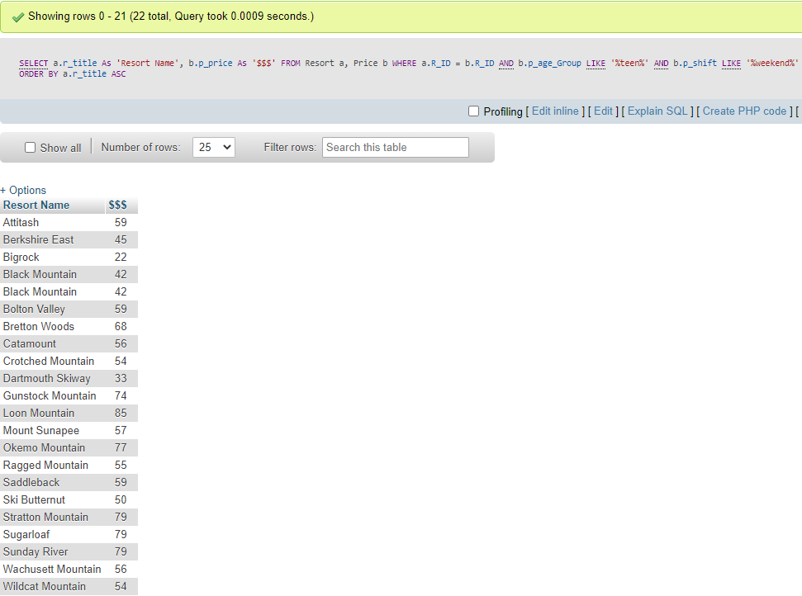

**Query 14. Which ski resort has the most expensive lift ticket for adult any day?**

**Query Used: “ SELECT a.r_title As 'Most Expensive Resort', b.p_price As '$$$' FROM Resort a, Price b WHERE a.R_ID = b.R_ID AND b.p_age_Group LIKE '%adult%' ORDER BY b.p_price DESC LIMIT 1 ”**

|  |  |
| --- | --- |
| Most Expensive Resort | $$$ |

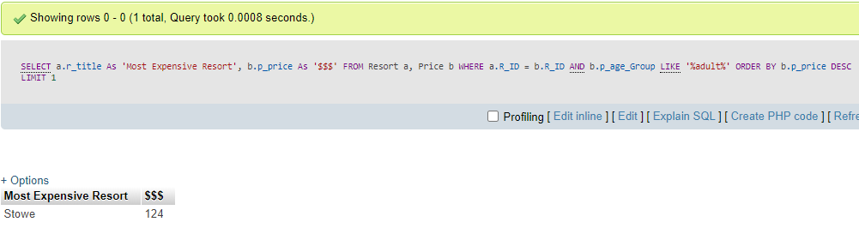

**Query 15. What are the average, most expensive and least expensive lift tickets in New England?**

**Query Used: “SELECT AVG(b.p_price) As 'Average Lift Ticket',MAX(b.p_price) As 'Most Expensive List Ticket', MIN(b.p_price) As 'Least Expensive Lift Ticket' FROM Resort a, Price b WHERE a.R_ID = b.R_ID ”**

|  |  |  |
| --- | --- | --- |
| Average Lift Ticket | Most Expensive Lift Ticket | Least Expensive Lift Ticket |

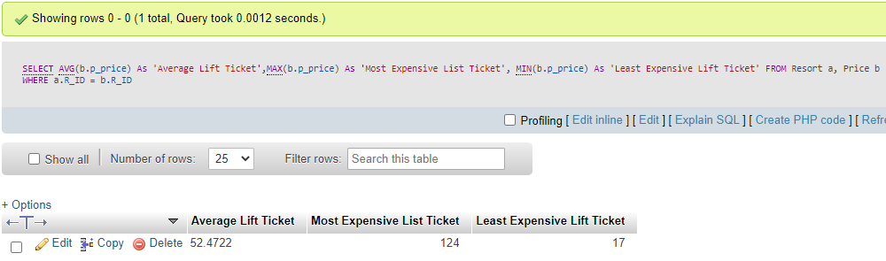

**Query 16. What are the average, most expensive and least expensive lift tickets in Vermont?**

**Query Used: “ SELECT AVG(b.p_price) As 'Average Lift Ticket',MAX(b.p_price) As 'Most Expensive List Ticket', MIN(b.p_price) As 'Least Expensive Lift Ticket' FROM Resort a, Price b WHERE a.R_ID = b.R_ID AND a.r_state LIKE '%VT%' ”**

|  |  |  |
| --- | --- | --- |
| Average Lift Ticket | Most Expensive Lift Ticket | Least Expensive Lift Ticket |

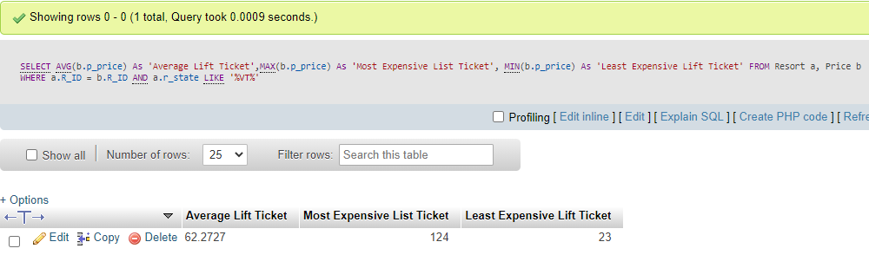

**Query 17. Display the blue trails in Stowe resort. How many records were returned by this query?**

**Query Used: “ SELECT a.t_name As 'Blue Trails in Stowe' FROM Trail a, Resort b WHERE a.R_ID = b.R_ID AND a.t_color LIKE '%blue%' AND b.r_title LIKE '%Stowe%' ”**

**64 results total**

|  |
| --- |
| Blue Trails in Stowe |

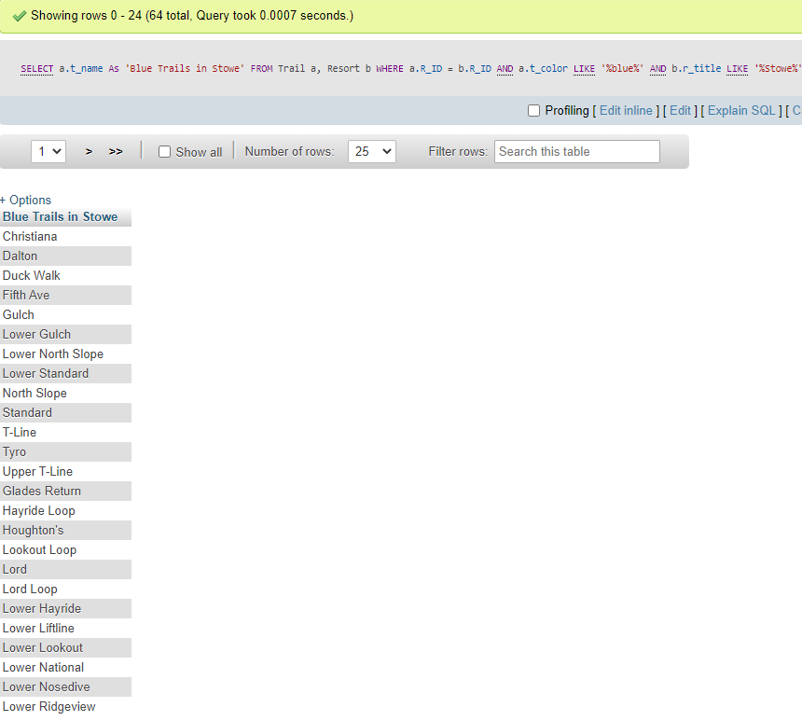

**Query 18. List the resorts and the number of lifts for each resort. The list should be in the order of the resort with most number of lifts to the resort with the least number of lifts. How many records were returned by this query?**

**Query Used: “ SELECT a.r_title As 'Resort Name', COUNT(b.R_ID) As 'Number of Lifts' FROM Resort a, Lift b WHERE a.R_ID = b.R_ID GROUP BY a.r_title ORDER BY COUNT(b.R_ID) DESC ”**

**37 Records Returned**

|  |  |
| --- | --- |
| Resort Name | Number of Lifts |

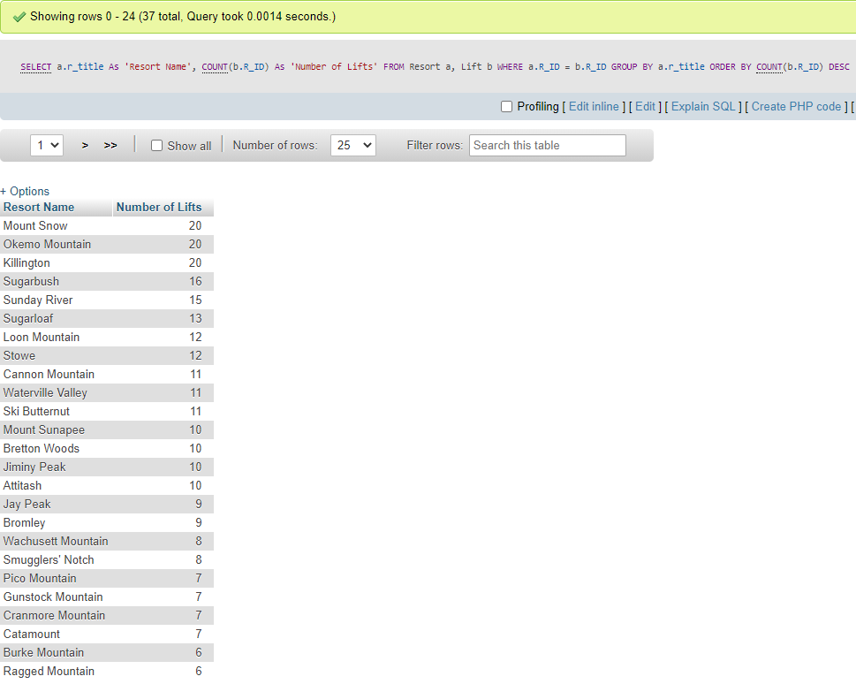

**Query 19. List complete information of all the resorts in Maine with lifts and trails.**

**Query Used: “ SELECT a.r_title As 'Resort Name', b.t_name As 'Trails', c.l_name As 'Lifts that can reach the trail' FROM Resort a, Trail b, Lift c, L_acc_T bc WHERE b.T_ID = bc.T_ID AND c.L_ID = bc.L_ID AND a.r_state LIKE '%ME%'”**

|  |  |  |
| --- | --- | --- |
| Resort Name | Trails | Lifts that can reach the trail |

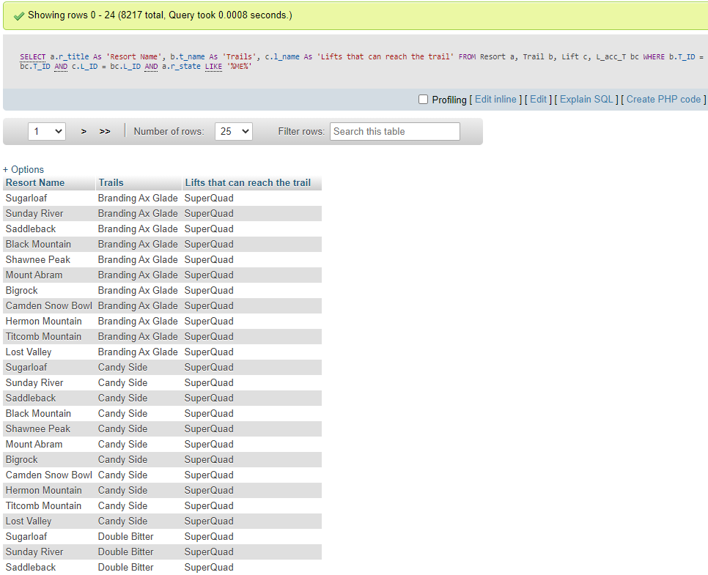

**Query 20. List all the resorts in New England with each resort’s all the lifts and the number of trails reachable from each lift. Display the result in ascending order of alphabetical order the resorts names.**

**Query Used: “ SELECT a.r_title As 'Resort Name', b.l_name As 'Lift Name', COUNT(c.t_name) As 'Number of trails reachable from each lift' FROM Resort a, Lift b, Trail c, L_acc_T bc WHERE b.L_ID = bc.L_ID AND c.T_ID = bc.T_ID GROUP BY a.r_title, b.l_name ORDER BY a.r_title ASC”**

|  |  |  |
| --- | --- | --- |
| Resort Name | Lift Name | Number of trails accessed by the lift |

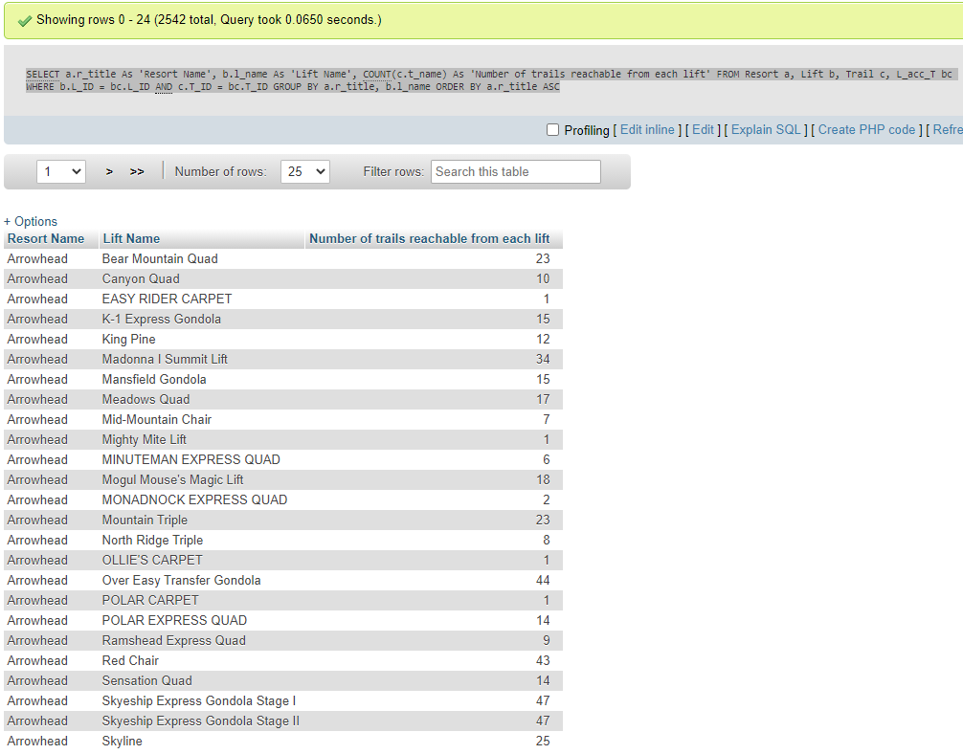

**Submission Requirements:**

* Submit a lab report (in .pdf format) that contains ALL your Lab 5 activities, including your answers and discussions for all the queries.
* Write a summary of what you learned in this lab.
  + I learned about the various SELECT commands. I also learned more about how to run advanced queries on a database as well as how to modify title values using the “As” command. I furthered my knowledge on combining columns of databases and how to ensure accuracy when doing so.