**CSC263 Database Systems**

**Laboratory Assignment #7**

**Database Connectivity and Web Technology - PHP Programming and MySQL**

**Lab Objectives**

* To practice connecting to and retrieving data from MySQL database hosted on a MySQL server.
* To learn how to build a very simple UI using html/PHP technology on the server side.
* To practice communicating with a database via a very simple UI.

**Part I: (5 pts)**

**Connect to a database from a browser and displays the retrieved information based on the following requirement.**

“In alphabetical order of their last name, retrieve the required information of all employees in the company.”

You must display the result in a tabular format with table heading like:

|  |  |  |
| --- | --- | --- |
| **Last Name** | **First Name** | **Salary** |

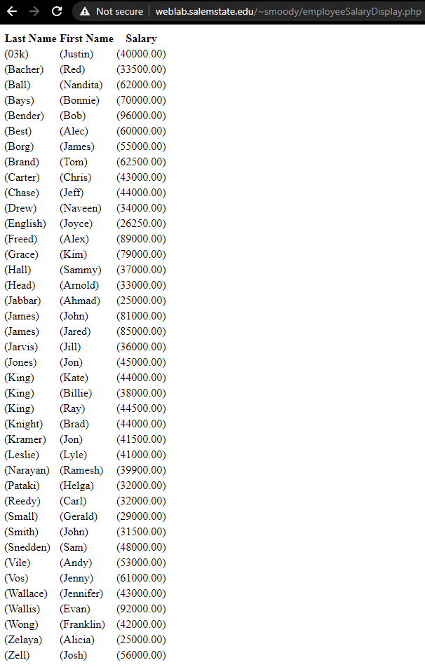

URL: http://weblab.salemstate.edu/~smoody/employeeSalaryDisplay.php

**Part II: (7 pts)**

**To use HTML/PHP technology to build a simple UI that displays the retrieved information based on the following requirement.**

“In alphabetical order of the last names, retrieve the required information of ALL employees in the company. For each employee, display the project name and hours worked on the project, the department he/she works in and the his/her manager’s last name.” (Note that you need to list ALL employees including those who do not work on any project at the current time.)

You must display the result in a tabular format with table heading like:

|  |  |  |  |  |  |
| --- | --- | --- | --- | --- | --- |
| **Last Name** | **First Name** | **Project Name** | **Hours Worked** | **Department Name** | **Manager Last Name** |

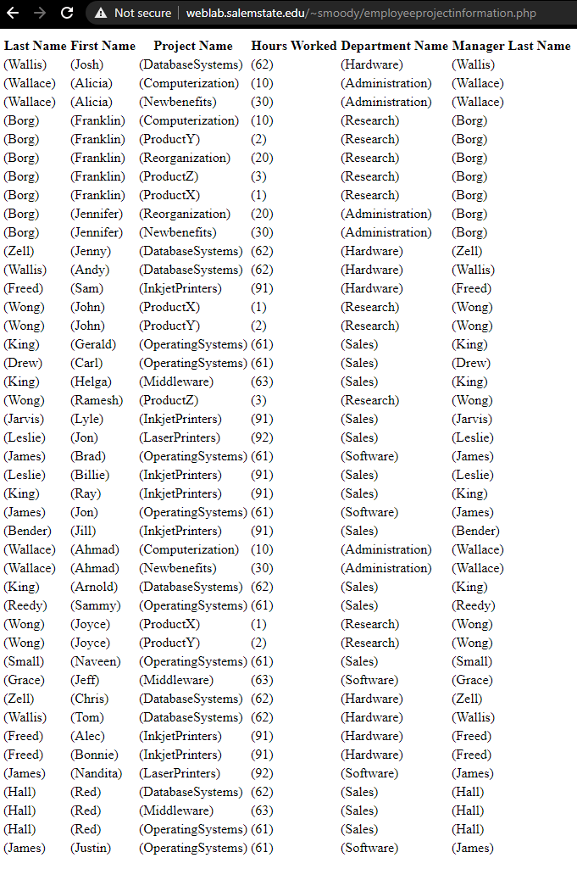

URL: http://weblab.salemstate.edu/~smoody/employeeprojectinformation.php

**Part III: (12 pts)**

**To use HTML/PHP technology to build a simple UI that displays the retrieved information based on the following requirement.**

1. Provide an option for an end-user to choose a specific employee ID among all employees in the company.

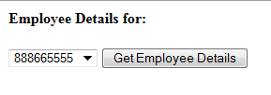

1. After receiving the selected employee ID from the user choice, display the following required detailed information of that chosen employee.

**Employee Last Name:**

**Employee First Name:**

**Dependent Name:**

**Relationship:**

Note that some employee may have more than 1 dependent and some may have none. You need to display correct information for any case.

I did this a little different, but I believe it is better. I used an index.php file to allow a user to search any ssn, then used a different .php file to display the information.

Search:

http://weblab.salemstate.edu/~smoody/index.php



Displayed information: http://weblab.salemstate.edu/~smoody/employeesearch.php?query=987654321

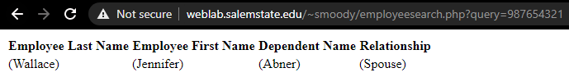

**Part IV: (16 pts) Build a simple UI that allows a user (1) to specify a base salary value, (2) to choose a department, (3) to specify a percentage among [in decimal] of salary increase. After receiving these information from a user, perform a salary increase by the percentage specified for all employees in that specified department whose salary are below the specified base value.**

For this part of the lab report, you must:

* present at least two cases (two different departments with different specified values),
* take screenshots of the user input on your UI,
* display before the salary increase and after the salary increase to prove that the information is indeed updated (You can do this part via phpMyAdmin interface), and
* show the results of the trigger fired by this action.

I was not able to do this, I did try an alternative for which my code is on the weblab server and zipped in this submission. My URLs were

<http://weblab.salemstate.edu/~smoody/index2.php>

http://weblab.salemstate.edu/~smoody/employeesaldepartmentsearch.php

Submission Requirements:

1. A Lab Report
2. For each part, submit the following required materials.

(1) The URL to your working site where I can perform testing of all requirements.

(2) All of your source code.