CSC263 Database Systems

Midterm Examination
Part II – Written (Max = 60 pts)

Name: _Steven Moody_________ Score: ______________/ 60
Instructions:
- Closed Book
- You must show your work to receive credit
~~~~~~~~~~~~~~~~~~~~~~~~~~~~~~~~~~~~~~~~~~~~~~~~~~~~~~~~~~~~~~~~~~~~~~~

- (25 pts) Multiple-Choice Questions

  - A database is an organized collection of ___Logically___ related data.
    - logically
    - physically
    - loosely
    - badly

  - The term ___Tuple____ is used to refer to a row.
    - Attribute
    - Tuple
    - Field
    - Instance

  - Data that describe the properties of other data are:
A) relationships.
B) logical.
C) physical.
D) none of the above.

  - Database __Schema________ , which is the logical design of the database, and the database __Instance_____,which is a snapshot of the data in the database at a given instant in time.
    - Instance, Schema
    - Relation, Schema
    - Relation, Domain
    - Schema, Instance

  - D The tuples of the relations can be of __Any______ order.
    - Any
    - Same
    - Sorted
    - Constant

  - The The most commonly used operation in relational algebra for projecting a set of tuple from a relation is
    - Join
    - Select
    - Projection
    - Union
  - An entity type whose existence depends on another entity type is called a __Weak______ entity.
    - strong
    - weak
    - codependent
    - variant

  - An attribute that can be broken down into smaller parts is called a(n) ___Composite_____ attribute.
    - associative
    - simple
    - composite
    - complex

  - The following figure shows an example of:
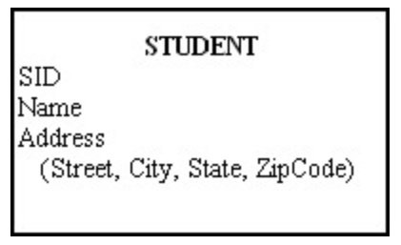
    - a composite attribute.
    - a relational attribute.
    - a derived attribute.
    - a multivalued attribute.

  - An attribute in a relation of a database that serves as the primary key of another relation in the same database is called a:
A) link attribute.
B) link key.
C) foreign key.
D) foreign attribute.

  - In the figure below, which attribute is multivalued?

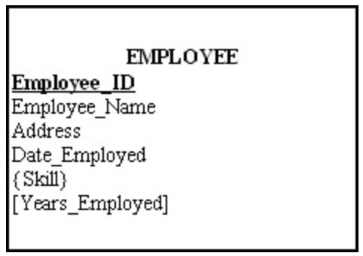

    - Years_Employed
    - Employee_ID
    - Skill
    - Address

  - The number of entity types that participate in a relationship is called the:
    - number.
    - identifying characteristic.
    - degree.
    - counter.

  - The entity integrity rule states that:
A) each entity must have a primary key.
B) referential integrity must be maintained across all entities.
C) a primary key must have only one attribute.
D) no primary key attribute can be null.

  - Which are the two ways in which entities can participate in a relationship?
    - Passive and active
    - Total and partial
    - Simple and Complex
    - All of the above

  - For like predicate which of the following is true.
- % matches zero of more characters.
- _ matches exactly one character.

- i only
- ii only
- Both of the mentioned
- None of the mentioned

  - Create domain YearlySalary numeric(8,2)
constraint salary value test __________;
In order to ensure that an instructor’s salary domain allows only values greater than a specified value use:
a) Value>=30000.00
b) Not null;
c) Check(value >= 29000.00);
d) Check(value)

  - Which _____ clause is an additional filter that is applied to the result.
- Select
- Group-by
- Having
- Order by

  - A ________ specifies the number of instances of one entity that can be associated with each instance of another entity.
    - degree
    - cardinality constraint
    - counter constraint
    - limit

  - A The attribute AGE is calculated from DATE_OF_BIRTH . The attribute AGE is
    - Single valued
    - Multi valued
    - Composite
    - Derived

  - In the figure below, what type of key is depicted?

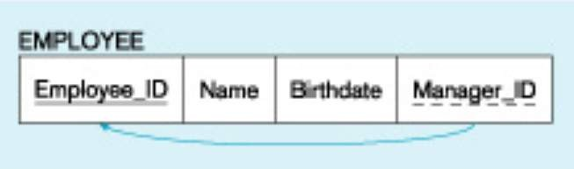

A) Primary
B) Recursive primary
C) Composite
D) Recursive foreign

  - Given Which of the following can be a multivalued attribute?
    - Phone_number
    - Name
    - Date_of_birth
    - All of the mentioned

  - Which of the following can be addressed by enforcing a referential integrity constraint?
    - All phone numbers must include the area code
    - Certain fields are required (such as the email address, or phone number) before the record is accepted
    - Information on the customer must be known before anything can be sold to that customer
    - Then entering an order quantity, the user must input a number and not some text (i.e., 12 rather than ‘a dozen’)

  - The entity set person is classified as student and employee .This process is called
    - Generalization
    - Specialization
    - Inheritance
    - Constraint generalization

  - Given the basic ER and relational models, which of the following is INCORRECT?
    - An attribute of an entity can have more than one value
    - An attribute of an entity can be composite
    - In a row of a relational table, an attribute can have more than one value
    - An entity may be related to the entity itself

  - Conceptual design
    - Is a documentation technique.
    - Needs data volume and processing frequencies to determine the size of the database.
    - Involves modelling independent of the DBMS.
    - Is designing the relational model.
- (8 pts) Short-answer Questions
  - Explain why we prefer to choose a primary key that has the characteristic of “no change over time”. Use example(s) to support your explanation.

We use a primary key that has the characteristics of “no change over time” because that is the unique key identifier within an entity that we can use to always ensure a unique identity to each value within than entity. For example, if we had an employee entity and had the attributes of Social security number, name, and department then Social security number would be the best option for a primary key. This is because many employees can have the same first/last name so in using that we could return incorrect values when running queries and could also create a conflict within out database. We also couldn’t use Department for the very same reason, however a social security number is guaranteed to be unique to every single person in America and would never repeat thus we can ensure that the identity of our entity is true.

  - Explain recursive relationships with the help of an example.

Recursive relationships are essentially when an entity shares a relationship with itself. The best example I can give of this is one I recall from a previous homework where we had an employee entity whose shared relationship was “Supervise”. This is because while all members of a company are considered employees, some of those employees are responsible for supervising other employees so even though they all fall under one entity it is important to create a recursive relationship to ensure we know there is a separation amongst them to identify who is a manager and who is not.

- (13 pts) You are to design a database system for an Attorneys at Law business. Complete the conceptual design based on the following set of business rules. Represent your design using an ER diagram.

- An attorney is retained by one or more clients for each case.
- Attributes of attorney are attorney identification, name, address, city, state, zip code, specialty (may be more than one), and bar (may be more than one).
- A client may have more than one attorney for each case
- Attributes of client are client identifier, name, address, city, state, zip code, telephone, and date of birth.
- A client may have more than one case.
- Attributes of case are case identifier, case description, and case type.
- An attorney may have more than one case.
- Each case is assigned to one and only one court.
- Attributes of court are court identifier, court name, city, state, and zip code.
- Each court has one or more judges assigned to it.
- Attributes of judge are judge identifier, name, and years in practice.
- Each judge is assigned to exactly one court.

Your ER model should be based on these business rules.

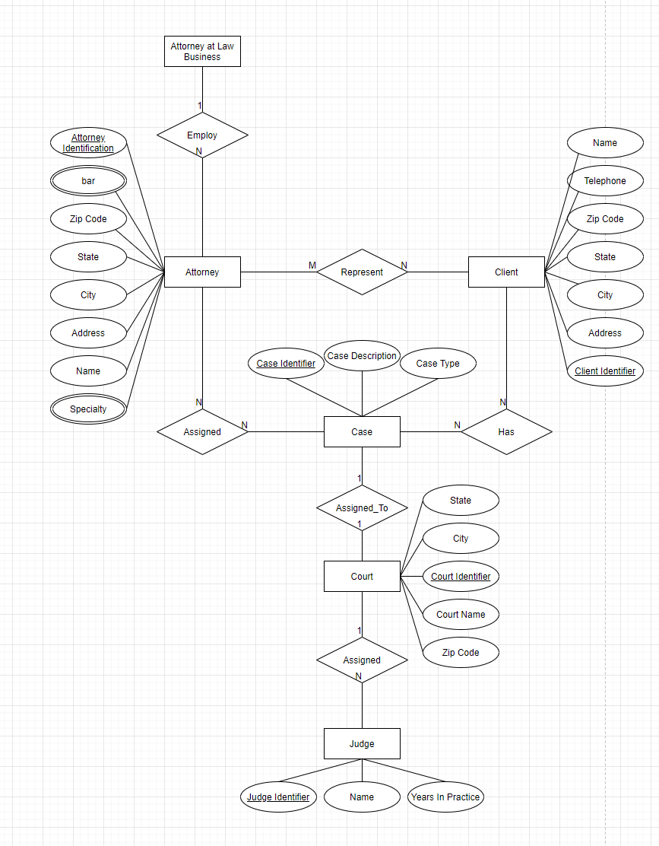

- (14 pts) Consider the following E-R diagram, which shows the conceptual model of an information system for a movie database. Map this E-R diagram to a relational database schema. Include all intra- and inter-relational dependencies and constraints.

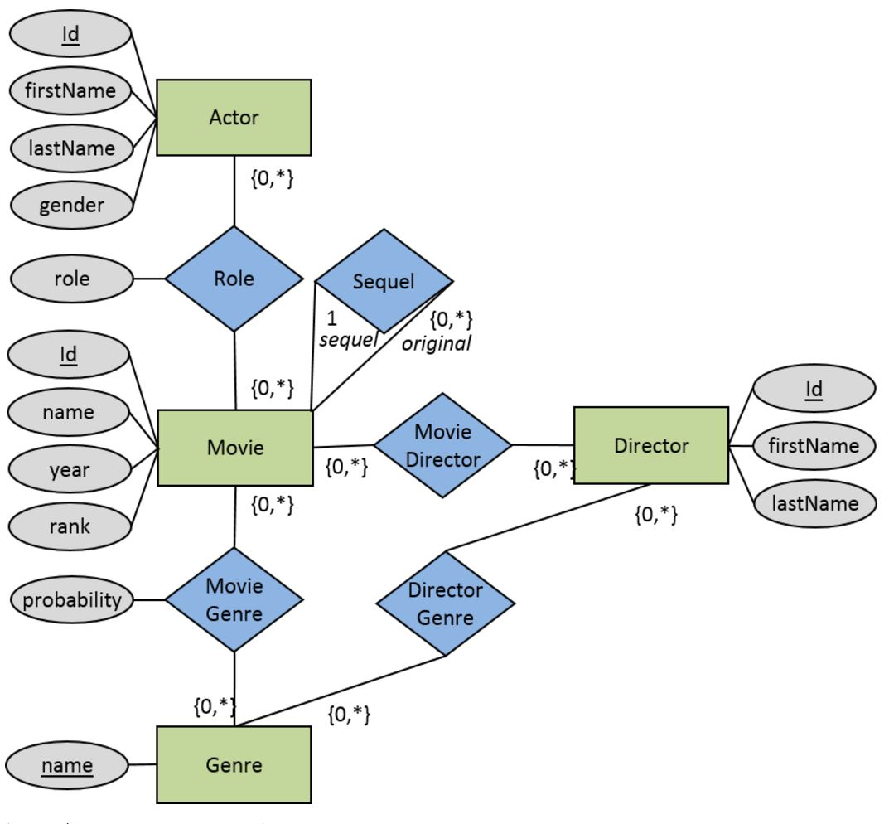

See screenshot below:

