**CSC263 Database Systems**

**Homework Assignment #2**

**Conceptual Design**

**Answer the following questions. You should use class textbook as a reference for your answers.**

1. Define/Discuss each of the following terms:

|  |  |  |  |  |
| --- | --- | --- | --- | --- |
| E-R Model | Key | Superkey | Primary Key | Composite Key |
| Surrogate Key | Foreign Key | Relationship Cardinality | Entity Integrity | Referential Integrity |
| deductive database system | persistent object | data model | database schema | database state |
| One-to-one Relationship | One-to-many Relationship | Total Participation | entity | attribute |
| Composite attribute | multivalued attribute | derived attribute | degree of a relationship | attribute value |

**E-R Model-** ER model stands for Entity Relationship model and our book states that it is a very popular data model. It is used to help visually represent data on a particular topic and show the relationships between said data.

**Surrogate Key-** A surrogate key is a key that is specifically defined and created, rather than a key that would be naturally defined from data.

**deductive database system**- A deductive Database System is a Database system that is able to derive certain “facts” about the data within the database system through “interpreting rules”.

**One-to-one Relationship**- A one-to one relationship is a term used when two entities have a relationship to each other in which each entity only has one relationship instance to the other.

**Composite attribute**- A composite attribute is an attribute that can be further defined and divided

**Key**- A key is a term used to describe a piece of data that is used to identify each entry within an entity of a database.

**Foreign Key-** A foreign key is a key that is used to create a link between two relating tables.

**Persistent object-** A persistent object is one that is permanently stored and saved within the database.

**One-to-many Relationship-** One-to many relationship is a relationship type in which one instance of an entity has many relationship instances with another entity that only shares one unique relationship instance in return.

**Multivalued attribute-** A multivalued attribute is an attribute that can hold more than one value at any given time.

**Superkey-** Similarly to “key”, A Superkey is a compilation of attributes that can uniquely identify a row within a database.

**Relationship Cardinality**- Relationship Cardinality is a term used when describing the relationship type between entities. For example, 1:1 is a relationship cardinality that denotes a one-to-one relationship.

**Data Model-** A data model is a visual aid in which the data is modelled in a conceptual way to show the structure of a database.

**Total Participation-** Total participation is a term that describes an entity in which each instance must be related to another entity.

**Derived Attribute**- A derived attribute is a term used when an attribute only exists due to being derived from other attributes.

**Primary Key-** A primary key is a key that is unique to each entry, such that it cannot be repeated.

**Entity Integrity-** Entity integrity is a constraint that specifies that any primary key value cannot be null and must specify a value.

**Database Schema-** A database schema is a description of the database structure using a modeling language.

**Entity-**An entity as described by our book is an “object with an independent existence”. In practice an example of an entity would be students going to a school, with their attributes being various information about them.

**Degree of a relationship-** the degree of a relationship is the total number of instances of an entity that are interacting with another.

**Composite Key-** These are keys that can contain multiple attributes and not just multiple values.

**Referential Key-** Referential Key is a term used to describe a constraint that specifies whenever a foreign key is used, it must be referencing a valid foreign key.

**Database state-** Database state is a term used to describe the current state of a database in a conceptual way at any given specific time.

**Attribute-** An attribute is a subset of an entity that is used to describe that entity. For example if we have an entity “STUDENTS” some attributes may be “first_Name”, “last_Name”, etc.

**Attribute Value-** an Attribute value is a value given to each instance of an attribute. For example, the value of “first_Name” may be “John”.

1. What are the differences among the **Relational Model**, the **Object Model**, and the **XML Model**?

**The relational model is based on relationships formed between entities and has related data stored together. The Object Model on the other hand is primarily used with object-oriented programming and relies on class hierarchies, with little-no relation. Lastly the XML Model, while similar to the object model, uses trees to organize data and is “self-describing” as our book states, where the data and its description are stored in the same location.**

1. Cardinality ratios often dictate the detailed design of a database. The cardinality ratio depends on the real-world meaning of the entity types involved and is defined by the specific application. For the following binary relationships, suggest cardinality ratios based on the common-sense meaning of the entity types. Clearly state any assumptions you make.
2. STUDENT ______________ SOCIAL_SECURITY_CARD

**There is a 1:1 ratio between STUDENT and SOCIAL_SECURITY_CARD**

1. STUDENT ______________ TEACHER

**I am assuming that this is per class, so this would be a M:1 ration between STUDENT and TEACHER due to the fact that each instance of a class is only taught by one teacher but each class can have many students.**

1. CLASSROOM ______________ WALL

**I am basing this on each instance of a classroom being unique, so this is a 1:M ratio between CLASSROOM and WALL, each classroom is only one of itself but contains multiple walls.**

1. COUNTRY ______________ CURRENT_PRESIDENT

**Based on the description, I would say this is a 1:1 ratio between COUNTRY and CURRENT_PRESIDENT.**

1. COURSE ______________ TEXTBOOK

**I am assuming here that each COURSE is unique, so I would say there is a 1:1 ratio assuming that each course only requires a single textbook.**

1. ITEM (that can be found in an order) ______________ ORDER

**I am assuming here that an order can contain multiple items that repeat, so I would say there is a M:1 ratio.**

1. STUDENT ______________ CLASS

**Here I am assuming that each class can have multiple iterations and so I would say this relationship is a M:N ratio as each class can have multiple iterations as well as each class can contain many students.**

1. CLASS ______________ INSTRUCTOR

**I am going to assume here that again each class can have multiple iterations, which can be taught by different teachers so I would say this is a M:N ratio.**

1. INSTRUCTOR ______________ OFFICE

**I am assuming here that the entity OFFICE is indicating a personal office, so the ratio here would be a 1:1 ratio where each Instructor has their own private office.**

1. EBAY_AUCTION_ITEM ______________ EBAY_BID

**This would be a 1:M ratio where each eBay Item is a unique instance but can have many bids.**

1. Consider the ER diagram shown below for part of a BANK database. Each bank can have multiple branches, and each branch can have multiple accounts and loans.
2. List the strong entity types in the ER diagram.

**The strong entity types are “BANK”, “ACCOUNT”, “LOAN”, and “CUSTOMER”**

1. Is there a weak entity type? If so, give its name, partial key, and identifying relationship.

**The weak entity type is “BANK_BRANCH”, partial key is “Branch_no”, and its identifying relationship is “BRANCHES”.**

1. What constraints do the partial key and the identifying relationship of the weak entity type specify in this diagram?

**Well, we can see here that the same Branch number can occur at different banks, we also see that each Branch number and Code specifies an identifier for the bank branch.**

1. List the names of all relationship types, and specify the (min, max) constraint on each participation of an entity type in a relationship type. Justify your choices.

Rel. Type Entity min,max Entity

**BRANCHES**: **BANK 1:N BANK_BRANCH**

**ACCTS: BANK_BRANCH 1:N ACCOUNT**

**LOANS: BANK_BRANCH 1:N LOAN**

**A_C: ACCOUNT M:N CUSTOMER**

**L_C: LOAN M:N CUSTOMER**



1. 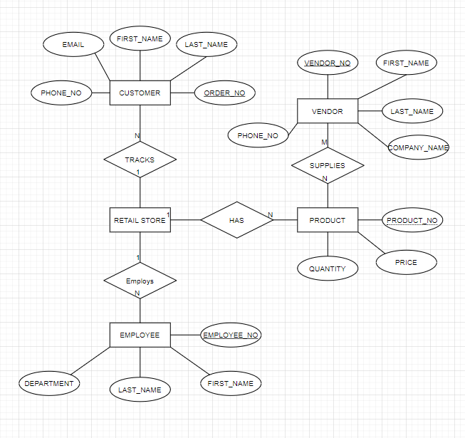Perform a conceptual design for a Retail Store. It needs to keep track of its customers’ information. A customer makes orders. An order may contain one or more products that a customer orders. The store needs to also keep track of its vendors’ information. A vendor supplies products to the store. Show your design with an ERD. Make all necessary assumptions. Your ERD must be as detailed as possible.
2. Based on the following description of operations, create the appropriate fully labeled ERD in both Chen’s Notation and Crow’s Foot Notation.

An insurance company wants to maintain a database containing the following information relating to its automobile policies:

* Each policy applies to exactly one car, but several people may be listed as drivers under the policy. A person may be listed under several policies.
* People are identified by their social-security numbers, and have names and addresses; cars are identified by their registration numbers, and have model names and years.
* Each policy has an identifying number and a list of coverage types (such as collision, comprehensive, damage to others’ property, etc.); for each coverage type the policy has a maximum amount of coverage and a deductible.
* The database also contains information about accidents covered by each policy. For each accident, the company needs to know the car and driver involved, as well as the date of the accident and the total amount of money paid out.

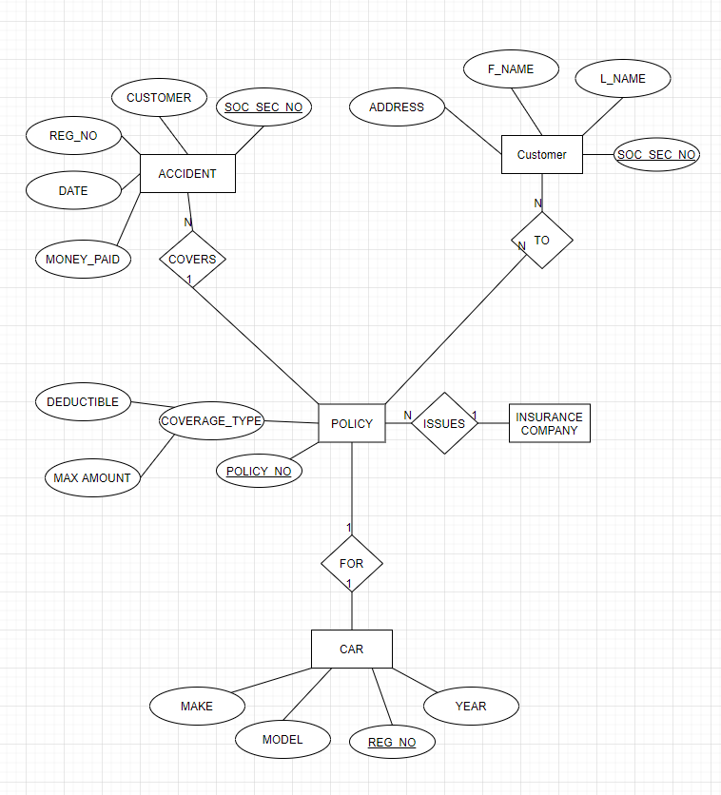**CHEN DIAGRAM:**

**CROW’S DIAGRAM:**

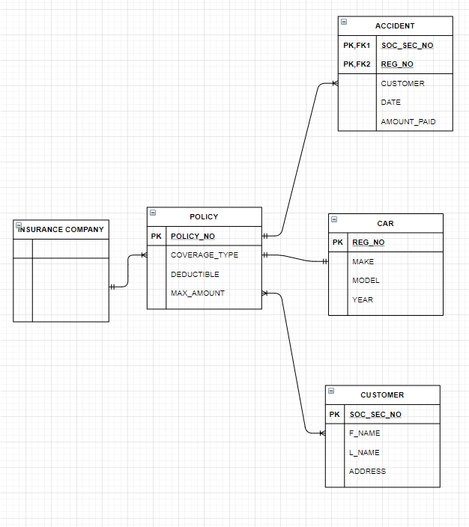

1. Convert the following COMPANY conceptual ERD to an ERD represented in Crow’a Foot Notation.



**Crow’s Foot**

