**CSC263 Database Systems**

**Homework Assignment #3**

Database System Development Lifecycle

**Logical Database Design: from ER to Schema**

**Problem 1 – From ER Diagram to Schema**

The ABC Hotel plans to create a database system to keep track of the information about their room types, guests, and reservations.

ABC Hotel has several room types. Each room type has a unique name (such as Standard, Duplex, Queen, and King), a rental price, and number of rooms. ABC assigns each guest who has made a reservation at ABC Hotel a unique guest number. ABC also wants to record the guest’s name (first name, last name) and email address. Some old guests are granted a “VIP” title. ABC Hotel keeps track of the special preference (e.g., “close to elevator”, “breakfast delivery”, etc.) of a VIP guest and offers her a little gift upon her future arrivals.

Guests may reserve room types over phone, via travel agencies, or on the Internet. ABC is very interested in analyzing the reservations by different origins (“phone”, “travel agency”, and “online”).

Each reservation is allocated a unique confirmation number. The total rental fee of a reservation is computed based on the rental price of the room type and the duration (consisting of arrival date and departure date) of the reservation. Each reservation is made by exactly one guest for exactly one room type. But a guest may make many reservations for many room types.

ABC Hotel allows at most a 5% over-reservation. The number of reservations for each room type can be at most 5% more than the number of rooms of that type at any time. After the limit of a room type has been reached, new reservations for that type will be denied.

After performing conceptual design for the given case, we can generate both an ER diagram and a specification that includes additional constraints not shown on the diagram. The specification is written in English.

1. Translate the conceptual schema (ER diagram) into a logical schema. Do not make any assumptions about the real world except those encoded in the E-R diagram. Be sure to specify keys and constraints for all relations.
2. What if the requirement has the following change: “Each reservation is made by exactly one guest and can be for one or more room type”, what changes would you make to the logical schema you already obtained in (1)? You only need to show the changes.

Constraints:



* The origin of a reservation must be one of “phone”, “travel agency”, and “online”.
* The number of reservations for each room type can be at most 5% more than the number of rooms of that type at any time.

1. **I am not sure how to list the constraints in a logical schema in the way I did for the midterm so I will list the tables and then explain the constraints and keys.**

**Guest**

|  |  |  |  |
| --- | --- | --- | --- |
| **Guest#** | **firstName** | **lastName** | **Email** |

**Guest would be the primary key**

**Reservation**

|  |  |  |  |  |  |
| --- | --- | --- | --- | --- | --- |
| **Confirm#** | **Origin** | **ArrivalDate** | **DepartureDate** | **Rental** | **RoomType** |

**Here, Confirm# would be the primary key, because duration is a multivalued attribute there are two columns for it.**

**RoomType**

|  |  |  |
| --- | --- | --- |
| **Name** | **Price** | **Rooms** |

**Name would be the primary key**

**VIP**

|  |  |
| --- | --- |
| **Guest#** | **Preference** |

**Here, Guest# would be the primary key as well as a foreign key**

**Make**

|  |  |
| --- | --- |
| **Guest#** | **Confirm#** |

**This extra table is needed because of the type of relationship that is shared**

**Constraints:**

**Check constraints would be needed for the Origin column in reservation as well as another check constraint to ensure that the proper percentage of rooms are being met.**

1. **The changes I would make are to introduce a new table that would further track what type of rooms the customer is renting as well as a check to ensure that only one guest is making the reservation. I would change the RoomType attribute in the Reservation table and then make RoomType its own entity that would then be used by Reservation.**

**Problem 2 -** Translate the conceptual schema (ER diagram) into a logical schema. Do not make any assumptions about the real world except those encoded in the E-R diagram. Be sure to specify keys and constraints for all relations.

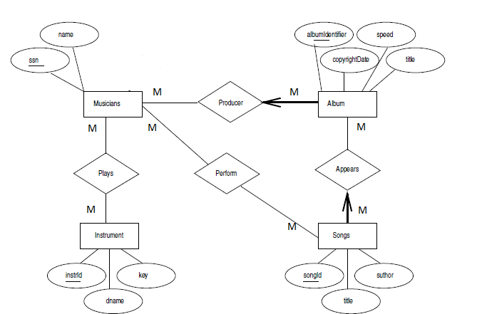

**See answer on next page**

