**User Story Requirement:**  
A name matching service is to be built that matches the Buyer names with Owner names.  
This service extracts up to first 4 characters of the last name from File A (Buyer) to File B (Owners).  
  
If there is a match, the flag is IsNameMatched is set to true.

Below is a sample scenario of 2 test files in JSON format.

**1. Compile all questions regarding this logic.  
2. Make your own assumptions to document a test plan with test cases, test scenarios and additional test data or files to perform positive, negative and edge case testing with expected IsNameMatched values.**

FileA.json

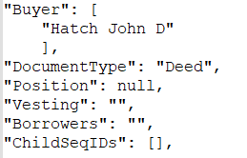

FileB.json

