# **Physics Destroyer Manual**

* **Prerequisites**:
  + JRE is required in order to run the program.
* **Downloading the Physics Destroyer Application**

1. In your browser, go to the GitHub repo for the project. This can be found [here](https://github.com/stevecatherman/sophomore-project/blob/master/Physics%20Destroyer%20V1.0.zip).
2. Click on the download button in the right corner to start the download.
3. When the download is completed, extract the zip and run the .exe inside.

* **Using the Calculator**
  + The Physics Destroyer Calculator with 9 variables. Fill in any known variables in the “Variable Entry” column text boxes and press the calculate button.

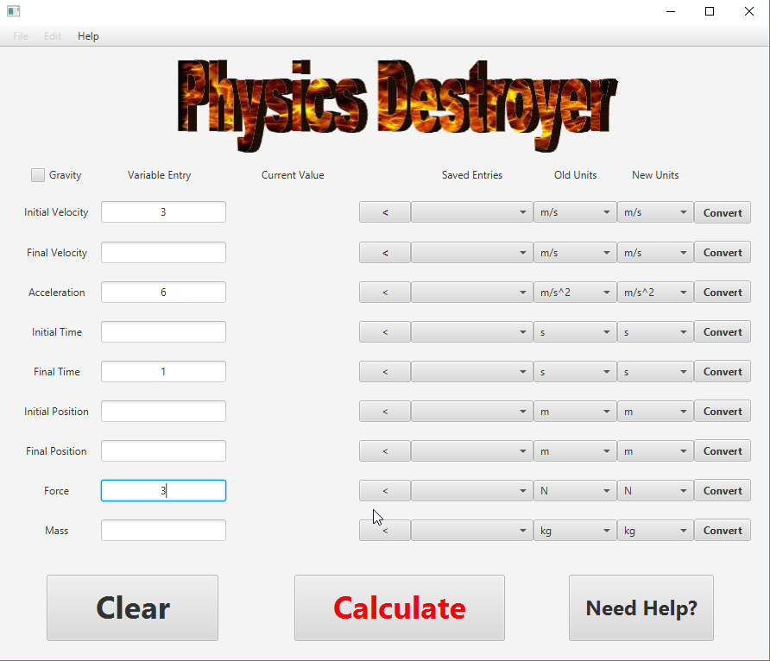

* + The solved values will appear to the right of the variable under the “Current Value” column. The variable values will be saved in the “Saved Entries” column, which can be used again for input by selecting the entry from the drop down list and selecting the arrow to the left of it.

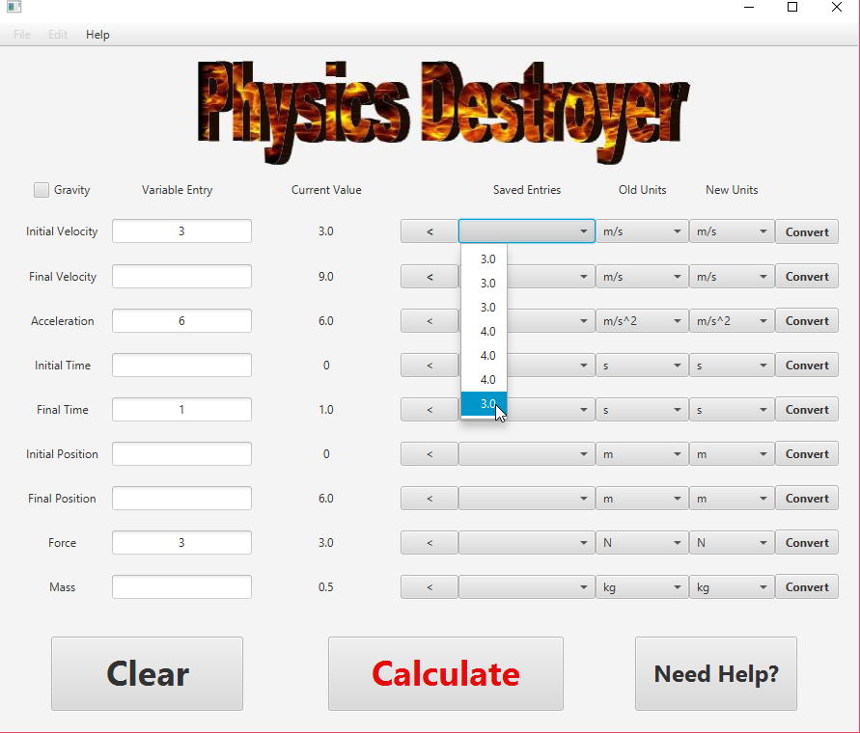

* **Converting Units**
  + Units can be converted by selecting a unit from the “New Unit” dropdown and selecting the convert button. The new value will overwrite the existing value.

