Project Name

Physics Calculator App – “Physics Destroyer” (Placeholder name)

Team Members

Product Owner - Dustin Bramos

Scrum Master - Steve Catherman

Developer - Chris Wiegand

Developer - Matthew Peace

Developer - Steven Jazrawi

Application Goal

A physics calculator to help students find all possible missing variables, from the known variables they enter.

Product Backlog and Sprint Schedule

Sprint 0 (May 9 - May 16)

* Set up communication tools, and learn how to use them

Sprint 1 (May 16 - May 23)

* Create list of variables and formulas
* Create simple GUI
* Get simple code working with limited number of variables

Sprint 2 (May 24 – June 6)

* Revise, improve, and expand code
* Get sample recursive method working
* Get code integrated into GUI

Sprint 3 (June 6 - June 20)

* Get expanded code working recursively
* Finalize GUI design
* Incorporate units

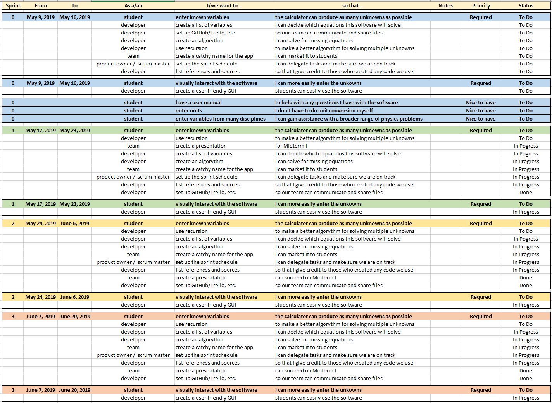

Challenges

1. Getting sharing resources, and communication channels set up, and learning how to use them.

* We read articles, watched videos, and learned through trial and error.

Images of Tools

**Discord** used to share files, links, and for voice communication:

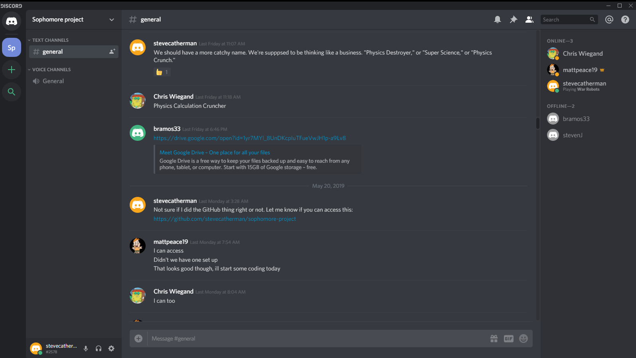

**Google Drive** used to store and share data:

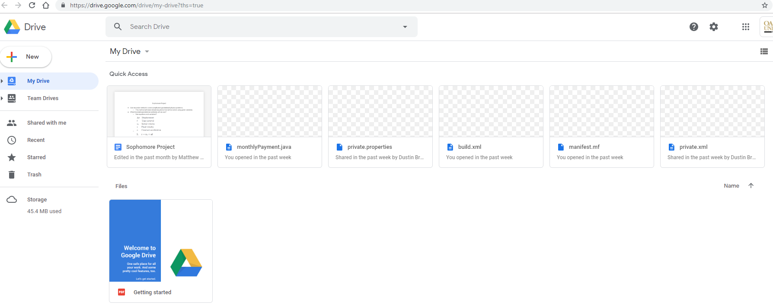

**Google Doc** used to set up initial plans for Sprint 0:

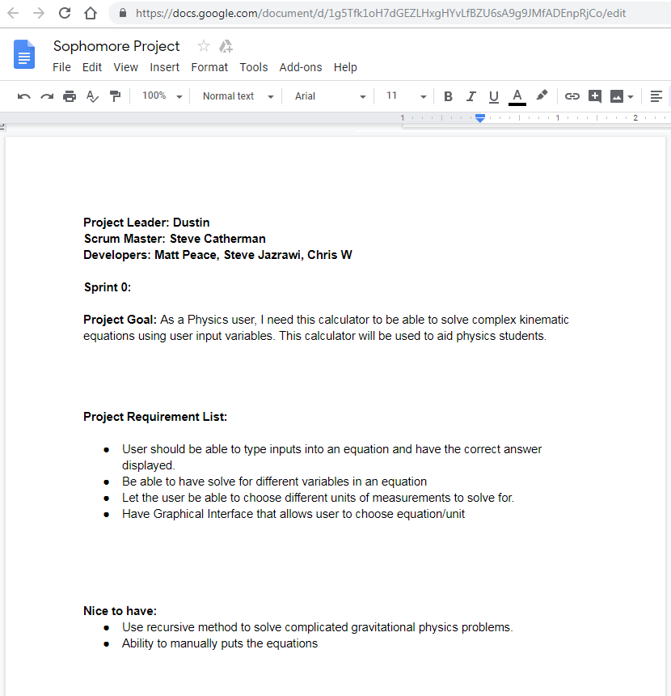

**Trello** Board used to manage tasks:

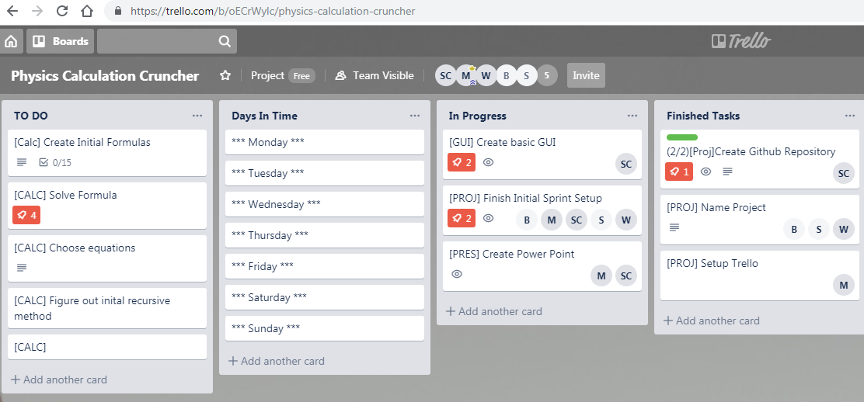

**GitHub** used to share and manage code versions:

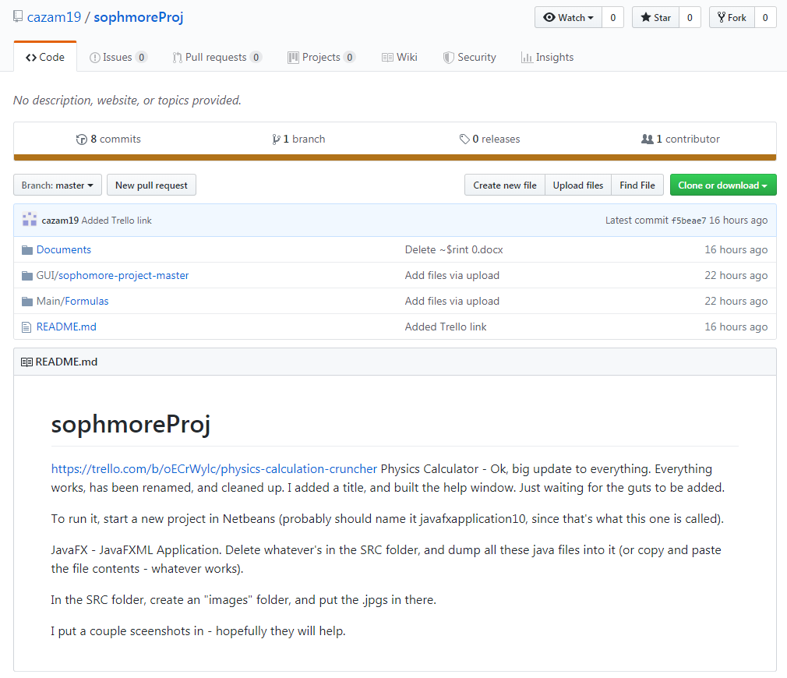

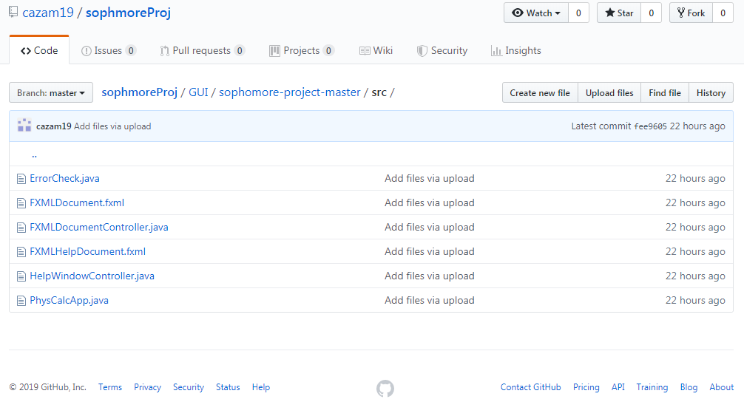

List of references used, so far:

1. John Damien Smith, at coderanch.com

* Copied code to set up drop down boxes for variable units
* https://coderanch.com/t/649781/java/Set-values-ChoiceBox-created-Scene