**Practical –1**

**Aim:** write a program in c to find an element in array using linear search

**Code:**

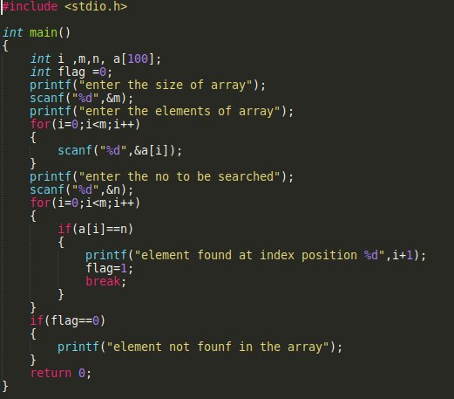

**Output:**

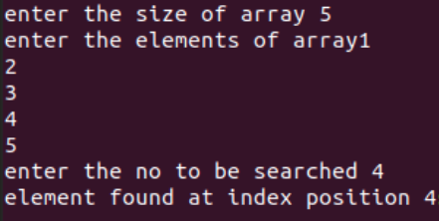

**Practical –2**

**Aim:** write a program in c to find an element in array using binary search

**Code:**

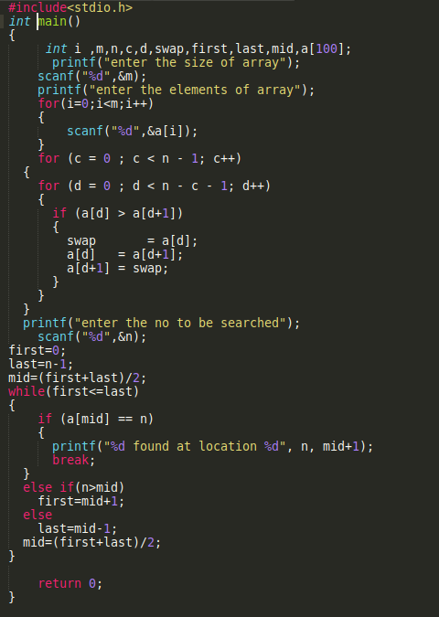

**Output:**

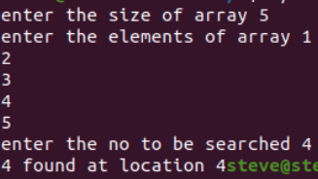

**Practical –3**

**Aim:** write a program in c to sort the elements in an array using insertion sort

**Code:**

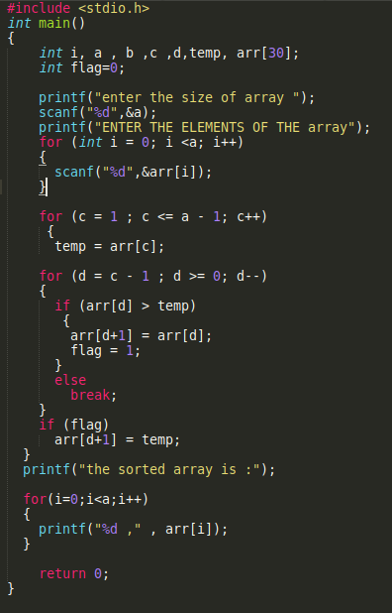

**Output:**

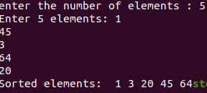

**Practical - 4**

**Aim :** write a program in c to sort the elements in an array using selection sort

**Code:**

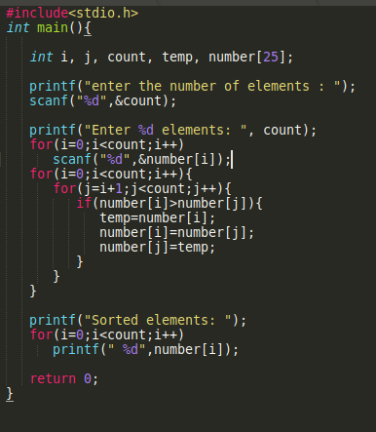

**Output:**

