Workforce Intelligence and Organizational Performance Analysis
Roblox Africa Operations (Ghana Hub)
Insight-Driven Analysis Report
Stage 9 · Project Deliverable — named in the brief as “Insight driven analysis report” · 8 August 2026
What this report is for
This report explains, in plain words, what we found when we looked closely at Roblox Africa's workforce data. No special training is needed to read it. Every number in here was checked, and every finding is written as one plain sentence you can act on — not just a number sitting on its own.

1. Why this report exists
Think of it like this. Over the last five years, Roblox Africa has been hiring people, training them, paying them, and looking after their health cover. Every one of those activities got written down — but each one got written down in its own separate notebook. One notebook for who works where. One for what they studied. One for their pay. One for their health cover. One for how well each person did each year. One for how well each department did each year.
Nobody had ever put all those notebooks side by side and actually read them together. So nobody could answer simple questions like: are we spending money in the right places? Is the person we hired actually doing the job their training prepared them for? Are we quietly building up a health risk we haven't noticed yet?
That is the whole job of this project. Take the seven separate notebooks, line them up so they tell one story, and read out what that story actually says.
2. What we actually did, step by step
Nothing in this report is a guess. Here is exactly how we got from seven messy files to the findings below.
Step 1 — We read everything first
Before changing a single number, we opened all seven files and just looked. How many rows. How many columns. What each column meant. This is like counting how many sheep you have before you decide anything about the flock.
Step 2 — We went hunting for mistakes
Every big pile of data has mistakes hiding in it — blanks where a number should be, a person listed twice, an age that makes no sense. We found 21 of these on purpose, wrote every single one down with the exact record it belonged to, and did not fix a single one until we knew exactly what was wrong.
Step 3 — We asked the client, then we cleaned
Six of those problems could only be fixed by Roblox itself — for example, nobody but Roblox could tell us a missing person's real age. We wrote a formal email asking, got real answers back, and only then applied every fix. Every single change we made is written down in a log, so anyone can see exactly what we changed and why, months from now.
Step 4 — We glued the right things together, and kept the wrong things apart
This is the part that is easiest to get wrong, so we want to explain it clearly. Five of our seven files each have exactly one row per person — one row for you, one row for the next person, and so on. Those five glue together safely into one clean table of 30,000 people.
But two of the files are different. They have one row per person, per year — five years, so five rows for every single person. If you glued those onto the other table the normal way, each person's salary would get counted five times over, and every total you calculated would come out five times too big. We checked for this specifically. We kept those two files separate and only combined the numbers the safe way — add up a department's figures first, then compare, never spread one department's total across every single person in it.
The picture below shows how the seven files connect to each other.
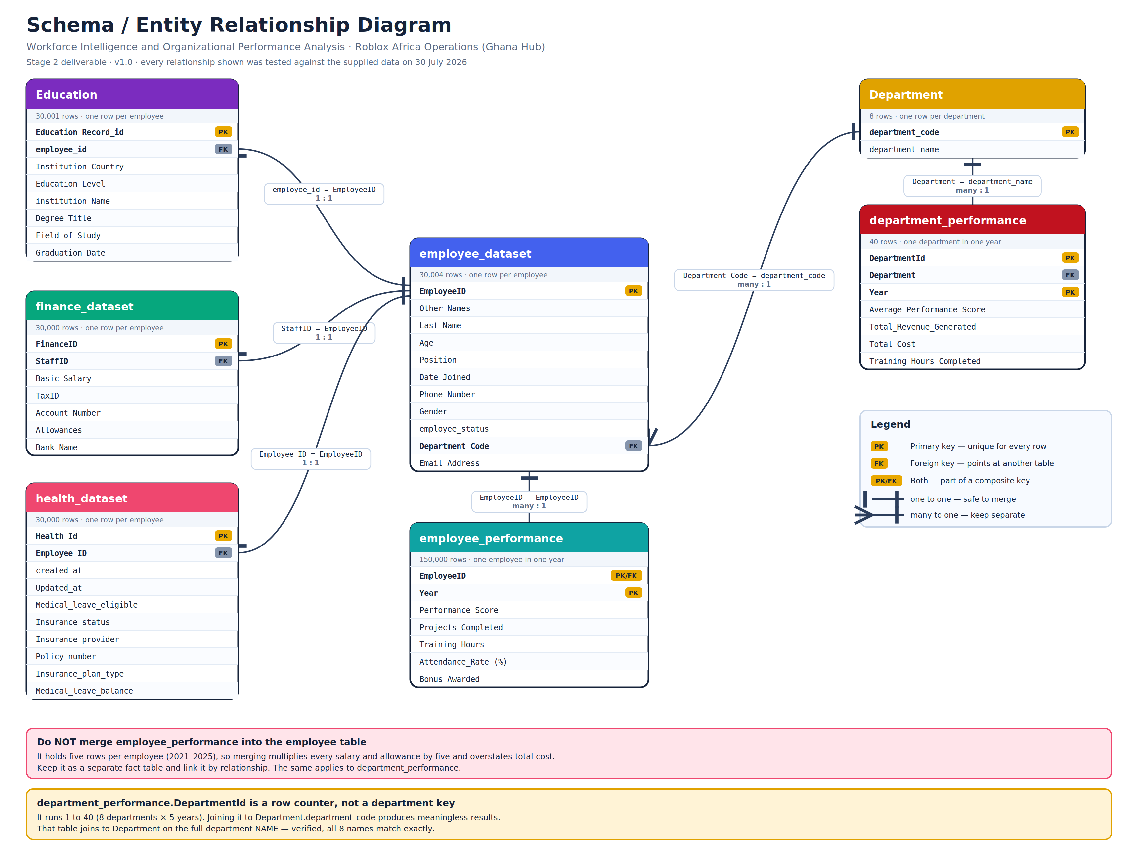
How the seven files connect. Five files glue safely onto one person. Two files hold five years per person or department, and are kept separate on purpose.
Step 5 — We built one place to ask questions from
All the cleaned, correctly-connected data was loaded into one database, so any question could be answered with one consistent set of numbers instead of hunting through seven files by hand.
Step 6 — We asked five questions, and checked every answer twice
Leadership had five things they wanted to know. We answered each one, then went back and checked every number in this report against the original database a second time, using a completely separate calculation, before writing it down. Every figure below passed that second check.

3. What we found
Sixteen findings, grouped under the five questions leadership asked. Each one is written as a single sentence that compares something to something — never just a number sitting by itself, because a number alone doesn't tell you if it's good, bad, or normal.
Question 1 — Who actually makes up our workforce?
In plain words: how many people work here, and how are they spread across departments, roles, ages, and gender?
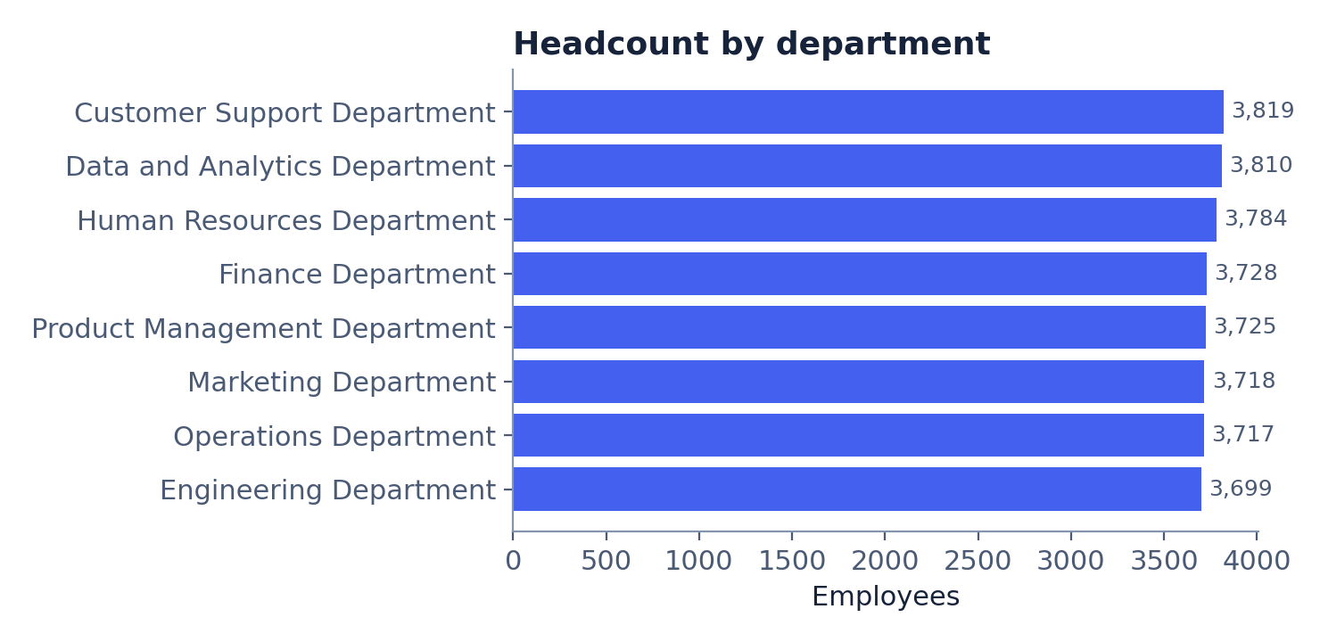
- Customer Support is the biggest department with 3,819 people, but only 120 more than Engineering, the smallest at 3,699. Nobody is short-staffed compared to anyone else — the whole company is spread almost dead evenly across all 8 departments.
- Executive is the single biggest job title, at 17.1% of everyone — more people hold that title than any other.
- The company is basically an even split — 50.0% men, 50.0% women.
- Only 33.6% of everyone counted as an employee is actually marked Active right now. The other 66.4%, close to 20,000 people, are Inactive or On Leave. If you only look at the total headcount number, you'll think you have far more working hands than you really do.
- The youngest age group, under 25, is the smallest slice of the company at 7.5%. Every other age group is at least double that size.
Question 2 — Did we put people where their training fits?
In plain words: if someone studied Computer Science, are they actually working in something like Engineering, or did they end up somewhere unrelated?
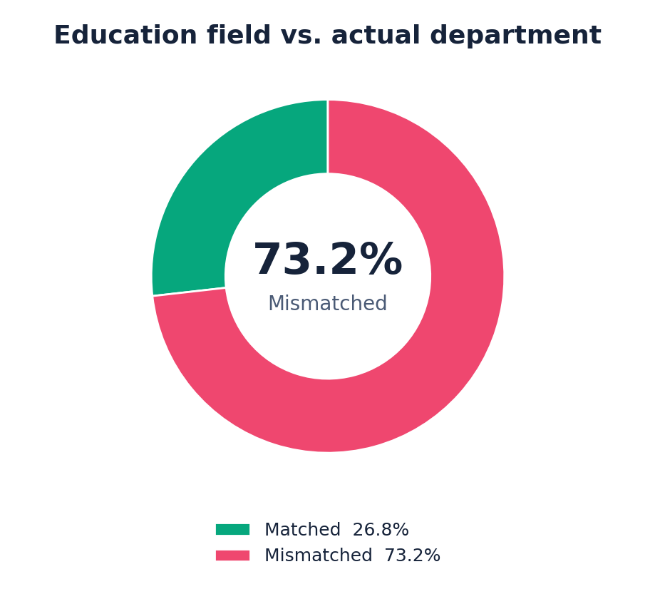
- Using our best judgement about which subject fits which department, about 73% of employees are sitting in a department that doesn't obviously match what they studied. This number depends on a judgement call we made about which subjects count as a match — explained fully in the Limits section below — so treat it as a strong early signal, not a locked-in fact, until Roblox confirms the matching rules themselves.
- Engineering graduates have the worst match of any subject — only 12.4% of them work in a department that fits their training.
Question 3 — Are we paying fairly, and is the money going where the people are?
In plain words: does a department with more people also get a bigger share of the pay, or is something out of balance? And does someone's job title actually predict how much they earn?
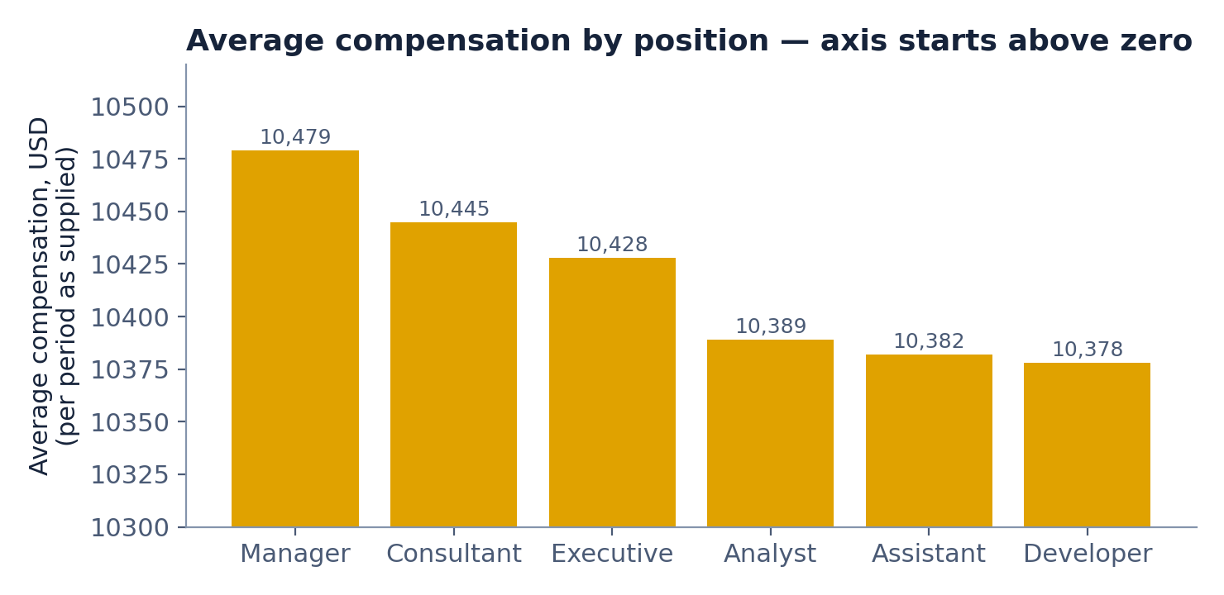
- Pay is spread across departments almost exactly the same way headcount is. The biggest gap between ‘share of people’ and ‘share of pay’ across all 8 departments is just 0.1 of a percentage point. In plain terms: nobody's department is quietly overpaid or underpaid relative to its size.
- Job title barely changes what someone earns. A Manager earns on average only $101 more than a Developer — about 1% — out of roughly $10,400. Every single job title pays almost the same.
- Education level tells the same story. The gap between the highest-paid and lowest-paid education level, across all four levels, is only $50. Having a Doctorate instead of a Diploma does not meaningfully change your pay here.
One honest limit on all three findings above: the company never confirmed whether these salary figures are a monthly amount or a yearly amount. We have not multiplied or divided anything to guess — every number above is reported exactly as it was given to us.
Question 4 — Are there hidden health risks in the workforce?
In plain words: does everyone have working health cover, and does anyone look close to running out of medical leave?
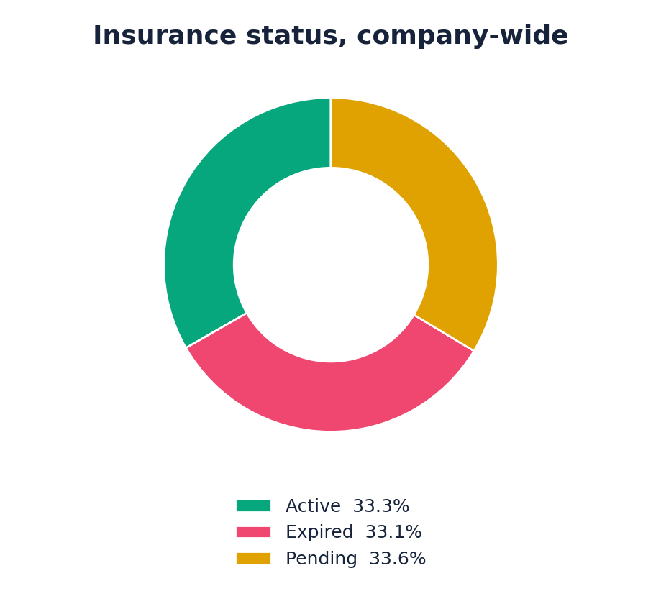
- 66.7% of employees — two out of every three people — currently do not have Active health cover. 33.1% has actually run out (Expired), and 33.6% is stuck waiting to be approved (Pending). This is not a small edge case — it affects the majority of the company.
- Customer Support has the worst cover of any department at 68.2% not Active. Product Management has the best, at 65.0%. Even the best department is still well over half.
- 5,740 people — about one in five employees — have 5 days or fewer of medical leave left out of a possible 30. That's worth flagging to HR regardless of which department they sit in.
Question 5 — Which departments are actually worth what we're spending on them?
In plain words: comparing how much money a department brings in against how much it costs to run, and how many people it takes to do that.
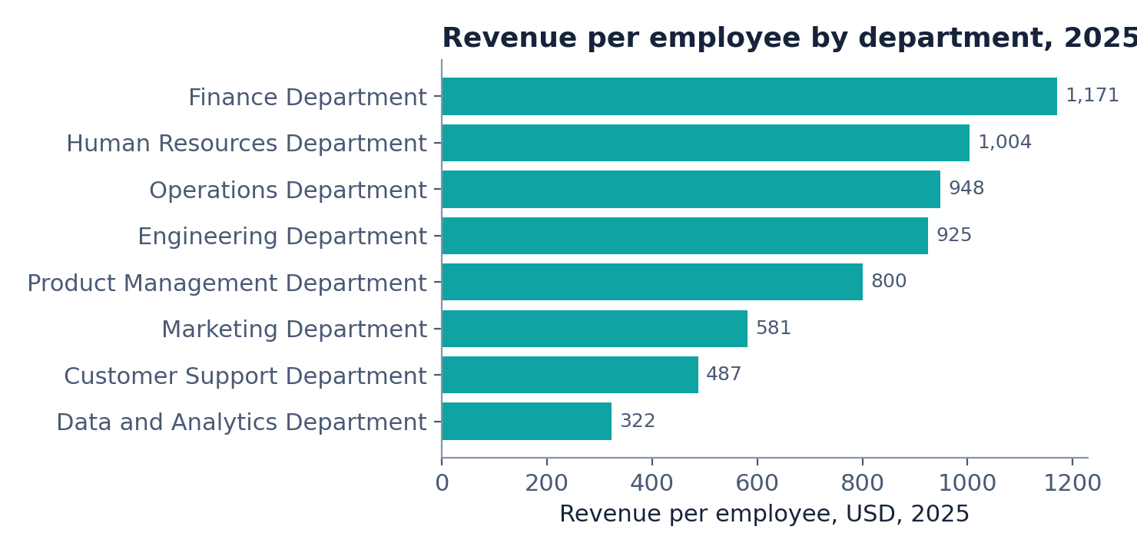
- In 2025, Finance made the most profit of any department — $1,853,832 more money in than out. Data and Analytics made the least, at $370,710. That's a gap of nearly $1.5 million between the best and worst department, in one year alone.
- Finance also gets 3.6 times more revenue out of each employee than Data and Analytics does — $1,171 per person compared to $322 per person. Same number of people could be producing very different amounts of value depending on the department.
- Operations Department's yearly performance score bounces around more than any other department — as low as 3.07 in one year, as high as 4.92 in another. Every other department stays comparatively steadier year to year.

4. What we think Roblox should do about it
A finding on its own is just a fact. It only becomes useful once it turns into a decision someone can act on. Below are six things worth doing, in the order we'd tackle them, each one tied straight back to a finding above — not a guess.
1. Fix health cover before anything else
Do this: Chase down why 66.7% of employees don't have Active insurance cover right now, starting with Customer Support Department, where the problem is worst (68.2%). Find out whether it's an approval backlog, a paperwork gap, or people who simply never got signed up, then clear it.
Why: This is the single biggest number in the whole report. Two out of three employees currently have no working health cover, and that is not a small technical issue — it's most of the company.
Who this helps: Every employee without cover right now, and HR, who can act on this immediately without needing anyone else's sign-off.
Timing: Quick win. Start this week.
2. Check in on the 5,740 people running low on medical leave
Do this: Have HR reach out directly to anyone with 5 or fewer medical leave days left out of their yearly 30, before it becomes a problem instead of after.
Why: One in five employees is close to running out of a benefit meant to last them the whole year. Waiting until someone actually runs out is the expensive way to find out there was a problem.
Who this helps: About 5,740 employees, and HR, who can prevent a bigger issue with a small, cheap check-in now.
Timing: Quick win. Can run alongside recommendation 1.
3. Get a straight answer on whether pay is monthly or yearly
Do this: Ask Roblox's payroll team directly to confirm the period on the Basic Salary and Allowances figures. This is a five-minute question that has been blocking a clean answer on total pay costs since Stage 4.
Why: Right now nobody can honestly say what the company spends on payroll in a year, because the number could be twelve times too small or exactly right, and we genuinely don't know which.
Who this helps: Finance and leadership, who need this number for any real budget conversation.
Timing: Quick win. This should have the shortest turnaround of anything on this list.
4. Look into why Data and Analytics earns so much less per person
Do this: Sit down with the Data and Analytics Department lead and work out why the department brings in only $322 of revenue per employee, against Finance's $1,171 — a 3.6 times gap. Work out whether that's simply how that kind of department is supposed to look (a cost centre that supports everyone else, not a revenue generator) or whether it's an actual problem worth fixing.
Why: This is the single biggest efficiency gap between any two departments in the whole company. It might be completely normal. It might not be. Nobody currently knows which, and that's worth five minutes finding out.
Who this helps: Leadership, when deciding where to invest next, and the Data and Analytics Department, which deserves to know if it's being judged on the wrong yardstick.
Timing: Longer term. Needs a conversation, not just a spreadsheet.
5. Find out why Operations Department's results swing so much
Do this: Ask the Operations Department lead what changed between its worst year (3.07) and its best year (4.92). Was it a change in leadership, a change in process, or something external? Whatever the answer, write it down so it isn't lost.
Why: Every other department stays fairly steady year over year. Operations doesn't. A department that swings this much is either hiding a real problem or hiding a real success — either way, worth knowing which.
Who this helps: Operations Department, and anyone trying to plan next year's targets based on this year's number.
Timing: Longer term.
6. Confirm the education-to-department matching rules with Roblox before repeating the 73% number anywhere official
Do this: Before this report's education-mismatch finding goes into any slide deck or gets repeated to Roblox's leadership as a hard fact, sit down with someone at Roblox who actually knows the departments and confirm which subjects genuinely belong where. Our matching rules were our best guess, not Roblox's own answer.
Why: A different, equally fair set of matching rules could move that 73% number up or down by a lot. Quoting it confidently before it's confirmed risks Roblox leadership making a decision on a number that turns out to be softer than it looked.
Who this helps: Whoever presents this report externally, and anyone at Roblox who might act on the mismatch number.
Timing: Do this before the next presentation, not urgently, but before anyone repeats the number out loud.
These six cover every major finding above except workforce composition and pay-by-role, which came back essentially healthy and don't need a fix — spread evenly, paid fairly, nothing to flag. Sometimes the right recommendation is simply: this part is fine, leave it alone.

5. What this data can't tell us
Being honest about the edges of what we know is just as important as the findings themselves. Here is exactly where this report should not be stretched further than it can go.
- We don't know if pay is monthly or yearly. Roblox never confirmed this. Every pay number in this report is shown exactly as given — we never guessed by multiplying or dividing.
- The ‘73% of people don't fit their training’ number depends on our own judgement call about which subject fits which department. A different, equally reasonable set of matching rules could move that number up or down. This needs Roblox's own confirmation before it's treated as a hard fact.
- Two numbers genuinely don't add up against each other, and we're saying so rather than hiding it: the department cost figures and the individual salary figures are on completely different scales — roughly 21 times apart. We do not know why yet, so we have never combined them into one number, and neither should anyone reading this report.
- We can see who does and doesn't have health cover, but we have zero medical information about anyone — no illnesses, no diagnoses, nothing clinical. This data can only tell you about paperwork and cover status, never about anyone's actual health.
- We can't yet tell you why anyone leaves the company, because nobody gave us a leaving-date or a reason-for-leaving column. That's a good next step for a future project, not something this report can answer.
- Seeing two things happen together — like a subject and a department — does not prove one caused the other. This report points at patterns worth asking about, not at proven explanations.
Every number in this report was checked against the original database a second time before being written down, using a separate calculation each time. Full details of that checking are recorded in the project's Validation Checklist.

