CE554 Progress Report (1 page report)

Team 02

2018/12/03

**This week progress:**

1. We conducted additional ‘walking over unperceived uneven terrain’ experiments. The maximum obstacle height used in those experiments was set to 30 [%] of the usable leg length of the quadruped robot, which is the condition proposed in the rebuttal game plan.
2. We performed a few dynamic gaits including dynamic horse walk gait, walking trot, walking pace. We will proceed more dynamic gaits including running trot, running pace, walking bound, running bound if there is available time left.
3. We have revised our paper according to the reviewers’ comments.

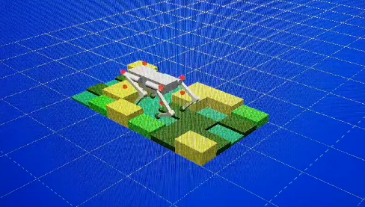

Figure 1. Walking over unperceived uneven terrain

**Issue:**

1. There was no issues during this week.