CE554 Progress Report (1 page report)

Team 02

2018/09/10

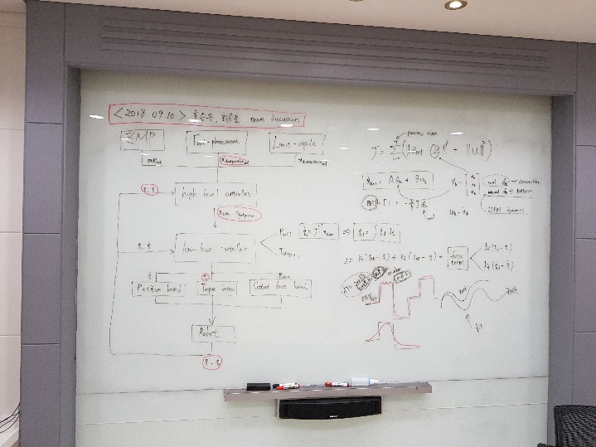**This week progress**

This week we performed

1) Outlining research big picture

2) Searching related research

3) Discussing about research feasibility

4) Writing introduction

**Issue**

1) Which robot platform should we used to test our controller in full body simulation?

We are going to design an optimization based whole body controller can be implemented by any kind of legged robots including biped robots, quadruped robots, and others. Since quadruped robots have better walking stability than biped robots and have a simpler system structure than multi-legged (more than four legs) robots. Therefore, in this research, given the adaptability of harsh environments, excellent carrying-load capacity of heavy objects and walking stability, and various tasks such as not only low-speed static walking but also relatively fast-speed dynamic walking, we choose to design and implement the controller on the quadruped robot platform.

2) Which combination of optimization vectors is the best to perform the QP (quadratic programming) of inverse dynamics of floating base systems?

There are three common combination of optimization vectors to execute the QP of inverse dynamics of floating base systems: full optimization vector (accelerations, torques, contact forces), reduced optimization vector (accelerations, torques), and another kind of reduced optimization vector (accelerations, contact forces). Although reduced optimization vector methods are computationally inexpensive and simpler than the full optimization vector, but both of them are derived based on dynamically consistent support null-space matrix so that if the constraints of contact assumption is violated then the rest of all the derivation fall into a failure. Even though the full optimization vector are computationally expensive than the others, but it can be efficiently solve by commercial QP solver to solve the QP problem in less than 3ms, which is fast enough to be considered as real-time implementation. Last but not the least, full optimization vector can include the contact force constraints that the others cannot be deal with.