CE554 Progress Report (1 page report)

Team 00

2018/09/03

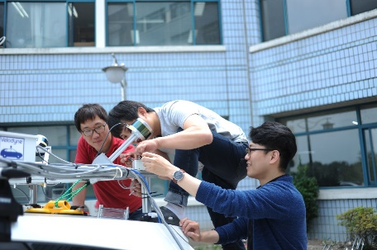**This week progress**

This week we performed

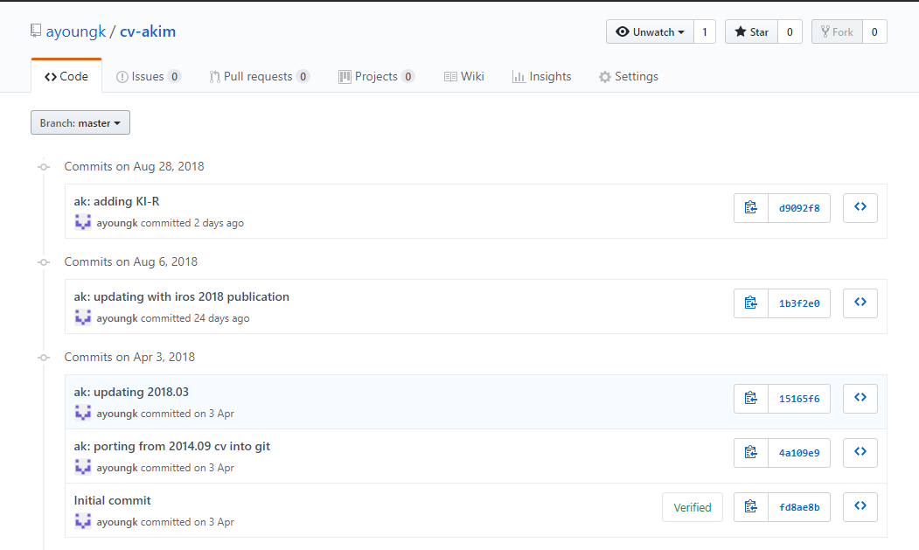1) Experiment

2) Collected data

3) Mostly coded

4) First XX module completed

**Issue**

1) Robot does not move

We tried A and B but C is not working somehow. We think the following plan will work. For example E and F may improve the performance.

2) Camera works but limited view

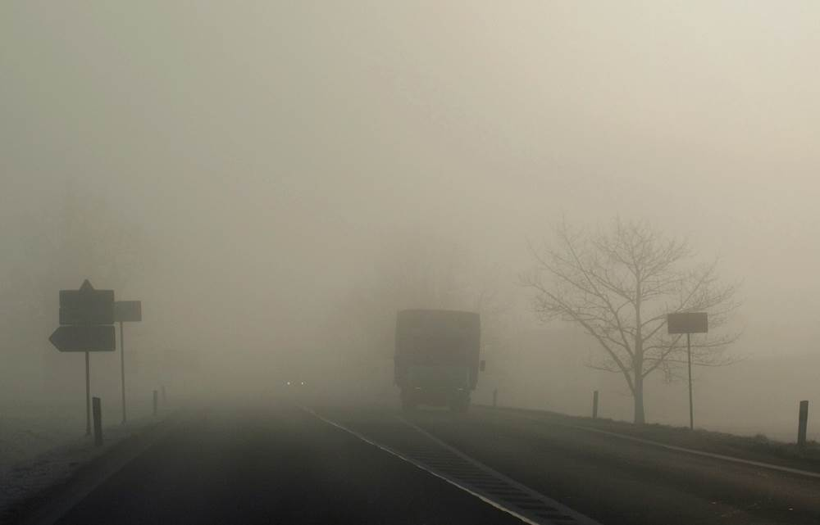 Due to the fog, the visibility drops.