Summative Portfolio: L4

Steve Crawshaw

2022-04-14

# Introduction

My name is Steve Crawshaw. I am a project manager for Bristol City Council and I have undertaken the L4 Apprenticeship (Data Analyst) to improve my knowledge and skill in data analytics with a view to undertaking the L7 apprenticeship and achieving a role as a data scientist.

I have worked for Bristol City Council (BCC) since 1998 in essentially the same role, although I was seconded to another organisation between 2013 and 2016. My main role now is managing a network of air quality monitors and the data that they generate. This will be the subject on which I will focus for the summative portfolio.

# Employer: Bristol City Council

[Bristol City Council](https://en.wikipedia.org/wiki/Bristol_City_Council) is a large unitary local authority in the South West of England.

## Goals, Vision and Values

Bristol City Council’s [Corporate Strategy](https://www.bristol.gov.uk/policies-plans-strategies/corporate-strategy) outlines a vision of driving an inclusive, sustainable and healthy city of hope and aspiration where everyone can share the city’s success. It also describes the activities required by law.

The Corporate Strategy’s main priorities are informed by 5 key principles.

* Development and delivery
* Environmental sustainability
* Equality and inclusion
* Resilience
* World-class employment

It’s also arranged around 7 main themes:

* **Children and young people:** A city where every child belongs and every child gets the best start in life, whatever circumstances they were born into.
* **Economy and skills:** Economic growth that builds inclusive and resilient communities, decarbonises the city and offers equity of opportunity.
* **Environment and sustainability:** Decarbonise the city, support the * recovery of nature and lead a just transition to a low-carbon future.
* **Health, care and wellbeing:** Tackle health inequalities to help people stay healthier and happier throughout their lives.
* **Homes and communities:** Healthy, resilient, and inclusive neighbourhoods with fair access to decent, affordable homes.
* **Transport and connectivity:** A more efficient, sustainable, and inclusive connection of people to people, people to jobs and people to opportunity.
* **Effective development organisation:** From city government to city governance: creating a focussed council that empowers individuals, communities, and partners to flourish and lead.

Bristol City Council is currently a mayoral - led authority. The current Mayor, [Marvin Rees](https://en.wikipedia.org/wiki/Marvin_Rees) has set out values for the organisation as shown below.

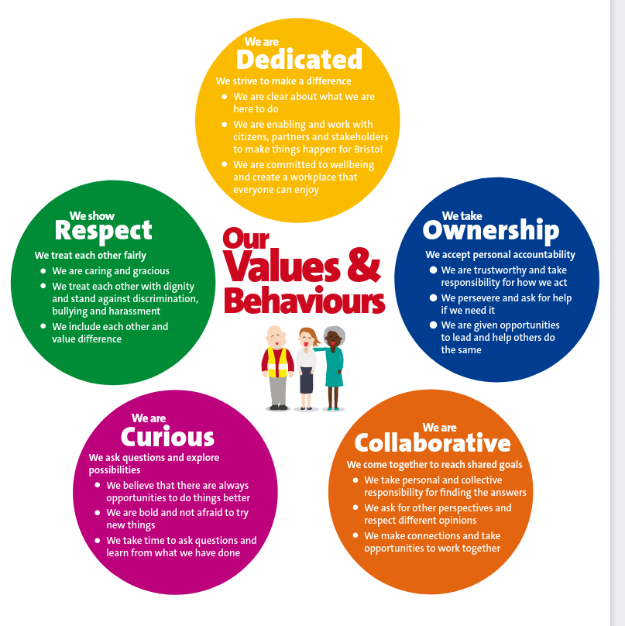

Bristol City Council’s values

## How BCC Uses Data

BCC is a large and complex organisation dealing with a wide range of functions, from managing highways and planning applications to looking after vulnerable people. It follows that multiple systems and approaches exist for managing data across the organisation, many of which have evolved over time and have not been centrally planned or managed.

A recently published [“Data, Insight and Information Strategy”](https://democracy.bristol.gov.uk/documents/s64321/DII%20Strategy%20Final.pdf) sets out the strategic direction and objectives for the council in this area:

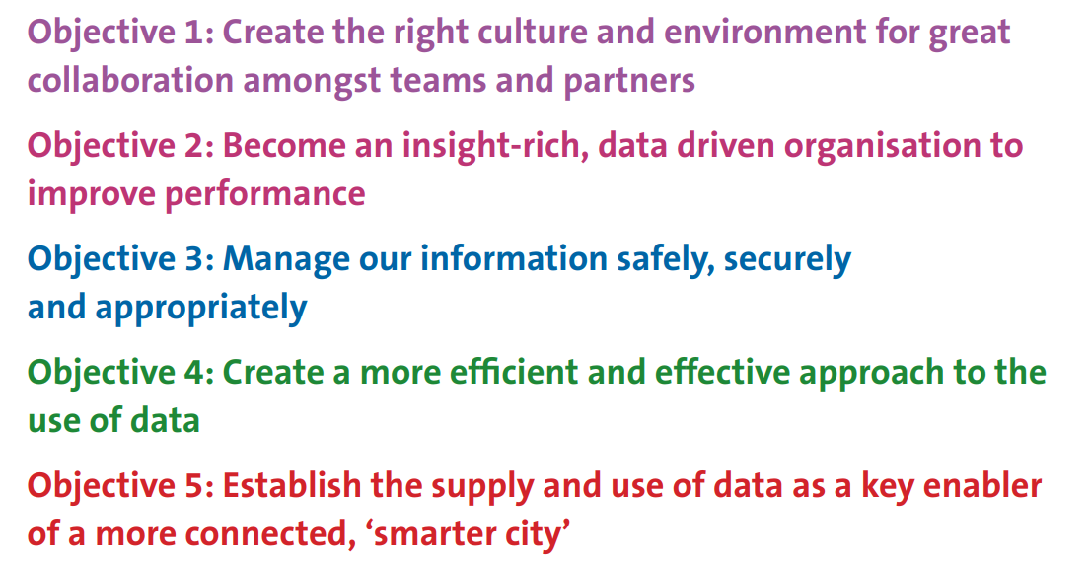 The strategy aims to deliver these objectives by developing a single analytics team to deliver insights across the organisation and by consolidating the disparate and distributed datasets across the council into a corporate data lake with analysis being done on one data analytics platform. Several projects are under way to deliver this change.

## Data Architecture

## Security Standards and Policies

# My Role: Air Quality Project Manager

My official job title is “Project Manager”. This is currently under review, partly because the extent of actual project management activity is quite limited. The majority of my time is spent managing a network of air quality monitors and the data that arises from the network.

## Key Deliverables

The deliverables for which I am responsible are summarised as follows:

1. Data capture rates exceeding 85% for continuous monitoring, 75% for passive.
2. Monthly data cleaning (ratification) of continuous data.
3. Annual reporting of air quality data.
4. Calculation of Key Performance Indicators (KPIs) for air quality.
5. Developing or revising KPIs as necessary.
6. Ad hoc analysis and summaries of air quality data to support other programmes.
7. Ensuring all relevant air quality data are published on the Open Data Portal.
8. Ensuring all relevant technical guidance is followed in relation to air quality management.
9. Responding to relevant requests from stakeholders for air quality data and analysis.
10. Delivery of specific projects such as “Slow the Smoke”

## Key Skills and Knowledge

The key skills and knowledge for my role are as follows:

### Knowledge

* A good understanding of the legal framework for air quality management in the UK.
* Familiarity with the relevant technical guidance on assessing air quality.
* Knowledge of air quality policy and interactions with other domains like transport.
* An understanding of the development management (land use planning) process in the UK including Environmental Impact Assessment (EIA).
* An understanding of the principles of open data and legal framework for public access to data.

### Skills

* Processing and analysing medium sized (up to 10 million observations) data sets
* SQL (SQL server, ODSSQL and MS Access)
* Excel
* HTML, Javascript and CSS for web development of open data
* R - packages openair, openaq, sf, timetk, fastverse, deweather and tidyverse are relevant to the air quality domain
* [FME](https://www.safe.com/) and FME Server for automating web services and data integration
* Time series analysis
* Network telemetry: IP, analogue, wireless, Teltonika RMS
* Technical report writing and comprehension of technical reports relating to the domain
* Communication skills - ability to report technical information to non - specialists
* Project management for small and medium sized projects
* Technical skills related to installation, maintenance and quality control of air monitoring instruments
* Negotiation skills for contract management and securing outcomes in the planning process

## Strengths and Weaknesses

### Strengths

* Long experience in the domain and a good level of skills and knowledge
* Strong work ethic
* Motivation to deliver and improve services and air quality
* Wide range of contacts internally and externally
* Collaborative approach to working

### Weaknesses

* Wide, rather than deep data skill set
* Limited understanding of statistical theory and advanced analysis
* No exposure to team environment of other data analysts so lacking peer support
* Isolated from corporate data analytics functions
* Limited employer incentive to improve skills

## Areas for Improvement

* Improved understanding of statistical theory and learning
* Power BI (corporate data analytics tool)
* Azure (corporate data platform)
* Python and PANDAS for comprehensive tooling of data science