Regional CO2 Emissions

West of England Combined Authority

Steve Crawshaw

2025-02-17

## Drivers of Falling Emissions

The UK has made significant progress in reducing its greenhouse gas emissions since 2005, driven by a combination of policy decisions, economic factors, and technological advancements[1].

### Policy Decisions

1. **Climate Change Act (2008)**: This landmark legislation set a legal framework for the UK to reduce greenhouse gas emissions and build resilience to climate change[2].
2. **Carbon Budgets**: The UK has implemented a system of carbon budgets, which place a cap on the amount of greenhouse gases the UK can emit over a 5-year period[3].
3. **UK Emissions Trading Scheme (ETS)**: This cap-and-trade system incentivises decarbonization in the power sector, heavy industry, and aviation[4].
4. **Clean Power Target**: The UK government has set an ambitious target of achieving a clean power system by 2030[5].

### Economic and Technological Factors

1. **Renewable Energy Growth**: The rapid expansion of renewable energy sources, particularly offshore wind, has been a key driver of emissions reductions[6].
2. **Coal Phase-Out**: The UK has significantly reduced its reliance on coal for electricity generation, with plans to completely phase out coal-fired power plants[7].
3. **Energy Efficiency Improvements**: Advancements in energy efficiency across various sectors have contributed to lower emissions[8].
4. **Industrial Decarbonization**: Initiatives like the Industrial Decarbonisation Challenge have stimulated investment in low-carbon technologies for energy-intensive industries[9].

## Regional Variations in Emissions Trends

Analysis of the per - capita emissions data from UK government data reveals significant regional variations in emissions trends across combined authority areas:

1. **Tees Valley**: Experienced the most dramatic reduction, with per capita emissions falling from 27.31 in 2005 to 6.47 in 2022, a 76.3% decrease.
2. **Cambridgeshire and Peterborough**: Showed a substantial decrease from 11.55 in 2005 to 6.73 in 2022, a 41.7% reduction.
3. **North East**: Reduced emissions from 8.78 in 2005 to 3.74 in 2022, a 57.4% decrease.
4. **West of England**: Decreased from 8 in 2005 to 3.6 in 2022, a 54.4% reduction.

These variations can be attributed to:

* **Industrial Composition**: Areas with energy-intensive industries, like Tees Valley, have seen larger reductions as these sectors decarbonize[10].
* **Economic Restructuring**: Shifts from manufacturing to service-based economies in some regions have contributed to emissions reductions[11].
* **Local Initiatives**: Some combined authorities have implemented specific decarbonization strategies, leading to faster progress[12].

The chart below illustrates the per capita emissions trends for combined authority areas over the period for which data are available. The data includes all sectors and is calculated by summing the emissions from the constituent unitary authorities and dividing by the population for each year.

It can be seen that Tees Valley is an outlier in terms of the per - capita emissions trends, because of the significant influence of the industrial sector in this region. Other regions are showing a steady decline in emissions, largely due to the factors listed above.

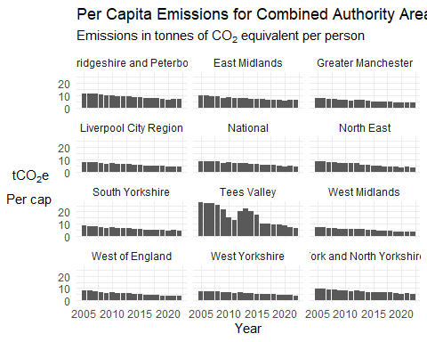

The West of England, has performed slightly better than the UK as a whole in terms of reducing per capita emissions. The table below shows the per capita emissions for the West of England and the UK as a whole in 2005 and 2022, along with the percentage change over this period.

| Area | 2005 | 2022 | Change percent |
| --- | --- | --- | --- |
| West of England | 8.0 | 3.6 | -55 |
| National | 8.8 | 4.5 | -49 |

The line chart below shows the per capita emissions trends for combined authority areas over the period for which data are available. The chart highlights the West of England and the National trendlines for comparison. Tees Valley has been omitted for visibility due to its outlier status.

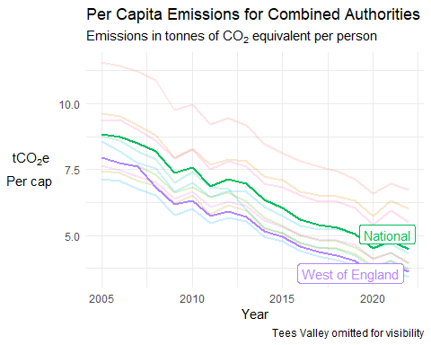

### Emissions within the West of England Mayoral Combined Authority

The three unitary authorities within the West of England Mayoral Combined Authority (Bath and North East Somerset, Bristol, and South Gloucestershire) have shown a consistent downward trend in absolute emissions over the period for which data are available. This trend is in line with the broader national and regional emissions reductions.

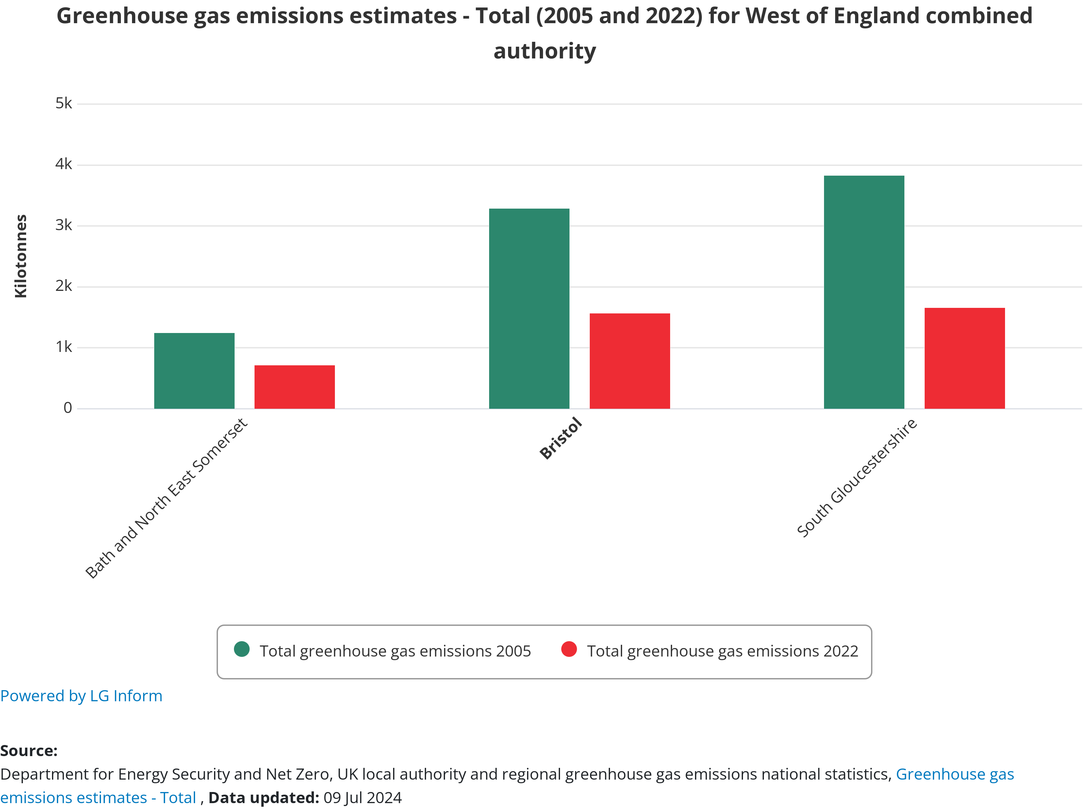

Unitary Authority Emissions

## Dominant Sectors in Emissions Changes

The key sectors driving changes in emissions include:

1. **Power Generation**: The transition from coal to renewables has been the largest contributor to emissions reductions[13].
2. **Industry**: Industrial decarbonization efforts, including the adoption of carbon capture and storage technologies, have played a significant role[14].
3. **Transport**: While progress has been slower in this sector, it is increasingly important for future emissions reductions[15].
4. **Buildings**: Improvements in energy efficiency and the transition to low-carbon heating systems are becoming more significant[16].
5. **Agriculture and Land Use**: These sectors are expected to play a growing role in future emissions reductions and carbon sequestration efforts[17].

In conclusion, while the UK has made substantial progress in reducing emissions, particularly in the power sector, future reductions will require more significant contributions from transport, buildings, and agriculture. Regional variations highlight the importance of tailored strategies that account for local industrial and economic contexts.

1. https://www.gov.uk/government/publications/uks-2035-nationally-determined-contribution-ndc-emissions-reduction-target-under-the-paris-agreement/united-kingdom-of-great-britain-and-northern-irelands-2035-nationally-determined-contribution
2. https://www.gov.uk/government/publications/uks-2035-nationally-determined-contribution-ndc-emissions-reduction-target-under-the-paris-agreement/united-kingdom-of-great-britain-and-northern-irelands-2035-nationally-determined-contribution
3. https://www.gov.uk/government/publications/uks-2035-nationally-determined-contribution-ndc-emissions-reduction-target-under-the-paris-agreement/united-kingdom-of-great-britain-and-northern-irelands-2035-nationally-determined-contribution
4. https://www.gov.uk/government/publications/uks-2035-nationally-determined-contribution-ndc-emissions-reduction-target-under-the-paris-agreement/united-kingdom-of-great-britain-and-northern-irelands-2035-nationally-determined-contribution
5. https://www.gov.uk/government/publications/uks-2035-nationally-determined-contribution-ndc-emissions-reduction-target-under-the-paris-agreement/united-kingdom-of-great-britain-and-northern-irelands-2035-nationally-determined-contribution
6. https://www.ukri.org/wp-content/uploads/2025/01/IUK-101224-NetZeroReview2024.pdf
7. https://www.gov.uk/government/publications/uks-2035-nationally-determined-contribution-ndc-emissions-reduction-target-under-the-paris-agreement/united-kingdom-of-great-britain-and-northern-irelands-2035-nationally-determined-contribution
8. https://www.ukri.org/wp-content/uploads/2025/01/IUK-101224-NetZeroReview2024.pdf
9. https://www.ukri.org/wp-content/uploads/2025/01/IUK-101224-NetZeroReview2024.pdf
10. https://www.ukri.org/wp-content/uploads/2025/01/IUK-101224-NetZeroReview2024.pdf
11. https://www.gov.uk/government/publications/uks-2035-nationally-determined-contribution-ndc-emissions-reduction-target-under-the-paris-agreement/united-kingdom-of-great-britain-and-northern-irelands-2035-nationally-determined-contribution
12. https://www.ukri.org/wp-content/uploads/2025/01/IUK-101224-NetZeroReview2024.pdf
13. https://www.theccc.org.uk/publication/progress-in-reducing-emissions-2024-report-to-parliament/
14. https://www.ukri.org/wp-content/uploads/2025/01/IUK-101224-NetZeroReview2024.pdf
15. https://www.theccc.org.uk/publication/progress-in-reducing-emissions-2024-report-to-parliament/
16. https://www.ukri.org/wp-content/uploads/2025/01/IUK-101224-NetZeroReview2024.pdf
17. https://www.theccc.org.uk/publication/progress-in-reducing-emissions-2024-report-to-parliament/