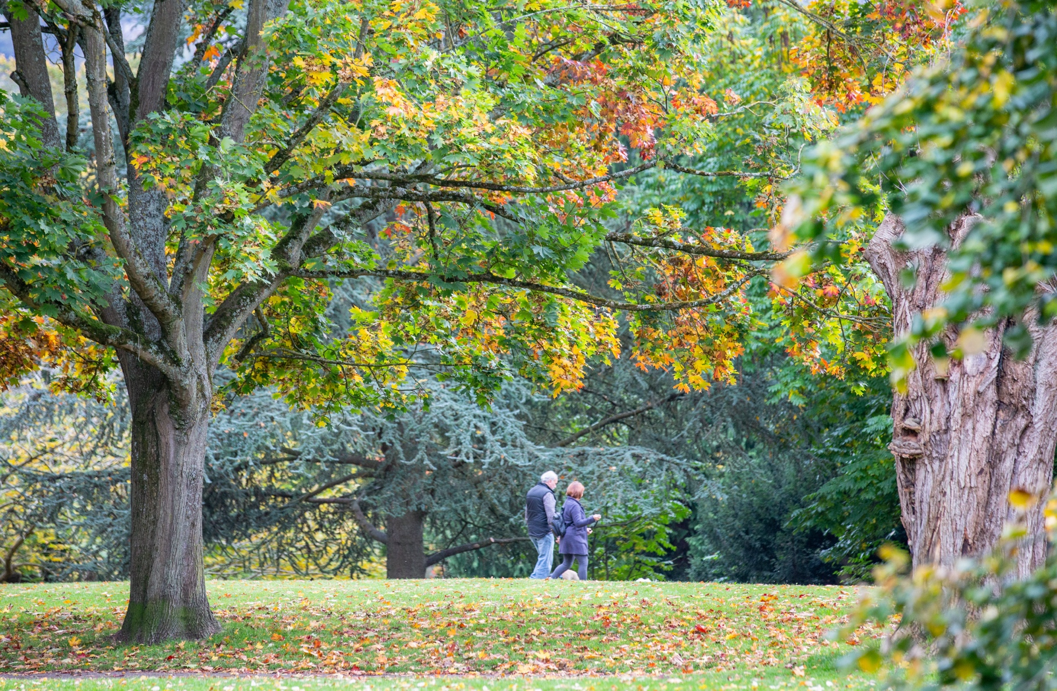

# Regional CO2 Emissions

### 19/02/2025

### 

### 