LNRS Database description

# Introduction

Local Nature Recovery Strategies are a new policy in the UK which creates a duty on all responsible bodies to describe their areas in terms of biodiversity priority and support farmers and landowners to improve their land and help nature recover.

The West of England Combined Authority (WECA) is a responsible body, along with other UK combined authorities and local authorities. WECA has procured the ODS platform to host a wide range of datasets, but also to deliver a key data product (the LNRS Interactive Map) to help farmers, landowners and other stakeholders to understand the biodiversity priorities we have defined for the region and help them direct investment in nature.

# Brief

We have collated key datasets to inform this application. The key functionality of which is set out in the powerpoint presentation previously provided. While we have a broad overall view of the desired functionality, we do not have a full, detailed model of operation. However, we would like all the key information in the datasets to be available to stakeholders through a clear and logical customer journey.

The substantive interface with the Interactive Map should be the Priority Areas for Biodiversity dataset published on the portal.

[LNRS Priority Areas for Biodiversity — WECA-open-data (opendatasoft.com)](https://westofenglandca.opendatasoft.com/explore/dataset/lnrs-areas-priority/table/)

Clicking on an area should bring up a dialog to help the user understand the area, the priorities for biodiversity and navigate the measures (AKA recommendation in the powerpoint) and the funding options that apply to the area, or priority.

A draft map has been developed here [Map — WECA-open-data (opendatasoft.com)](https://westofenglandca.opendatasoft.com/map/lnrs_demo_map/?location=10,51.45529,-2.68341&basemap=jawg.streets). The two lower layers: *LNRS Focus Areas for Nature Recovery* and *LNRS Areas of Importance to Biodiversity* do not have any data associated and exist to provide context in this application.

The LNRS Priority Areas for Biodiversity layer is the key dataset and clicking on one of these layers should guide the user through the data model to be able to view:

1. Priorities for the Area
2. Measures for the priorities
3. Measures for the Area
4. Funding Schemes for the Area
5. Grants for the Area
6. Grants for the Priorities associated with the Area

Building this functionality is the key aspect of work we need support with, and making this work in a way that is understandable, performant and easy to use by a farmer of landowner (on PC and mobile devices) is important.

# Data Model

## Tables and Relationships.

The source data for the application were collected by domain experts and through consultation with stakeholders in a spreadsheet. These data were then processed and normalised to show the relationships between datasets. The entity – relationship diagram for the application data is shown below.

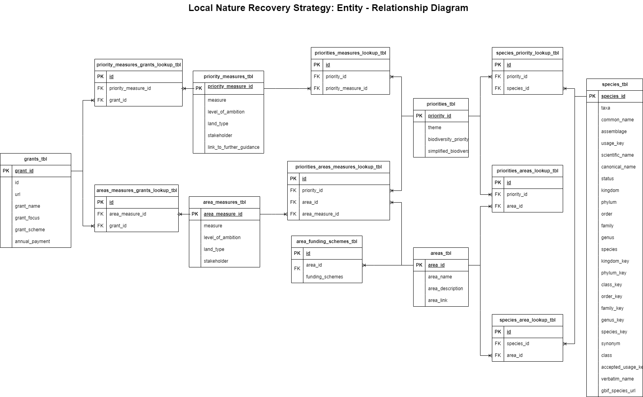

### areas_tbl

This defines the priority areas for biodiversity. There are 50 areas in total ([LNRS Priority Areas for Biodiversity — WECA-open-data (opendatasoft.com)](https://westofenglandca.opendatasoft.com/explore/dataset/lnrs-areas-priority/table/?sort=id) This will be created as dataset with polygon geoshapes.

### species_tbl

We have defined 39 species of importance in the context of the LNRS, listed in the species_tbl, which also contains data about the species derived from the GBIF. Species are related to areas and priorities. So multiple species are important for a given area and (potentially different) species are important for different priorities. Species are related to areas and priorities through the relevant lookup tables.

### priortities_tbl

There are 33 priorities for biodiversity in the region, grouped into themes. Each priority can apply to multiple areas, and each area can have multiple priorities.

## Measures

Measures can be thought of as **actions**, or **recommendations for actions** which will deliver biodiversity priorities in appropriate areas. Measures have been split into two tables, because there are some area – specific measures (which also deliver on a priority), and many priority – specific measures which could apply in multiple areas.

### area_measures_tbl

These are measures which relate specifically to an area, but also deliver a priority. The relationship with the priority is defined by the priorities_areas_measures_lookup_tbl.

### priority_measures_tbl

These are measures which could deliver priorities across any area in the region. They are linked to the priorities_tbl through the priorities_measures_lookup_tbl.

### grants_tbl

A range of financial incentives or grants are available to landowners. These can be related to areas or priorities, and they fund specific measures. Lookup tables connect grants to area_measures_tbl and priority_measures_tbl.

## Resources

The constituent tables shown in the entity – relationship diagram are provided as “;” separated csv files, and in a single Excel workbook called main_sheets.xlsx. In addition, a duckdb database has been built with the tables and constraints shown in the diagram. An iPython notebook to build the database from the csv files is also included for completeness. All these files are provided in a zipped archive.