骨盆底巨大硬皮囊腫擬似直腸惡性腫瘤：病例報告
A Large Epidermoid Cyst of the Pelvic Floor Mimicking Rectal Malignancy: A Case Report
王子建¹、陳紹寬²、吳美智¹、陳樞鴻³
Wang Tzu-Chien, NP¹, Chen Shao-Kuan, MD², Wu Mei-Chih, NP¹, and Chen Shu-Hung, MD³
¹ 新北市汐止區國泰綜合醫院 護理部 Department of Nursing, Xizhi Cathay General Hospital, New Taipei City, Taiwan ² 新北市汐止區國泰綜合醫院 泌尿科 Department of Urology, Xizhi Cathay General Hospital, New Taipei City, Taiwan ³ 新北市汐止區國泰綜合醫院 一般外科 Department of General Surgery, Xizhi Cathay General Hospital, New Taipei City, Taiwan
通訊作者：陳樞鴻，新北市汐止區國泰綜合醫院一般外科。 電話：0983701132（院內手機）；傳真：(02)2648-2690； 電子郵件：cgh07668@cgh.org.tw
Corresponding author: Chen Shu-Hung, MD, Department of General Surgery, Xizhi Cathay General Hospital, New Taipei City, Taiwan. Tel: 0983701132; Fax: (02)2648-2690; E-mail: cgh07668@cgh.org.tw
中文短標題：盆底硬皮囊腫擬似直腸腫瘤
Running title: Epidermoid Cyst Mimicking Rectal Cancer

Abstract
Background: Epidermoid cysts of the pelvic floor are rare benign lesions that can closely mimic malignancy on CT, posing significant diagnostic challenges.
Case Summary: A 61-year-old male presented with lower abdominal pain, hematuria, and rectal tenesmus. Contrast-enhanced CT revealed a 10 cm pelvic mass with apparent lymphadenopathy, raising suspicion for GIST, lymphoma, or neuroendocrine tumor. Three pre-operative findings redirected the diagnosis: negative colonoscopy, normal tumor markers (CEA, AFP, CA19-9), and absent mass enhancement on CT. Prophylactic ureteral stenting was placed pre-operatively given the mass’s proximity to the left ureter. Laparotomy with complete excision confirmed an epidermoid cyst; histopathology demonstrated a cyst wall lined by keratinized stratified squamous epithelium without adnexal structures.
Conclusion: When a non-enhancing extrinsic pelvic mass is accompanied by negative colonoscopy and normal tumor markers, epidermoid cyst should be included in the differential. Complete surgical excision offers an excellent prognosis.
Keywords: epidermoid cyst; pelvic floor; pelvic mass; differential diagnosis; laparotomy

摘要
背景：骨盆底硬皮囊腫為罕見良性病灶，CT上易與惡性腫瘤混淆。
病例摘要：61歲男性因下腹痛、血尿及裡急後重就醫，CT見左側直腸旁10公分腫塊，合併疑似淋巴結轉移。大腸鏡陰性、腫瘤標記正常、CT未見強化，共同指向良性外壓性腫塊。術前置入雙J管後行剖腹手術完整切除，病理證實為硬皮囊腫。
結論：大腸鏡陰性且腫瘤標記正常之非強化性骨盆腫塊，應納入硬皮囊腫鑑別診斷；完整切除預後良好。
關鍵詞： 硬皮囊腫；骨盆底；骨盆腫塊；鑑別診斷；剖腹手術

- Introduction
Epidermoid cysts within the pelvic floor are exceedingly rare, with, to our knowledge, fewer than 20 cases reported in the literature through 2024.[1-3] Embryological sequestration of ectopic epidermal rests is the most plausible pathogenic mechanism.[4] Their capacity to grow large and compress adjacent pelvic structures frequently leads to misdiagnosis as malignancy.[1,5] We report a case initially misidentified as rectal submucosal malignancy on CT, highlighting pre-operative clues that can redirect diagnosis.
- Case Presentation
This case report was approved by the Institutional Review Board of Xizhi Cathay General Hospital (approval number: CGH-P115074), and written informed consent was obtained from the patient for publication.
A 61-year-old male with no prior surgical history and no significant medical comorbidities presented to the emergency department with lower abdominal pain of two weeks’ duration and hematuria identified on admission urinary catheterisation for one week. He reported bowel habit changes with diarrhea and rectal tenesmus over the preceding two months. He denied weight loss, fever, or family history of malignancy; blood pressure on arrival was 168/112 mmHg. Physical examination revealed abdominal distension and lower abdominal tenderness without peritoneal signs. Digital rectal examination on hospital day two identified a large, hard mass at the left-side 2 o’clock position with luminal obstruction, palpable approximately 4 cm from the anal verge. Laboratory investigations showed leukocytosis (WBC 12,310/μL) and an elevated C-reactive protein (2.083 mg/dL).
Contrast-enhanced CT of the abdomen and pelvis (CECT) revealed a 10 cm mass at the left low rectum described as a submucosal lesion with apparent lymphadenopathy in the right internal iliac region, raising the differential diagnoses of GIST, lymphoma, and neuroendocrine tumor (Figure 2). Additional findings included a left renal calculus and an incidental L2 compression fracture without neurological symptoms; its aetiology was not further evaluated and was presumed degenerative. The patient was admitted under the general surgery service for further evaluation.
Three subsequent investigations were pivotal in redirecting the diagnosis. First, colonoscopy to the cecum demonstrated no mucosal tumor or ulceration, with only internal hemorrhoids noted (Figure 3) — reclassifying the pelvic mass as extrinsic to the bowel rather than intraluminal. Second, tumor markers (AFP 3.42 ng/mL, CEA 1.70 ng/mL, CA19-9 4.4 U/mL) were entirely within normal limits, arguing against adenocarcinoma and AFP-producing tumors. Third, retrospective review of the CECT by the treating surgical team confirmed the absence of internal enhancement within the mass — a feature inconsistent with hypervascular GIST or enhancing lymphoma.
MRI was not performed; the CT findings combined with negative colonoscopy and normal tumour markers were considered sufficient to guide surgical decision-making. Urology consultation with independent CT review identified moderate-to-severe left hydronephrosis — not documented in the formal radiology report — confirming ureteral compression by the mass; cardiac and pulmonary evaluation confirmed low surgical risk.
On March 10, 2026, the patient underwent laparotomy. A ureteral J-stent (6F × 26 cm, Double-J) was inserted cystoscopically under general anaesthesia prior to laparotomy to protect the left ureter during dissection. Intra-operative findings confirmed a well-encapsulated pelvic floor mass with moderate-to-severe left hydronephrosis, consistent with the pre-operative urological assessment. The cyst was intentionally decompressed by aspiration to facilitate dissection; the cyst wall and fibrous capsule were then completely excised without inadvertent rupture or intraperitoneal spillage. Post-operative recovery was uneventful: flatus was noted on day 3, oral diet was resumed on day 4, and the surgical drain was removed on day 7. Hematuria resolved during the post-operative hospital course. Renal function remained stable post-operatively (serum creatinine 0.85 mg/dL; eGFR 99 mL/min/1.73 m²) with no clinical or biochemical evidence of persistent hydronephrosis at discharge. The Double-J ureteral stent was retained in situ, with outpatient removal planned. Tumour marker surveillance (CEA, CA19-9) with complete blood count and biochemistry was scheduled at six months. The patient was discharged on post-operative day 9 with a clean, dry wound.
Gross pathological examination showed multiple firm, gray tissue fragments measuring up to 10.0 × 3.0 × 0.5 cm. Microscopic examination demonstrated keratin fragments and a fibrous cystic wall lined by stratified squamous epithelium (Figure 1). The final pathological diagnosis was epidermoid cyst; unlike a dermoid cyst, no hair follicles or sebaceous glands were present. The clinical timeline is summarised in Table 1.

- Discussion
Epidermoid cysts in the pelvic cavity represent a rare diagnostic challenge. While the gross CT morphology of a 10 cm pelvic mass with apparent lymphadenopathy strongly suggested malignancy in the present case, three pre-operative features were inconsistent with this hypothesis and ultimately guided appropriate management.
A diagnostic triad pointing toward benign extrinsic pathology. First, colonoscopy was negative for any mucosal lesion, confirming the mass was extrinsic to the rectum rather than an intraluminal neoplasm; large epidermoid cysts can compress the rectal wall to create a CT appearance of a submucosal mass.[6] Second, normal tumor markers (CEA, AFP, CA19-9) substantially reduced the probability of common GI malignancies. Third, the absence of internal enhancement on CECT argued against hypervascular GIST and enhancing lymphoma.[5] Individually, none is specific for epidermoid cyst, but together they suggest a benign non-enhancing extrinsic mass. Despite the DRE identifying a large firm mass — a finding that initially heightened malignancy concern — the clinical team elected direct surgical excision rather than pre-operative tissue biopsy, judging that the non-enhancing cystic morphology was inconsistent with the solid tumours in the differential and that complete excision would serve as both the definitive diagnostic and therapeutic step.
CT misidentification and the “metastatic lymphadenopathy” red herring. The initial CT report described “metastatic LAP of the right internal iliac region,” substantially raising concern for malignancy. In retrospect, regional lymphadenopathy adjacent to a large benign cystic mass may reflect reactive inflammation or mechanical compression rather than true metastasis — an interpretation consistent with the mild leukocytosis and CRP elevation, uniformly normal tumor markers, and pathological absence of malignancy. These nodes were contralateral to the mass, arguing against direct compression and favouring a reactive cause. As neither nodal biopsy nor post-operative imaging was performed, the reactive interpretation remains inferential; clinicians should exercise caution in attributing lymphadenopathy to metastatic disease without a confirmed primary.
Pathogenesis. In this patient with no prior abdominal surgery, embryological sequestration of ectodermal cells within the pelvic mesenchyme is the most plausible mechanism, with keratin accumulating over decades until the lesion becomes symptomatic.[1,4]
Comparison with published cases. Prior reports share key features with the present case — extrinsic rectal compression, ureteral obstruction, and mass size exceeding 10 cm.[1,7] The compelling CT mimicry, including apparent lymphadenopathy, is not prominently described in prior reports.
Management of ureteral compression risk. A large pelvic cyst with ureteral compression risk warrants prophylactic pre-operative or concurrent ureteral stenting. In the present case, a Double-J stent placed cystoscopically under the same anaesthetic allowed safe dissection without ureteral injury — an approach consistent with prior reports.[1]
Surgical principles and prognosis. Complete surgical excision with intact capsule removal is the cornerstone of treatment. Simple cyst drainage or aspiration without wall resection carries a high risk of recurrence.[8] In the index case, the cyst was intentionally decompressed prior to wall excision; complete resection of the cyst wall with intact capsule was achieved without inadvertent rupture or intraperitoneal spillage, and post-operative recovery was uneventful. This approach presupposed a benign cyst, as aspiration would risk tumour spillage if malignancy were present. Prognosis following complete resection is excellent, with recurrence rarely reported in the literature.[3] Malignant transformation to squamous cell carcinoma within a pre-existing epidermoid cyst has been documented in one case involving a 69-year-old male with a large abdominal cyst, emphasizing the importance of complete pathological sampling, long-term follow-up, and caution when forgoing pre-operative tissue diagnosis.[9]
Pathological distinction. The histopathological distinction between an epidermoid cyst and a dermoid cyst (mature cystic teratoma) is clinically important: dermoid cysts contain hair follicles and sebaceous glands in addition to squamous epithelium, whereas epidermoid cysts do not. Retrorectal tailgut cyst — another non-enhancing extrinsic pelvic cyst that satisfies the same diagnostic triad — is lined by columnar or transitional epithelium rather than keratinized squamous epithelium; the squamous lining in the present case excludes this entity.
Limitations. CT Hounsfield unit values were not extracted. Pre-operative tissue sampling was not performed; the decision to proceed directly to laparotomy was based on the non-enhancing cystic morphology and low surgical risk. MRI was not performed, limiting assessment of the lesion’s compartment of origin and regional nodes. Follow-up was limited to the index admission; no surveillance data beyond discharge are available, precluding confirmation of freedom from recurrence. The reactive interpretation of regional lymphadenopathy remains inferential.

- Conclusion
Large pelvic floor epidermoid cysts can convincingly mimic rectal submucosal malignancy on CT. The combination of negative colonoscopy, normal tumor markers, and a non-enhancing mass should prompt inclusion of epidermoid cyst in the differential of an extrinsic pelvic mass; because non-enhancement does not exclude a cystic malignancy, definitive diagnosis rests on histopathology of the excised specimen. Prophylactic ureteral stenting should be considered when the mass lies in proximity to the ureter. Complete excision offers an excellent prognosis, though follow-up is required to confirm absence of recurrence.

Patient Perspective
The patient reported resolution of pre-operative lower abdominal pain, hematuria, and rectal tenesmus during the post-operative course, and expressed satisfaction with the surgical outcome at discharge.

References
- Fdili Alaoui FZ, Oussaden A, Bouguern H, El Fatemi H, Melhouf MA, Amarti A, et al. Giant pelvic retroperitoneal epidermoid cyst: a rare case report. Pan Afr Med J. 2012;13:51.
- Jain P, Pal DK. Pelvic epidermoid cyst: a rare cause of lower urinary tract symptoms. BMJ Case Rep. 2018;2018:bcr2017223386.
- Nasim S, Kumar S, Azim D, Rai L, Saeed S. Retrorectal epidermal inclusion cyst: an incidental finding during cesarean section. Int J Surg Case Rep. 2020;77:467–70.
- Hyseni NS, Llullaku SS, Koçinaj DH, Jashari HJ, Kelmendi BZ. An unusual location of retroperitoneal epidermoid cyst in a child: a case report. Cases J. 2009;2:9362.
- Bates DDB, Fernandes de Paula MC, Horvat N, Sheedy S, Lall C, Kassam Z, et al. Beyond adenocarcinoma: MRI of uncommon rectal neoplasms and mimickers. Radiographics. 2019;40:205–22.
- Kesavan R, Parthasarathi R, Gupta A, Palanivelu C. Laparoscopic management of epidermoid cyst in an unusual location: a case report. J Med Case Rep. 2019;13:47.
- AlSulimani SO, Almalki AM, Alzahrani KA, Alshehri AO, Almotairi R. Infected giant right seminal vesicle epidermoid cyst in a young male patient: a case report. Int J Surg Case Rep. 2023;110:108732.
- Koppel BS, Weinberger G. Radiologic evaluation of epidermoid cyst. J Natl Med Assoc. 1987;79:209–12.
- Hu T, Wang D, Tian Y, Yuan X, Li Y. Abdominal giant epidermoid cyst with squamous epithelial heterogeneous proliferation carcinoma: a case report. Transl Cancer Res. 2022;11:1457–62.

Figure Legends
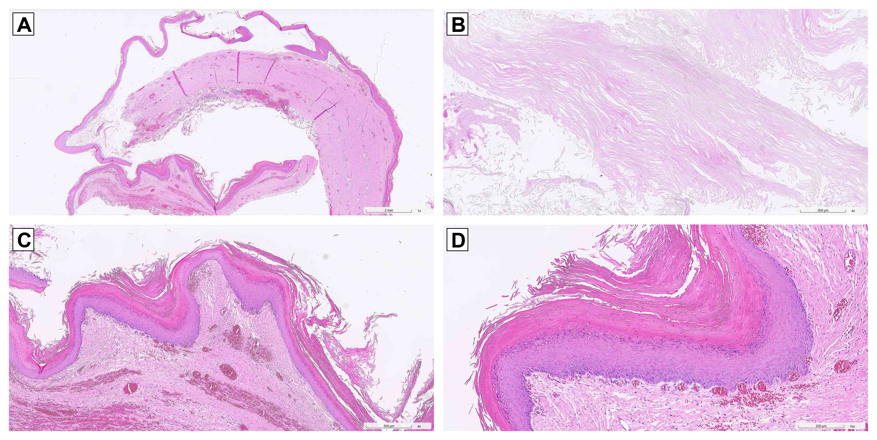
Figure 1. Histopathology of the excised pelvic floor mass (hematoxylin and eosin stain). (A) Low-power overview (1×; scale bar, 2 mm) showing the collapsed cyst wall folded upon itself — a thin stratified squamous epithelial lining overlying a fibrous wall, with abundant laminated keratin; the lumen is largely empty following intraoperative decompression. (B) The keratin consists of loose, wavy, lamellated eosinophilic debris (4×; scale bar, 500 µm). (C) The cyst is lined by stratified squamous epithelium overlying a dense fibrous wall containing congested blood vessels (4×; scale bar, 500 µm). (D) Higher magnification confirms the stratified squamous lining with a well-formed granular layer and surface lamellar keratinization. No adnexal structures are seen in the fields shown, consistent with an epidermoid cyst rather than a dermoid (mature cystic teratoma) (10×; scale bar, 200 µm).
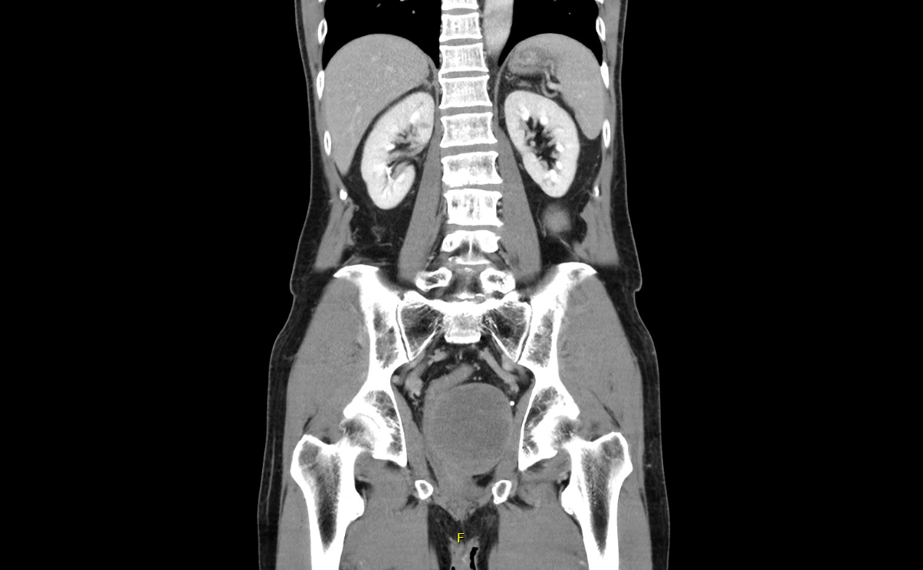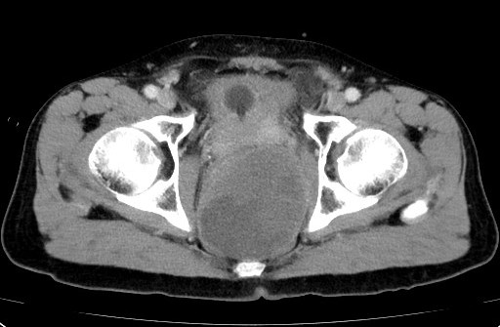
Figure 2. Contrast-enhanced CT of the abdomen and pelvis. (A) Coronal view demonstrating a large, well-defined pelvic floor mass with no internal enhancement. (B) Axial view at the level of the pelvic inlet showing the 10 cm non-enhancing mass abutting the left lateral rectal wall, with apparent lymphadenopathy in the right internal iliac region and an incidental left renal calculus. The yellow line in panel (B) indicates a measurement annotation from the PACS workstation.
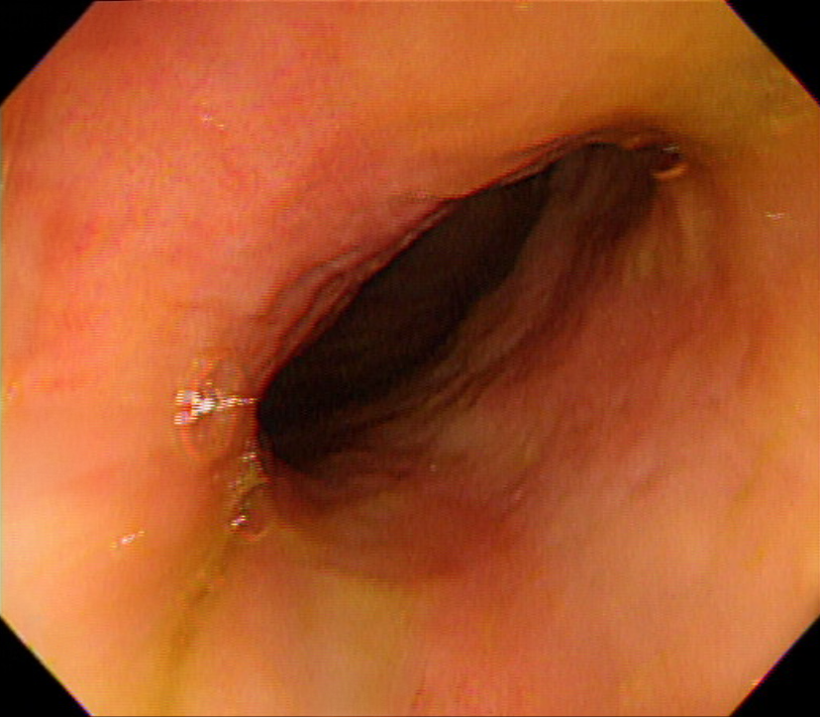
Figure 3. Colonoscopy image of the rectum demonstrating smooth external compression of the rectal wall without mucosal ulceration, friability, or intraluminal tumor, confirming that the pelvic mass is extrinsic to the bowel.

Table 1. Clinical timeline of the present case.
Timepoint | Event
~2 months before presentation | Onset of bowel habit changes and rectal tenesmus
~2 weeks before presentation | Onset of lower abdominal pain
~1 week before presentation | Hematuria identified on urinary catheterisation
March 1, 2026 | Emergency presentation; CECT: 10 cm non-enhancing pelvic mass with apparent right internal iliac lymphadenopathy; leukocytosis and elevated CRP
March 2, 2026 | Digital rectal examination: large hard mass at left-side 2 o’clock with luminal obstruction, 4 cm from anal verge
March 3–9, 2026 | Colonoscopy: no mucosal lesion; tumour markers (AFP, CEA, CA19-9): within normal limits; urology consultation — moderate-to-severe left hydronephrosis identified on CT review (not in formal radiology report); cardiac and pulmonary pre-operative evaluation: low surgical risk
March 10, 2026 | Cystoscopic Double-J ureteral stenting + laparotomy; complete excision of pelvic floor cyst; moderate-to-severe left hydronephrosis confirmed intraoperatively
Post-operative day 3 | First flatus
Post-operative day 4 | Oral diet resumed
Post-operative day 7 | Surgical drain removed
March 19, 2026 (post-operative day 9) | Discharge; hematuria resolved; Cr 0.85 mg/dL, eGFR 99 mL/min/1.73 m²; Double-J stent in situ; final histopathology: epidermoid cyst
September 2026 (planned) | Tumour marker surveillance (CEA, CA19-9), CBC, biochemistry

Mandatory Disclosures
Ethics Declaration: This case report was conducted in accordance with the Declaration of Helsinki. Institutional review board approval for this case report was obtained from the Institutional Review Board of Xizhi Cathay General Hospital (approval number: CGH-P115074).
Patient Consent: Written informed consent was obtained from the patient for publication of this case report and any accompanying images.
Author Contributions (CRediT):
- Conceptualization: 陳樞鴻
- Data curation: 王子建, 吳美智
- Investigation: 陳紹寬, 吳美智
- Writing – original draft: 王子建
- Writing – review & editing: 陳樞鴻, 陳紹寬
- Supervision: 陳樞鴻
Conflict of Interest: The authors declare no conflicts of interest.
Guarantor: Chen Shu-Hung (corresponding author) accepts full responsibility for the work, had access to the data, and controlled the decision to publish.
Funding: No funding was received for this work.
Data Availability Statement: All data supporting the findings are contained within the case report. Anonymized data are available from the corresponding author upon reasonable request.
AI Usage Disclosure: Claude (Anthropic) was used to assist with literature search and synthesis during the preparation of this manuscript. All content was reviewed, verified, and approved by the authors. No AI tool is listed as an author.

