WAYS TO CONSERVE ELECTRICITY (IN GENERAL)

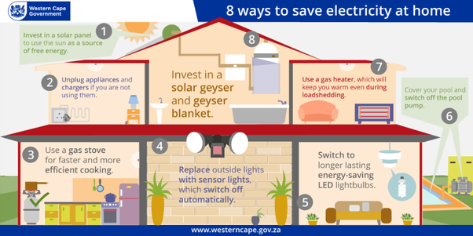

Energy conservation is efforts made to reduce the [consumption of energy](https://en.wikipedia.org/wiki/Energy_consumption) by using less of an energy service. This can be achieved either by [using energy more efficiently](https://en.wikipedia.org/wiki/Efficient_energy_use) (using less energy for a constant service) or by reducing the amount of services used (for example, by driving less). Energy conservation is a part of the concept of [eco-sufficiency](https://en.wikipedia.org/wiki/Eco-sufficiency). Energy conservation reduces the need for energy services, and can result in increased [environmental](https://en.wikipedia.org/wiki/Natural_environment) quality, [national security](https://en.wikipedia.org/wiki/National_security), [personal financial security](https://en.wikipedia.org/wiki/Personal_security) and higher savings. It is at the top of the sustainable [energy hierarchy](https://en.wikipedia.org/wiki/Energy_hierarchy). It also lowers energy costs by preventing future [resource depletion](https://en.wikipedia.org/wiki/Resource_depletion). Energy can be conserved by reducing wastage and losses, improving efficiency through technological upgradation and improved operation and maintenance.