TRASH QWINS
TURNING WASTE INTO WEALTH.
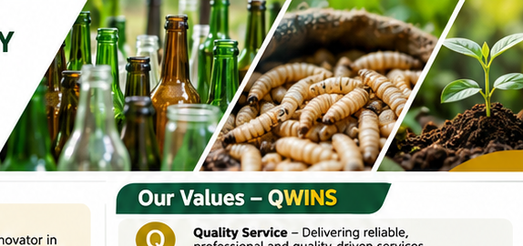
WASTE RECOVERY | RESOURCE INNOVATION | SUSTAINABLE LIVELIHOODS
OUR PURPOSE
We recover overlooked waste streams and turn them into useful products, business opportunities and sustainable livelihoods.

1. About Trash Qwins
Trash Qwins is a Kenyan waste-to-value company focused on transforming waste into valuable resources through recovery, aggregation, recycling and value addition. The company is initially concentrating on glass bottles and organic waste, using glass recovery and Black Soldier Fly (BSF) technology to unlock the economic potential of materials that are often discarded.
We work with communities, waste pickers, hotels, restaurants, institutions, Material Recovery Facilities (MRFs), recyclers and agribusinesses to build practical circular-economy value chains. Our approach combines commercial thinking with environmental responsibility: waste is not simply something to dispose of, but a resource that can be recovered, transformed and returned to productive use.

2. Vision, Mission and Slogan
VISION | To be a leading innovator in transforming waste into wealth for sustainable communities and a circular economy.
MISSION | To recover, transform and commercialise waste through innovative solutions that create economic opportunities, protect the environment and promote sustainable livelihoods.
SLOGAN | Turning Waste into Wealth.

3. Our Values – QWINS
LETTER | VALUE | OUR COMMITMENT
Q | Quality Service | Delivering reliable, professional and quality-driven services.
W | Women and Youth Empowerment | Creating opportunities for women and young people through the circular economy.
I | Innovation | Developing creative, practical and commercially viable waste-to-value solutions.
N | Nurturing Nature | Protecting ecosystems through responsible resource recovery and environmental stewardship.
S | Sustainability and Social Responsibility | Building environmentally sound, socially inclusive and economically sustainable enterprises.

4. Our Core Business Areas

4.1 Glass Waste Recovery and Value Addition
We recover and aggregate discarded glass bottles, creating opportunities for reuse, recycling and creative value addition.
- Glass bottle collection and aggregation.
- Supply of recovered glass to recycling industries and other end-users.
- Glass cutting, craft, decorative and functional products.
- Partnerships with hotels, restaurants and institutions for bottle recovery programmes.

4.2 Organic Waste Valorisation – Black Soldier Fly (BSF)
We use Black Soldier Fly technology to convert suitable organic waste into valuable agricultural inputs, linking waste management with agribusiness and food security.
- Organic waste sourcing, collection and processing.
- BSF larvae production for animal feed, subject to applicable standards and approvals.
- Frass production for soil enrichment and agricultural use.
- Partnerships with farms, livestock producers and agribusinesses.

4.3 Waste Management and Resource Recovery
We develop and support practical waste recovery systems that collect, sort and aggregate materials for productive use.
- Waste collection, sorting and aggregation.
- Establishment and support of aggregation hubs.
- Material recovery partnerships and supply-chain coordination.
- Linking recovered materials with reliable buyers and processors.

4.4 Consultancy, Capacity Building and Advocacy
- Waste management and circular economy consultancy.
- Capacity building and practical training for communities and institutions.
- Environmental awareness, education and advocacy.
- Development of waste recovery programmes and institutional partnerships.
- Participation in relevant tenders and service contracts.

5. Our Integrated Business Model
Trash Qwins is structured around three connected business pillars. This model allows the company to begin with aggregation, build dependable supply and buyer relationships, and progressively expand into processing and value addition.
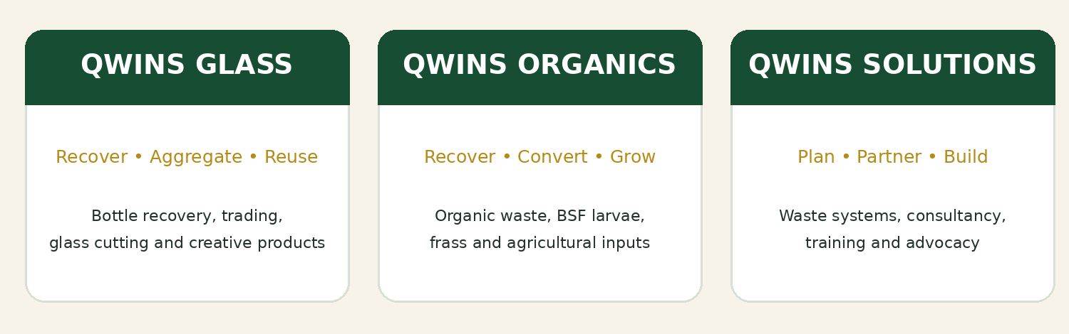

6. What Makes Trash Qwins Different
Focus on underutilised waste streams: We are prioritising glass and organic waste streams that offer opportunities for stronger recovery, reuse and value creation.
Creative glass economy: Our glass model extends beyond collection to aggregation, supply, cutting, creative products and decorative applications.
Commercial partnerships: We can develop tailored recovery arrangements with hotels, restaurants, institutions and businesses, turning discarded bottles into a managed resource stream.
Waste-to-agriculture integration: BSF technology links organic waste recovery to animal feed inputs and soil enrichment, supporting a circular relationship between urban waste and agriculture.
Inclusive enterprise: Our approach creates opportunities for waste pickers, women, youth and community-based organisations to participate in value chains.

7. Strategic Objectives
- Establish reliable waste collection, sorting and aggregation systems.
- Develop commercially viable glass recovery, reuse and value-addition operations.
- Establish and scale BSF operations for suitable organic waste streams.
- Build long-term supply and offtake partnerships with businesses and recycling industries.
- Create employment and enterprise opportunities for women, youth and waste pickers.
- Provide consultancy, training and capacity-building services.
- Promote environmental awareness and responsible waste management.
- Grow a financially sustainable business that contributes to a cleaner environment and circular economy.

8. Markets and Strategic Partnerships
Trash Qwins will build its market around organisations that generate, recover, process, purchase or use recyclable materials and organic-waste-derived products.
- Hotels, restaurants and hospitality establishments.
- Material Recovery Facilities (MRFs) and community-based organisations.
- Waste pickers and organised collection groups.
- Glass recyclers, manufacturers and creative enterprises.
- Farms, livestock producers and agribusinesses.
- County governments, public institutions and development partners.

9. Operational Footprint and Site Development
The company intends to develop a network of collection, aggregation and processing sites. Site roles will be confirmed through technical assessments, partnership discussions, access to feedstock, logistics and market demand.
PROPOSED SITE | INTENDED ROLE
Mukuru Site | Potential collection and aggregation hub; final function subject to site assessment and agreements.
Korogocho Site | Glass aggregation and supply partnership linked to the Material Recovery Facility.
Kiganjo Site | Potential processing and value-addition location, subject to feasibility assessment.
BSF Sites | Organic waste processing and Black Soldier Fly production sites, subject to feedstock and technical assessment.

10. Implementation Roadmap
PHASE | FOCUS | KEY ACTIVITIES
Phase 1 | Months 1–2 | Business establishment | Confirm business cooperation arrangements, licensing, permits, site assessments and priority partnerships.
Phase 2 | Months 2–9 | Operationalisation | Set up aggregation operations, secure supply and offtake arrangements, begin glass recovery and establish organic-waste sourcing.
Phase 3 | Months 6–12 | Value addition | Introduce glass cutting and creative products; develop and operationalise BSF production following technical and regulatory requirements.
Phase 4 | Year 2 onward | Expansion | Scale aggregation hubs, deepen institutional partnerships, diversify markets and expand proven operations.

11. Commercial and Operational Approach
The company’s growth will be anchored in a disciplined, market-led approach. Initial operations will prioritise aggregation and trading rather than immediate investment in extensive processing infrastructure. Trash Qwins will first establish reliable sources of material, understand quality and logistics requirements, and secure buyers or offtake arrangements. This will help validate demand, build predictable cash flow and reduce the risk of investing in machinery before sufficient volumes and markets are established.
As supply chains and revenues strengthen, the company will progressively invest in value addition, including glass cutting and creative glass products, alongside BSF processing. Equipment purchases and site investments will be guided by feasibility, available feedstock, operating costs, product standards, regulatory requirements and confirmed market opportunities.
OUR OPERATING PRINCIPLE
Secure the material. Secure the market. Build the value-addition capacity. Scale what works.

12. Quality, Compliance and Responsible Operations
Trash Qwins will pursue the licences, permits and approvals applicable to its activities and operating locations. The company will apply safe handling, storage, transport and processing practices; maintain clear material records; and work with relevant authorities, technical partners and buyers to meet applicable environmental, occupational health, product and business requirements.

13. Our Impact
- Cleaner neighbourhoods through the recovery of discarded glass and organic waste.
- More productive use of materials that would otherwise be dumped or poorly managed.
- Green jobs and enterprise opportunities across collection, aggregation, processing and value addition.
- Women and youth participation in circular-economy businesses.
- Agribusiness and food-security benefits through responsible organic waste valorisation.
- Stronger local circular-economy systems through partnerships and innovation.

14. Brand Identity
MUSTARD YELLOW | DARK GREEN
#B58A16  Energy • Creativity • Value | #174D32  Nature • Trust • Sustainability
The visual identity should be applied consistently across company stationery, site signage, staff apparel, collection points, digital platforms and marketing materials.
TRASH QWINS
Turning Waste into Wealth.

