(1) Use jupyter notebook to import csv files into dataframes using pandas. (I’m not sure how to do this in the terminal – when NOT using jupyter notebook).

<<6/9/2018 – Brandon mentioned that Flask does not really work with Jupyter notebook so he says I need to stick with the pure python files if I am going the csv reading route – He recommended I look at Python class 3.02 – activity 8 – get the data save it in a variable – then simply “return” in the flask route>>

(2) Once I have the csv files in dataframe format, it says I need to “output the data as JSON” and I’m not sure what that means?

(3) Create index.html dashboard landing page. For bootstrap – I can use 01-12-03-05 class activity as a demo.

(4) Create flask routes – looking at the 01-15-03-04-Bigfoot example, I am not following the code underneath it. I understand that “sessions” is a SQL Alchemy keyword. I am specifically trying to understand how to get this info to a webpage via Flask from a pandas database. See 11.03 – 07 justice league activity

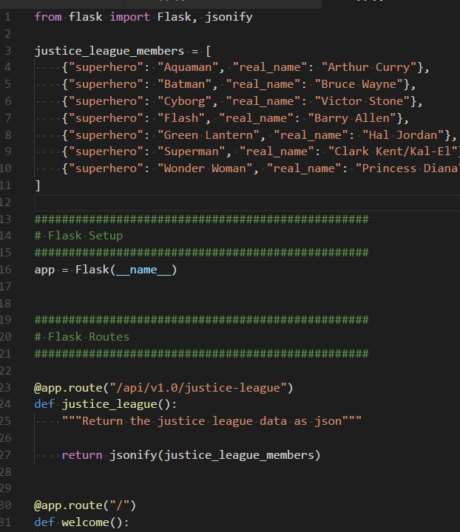

In the justice_league example, the initial data is a list of dictionaries.

To return a list of the samples, do I need to

<http://pandas.pydata.org/pandas-docs/version/0.22/generated/pandas.DataFrame.to_dict.html>

I believe after I create the dataframe – I just say dataframe.to_dict() to convert it to a dictionary

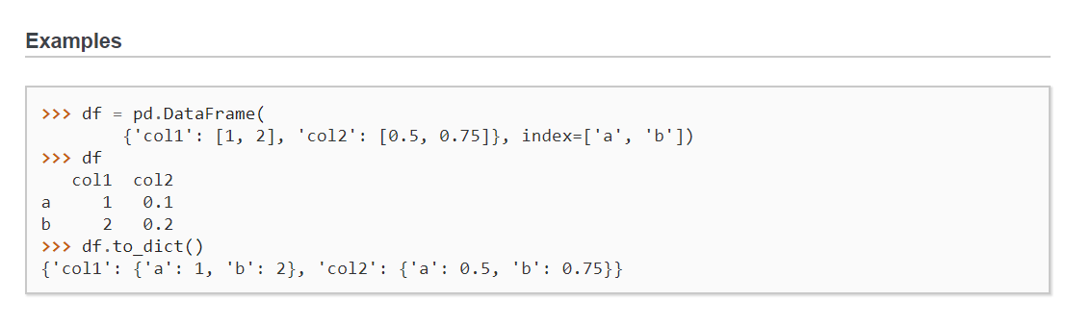



PLOTLY



Attempting the Pie Chart

