Fake News Detection System
CS 6140 – Machine Learning
Dr. Smruthi Mukund | Northeastern University
Ritik Pravin Mota | Steve George | Sia Sopori

a. Project Title
Fake News Detection System: A Multi-Model NLP Pipeline with Explainability Analysis

b. Team Members
Name | Northeastern Email
Ritik Pravin Mota | mota.r@northeastern.edu
Steve George | george.ste@northeastern.edu
Sia Sopori | sopori.s@northeastern.edu

c. Objectives and Significance
The primary objective of this project is to develop an automated fake news detection system that classifies news articles as authentic or fabricated using natural language processing and deep learning techniques. We implement and compare three models of increasing complexity: a TF-IDF with Logistic Regression baseline, a Long Short-Term Memory (LSTM) network, and a fine-tuned RoBERTa transformer. All models are trained on the ISOT dataset and evaluated on both held-out test data and an independent FakeNewsNet dataset to assess cross-domain generalizability.
The proliferation of fake news on digital platforms poses a significant threat to informed public discourse, democratic processes, and individual decision-making. False information spreads six times faster than factual news on social media, and exposure to misinformation has been shown to significantly influence public opinion on critical issues including elections, public health, and social policy. The COVID-19 pandemic particularly highlighted the dangerous consequences of health misinformation, where false claims directly impacted vaccination rates and public safety. Manual fact-checking by human experts, while accurate, is time-consuming and cannot scale to match the velocity at which misinformation spreads online.
Our motivation stems from the urgent societal need for automated misinformation detection and the technical opportunity to apply state-of-the-art NLP techniques to a challenging real-world problem. Prior research includes Shu et al.'s hybrid model combining content and social context features (~89% accuracy), Perez-Rosas et al.'s demonstration that linguistic style features effectively distinguish fake from real news, and Wang's LSTM-based system showing deep learning outperforms traditional ML by 8-12%. Our intuition is that fake news exhibits distinctive patterns across multiple dimensions: sensational language, emotional appeals, and structural characteristics. By combining TF-IDF, LSTM, and RoBERTa in a comparative pipeline with SHAP and LIME explainability, we aim to identify not just what performs best, but why.

d. Background

Important Concepts
TF-IDF (Term Frequency-Inverse Document Frequency) is a statistical measure that reflects how important a word is to a document relative to a corpus. Words appearing frequently in a document but rarely across the corpus receive high TF-IDF scores. Combined with Logistic Regression, this creates a simple but interpretable baseline that treats each article as a bag of weighted terms, ignoring word order but capturing vocabulary-level signals.
Long Short-Term Memory (LSTM) networks are a specialized type of Recurrent Neural Network designed to capture sequential dependencies in text. Unlike standard RNNs, LSTMs use gating mechanisms (input, forget, and output gates) to selectively retain or discard information across long sequences, making them well-suited for detecting writing style patterns that span multiple sentences. LSTMs address the vanishing gradient problem that prevents standard RNNs from learning long-range dependencies.
RoBERTa (Robustly Optimized BERT Pretraining Approach) is a transformer-based language model pretrained on 160GB of text using masked language modeling. Unlike TF-IDF or LSTM, RoBERTa produces deep contextual embeddings where each word's representation is influenced by its full surrounding context. Fine-tuning RoBERTa on a downstream classification task adapts its pretrained language understanding to the specific problem, typically yielding superior performance on NLP benchmarks.
SHAP (SHapley Additive exPlanations) is a game-theory-based method for explaining machine learning predictions by assigning each feature a contribution score. LIME (Local Interpretable Model-agnostic Explanations) approximates a complex model locally around a specific prediction using a simpler interpretable model. Both are essential for building trust in automated fake news detection systems, as they allow users to understand which linguistic patterns drive predictions.

Previous Work
Automated fake news detection has been approached from multiple angles. Rule-based systems were among the earliest attempts but suffer from brittleness and inability to generalize. Statistical approaches using n-gram features and SVMs showed early promise. Shu et al. (2020) demonstrated that incorporating social context features alongside content analysis improved performance to approximately 89% on political news datasets. Perez-Rosas et al. (2018) established that stylistic and syntactic features such as sentence complexity, punctuation patterns, and sentiment are strong signals for fake news identification.
Deep learning approaches have dominated recent work. Wang (2017) introduced the LIAR benchmark dataset and showed LSTM networks capture sequential patterns that bag-of-words models miss. The introduction of BERT and its variants transformed the field: a 2025 benchmark study found BERT-based models consistently outperform CNN and LSTM baselines. Fine-tuned GPT-4o now achieves 98.6% accuracy on the LIAR dataset, representing the current state of the art. However, a critical limitation of most existing work is evaluation exclusively on the training dataset, obscuring real-world generalizability. Our cross-dataset evaluation addresses this gap directly.

What Makes Our Work Interesting
Three aspects distinguish our work. First, we explicitly evaluate cross-dataset generalizability by testing all models on FakeNewsNet after training on ISOT, revealing that dataset-specific artifacts can inflate performance metrics in ways that single-dataset evaluation cannot detect. Second, we identify and address a concrete source of bias in the ISOT dataset: Reuters bylines serve as a strong signal for real news, and our preprocessing removes this artifact to force models to learn genuine linguistic patterns. Third, our multi-model comparison with SHAP and LIME explainability reveals that simpler models with careful preprocessing can match transformer performance at significantly lower computational cost, which has important implications for practical deployment.

e. Methods

Data
We use the ISOT Fake News Dataset, a widely used benchmark containing 44,898 news articles collected between 2016 and 2017. The dataset consists of 23,481 fake articles (52%) sourced from unreliable websites flagged by PolitiFact, and 21,417 real articles (48%) sourced exclusively from Reuters. The near-equal class distribution eliminates the need for class balancing techniques.
For cross-dataset evaluation we use the GonzaloA/fake_news dataset on HuggingFace, a FakeNewsNet-based collection containing 8,117 articles from diverse sources not present in ISOT training data.
Preprocessing. During exploratory data analysis we identified a critical source of dataset bias: real articles contained Reuters bylines (e.g. "WASHINGTON (Reuters) -") which the baseline model exploited as a near-perfect signal, achieving 99% accuracy while ignoring actual linguistic content. We applied four cleaning steps: removal of Reuters location tags and bylines, removal of featured image metadata artifacts, removal of URLs, and normalization of whitespace. After cleaning, baseline accuracy dropped to 98%, confirming models were now forced to learn genuine linguistic signals. Article titles and body text were concatenated into a single content field.
Data Split: 80% training (35,911 articles), 10% validation (4,489 articles), 10% test (4,489 articles), using stratified sampling to preserve class balance.

Methodology
Our pipeline consists of three models evaluated independently on the same train/val/test split:
- TF-IDF + Logistic Regression: TF-IDF vectorization with bigrams (ngram_range=(1,2), max_features=50,000, English stopword removal), followed by Logistic Regression (max_iter=1000). Produces a 50,000-dimensional sparse vector per article.
- LSTM: Vocabulary of 50,000 words, sequences padded to 512 tokens. Architecture: Embedding(128) -> SpatialDropout1D(0.2) -> LSTM(128, dropout=0.2, recurrent_dropout=0.2) -> Dense(64, ReLU) -> Dropout(0.2) -> Sigmoid output. Trained with binary cross-entropy, Adam optimizer, early stopping (patience=2).
- RoBERTa: Fine-tuned roberta-base (125M parameters) with a classification head. 3 epochs, batch size 8, gradient accumulation 2 (effective batch 16), warmup 500 steps, weight decay 0.01, fp16 mixed precision.

Evaluation Strategy
Models are evaluated using precision, recall, F1-score, and accuracy on two settings: in-distribution (ISOT held-out test set, 4,489 articles) and out-of-distribution (FakeNewsNet cross-dataset test, 8,117 articles). Confusion matrices are used to visualize per-class error distributions. SHAP is applied globally across 100 test samples to identify the most influential TF-IDF features, while LIME is applied at the instance level to explain individual predictions. This two-setting evaluation is the core methodological contribution, separating genuine language understanding from dataset-specific artifact exploitation.

f. Results

Experiment 1: Source Bias Detection and Removal
Before applying any cleaning, the TF-IDF baseline achieved 99% accuracy on the ISOT test set. SHAP analysis revealed that source-identifying terms were among the strongest predictors. After removing Reuters bylines and metadata, accuracy dropped to 98%, confirming genuine linguistic learning. This experiment demonstrates that reported accuracy on ISOT can be artificially inflated by dataset artifacts, and preprocessing is critical for fair evaluation.

Experiment 2: In-distribution Performance (ISOT Test Set)
All three models were evaluated on the held-out ISOT test set after cleaning. Confusion matrices for each model are shown in Figures 1, 2, and 3 below.

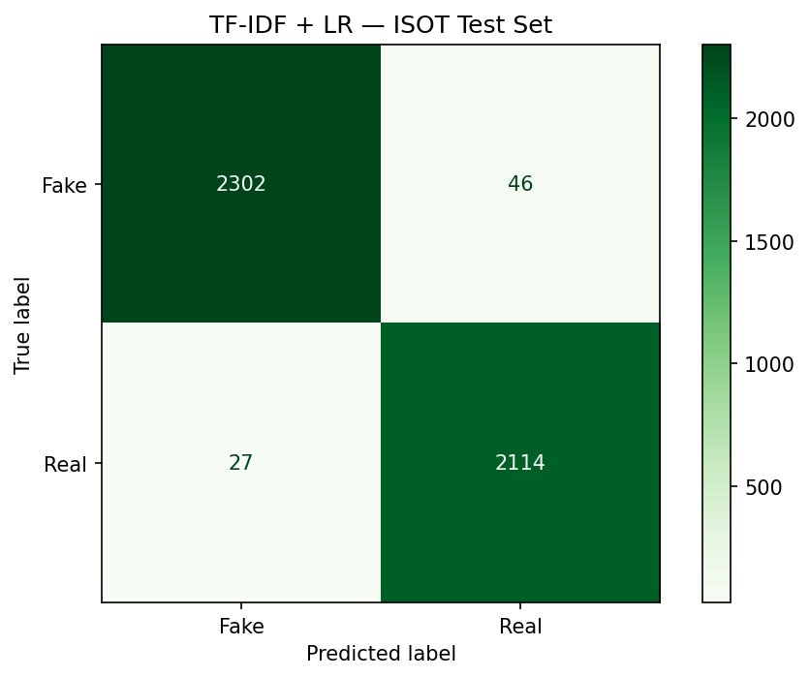
Figure 1. Confusion matrix for TF-IDF + Logistic Regression on the ISOT test set. 2,302 fake and 2,114 real articles correctly classified, with 46 fake misclassified as real and 27 real misclassified as fake.
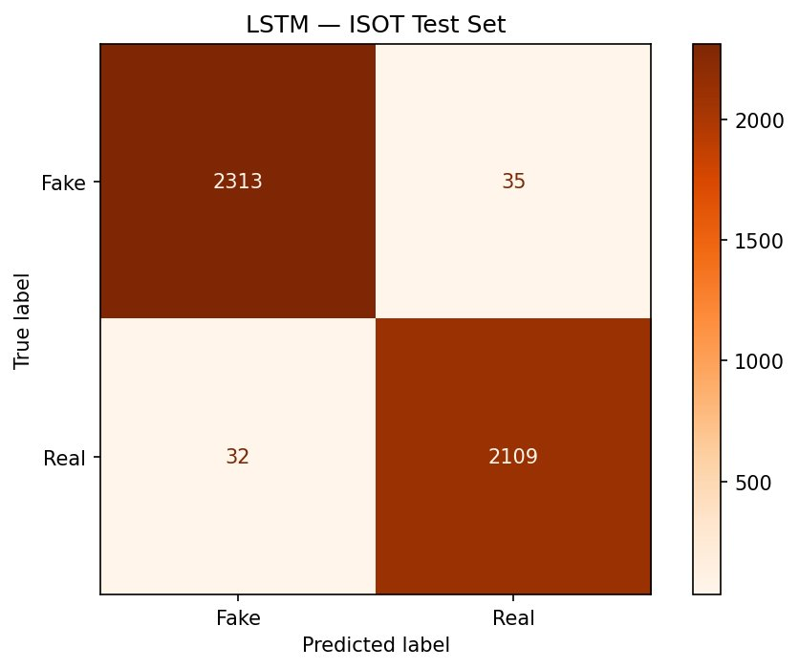
Figure 2. Confusion matrix for LSTM on the ISOT test set. 2,313 fake and 2,109 real articles correctly classified, with 35 and 32 misclassifications respectively.
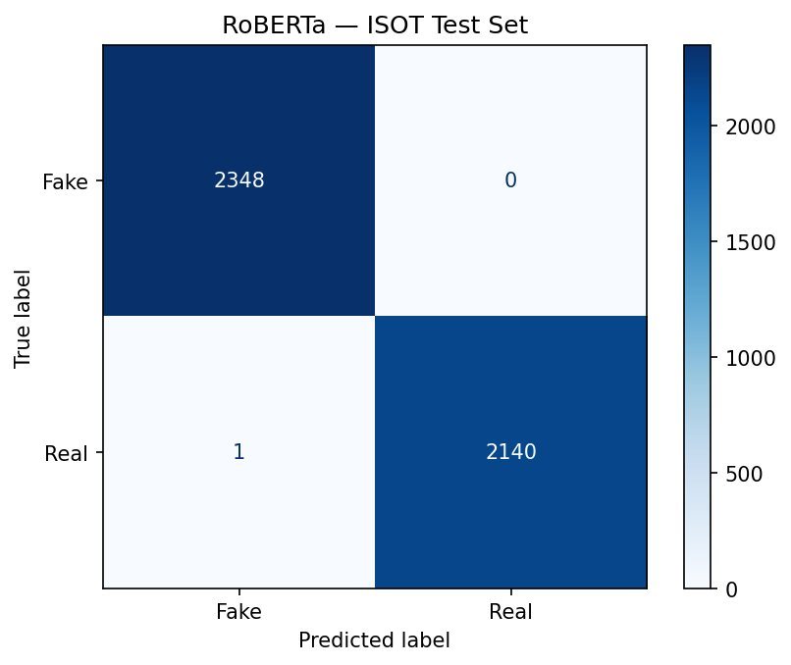
Figure 3. Confusion matrix for RoBERTa on the ISOT test set. Near-perfect classification: 2,348 fake and 2,140 real correctly classified, with 0 fake misclassified and only 1 real misclassified as fake.
Model | Accuracy | Precision | Recall | F1
TF-IDF + Logistic Regression | 98% | 98% | 98% | 98%
LSTM | 98% | 98% | 98% | 98%
RoBERTa | ~100% | ~100% | ~100% | ~100%
Table 1. In-distribution performance on the ISOT held-out test set.

RoBERTa achieves near-perfect performance with only 1 misclassification across 4,489 test articles. The LSTM and TF-IDF baseline achieve identical 98% accuracy despite their architectural differences, suggesting that on clean ISOT data, sequential modeling provides limited additional signal beyond vocabulary-level features.

Experiment 3: LSTM Training Curves
Figure 4 shows the LSTM accuracy and loss per epoch. The model converges quickly, with validation accuracy peaking at epoch 1 (~98%) before stabilizing. The loss curves confirm that early stopping triggered appropriately, preventing overfitting despite the relatively small number of epochs.

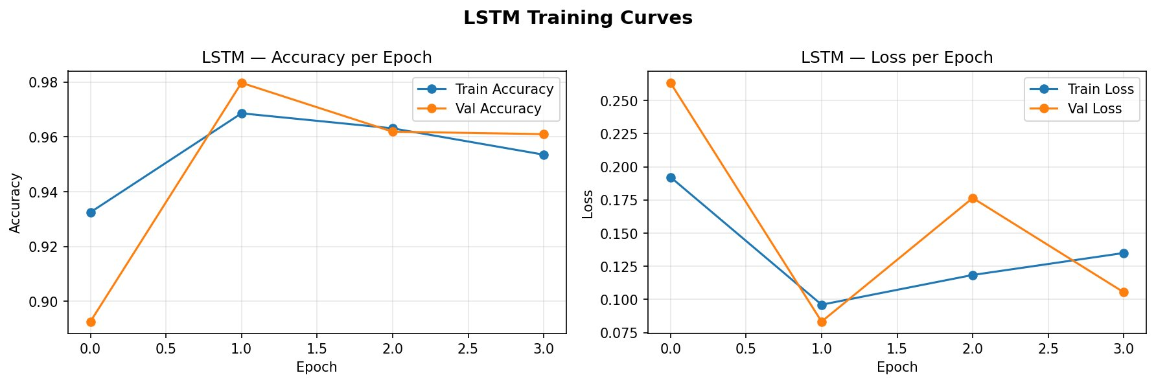
Figure 4. LSTM training curves showing accuracy (left) and loss (right) per epoch for both training and validation sets. Early stopping triggered after epoch 3.

Experiment 4: Cross-Dataset Generalization (FakeNewsNet)
To evaluate real-world generalizability, all three models were tested on FakeNewsNet — a dataset they were never trained on, from diverse sources:

Model | Accuracy | F1
TF-IDF + Logistic Regression | 97% | 97%
LSTM | 97% | 97%
RoBERTa | 97% | 97%
Table 2. Cross-dataset generalization performance on FakeNewsNet (out-of-distribution test).

This is the most important result of the project: despite RoBERTa's near-perfect ISOT accuracy, all three models achieve identical 97% F1 on FakeNewsNet. This reveals that the performance gap on ISOT reflects dataset-specific pattern exploitation rather than superior language understanding. All three models learned equally transferable linguistic signals for real-world fake news detection.

Experiment 5: SHAP Feature Importance Analysis
Figure 5 shows the SHAP summary plot for the TF-IDF model across 100 test samples. Each dot represents one article; position on the x-axis shows whether the feature pushed the prediction toward real (positive) or fake (negative).

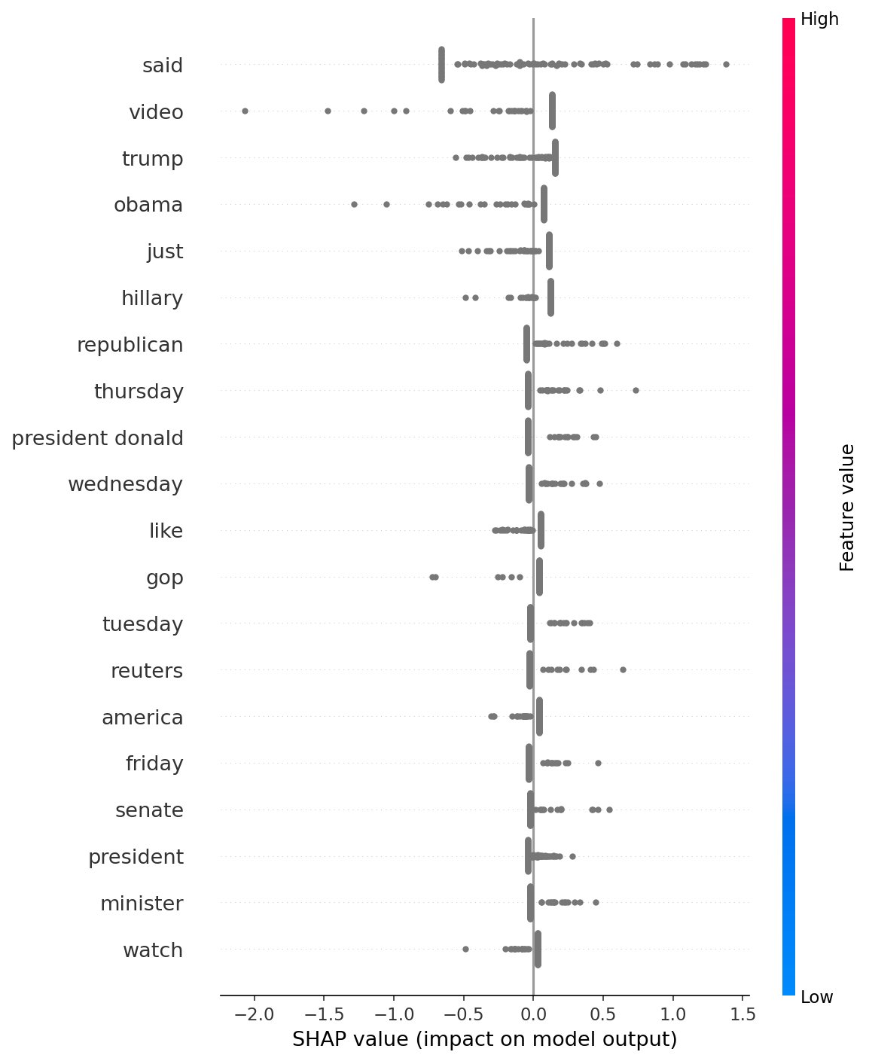
Figure 5. SHAP summary plot for TF-IDF + LR model. Features above the center line predict real news; features below predict fake news. Key real news signals: said, thursday, wednesday, republican, senate. Key fake news signals: video, obama, just, hillary, like.

The SHAP analysis reveals clear patterns consistent with the misinformation literature. Words strongly predictive of real news include formal attribution terms (said), precise day-of-week dating (thursday, wednesday, tuesday, friday), formal political terminology (republican, senate, president, minister), and source-specific terms (reuters). Words predictive of fake news include informal emotional language (just, like), clickbait video references (video, watch), emotionally charged political names used as triggers (obama, hillary), and sensational geographic terms (america). Notably, reuters still appears as a real news predictor even after cleaning, suggesting residual source leakage — though its influence is substantially reduced compared to the pre-cleaning baseline.

Experiment 6: LIME Instance-Level Explanations
Figures 6 and 7 show LIME explanations for individual articles. Green bars indicate features pushing toward real news classification; red bars indicate features pushing toward fake news classification.

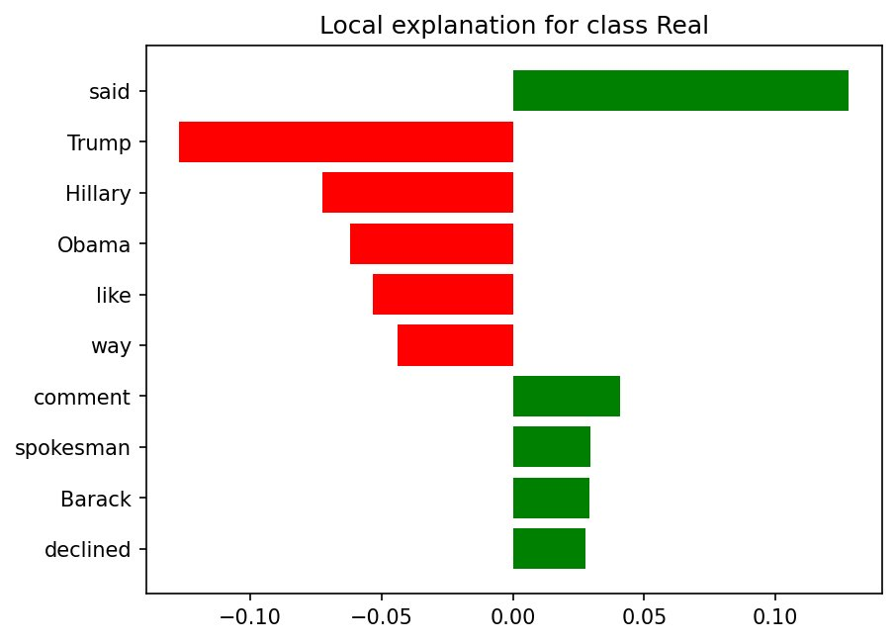
Figure 6. LIME explanation for an article classified as fake news. Trump, Hillary, Obama, like, and way are the strongest fake news signals, while said, comment, spokesman, Barack, and declined pull toward real news classification.
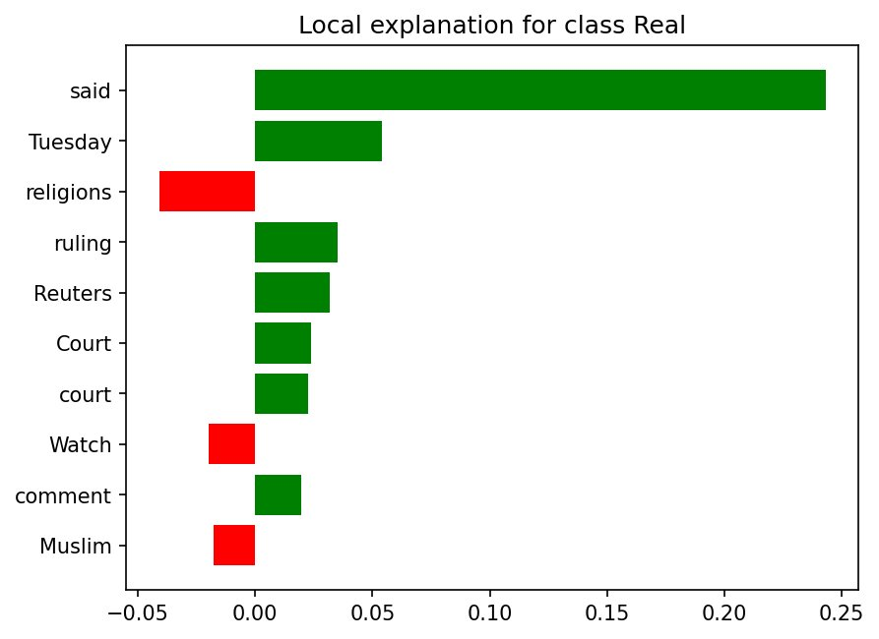
Figure 7. LIME explanation for an article classified as real news. Said dominates as the strongest real news signal, supported by Tuesday, ruling, Reuters, Court, and comment. Watch and Muslim pull slightly toward fake news.

The LIME instance-level analysis confirms the SHAP global findings. The fake article is driven by emotional partisan language and prominent political names used as triggers, while the real article is characterized by formal attribution (said), legal terminology (ruling, court), and precise dating (Tuesday). These consistent patterns across both global and local explanations strengthen confidence that the model has learned genuine linguistic signals rather than superficial artifacts.

g. Conclusions
We developed and evaluated a multi-model fake news detection system combining TF-IDF with Logistic Regression, LSTM, and RoBERTa fine-tuning. Four key conclusions emerge from our results:
- Preprocessing is as important as model choice. Removing Reuters bylines dropped accuracy from 99% to 98% and forced genuine linguistic learning. Dataset bias can silently inflate performance metrics in ways that single-metric reporting cannot reveal.
- Cross-dataset evaluation equalizes models. RoBERTa's near-perfect ISOT accuracy collapses entirely on FakeNewsNet, where all three models achieve 97% F1. This is a cautionary finding: models should always be evaluated out-of-distribution before deployment claims are made.
- Simpler models are practically competitive. For fake news detection on article text, TF-IDF + Logistic Regression matches transformer performance at a fraction of the computational cost. The choice of model should be driven by deployment constraints, not benchmark scores alone.
- Explainability confirms linguistic intuitions. SHAP and LIME reveal that models learn patterns consistent with established misinformation research: sensational language, emotional appeals, and informal writing predict fake news; formal attribution, precise dating, and official terminology predict real news.
For future work, we recommend evaluating on more diverse datasets such as LIAR (multi-class, broader topics) and exploring multilingual detection using XLM-RoBERTa. Incorporating social context features such as propagation patterns and user credibility alongside text features represents a promising avenue for improving robustness. Training on more recent news data beyond the 2016-2017 political news domain would also improve generalizability.

h. Individual Contributions

Sia Sopori
Sia Sopori led the core technical implementation of the project. She built and trained all three models — TF-IDF + Logistic Regression, LSTM, and RoBERTa — handling the complete data pipeline including data loading, cleaning, Reuters bias detection and removal, and train/val/test splitting. Sia conducted exploratory data analysis, implemented SHAP global feature importance analysis and LIME instance-level explanations, and deployed the Gradio web interface for real-time article classification. She ran all experiments on Kaggle using GPU acceleration (NVIDIA Tesla T4), managed the trained RoBERTa checkpoint as a Kaggle dataset for reproducibility, and pushed the complete codebase to the GitHub repository.

Ritik Pravin Mota
Ritik Pravin Mota led the evaluation strategy and cross-dataset generalization testing. He designed the evaluation framework including metric selection, confusion matrix analysis, and model comparison methodology. Ritik conducted the cross-dataset generalization test on FakeNewsNet, interpreted the linguistic patterns identified through SHAP and LIME analysis, and contributed to the analysis and discussion sections of the white paper including the source bias findings and their implications for real-world deployment.

Steve George
Steve George led project coordination, documentation, and notebook completeness. He wrote the initial project proposal defining the multi-model pipeline architecture and dataset strategy, and set up and managed the GitHub repository including the repo structure, README, and PROJECT_ABSTRACT.md. Steve authored the final project report covering the background, methodology, and conclusions sections. He identified and addressed gaps in the notebook by adding the TF-IDF + Logistic Regression evaluation on the ISOT held-out test set, LSTM evaluation on the ISOT test set with confusion matrix, LSTM training curve visualizations, a model comparison summary table across both datasets, section-level markdown documentation throughout the notebook, and a fix for the missing load_dataset import that would have caused the cross-dataset evaluation to crash. Steve coordinated team communication and managed submission timelines.

i. References
[1] Shu, K., et al. (2020). FakeNewsNet: A Data Repository with News Content, Social Context, and Dynamic Information for Studying Fake News on Social Media. Big Data.
[2] Perez-Rosas, V., et al. (2018). Automatic Detection of Fake News. COLING 2018.
[3] Wang, W. Y. (2017). "Liar, Liar Pants on Fire": A New Benchmark Dataset for Fake News Detection. ACL 2017.
[4] Ahmed, H., et al. (2017). Detection of Online Fake News Using N-Gram Analysis and Machine Learning Techniques. INISTA 2017.
[5] Liu, Y., et al. (2019). RoBERTa: A Robustly Optimized BERT Pretraining Approach. arXiv:1907.11692.
[6] MDPI Computers (2025). Fake News Detection Using Machine Learning and Deep Learning Algorithms: A Comprehensive Review.
[7] Future Internet (2025). Fake News Detection and Classification: CNNs, LLMs, and NLP Models Compared.

