8.8 Database Permissions DCL
Data Control Language
Submission by Steve Gonzales for IMT543
Allowed by professor Gridiron: using Postgres.
This assignment requires us to build the Northwinds Database, create some logins (users or roles) and then see how changing the user affects the ability to SELECT or INSERT data.
CREATE ROLE nw_login_1 WITH LOGIN PASSWORD 'imt543';
CREATE ROLE nw_login_2 WITH LOGIN PASSWORD 'imt543';
CREATE ROLE nw_login_3 WITH LOGIN PASSWORD 'imt543';
CREATE ROLE nw_login_4 WITH LOGIN PASSWORD 'imt543';
SELECT * FROM pg_roles WHERE rolname iLIKE 'nw_%' ORDER BY rolname;

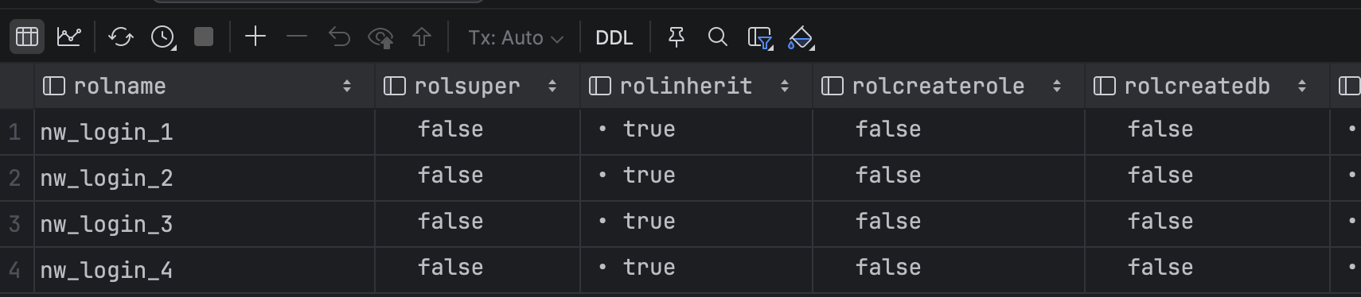

-- Table permissions assignment
-- Table 1 (First login): Select, insert, update
GRANT SELECT, INSERT, UPDATE ON Employees TO nw_login_1;
-- Table 2 (Second Login): Select
GRANT SELECT ON Categories TO nw_login_2;
-- Table 3 (Third Login): Insert, Update, Delete
GRANT INSERT, UPDATE, DELETE ON Customers TO nw_login_3;
-- Table 4 (Fourth Login): Select, Insert
GRANT SELECT, INSERT ON Shippers TO nw_login_4;
SET ROLE postgres;
SELECT 'current_user' lbl, current_user user_name UNION
SELECT 'session_user' lbl, session_user user_name;

Not sure if this is the same in SQL Server, but in Postgres, you have the role that you logged into (current_user) and the role that you are currently using (impersonating). When I create the database and objects, I am logged in as postgres and currently using that role:
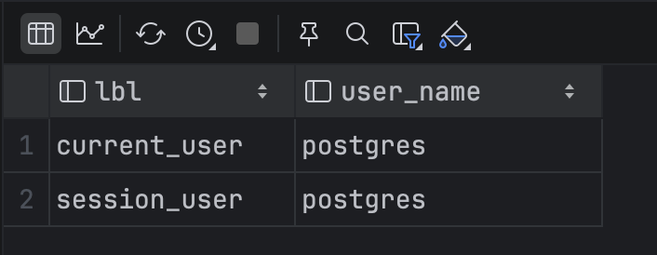
As the postgres user (super admin), I am able to INSERT rows into the customer table:
[2026-02-08 13:16:31] > SET ROLE postgres
[2026-02-08 13:16:31] completed in 4 ms
[2026-02-08 13:16:35] uw.northwinds> INSERT INTO customers (customerid, companyname, contactname, contacttitle, address, city, region, postalcode, country, phone, fax)
VALUES('ALFKI','Alfreds Futterkiste','Maria Anders','Sales Representative','Obere Str. 57','Berlin',NULL,'12209','Germany','030-0074321','030-0076545')
[2026-02-08 13:16:35] 1 row affected in 10 ms

Then I will switch to role nw_login_2 and see if I can SELECT and/or INSERT:
[2026-02-08 13:18:08] uw.northwinds> SET ROLE nw_login_2
[2026-02-08 13:18:08] completed in 5 ms
[2026-02-08 13:21:56] uw.northwinds> SELECT * FROM northwinds.customers
[2026-02-08 13:21:56] 1 row retrieved starting from 1 in 594 ms (execution: 7 ms, fetching: 587 ms)
[2026-02-08 13:22:01] uw.northwinds> INSERT INTO customers (customerid, companyname, contactname, contacttitle, address, city, region, postalcode, country, phone, fax)
VALUES('ANTON','Antonio Moreno Taquería','Antonio Moreno','Owner','Mataderos 2312','México D.F.',NULL,'05023','Mexico','(5) 555-3932',NULL)
[2026-02-08 13:22:01] [42501] ERROR: permission denied for table customers

I can “see” (ie SELECT), but I cannot INSERT. This is because the administrator only granted me SELECT on the customer table:
SET ROLE postgres;
GRANT USAGE ON SCHEMA northwinds TO nw_login_2;
GRANT SELECT ON northwinds.customers TO nw_login_2;

Not sure about SQL Server, but on Postgres, you also have to GRANT USAGE on the schema before a user/role can have any access.

