Statement of Work: AI Delivery Assurance Copilot
Oct 27, 2026 · @Steve
This SOW commits to delivering a working, evaluated AI delivery-assurance copilot over 8 weeks (Oct 19 to Dec 13, 2026), built from the weekly plan in docs/plan/ROADMAP.md.

How to read this SOW
A statement of work is the agreement on what will be delivered, when, and how we will know it is done. Each section answers one question:
Section | The question it answers
Background | Why does this work exist?
Objectives | What outcomes count as success?
Scope | What is included, and just as important, what is not?
Deliverables | What concrete things will be handed over?
Schedule | When does each piece land?
Approach | How will the work be done, and under what rules?
Assumptions, constraints, risks | What must hold true, and what could go wrong?
Acceptance | Who signs off, and against what criteria?
In a client engagement, Scope and Acceptance are where most disputes start, so they are the sections worth the most care.

Background
Delivery teams lose business intent between requirements, implementation and testing, and often cannot answer: "Are we ready to release, and what evidence supports that?" Capstone 4 asks for a governed AI copilot that keeps the Requirement → Acceptance Criterion → Test → Result chain intact and explains release readiness with evidence.
This is a learning project for Steve's cohort. The goal is to understand every part well enough to explain and defend it, so understanding takes priority over speed. Sources: PROJECT_BRIEF.md, Capstone4_usecase_definition.md and the supplied dataset.

Objectives and success criteria
The project succeeds when the copilot answers the golden scenarios with cited evidence, and Steve can explain every design decision behind it.
Objective | Measured by
Answer coverage and readiness questions without AI | Deterministic gap report and readiness decision for release R26.10, every reason traceable to row IDs
Ground every AI output in sources | Each statement cites a document, section or row ID, or is blocked as unsupported
Measure quality from the first AI feature | Golden-scenario scorecard: Week 1 manual baseline as the human reference, Week 3 automated baseline, Week 8 rerun
Keep humans in control | No generated AC or test becomes ACTIVE without an approval record
Know the cost of every call | Model, tokens, latency and cost logged per call; at least two models compared
Generalize beyond the reference data | Set A (Jira) runs through adapters and config without editing core logic
Understand it all | ADRs for each major choice, a weekly journal, and a final walkthrough

Scope
In scope
- A normalized delivery model with provenance and origin (HUMAN, AI_SUGGESTED, AI_APPROVED) on every artifact and link
- Loading and validating the 11 reference CSVs
- Deterministic traceability queries, coverage gap reports and readiness rules
- An LLM client with TokenOps logging, and an acceptance-criteria quality classifier
- A golden-scenario evaluation harness with saved baselines
- Ingestion of the 8 PDFs, chunking with metadata, hybrid and version-aware retrieval
- Grounded generation of ACs and test cases with citations and unsupported-claim checks
- A human review gate and conflict detection across current documents
- Change impact and stale-test detection, plus an LLM explanation of the readiness decision
- Comparison of at least two models, caching and context minimization
- Onboarding Set A (Jira) through an adapter
- A minimal coverage and readiness view with drill-down to evidence
Cut order, if behind
- Sets B (Kanban) and C (Mobile Banking)
- Traceability graph view
- Agentic test execution with approval gates
- Reduce Set A to coverage only
Requirement extraction from PDFs (W4-05) is also stretch, cut as soon as Week 4 runs long.
Without W4-05, requirements come from the supplied requirements.csv, and the schema-validated AC quality classifier (W3-03) covers the brief's structured-output requirement.
Out of scope
- Production deployment, authentication or multi-user hosting
- Real Jira or Azure DevOps integration
- Editing or regenerating the source dataset, which stays read-only
- Any LLM making the readiness decision; rules decide and the LLM only explains

Deliverables
Each deliverable maps to an issue in docs/plan/ISSUES.md and lands through its own branch and PR.
Week | Deliverable | Issues
1 | Glossary and concept diagram, data profile, manual baseline for 5 golden scenarios, stack ADR | W1-01 to W1-04
2 | Delivery model ADR, one-command CSV loader with data-quality report, traceability and coverage gap report, readiness rules v0 | W2-01 to W2-04
3 | LLM wrapper with TokenOps log, 30 hand-labeled ACs, AC quality classifier, evaluation runner with baseline scorecard | W3-01 to W3-04
4 | Structured PDF extraction, chunking ADR, hybrid search with recall@k table, version-aware retrieval | W4-01 to W4-04 (W4-05 stretch)
5 | Citation and unsupported-claim checks, generated ACs and test cases, review queue, conflict report | W5-01 to W5-05
6 | Change impact and stale-test lists, cited readiness summary, model comparison ADR | W6-01 to W6-03
7 | Before/after TokenOps table, adapter contract and Set A onboarding | W7-01, W7-02 (W7-03 stretch)
8 | Coverage and readiness view, final evaluation vs baseline, retrospective and walkthrough | W8-01, W8-02 (W8-03, W8-04 stretch)
Every week also produces a journal entry in docs/journal/week-NN.md.

Schedule and milestones
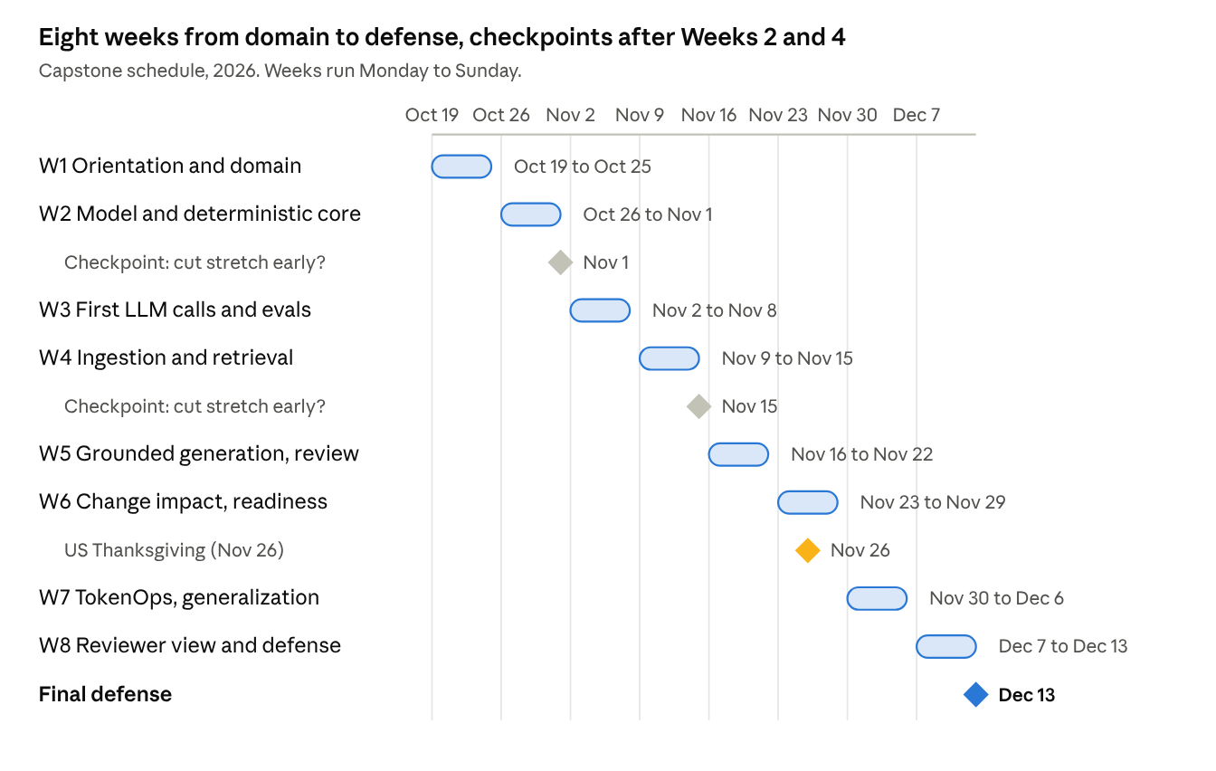
capstone schedule · 8 weeks, 2 checkpoints, final defense
Each week is one milestone. The checkpoints at the end of Weeks 2 and 4 are where stretch work gets cut, early rather than late, and the Week 6 buffer for Thanksgiving comes from cutting stretch work at the Week 4 checkpoint.

Approach and working agreements
The build order is deliberate: domain first, then the deterministic core, then AI with evaluation from day one, then generalization.
- Rules before AI. Anything a query can answer (traceability, coverage, readiness) stays deterministic. The LLM extracts, generates and explains, but never decides readiness.
- Measure from the start. The evaluation harness arrives with the first LLM feature, so every later change is compared to a baseline.
- Cite or block. Every AI output cites document, section or row IDs, or is marked unsupported.
- Human gates. Generated ACs and tests stay DRAFT until approved, with reviewer, time and diff recorded.
- Decisions are written down. Design choices go in ADRs (docs/adr/NNNN-title.md), written by Steve.
- Weekly rhythm. Start: read the week's issues and pick what to cut. During: one issue per branch and PR. End: journal entry and baseline update.
- Teaching mode. Steve writes the code by default; the assistant explains, hints and reviews.

Assumptions, constraints and risks
Assumptions
- 8 to 10 focused hours a week are available.
- The supplied dataset and golden scenarios are the source of truth for evaluation.
- Access to at least two LLMs is available for the model comparison.
Constraints
- The dataset folder is read-only.
- API keys live in .env, never in the repo.
- No paid LLM call runs in a loop or at batch scale without a cost estimate first.
- No new dependency, framework or service without an explanation and a yes.
Risks
Risk | Likelihood | Mitigation
Eight weeks is tight; most weeks combine two themes | High | Cut stretch work in the stated order; check progress at the end of Weeks 2 and 4
Week 6 includes US Thanksgiving (Nov 26) | High | Cut stretch at the Week 4 checkpoint to free time for Week 6
PDF parsing loses tables or the Doc 05 diagram | Medium | Note failures; transcribe the diagram manually if needed
The LLM softens or contradicts a BLOCKED decision | Medium | Rules own the decision; check the summary against it
LLM costs grow during evaluation runs | Medium | TokenOps logging from the first call; caching in Week 7
The Week 2 model does not fit Set A | Medium | Record core changes in an ADR; treat it as a learning outcome

Acceptance and sign-off
Each issue is accepted when its "Done when" criteria in ISSUES.md are met and its PR is merged. The project as a whole is accepted when:
- ☐ The end-to-end scenario (§26 of the use-case definition) can be demoed
- ☐ The final evaluation is rerun and compared with the Week 3 baseline and the Week 1 manual baseline
- ☐ Every AI output in the demo cites its sources or is marked unsupported
- ☐ Every major design choice has an ADR Steve can explain and defend
- ☐ The §1P questions ("What the team should be able to explain") have prepared answers
Checkpoints: scope review at the end of Week 2 (Nov 1, 2026) and Week 4 (Nov 15, 2026); final defense by Dec 13, 2026.
Sign-off: Steve, as project owner.
Open question: does the cohort have a reviewer or instructor who should also sign off, and on what date is the defense?

