FULL STACK DEVELOPMENT
(SKILL ENHANCEMENT COURSE)
Experiment:1
- Lists, Links and Images)
1a)
Aim: Write a HTML program, to explain the working of lists. Note: It should have an ordered list, unordered list, nested lists and ordered list in an unordered list and definition lists.

Source code:

<doctype html>
<html>
<head>
<title>work with lists</title>
</head>
<body>
<h1>Types of lists</h1>
<ol>
<li>ordered list</li>
<li>unordered list</li>
<li>description list</li>
<li>nested list</li>
</ol>
<h2>Description about the Lists</h2>
<dl>
<dt>ordered list</dt>
<dd>An ordered list starts with the ol tag. Each list item starts with the li tag.
The list items will be marked with numbers by default:
</dd>
<dt>unordered list</dt>
<dd>An unordered list starts with the ul tag. Each list item starts with the li tag.

The list items will be marked with bullets (small black circles) by default:</dd>
<dt>description list</dt>
<dd>A description list is a list of terms, with a description of each term.
The dl tag defines the description list, the dt tag defines the term (name), and the dd tag describes each term:
</dd>
<dt>nested list</dt>
<dd>Lists can be nested (list inside list):</dd>

</dl>
<h2>fullstack technologies</h2>
<ol>
<li>FRONT END TECHNOLOGIES</li>
<ul type="square">
<li>HTML</li>
<li>CSS</li>
<li>JAVASCRIPT</li>
</ul>
<li>SERVER SIDE TECHNOLOGIES</li>
<li>DATABASE SIDE TECHNOLOGIES</li>
</ol>
</body>
</html>

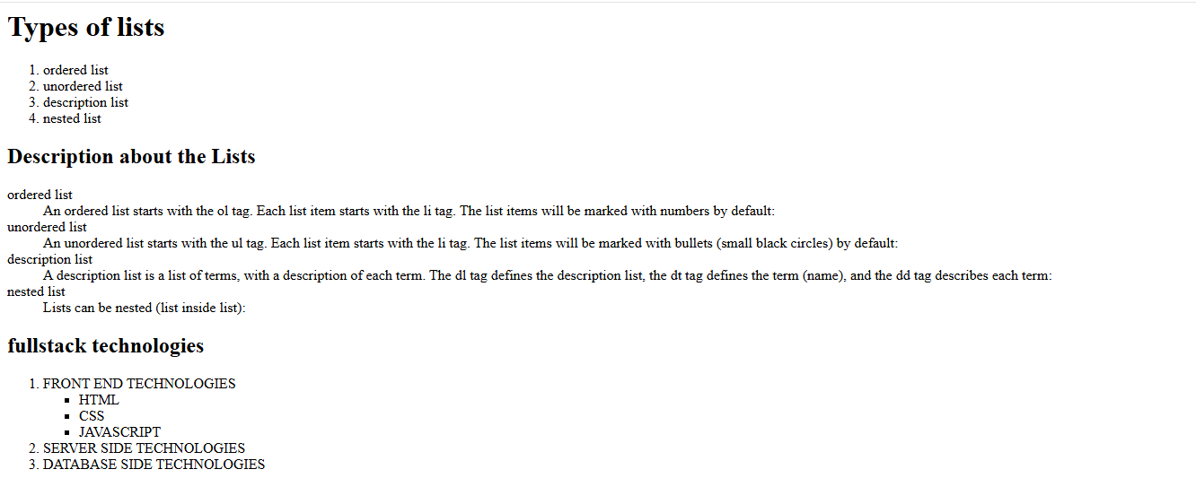

2b)
Aim: Write a HTML program, to explain the working of hyperlinks using tag and href, target Attributes.

Source code:
<!--working with anchor tag-->
<!doctype html>
<html>
<head><title>navigation bar</title></head>
<body>
<div style="background-color: bisque;">
<h3 align="center">ST.ANN'S COLLEGE OF ENGINEERING & TECHNOLOGY</h3>
<a href="#" target="_blank">Home</a>
<a href="1c.html" target="_blank">contact us</a>

</div>
<pre>
HTML Links
Links are found in nearly all web pages. Links allow users to click their way from page to page.

HTML Links - Hyperlinks
HTML links are hyperlinks.

You can click on a link and jump to another document.

When you move the mouse over a link, the mouse arrow will turn into a little hand.

Note: A link does not have to be text. A link can be an image or any other HTML element!
HTML Links - Syntax
The HTML <a> tag defines a hyperlink.

The most important attribute of the a element is the href attribute, which indicates the link's destination.

The link text is the part that will be visible to the reader.

Clicking on the link text, will send the reader to the specified URL address.

HTML Links - The target Attribute
By default, the linked page will be displayed in the current browser window. To change this, you must specify another target for the link.

The target attribute specifies where to open the linked document.

The target attribute can have one of the following values:

_self - Default. Opens the document in the same window/tab as it was clicked
_blank - Opens the document in a new window or tab
_parent - Opens the document in the parent frame
_top - Opens the document in the full body of the window

</pre>
</body>
</html>
Output:
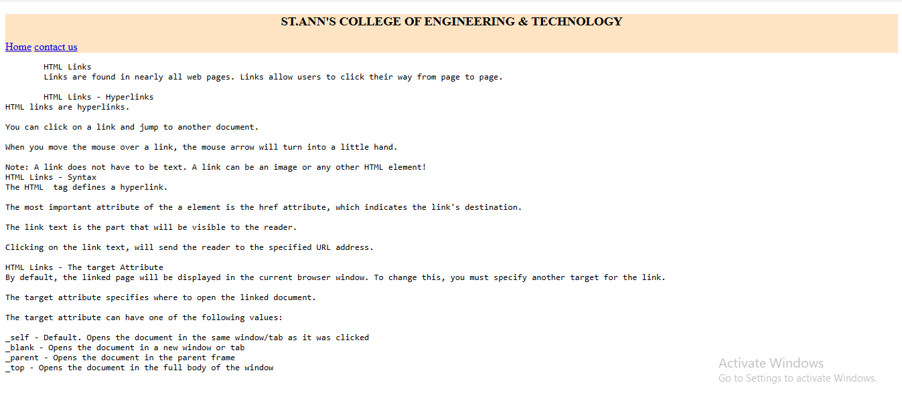

c.
Aim: Create a HTML document that has your image and your friend’s image with a specific height and width. Also when clicked on the images it should navigate to their respective profiles.

Source code:
<!--create a html document that has your image and yours friends image with specific height and width-->
<!doctype html>
<html>
<head>
<title>images</title>
</head>
<body align="center">
<pre>Dr.P.Harini
Head Of the Department,CSE.
SACET.
</pre>
<a href="2a.html" target="_blank">
<img src="csedept.jpg" alt="HOD" width="300" height="300">
</a>
<pre>Dr.P.Jagadesshbabu
Principal,
SACET.
</pre>
<a href="2a.html" target="_blank">
<img src="eeedept.jpg" alt="Principal" width="300" height="300">
</a>
</body>
</html>
Output:
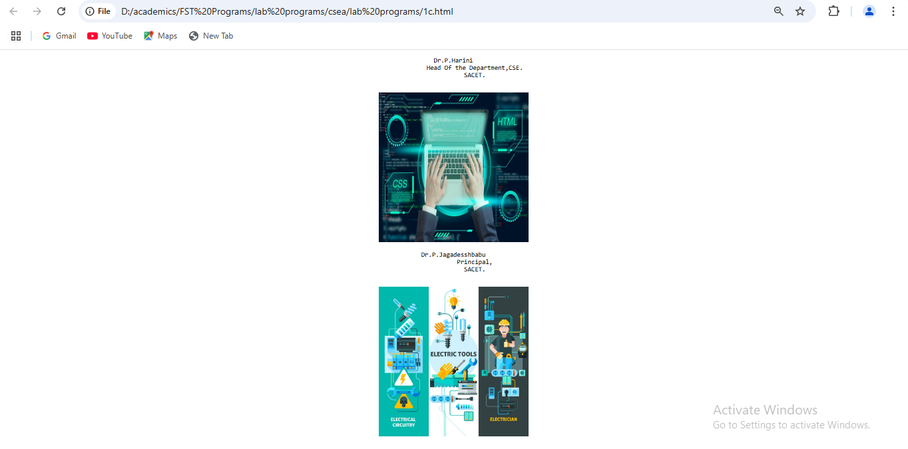

1d)
Aim:Write a HTML program, in such a way that, rather than placing large images on a page, the preferred technique is to use thumbnails by setting the height and width parameters to something like to 100*100 pixels. Each thumbnail image is also a link to a full sized version of the image. Create an image gallery using this technique.

source code:
<!-- Write a HTML program, in such a way that, rather than placing large images on a page,
the preferred technique is to use thumbnails by setting the height and width parameters
to something like to 100*100 pixels. -->
<!doctype html>
<html>
<head>
<title>thumbnails</title>
</head>
<body>
<h3>gallery</h3>
<a href="hod.png" taget="_blank">
<img src="hod.png" alt="hod" widht="100" height="100">
</a>
<a href="mypic.jpg" taget="_blank">
<img src="mypic.jpg" alt="tss" widht="100" height="100">
</a>
<a href="hod.png" taget="_blank">
<img src="atp.png" alt="atp" widht="100" height="100">
</a>
<a href="hod.png" taget="_blank">
<img src="dnb.png" alt="dnb" widht="100" height="100">
</a>
<a href="hod.png" taget="_blank">
<img src="pvss.png" alt="pvss" widht="100" height="100">
</a>
<a href="hod.png" taget="_blank">
<img src="ramesh.jpg" alt="ramesh" widht="100" height="100">
</a>

</body>
</html>

output:
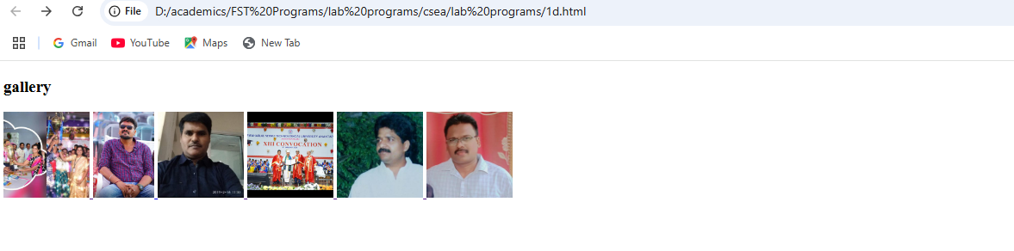
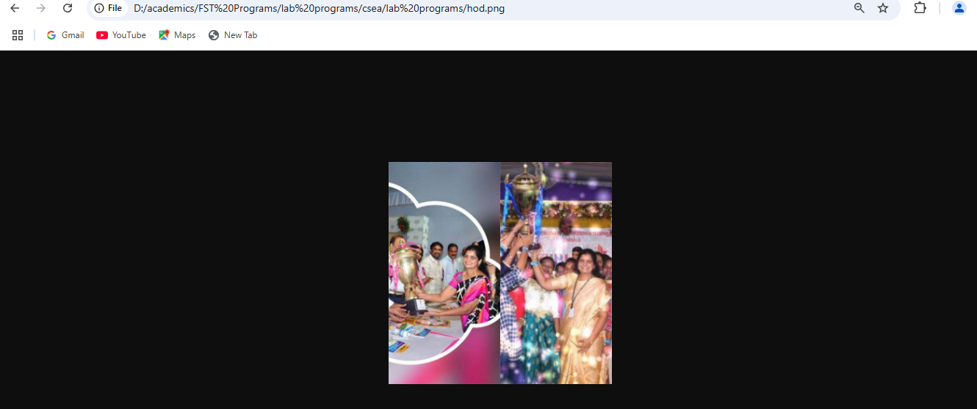
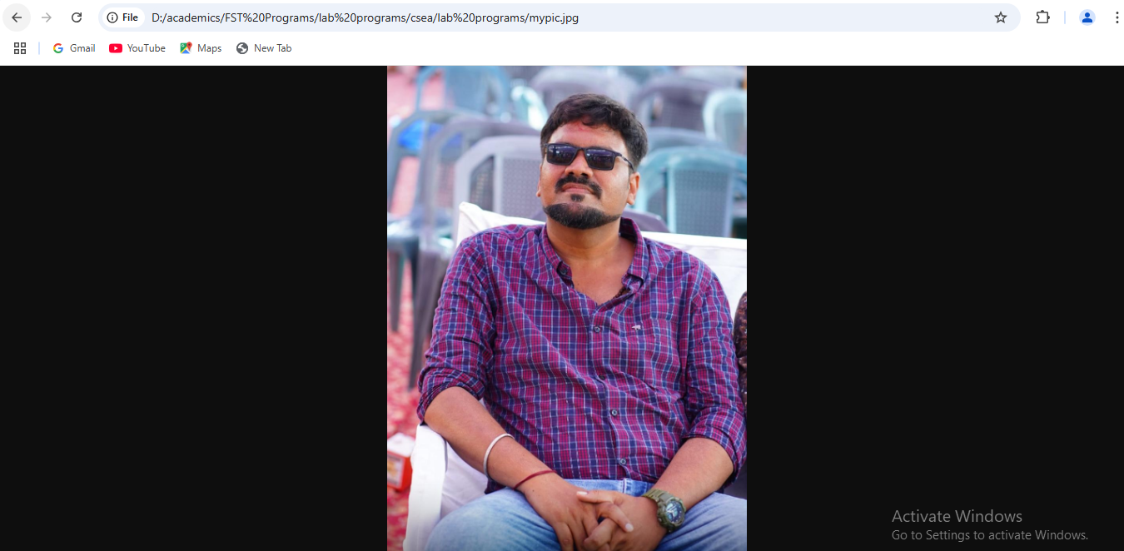

Experiment:2
HTML Tables
2a)
Aim:write a html program to explain the working of tables using <table><tr>td><th> tags and
attributes :border,rowspan and colspan.

Source code:

<!working with table,th,tr,td elements with cell spacing and cell padding
<!doctype html>
<html>
<head></head>
<style>
table,th,td{
border: 3px solid red;
border-spacing: 20px;
}
th,td{
padding:20px;
}
</style>
<body>
<table>
<th>sino</th>
<th>name of the student</th>
<th>hallticket number</th>
<th>phone number</th>
<th>email id</th>
<th>address</th>
<tr>
<td>1</td>
<td>steve jobs</td>
<td>566</td>
<td>9885924188</td>
<td>stevejobs@gmail.com</td>
<td>kothapeta,chirala</td>
</tr>
<tr>
<td>2</td>
<td>steveharris</td>
<td>567</td>
<td>9885924189</td>
<td>sacet623@gmail.com</td>
<td>kothapet,chirala</td>
</tr>
<tr>
<td>3</td>
<td>jhon smith</td>
<td>568</td>
<td>9885924187</td>
<td>jhonsmith2gmail.com</td>
<td>iltd colony,chirala</td>
</tr>
<tr>
<td>4</td>
<td>petterpaul</td>
<td>569</td>
<td>9885924187</td>
<td>petterpaul@gmail.com</td>
<td>perala,chirala</td>
</tr>
<tr>
<td>5</td>
<td>richarson</td>
<td>570</td>
<td>9885924156</td>
<td>ricjard@gmail.com</td>
<td>perala,chirala</td>
</tr>
</table>
</body>
</html>

Output:

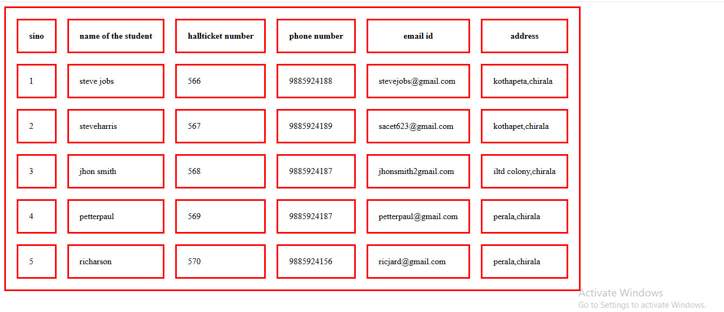

b. Write a HTML program, to explain the working of tables by preparing a timetable. (Note: Use tag to set the caption to the table & also use cell spacing, cell padding, border, rowspan, colspan etc.).

SOURCE CODE:

<!--working with table and colspan and rowspan-->
<!doctype html>
<html>
<head></head>
<style>
th,td{
padding:20px;
border:2px solid red;
}
</style>
<body>
<table border="3" style="border-collapse: collapse;">
<caption>TIMETABEL</caption>
<th>day</th>
<th>9.00-10.00</th>
<th>10.00-11.00</th>
<th>11.00-12.00</th>
<th>12.00-12.50</th>
<th>12.50-1.50</th>
<th>1.50-2.50</th>
<th>2.50-3.50</th>
<tr>
<td>mon</td>
<td colspan="3">lab</td>
<td rowspan="6">lunch</td>
<td>os</td>
<td>java</td>
<td>msd</td>
</tr>
<tr>
<td>tue</td>
<td>cns</td>
<td>os</td>
<td>java</td>
<td colspan="3">msd lab</td>
</tr>
<tr>
<td>wed</td>
<td colspan="3">lab</td>
<td>os</td>
<td>java</td>
<td>msd</td>
</tr>
<tr>
<td>thu</td>
<td colspan="3">lab</td>

<td>os</td>
<td>java</td>
<td>msd</td>
</tr>

<tr>
<td>fri</td>
<td colspan="3">lab</td>

<td>os</td>
<td>java</td>
<td>msd</td>
</tr>
<tr>
<td>sat</td>
<td colspan="3">lab</td>

<td>os</td>
<td>java</td>
<td>msd</td>
</tr>

</table>
</body>
</html>

OUTPUT:
TIMETABLE

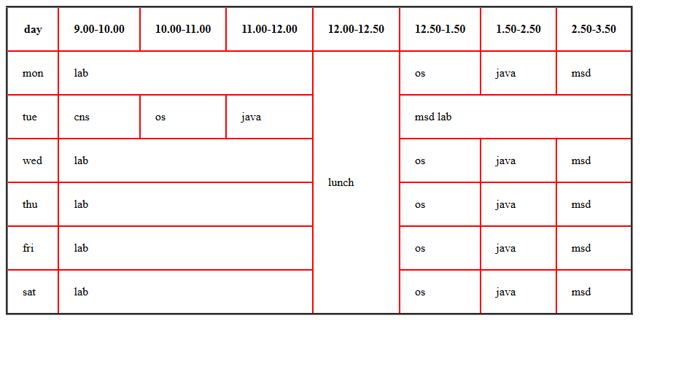

c. Write a HTML program, to explain the working of forms by designing Registration form. (Note: Include text field, password field, number field, date of birth field, checkboxes,radio buttons,list boxes using and two buttons ie:submit and reset. Use tables to provide a better view).
Source Code:
<!DOCTYPE html>
<html>
<head></head>
<style>
table,th,td{
padding:10px;
border-spacing: 10px;
}
</style>
<body style="background-color: beige;">
<form>
<table>
<caption>Registration Form</caption>
<tr>
<td>
<label for="firstname">Enter first name</lable>
</td>
<td>
<input type="text" id="firstname" name="firstname" placeholder="enter firstname">
</td>
</tr>
<tr>
<td>
<label for="lastname">lastname</lable>
</td>
<td>
<input type="text" id="lastname" name="lastname" placeholder="eter lastname">
</td>
</tr>
<tr>
<td>
<label for="emailid">enter emailid</label>
</td>
<td>
<input type="email" id="email" name="email" placeholder="enter email id">
</td>

</tr>
<tr>
<td>
<lable for="password">new password</lable>
</td>
<td>
<input type="password" id="password" name="password" placeholder="set password">
</td>
</tr>
<tr>
<td>
<lable for="password">re-enter password</lable>
</td>

<td>
<input type="password" id="password" name="password" placeholder="re-typepassword">
</td>
</tr>
<tr>
<td>
<lable for="age">enter age</lable>
</td>
<td>
<input type="number" id="age" name="age" placeholder="select age" >
</td>
</tr>
<tr>
<td>
<lable for="dob">date of birth</lable>
</td>
<td>
<input type="date" id="dob" name="dob" >
</td>
</tr>
<tr>
<td>
<span>gender</span>
</td>
<td>
<label for="male">male</label>
<input type="radio" id="male" name="gender" >
<label for="female">female</label>
<input type="radio" id="female" name="gender" >
<label for="transgender">transgender</label>
<input type="radio" id="transgender" name="gender" >
</td>
</tr>
<tr>
<td>
<span>Hobbies</span>
</td>
<td>
<label for="tv">watching tv</label>
<input type="checkbox" id="tv" name="hobbies" >
<label for="games">playing games</label>
<input type="checkbox" id="games" name="hobbies" >
<label for="reading">reading books</label>
<input type="checkbox" id="reading" name="hobbies" >

</td>
</tr>
<td>
<label for="country">country</label>
</td>
<td>
<select id="country" name="country">
<option value="">seelct your country</option>
<option value="india">india</option>
<option value="russia">russia</option>
<option value="australia">australia</option>
</select> </td>
<tr>
<td>
<lable for="comments">comments</lable>
</td>
<td>
<textarea id="comments" name="comments" placeholder="enter comments"></textarea>
</td>
</tr>
<tr>
<td>
<span>favourite food</span>
</td>
<td>
<input list="favfood" placeholder="favourite food">
<datalist id="favfood">
<option value="idly">idly</option>
<option value="idly">idly</option>
<option value="idly">idly</option>
</datalist>
</td>

</tr>
<tr>
<td>
<button>submit</button>

</td>
<td>
<button>reset</button>
</td>
</tr>
</table>
</form>
</body>
</html>
Output:
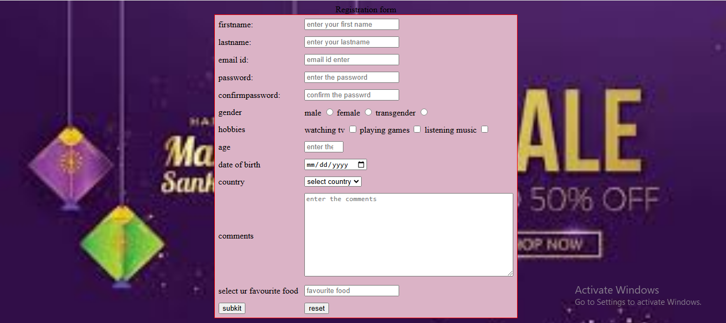

d. Write a HTML program, to explain the working of frames, such that page is to be divided into 3 parts on either direction. hyperlink. And also◊ paragraph, third frame ◊ image, second frame ◊(Note: first frame make sure of using “no frame” attribute such that frames to be fixed).
Source code:
<!DOCTYPE html>
<html>
<head>
<title>Frames Example</title>
</head>
<body>
<iframe src="image.html" width="1250" height="2100" frameborder="0"></iframe>
<iframe src="paragraph.html" width="1200" height="100" frameborder="0"></iframe>
<iframe src="hyperlink.html" width="1200" height="100" frameborder="0"></iframe>

</body>
</html>

Image.html:
<!DOCTYPE html>
<html>
<head>
<title>Image Frame</title>
</head>
<body>
<img src="ajio1.PNG" alt="Example Image" style="width:100%; height:100%;">
<img src="ajio2.PNG" alt="Example Image" style="width:100%; height:100%;">
<img src="ajio3.PNG" alt="Example Image" style="width:100%; height:100%;">
<img src="ajio4.PNG" alt="Example Image" style="width:100%; height:100%;">
<img src="ajio5.PNG" alt="Example Image" style="width:100%; height:100%;">

</body>
</html>

Paragraph.html:
<!DOCTYPE html>
<html>
<head>
<title>Paragraph Frame</title>
</head>
<body>
<p>This is an example paragraph to demonstrate the use of frames in HTML. Frames allow you to divide the browser window into multiple sections, each capable of displaying a different document.</p>
</body>
</html>

Hyperlink.html
<!DOCTYPE html>
<html>
<head>
<title>Hyperlink Frame</title>
</head>
<body>
<a href="https://www.example.com" target="_blank">Visit Example.com</a>
</body>
</html>

Output:
