FULL STACK DEVELOPMENT

(SKILL ENHANCEMENT COURSE)

Experiment:1

1. Lists, Links and Images)

1a)

Aim: Write a HTML program, to explain the working of lists. Note: It should have an ordered list, unordered list, nested lists and ordered list in an unordered list and definition lists.

Source code:

<doctype html>

    <html>

        <head>

            <title>work with lists</title>

        </head>

        <body>

            <h1>Types of lists</h1>

            <ol>

                <li>ordered list</li>

                <li>unordered list</li>

                <li>description list</li>

                <li>nested list</li>

            </ol>

            <h2>Description about the Lists</h2>

            <dl>

                <dt>ordered list</dt>

                <dd>An ordered list starts with the ol tag. Each list item starts with the li tag.

                    The list items will be marked with numbers by default:

                </dd>

                <dt>unordered list</dt>

                <dd>An unordered list starts with the ul tag. Each list item starts with the li tag.

                    The list items will be marked with bullets (small black circles) by default:</dd>

                <dt>description list</dt>

                <dd>A description list is a list of terms, with a description of each term.

                    The dl tag defines the description list, the dt tag defines the term (name), and the dd tag describes each term:

                </dd>

                <dt>nested list</dt>

                <dd>Lists can be nested (list inside list):</dd>

            </dl>

            <h2>fullstack technologies</h2>

            <ol>

                <li>FRONT END TECHNOLOGIES</li>

                <ul type="square">

                    <li>HTML</li>

                    <li>CSS</li>

                    <li>JAVASCRIPT</li>

                </ul>

                <li>SERVER SIDE TECHNOLOGIES</li>

                <li>DATABASE SIDE TECHNOLOGIES</li>

            </ol>

      </body>

    </html>

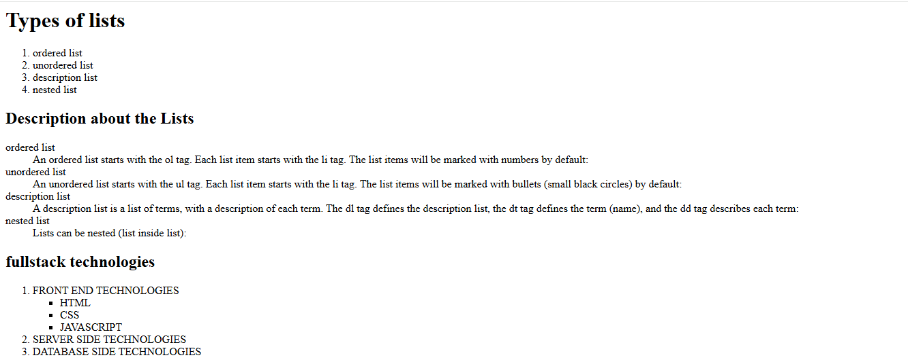

2b)

Aim: Write a HTML program, to explain the working of hyperlinks using tag and href, target Attributes.

Source code:

<!--working with anchor tag-->

<!doctype html>

<html>

    <head><title>navigation bar</title></head>

    <body>

        <div style="background-color: bisque;">

        <h3 align="center">ST.ANN'S COLLEGE OF ENGINEERING & TECHNOLOGY</h3>

        <a href="#" target="_blank">Home</a>

        <a href="1c.html" target="_blank">contact us</a>

    </div>

    <pre>

        HTML Links

        Links are found in nearly all web pages. Links allow users to click their way from page to page.

        HTML Links - Hyperlinks

HTML links are hyperlinks.

You can click on a link and jump to another document.

When you move the mouse over a link, the mouse arrow will turn into a little hand.

Note: A link does not have to be text. A link can be an image or any other HTML element!

HTML Links - Syntax

The HTML <a> tag defines a hyperlink.

The most important attribute of the a element is the href attribute, which indicates the link's destination.

The link text is the part that will be visible to the reader.

Clicking on the link text, will send the reader to the specified URL address.

HTML Links - The target Attribute

By default, the linked page will be displayed in the current browser window. To change this, you must specify another target for the link.

The target attribute specifies where to open the linked document.

The target attribute can have one of the following values:

_self - Default. Opens the document in the same window/tab as it was clicked

_blank - Opens the document in a new window or tab

_parent - Opens the document in the parent frame

_top - Opens the document in the full body of the window

    </pre>

    </body>

</html>

Output:

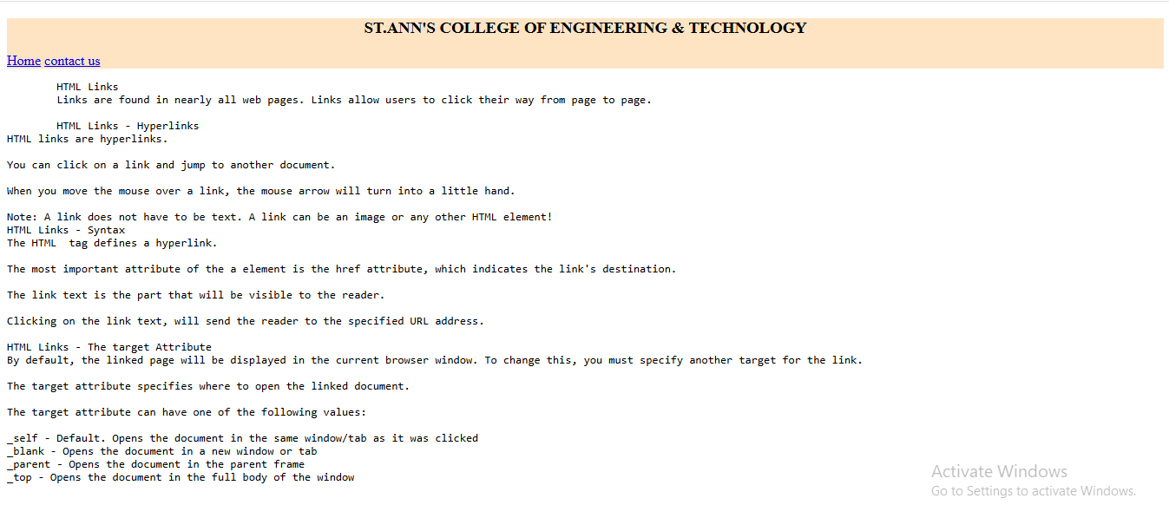

c.

Aim: Create a HTML document that has your image and your friend’s image with a specific height and width. Also when clicked on the images it should navigate to their respective profiles.

Source code:

<!--create a html document that has your image and yours friends image with specific height and width-->

<!doctype html>

<html>

    <head>

        <title>images</title>

    </head>

    <body align="center">

        <pre>Dr.P.Harini

            Head Of the Department,CSE.

            SACET.

        </pre>

        <a href="2a.html" target="_blank">

        <img src="csedept.jpg" alt="HOD" width="300" height="300">

    </a>

        <pre>Dr.P.Jagadesshbabu

            Principal,

            SACET.

        </pre>

        <a href="2a.html" target="_blank">

        <img src="eeedept.jpg" alt="Principal" width="300" height="300">

    </a>

    </body>

</html>

Output:

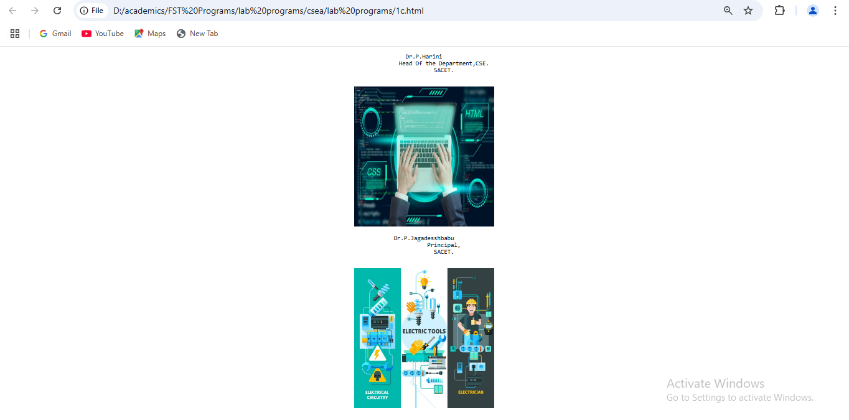

1d)

Aim:Write a HTML program, in such a way that, rather than placing large images on a page, the preferred technique is to use thumbnails by setting the height and width parameters to something like to 100*100 pixels. Each thumbnail image is also a link to a full sized version of the image. Create an image gallery using this technique.

source code:

<!-- Write a HTML program, in such a way that, rather than placing large images on a page,

the preferred technique is to use thumbnails by setting the height and width parameters

to something like to 100*100 pixels. -->

<!doctype html>

<html>

<head>

    <title>thumbnails</title>

</head>

<body>

<h3>gallery</h3>

<a href="hod.png" taget="_blank">

<img src="hod.png" alt="hod" widht="100" height="100">

</a>

<a href="mypic.jpg" taget="_blank">

<img src="mypic.jpg" alt="tss" widht="100" height="100">

</a>

<a href="hod.png" taget="_blank">

<img src="atp.png" alt="atp" widht="100" height="100">

</a>

<a href="hod.png" taget="_blank">

<img src="dnb.png" alt="dnb" widht="100" height="100">

</a>

<a href="hod.png" taget="_blank">

<img src="pvss.png" alt="pvss" widht="100" height="100">

</a>

<a href="hod.png" taget="_blank">

<img src="ramesh.jpg" alt="ramesh" widht="100" height="100">

</a>

</body>

</html>

output:

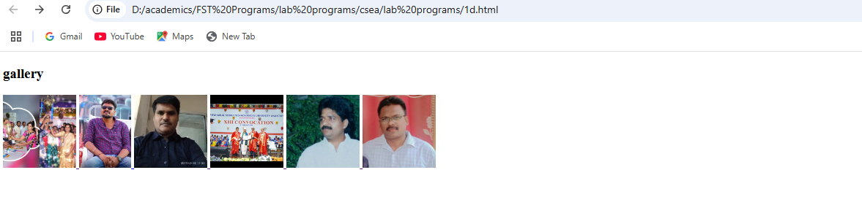

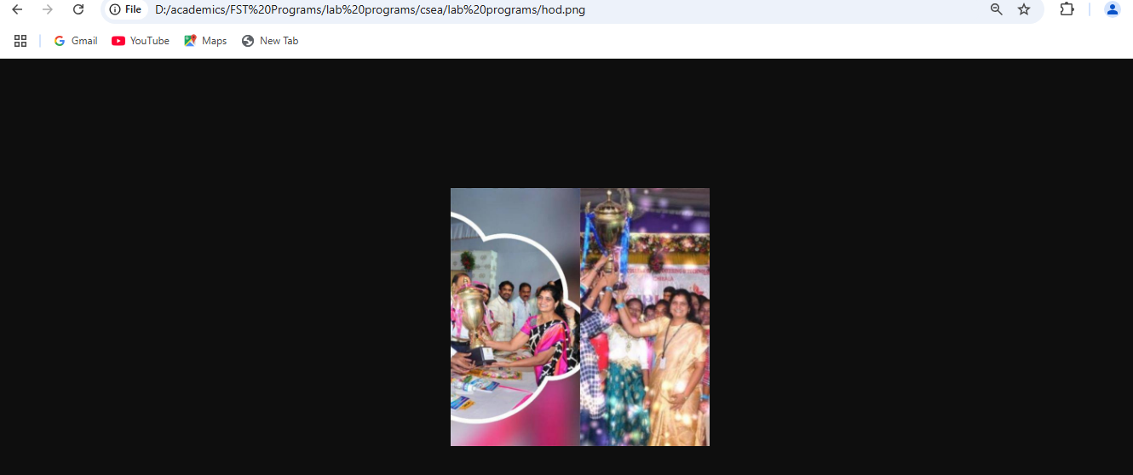

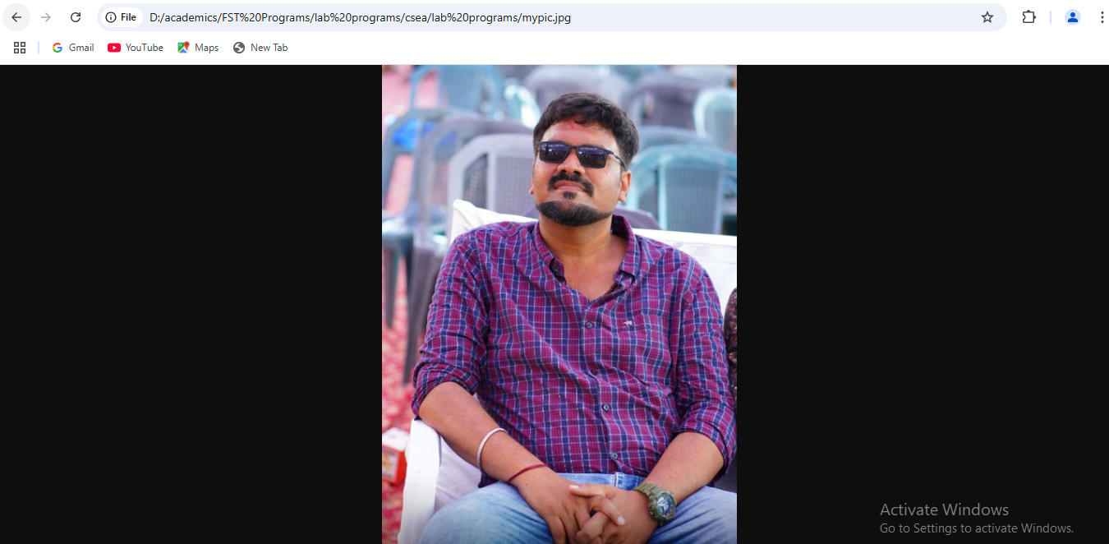

Experiment:2

HTML Tables

2a)

Aim:write a html program to explain the working of tables using <table><tr>td><th> tags and

attributes :border,rowspan and colspan.

Source code:

<!working with table,th,tr,td elements with cell spacing and cell padding

<!doctype html>

<html>

    <head></head>

    <style>

        table,th,td{

            border: 3px solid red;

            border-spacing: 20px;

        }

        th,td{

            padding:20px;

        }

    </style>

    <body>

        <table>

            <th>sino</th>

            <th>name of the student</th>

            <th>hallticket number</th>

            <th>phone number</th>

            <th>email id</th>

            <th>address</th>

            <tr>

                <td>1</td>

                <td>steve jobs</td>

                <td>566</td>

                <td>9885924188</td>

                <td>stevejobs@gmail.com</td>

                <td>kothapeta,chirala</td>

            </tr>

            <tr>

                <td>2</td>

                <td>steveharris</td>

                <td>567</td>

                <td>9885924189</td>

                <td>sacet623@gmail.com</td>

                <td>kothapet,chirala</td>

            </tr>

            <tr>

                <td>3</td>

                <td>jhon smith</td>

                <td>568</td>

                <td>9885924187</td>

                <td>jhonsmith2gmail.com</td>

                <td>iltd colony,chirala</td>

            </tr>

            <tr>

                <td>4</td>

                <td>petterpaul</td>

                <td>569</td>

                <td>9885924187</td>

                <td>petterpaul@gmail.com</td>

                <td>perala,chirala</td>

            </tr>

            <tr>

                <td>5</td>

                <td>richarson</td>

                <td>570</td>

                <td>9885924156</td>

                <td>ricjard@gmail.com</td>

                <td>perala,chirala</td>

            </tr>

        </table>

    </body>

</html>

Output:

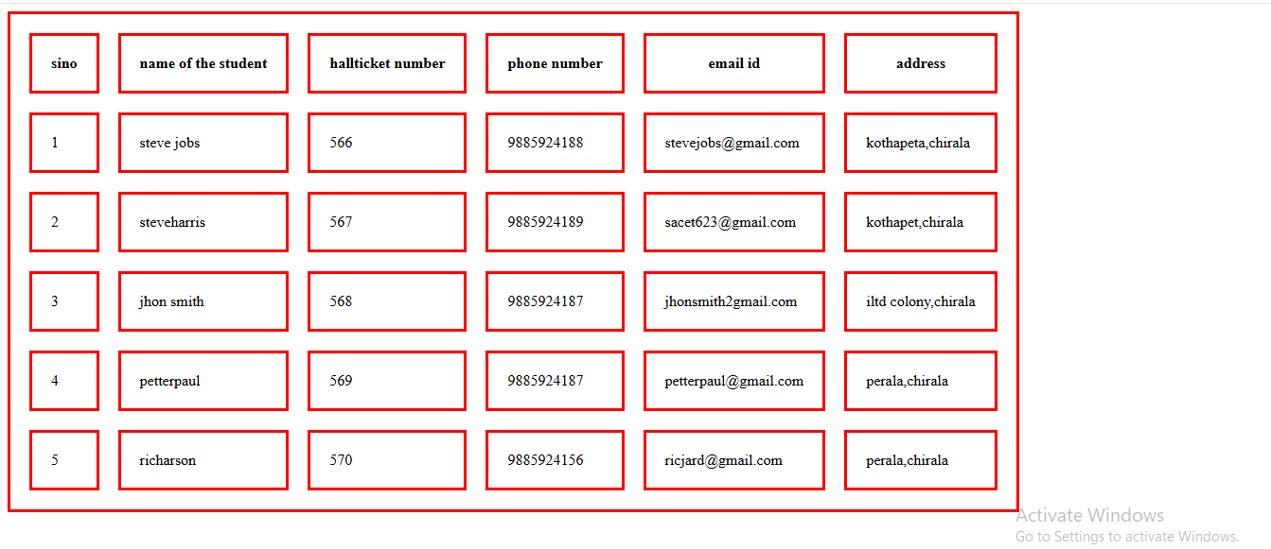

b. Write a HTML program, to explain the working of tables by preparing a timetable. (Note: Use tag to set the caption to the table & also use cell spacing, cell padding, border, rowspan, colspan etc.).

**SOURCE CODE:**

<!--working with table and colspan and rowspan-->

<!doctype html>

<html>

    <head></head>

    <style>

        th,td{

            padding:20px;

            border:2px solid red;

        }

    </style>

    <body>

        <table border="3" style="border-collapse: collapse;">

<caption>TIMETABEL</caption>

            <th>day</th>

            <th>9.00-10.00</th>

            <th>10.00-11.00</th>

            <th>11.00-12.00</th>

            <th>12.00-12.50</th>

            <th>12.50-1.50</th>

            <th>1.50-2.50</th>

            <th>2.50-3.50</th>

            <tr>

                <td>mon</td>

                <td colspan="3">lab</td>

                <td rowspan="6">lunch</td>

                <td>os</td>

                <td>java</td>

                <td>msd</td>

            </tr>

            <tr>

                <td>tue</td>

                <td>cns</td>

                <td>os</td>

                <td>java</td>

                <td colspan="3">msd lab</td>

            </tr>

            <tr>

                <td>wed</td>

                <td colspan="3">lab</td>

                <td>os</td>

                <td>java</td>

                <td>msd</td>

            </tr>

            <tr>

                <td>thu</td>

                <td colspan="3">lab</td>

                <td>os</td>

                <td>java</td>

                <td>msd</td>

            </tr>

<tr>

                <td>fri</td>

                <td colspan="3">lab</td>

                <td>os</td>

                <td>java</td>

                <td>msd</td>

            </tr>

            <tr>

                <td>sat</td>

                <td colspan="3">lab</td>

                <td>os</td>

                <td>java</td>

                <td>msd</td>

            </tr>

        </table>

    </body>

</html>

**OUTPUT:**

TIMETABLE

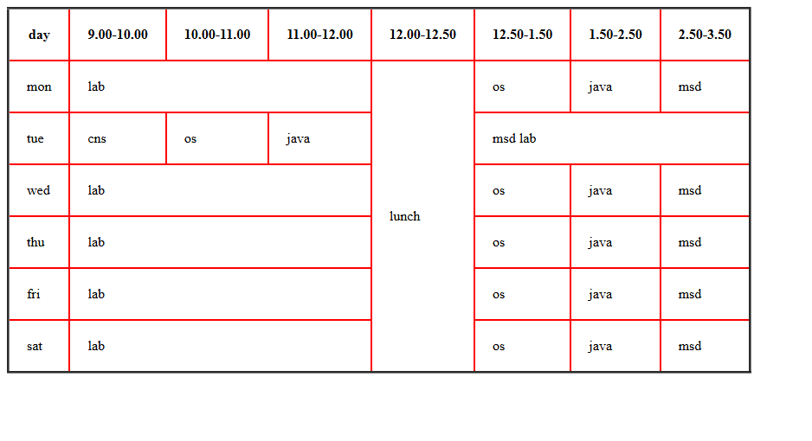

c. Write a HTML program, to explain the working of forms by designing Registration form. (Note: Include text field, password field, number field, date of birth field, checkboxes,radio buttons,list boxes using and two buttons ie:submit and reset. Use tables to provide a better view).

Source Code:

<!DOCTYPE html>

<html>

    <head></head>

    <style>

        table,th,td{

            padding:10px;

            border-spacing: 10px;

        }

        </style>

    <body  style="background-color: beige;">

        <form>

            <table>

                <caption>Registration Form</caption>

                <tr>

                    <td>

                    <label for="firstname">Enter first name</lable>

                </td>

                <td>

                    <input type="text" id="firstname" name="firstname" placeholder="enter firstname">

                </td>

                </tr>

            <tr>

                <td>

                    <label for="lastname">lastname</lable>

                </td>

                <td>

                    <input type="text" id="lastname" name="lastname" placeholder="eter lastname">

                </td>

            </tr>

            <tr>

                <td>

                    <label for="emailid">enter emailid</label>

                </td>

                <td>

                    <input type="email" id="email" name="email" placeholder="enter email id">

                </td>

            </tr>

            <tr>

                <td>

                    <lable for="password">new password</lable>

                </td>

                <td>

                    <input type="password" id="password" name="password" placeholder="set password">

                </td>

            </tr>

            <tr>

                <td>

                    <lable for="password">re-enter password</lable>

                </td>

<td>

                    <input type="password" id="password" name="password" placeholder="re-typepassword">

                </td>

            </tr>

            <tr>

                <td>

                <lable for="age">enter age</lable>

            </td>

            <td>

                <input type="number" id="age" name="age" placeholder="select age" >

            </td>

            </tr>

            <tr>

                <td>

                <lable for="dob">date of birth</lable>

            </td>

            <td>

                <input type="date" id="dob" name="dob"  >

            </td>

            </tr>

            <tr>

                <td>

                <span>gender</span>

            </td>

            <td>

                <label for="male">male</label>

                <input type="radio" id="male" name="gender"  >

                <label for="female">female</label>

                <input type="radio" id="female" name="gender"  >

                <label for="transgender">transgender</label>

                <input type="radio" id="transgender" name="gender"  >

            </td>

            </tr>

            <tr>

                <td>

                <span>Hobbies</span>

            </td>

            <td>

                <label for="tv">watching tv</label>

                <input type="checkbox" id="tv" name="hobbies"  >

                <label for="games">playing games</label>

                <input type="checkbox" id="games" name="hobbies"  >

                <label for="reading">reading books</label>

                <input type="checkbox" id="reading" name="hobbies"  >

            </td>

            </tr>

            <td>

                <label for="country">country</label>

            </td>

            <td>

                <select id="country" name="country">

                    <option value="">seelct your country</option>

                    <option value="india">india</option>

                    <option value="russia">russia</option>

                    <option value="australia">australia</option>

                </select>            </td>

            <tr>

                <td>

                    <lable for="comments">comments</lable>

                </td>

                <td>

                    <textarea id="comments" name="comments" placeholder="enter comments"></textarea>

                </td>

            </tr>

            <tr>

                <td>

                    <span>favourite food</span>

                </td>

                <td>

                    <input list="favfood" placeholder="favourite food">

                    <datalist id="favfood">

                        <option value="idly">idly</option>

                        <option value="idly">idly</option>

                        <option value="idly">idly</option>

                    </datalist>

                </td>

            </tr>

        <tr>

            <td>

                <button>submit</button>

            </td>

            <td>

                <button>reset</button>

            </td>

        </tr>

     </table>

        </form>

    </body>

</html>

Output:

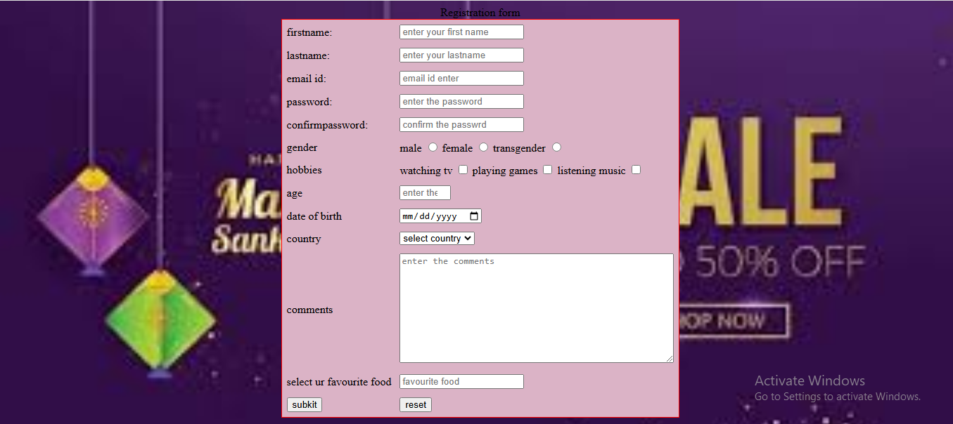

d. Write a HTML program, to explain the working of frames, such that page is to be divided into 3 parts on either direction. hyperlink. And also◊ paragraph, third frame ◊ image, second frame ◊(Note: first frame make sure of using “no frame” attribute such that frames to be fixed).

Source code:

<!DOCTYPE html>

<html>

<head>

    <title>Frames Example</title>

</head>

<body>

    <iframe src="image.html" width="1250" height="2100" frameborder="0"></iframe>

    <iframe src="paragraph.html" width="1200" height="100" frameborder="0"></iframe>

    <iframe src="hyperlink.html" width="1200" height="100" frameborder="0"></iframe>

</body>

</html>

Image.html:

<!DOCTYPE html>

<html>

<head>

    <title>Image Frame</title>

</head>

<body>

    <img src="ajio1.PNG" alt="Example Image" style="width:100%; height:100%;">

    <img src="ajio2.PNG" alt="Example Image" style="width:100%; height:100%;">

    <img src="ajio3.PNG" alt="Example Image" style="width:100%; height:100%;">

    <img src="ajio4.PNG" alt="Example Image" style="width:100%; height:100%;">

    <img src="ajio5.PNG" alt="Example Image" style="width:100%; height:100%;">

</body>

</html>

Paragraph.html:

<!DOCTYPE html>

<html>

<head>

    <title>Paragraph Frame</title>

</head>

<body>

    <p>This is an example paragraph to demonstrate the use of frames in HTML. Frames allow you to divide the browser window into multiple sections, each capable of displaying a different document.</p>

</body>

</html>

Hyperlink.html

<!DOCTYPE html>

<html>

<head>

    <title>Hyperlink Frame</title>

</head>

<body>

    <a href="https://www.example.com" target="_blank">Visit Example.com</a>

</body>

</html>

Output:

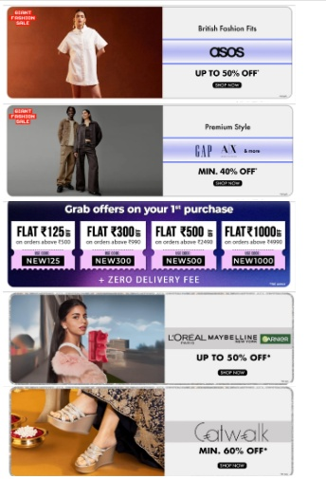

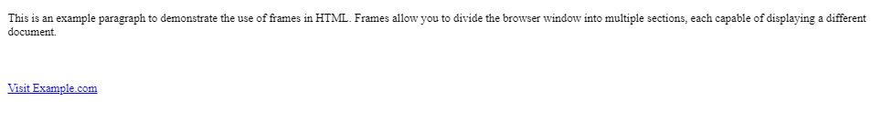

Experiment:3

HTML 5 and Cascading Style Sheets, Types of CS

a.Write a HTML Program that makes use of <article>,<aside>,<figure>,<figcaption>,<footer>,<header>,<main>,

<nav>,<section>,<div>,<span> tags.

**Souce code:**

<!DOCTYPE html>

<html>

    <head></head>

    <body>

        <section style="text-align: center;">

            <header>

                <h1>baapare shopping</h1>

                <nav>

                    <a href="#" target="_blank">home</a>

                    <a href="#" target="_blank">login</a>

                    <a href="#" target="_blank">registration</a>

                </nav>

            </header>

        </section>

        <main>

            <article style="border-style: double;">

                <h3 style="text-align: center;">welcome to bapaare online shopping</h3>

                <aside style="float:left;width:150px;height:170px;">

                    <figure>

                    <img src="shopping.jpg" alt="welcome image" width="100" height="100">

                    <figcaption>welcome</figcaption>

                </figure>

                </aside>

                <p>We appreciate that you chose us for your shopping. We value your trust and confidence in us.

                    We’re here to support you every step of the way. If you have any questions or need assistance, don’t hesitate to reach out to our support team.

                    Welcome to the bapaare family, where we take great satisfaction in helping people like you achieve needs through our Services.

                </p>

            </article>

            <div>

                <h4>AJIO is an online shopping platform  </h4>

                <span>that sells clothing, shoes, accessories, beauty products, home decor, and more. It's a digital commerce initiative of Reliance Retail and is headquartered in Bangalore, India.

                </span>

            </div>

        </main>

        <br>

        <footer>

            <div>

               <span>bapaare<span>

               <nav>

                <a href="#" target="_blank">who we are</a>

                <br>

                <a href="#" target="_blank">join our team</a>

                <br>

                <a href="#" target="_blank">terms and conditions</a>

               </nav>

            </div>

        </footer>

    </body></html>

Output:

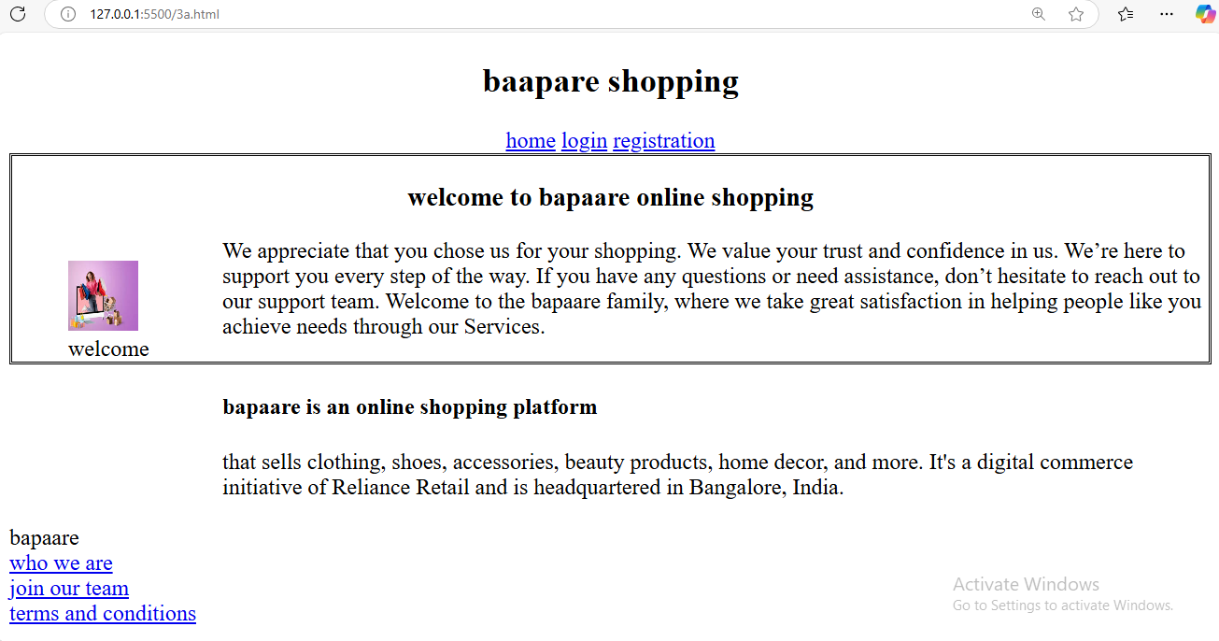

b. Write a HTML program, to embed audio and video into HTML web page.

**Source code:**

<!DOCTYPE html>

<html>

    <head></head>

    <body>

        <embed src="gabbar_singh.mp3">

            <br>

            <embed src="pspkmania.mp4" width="700" height="300">

    </body>

</html>

Output:

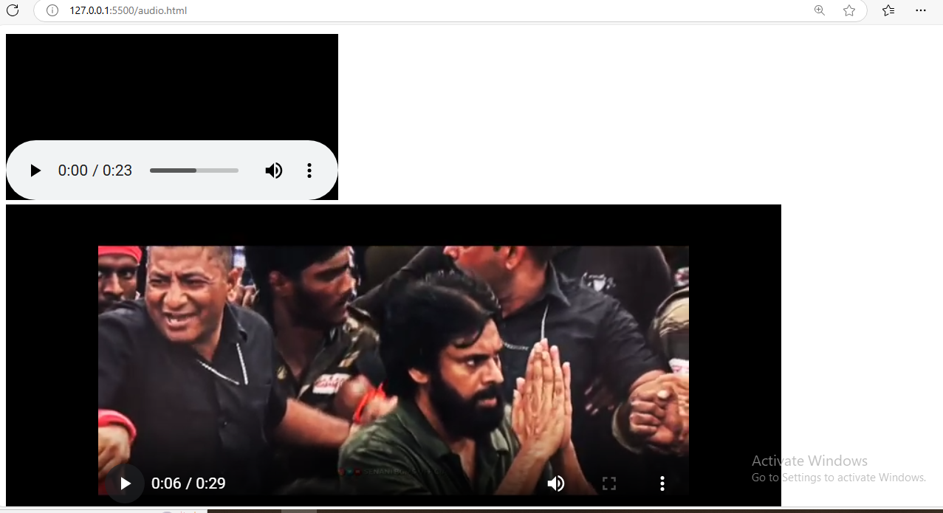

c. Write a program to apply different types (or levels of styles or style specification formats)- inline, internal, external styles to HTML elements. (identify selector, property and value).

Sourcecode:

<!DOCTYPE html>

<html>

    <head>

        <!-- external style -->

        <link rel="stylesheet" href="externalcss.css" type="text/css">

    </head>

    <!-- internal style -->

    <style>

        header{

            background-color: rgb(167, 112, 45);

        }

    </style>

    <body style="background-color: antiquewhite;">

        <section style="text-align: center;">

            <header>

                <!-- <!inline element-->

                <h1 style="color:gold">baapare shopping</h1>

                <nav>

                    <a href="#" target="_blank">home</a>

                    <a href="#" target="_blank">login</a>

                    <a href="#" target="_blank">registration</a>

                </nav>

            </header>

        </section>

        <main>

            <article style="border-style: double;">

                <h3 style="text-align: center;">welcome to bapaare online shopping</h3>

                <aside style="float:left;width:150px;height:170px;">

                    <figure>

                    <img src="shopping.jpg" alt="welcome image" width="50" height="50">

                    <figcaption>welcome</figcaption>

                </figure>

                </aside>

                <p>We appreciate that you chose us for your shopping. We value your trust and confidence in us.

                    We’re here to support you every step of the way. If you have any questions or need assistance, don’t hesitate to reach out to our support team.

                    Welcome to the bapaare family, where we take great satisfaction in helping people like you achieve needs through our Services.

                </p>

            </article>

            <div>

                <h4>bapaare is an online shopping platform  </h4>

                <span>that sells clothing, shoes, accessories, beauty products, home decor, and more. It's a digital commerce initiative of Reliance Retail and is headquartered in Bangalore, India.

                </span>

            </div>

        </main>

        <br>

        <footer>

            <div>

               <span>bapaare<span>

               <nav>

                <a href="#" target="_blank">who we are</a>

                <br>

                <a href="#" target="_blank">join our team</a>

                <br>

                <a href="#" target="_blank">terms and conditions</a>

               </nav>

            </div>

        </footer>

    </body>

</html>

externalcss.css

a{

    color:black;

}

a:hover{

    color:white;

}

article{

    background-color: burlywood;

}

h1{

    color:red;

    font-family: cursive;

}

h3{

    color:green;

}

Output:

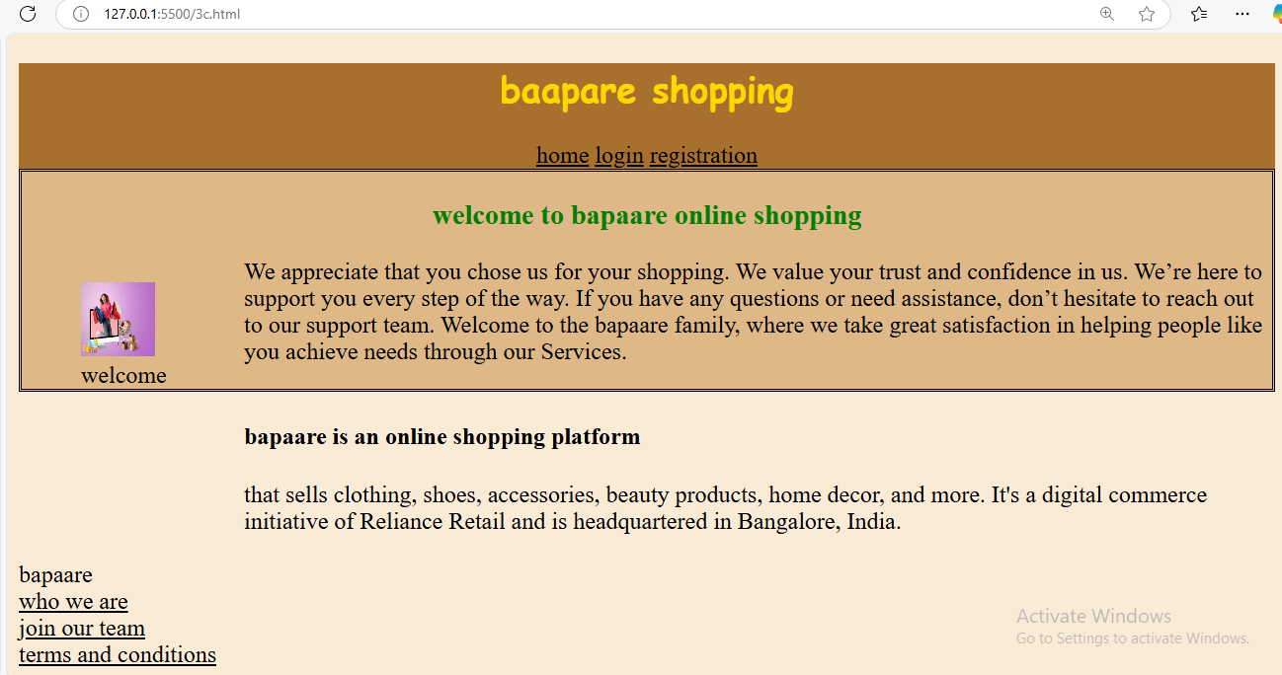

Experiment:4 Selector forms

4a. Write a program to apply simple selector forms

i.using element selector

**Source code:**

<!-- write a html program to apply selector forms -->

<!doctype html>

<html>

    <haed></haed>

    <style>

           h1{

        color:red;

        background-color: yellow;;

    }

    </style>

    <body>

        <h1 id="parag">

            <p class="pa">this is cseb section</p>

            <p>cseb section is this</p>

            <p >where is csebsection</p>

            <p>how is cseb scetion</p>

        </h1>

        <pre >what about cseb</pre>

        <pre >is it fine otr not</pre>

        <h2>welcome</h2>

        <p class="pa" >hello</p>

    </body>

</html>

Output:

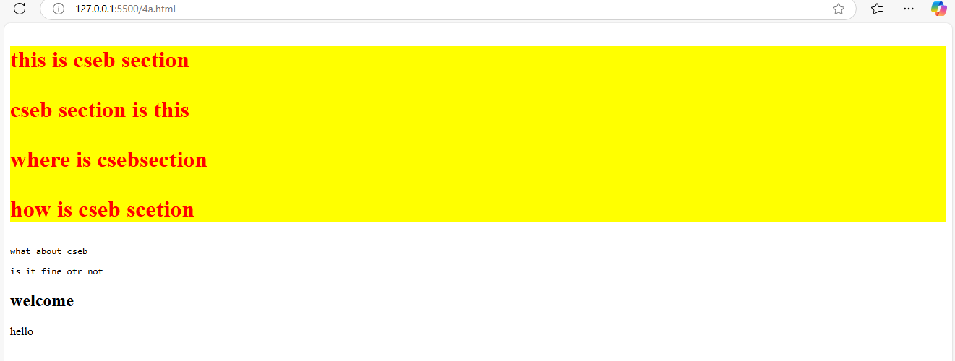

ii. id selector

**Source code:**

<!-- write a html program to apply selector forms -->

<!doctype html>

<html>

    <haed></haed>

    <style>

     /* id element style */

#parag{

        color:indigo;

        background-color: goldenrod;

     }

    </style>

    <body>

        <h1 id="parag">

            <p class="pa">this is cseb section</p>

            <p>cseb section is this</p>

            <p >where is csebsection</p>

            <p>how is cseb scetion</p>

        </h1>

        <pre >what about cseb</pre>

        <pre >is it fine otr not</pre>

        <h2>welcome</h2>

        <p class="pa" >hello</p>

    </body>

</html>

Output:

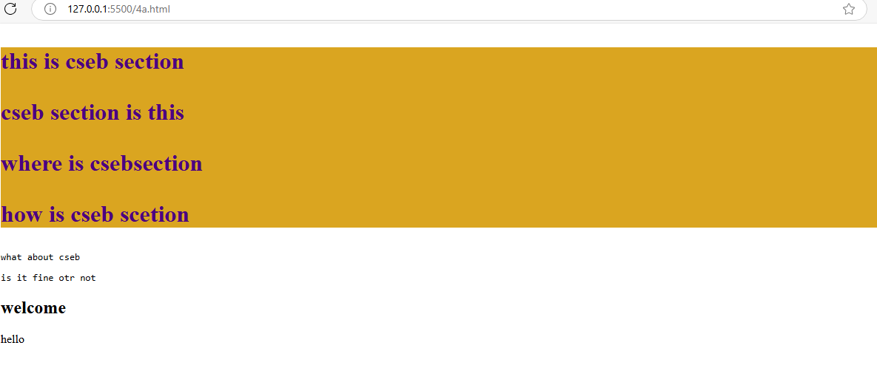

iii. using class selector

**Source code:**

<!-- write a html program to apply selector forms -->

<!doctype html>

<html>

    <haed></haed>

    <style>

     /* class element style */

     .pa{

        color:blue;

        background-color: antiquewhite;

     }

    </style>

    <body>

        <h1 id="parag">

            <p class="pa">this is cseb section</p>

            <p>cseb section is this</p>

            <p >where is csebsection</p>

            <p>how is cseb scetion</p>

        </h1>

        <pre >what about cseb</pre>

        <pre >is it fine otr not</pre>

        <h2>welcome</h2>

        <p class="pa" >hello</p>

    </body>

</html>

Output:

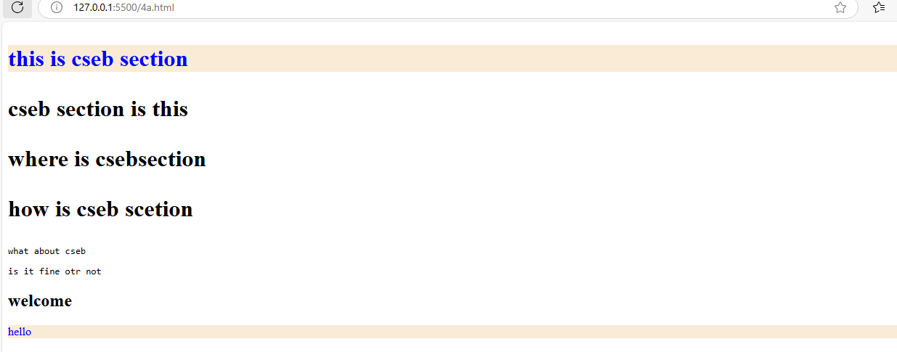

iv. using group selector

**Source code:**

<!-- write a html program to apply selector forms -->

<!doctype html>

<html>

    <haed></haed>

    <style>

/* group selector */

     h2,pre{

        color:aqua;

        background-color: black;

     }

    </style>

    <body>

        <h1 id="parag">

            <p class="pa">this is cseb section</p>

            <p>cseb section is this</p>

            <p >where is csebsection</p>

            <p>how is cseb scetion</p>

        </h1>

        <pre >what about cseb</pre>

        <pre >is it fine otr not</pre>

        <h2>welcome</h2>

        <p class="pa" >hello</p>

    </body>

</html>

Output:

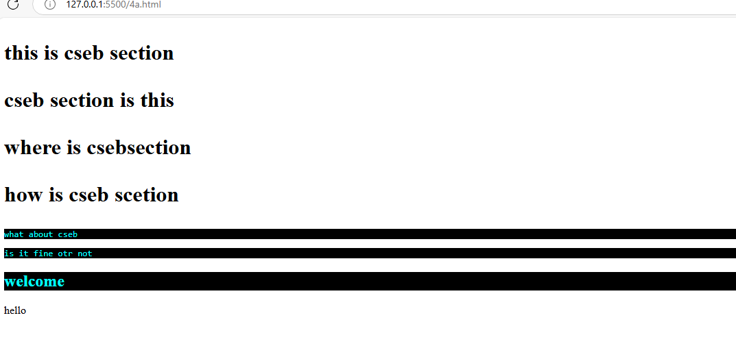

v.using universal selector

**Source code:**

<!-- write a html program to apply selector forms -->

<!doctype html>

<html>

    <haed></haed>

    <style>

/* universal selector */

     *{

        color:green;

        background-color: chocolate;

     }

    </style>

    <body>

        <h1 id="parag">

            <p class="pa">this is cseb section</p>

            <p>cseb section is this</p>

            <p >where is csebsection</p>

            <p>how is cseb scetion</p>

        </h1>

        <pre >what about cseb</pre>

        <pre >is it fine otr not</pre>

        <h2>welcome</h2>

        <p class="pa" >hello</p>

    </body>

</html>

Output:

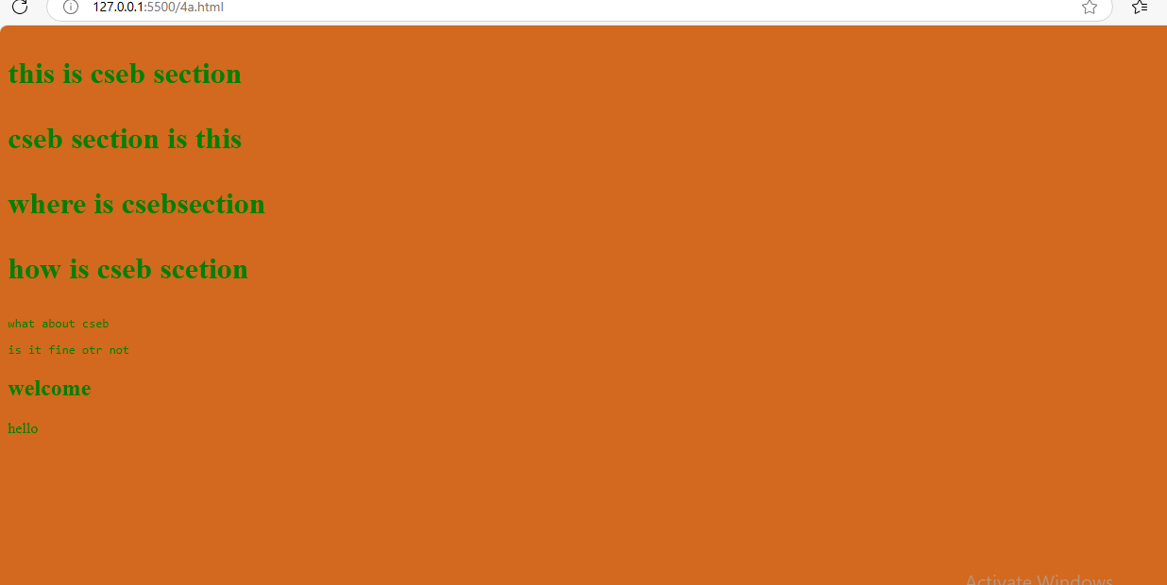

4b. Write a program to apply Combinator selector

i.using Descendant selector

**source code:**

<!DOCTYPE html>

<html>

    <head></head>

     <style>

        /* descending style */

        /* applyied color to the all the childs of the parent */

      div p{

        color:greenyellow;

      }

</style>

    <body>

       <div>

            <h3>A CSS combinator is used to specify the relationship between two CSS selectors. There are four different combinators in CSS:</h3>

            <p>Descendant combinator (space): Selects an element that is a descendant of another element.</p>

            <p>The descendant combinator matches all elements that are descendants of a specified element.</p>

            <section>

                <pre>descendant combinator</pre>

                <p>descendant combinator is the one of the combinator</p>

            </section>

        </div>

    </body>

</html>

**Output:**

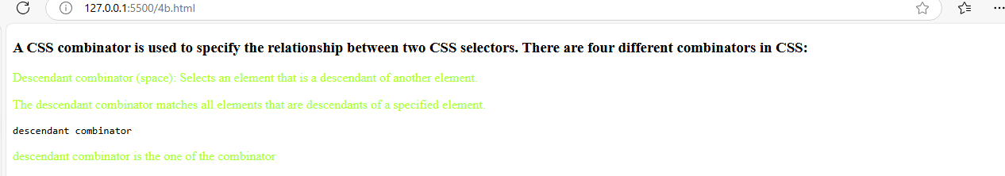

ii.using child selector

**source code:**

<!DOCTYPE html>

<html>

    <head></head>

     <style>

       /* child seelctor forms */

      /* apply styles to dirct childerens of the parent */

      div>p{

        color:red;

      }

</style>

    <body>

       <div>

            <h3>A CSS combinator is used to specify the relationship between two CSS selectors. There are four different combinators in CSS:</h3>

            <p>Child combinator (> or empty space): Selects an element that is a direct child of another element.</p>

            <p>TThe child combinator selects all elements that are the children of a specified element.</p>

            <section>

                <pre>descendant combinator</pre>

                <p>it is not direct child</p>

            </section>

        </div>

    </body>

</html>

Output:

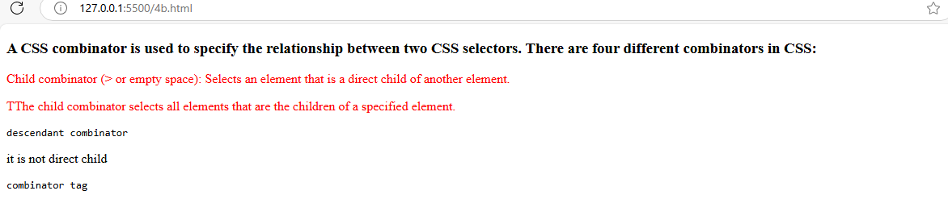

iii.using adjacent sibling selector

**source code:**

<!DOCTYPE html>

<html>

    <head></head>

     <style>

       /* adjacent sibling selector

      direct first nextsibling of child sto apply */

      article+p{

        color:blueviolet;

      }

</style>

    <body>

       <div>

            <h3>A CSS combinator is used to specify the relationship between two CSS selectors. There are four different combinators in CSS:</h3>

            <p>Child combinator (> or empty space): Selects an element that is a direct child of another element.</p>

            <p>TThe child combinator selects all elements that are the children of a specified element.</p>

            <section>

                <pre>descendant combinator</pre>

                <p>it is not direct child</p>

            </section>

        </div>

        <pre>combinator tag</pre>

        <article>

            <p>adjacent selector</p>

            <p>The next sibling combinator is used to select an element that is directly after another specific element.</p>

        </article>

        <p>Sibling elements must have the same parent element, and "adjacent" means "immediately following".</p>

        <p>these arethe siblings after the artcle</p>

    </body>

</html>

Output:

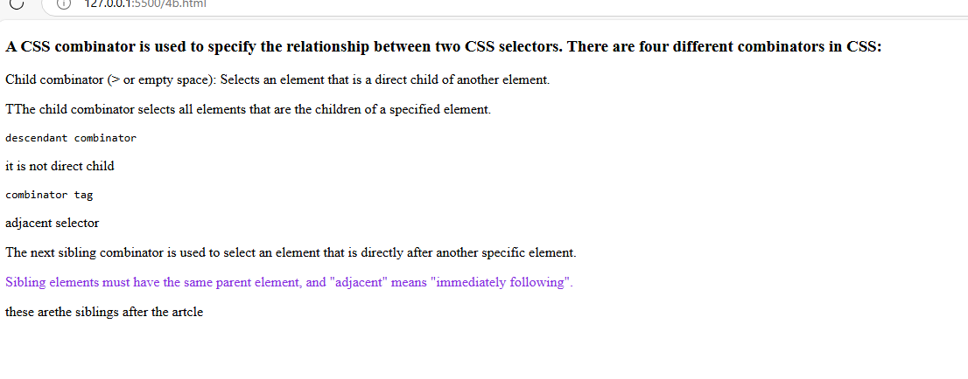

iv.using general sibling selector

**source code:**

<!DOCTYPE html>

<html>

    <head></head>

<style>

/* general sibling selector

      using tilled sysmbol and styles applied to all sibling after parent element */

      article~p{

        color:burlywood;

      }

</style>

<body>

        <div>

            <h3>A CSS combinator is used to specify the relationship between two CSS selectors. There are four different combinators in CSS:</h3>

            <p>Child combinator (> or empty space): Selects an element that is a direct child of another element.</p>

            <p>TThe child combinator selects all elements that are the children of a specified element.</p>

            <section>

                <pre>descendant combinator</pre>

                <p>it is not direct child</p>

            </section>

        </div>

        <pre>combinator tag</pre>

        <article>

            <p>adjacent selector</p>

            <p>The next sibling combinator is used to select an element that is directly after another specific element.</p>

        </article>

        <p>Sibling elements must have the same parent element, and "adjacent" means "immediately following".</p>

        <p>these arethe siblings after the artcle</p>

        </body>

</html>

Output:

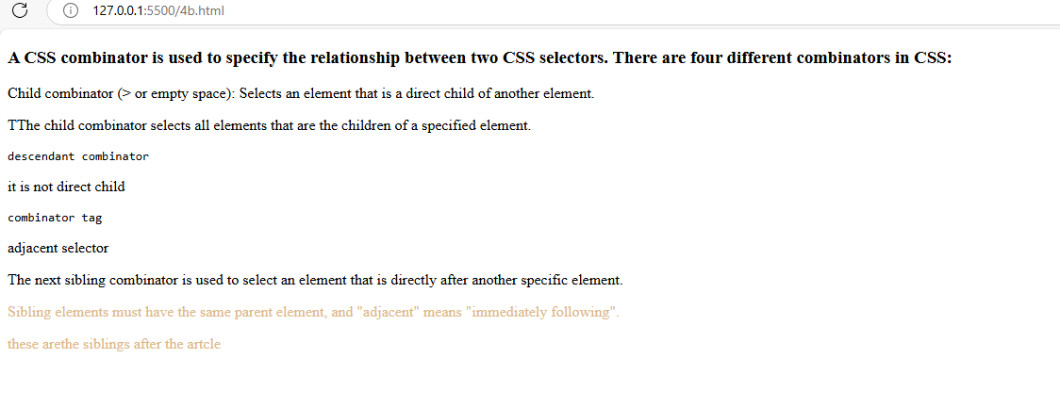

4c. Write a program to apply pseudo class selector

**Source code:**

<!doctype html>

 <html>

    <head></head>

    <style>

    a:link{

        color:brown;

        background-color: grey;

    }

    a:hover{

        color:white;

        background-color: green;

    }

    </style>

    <body>

        <h1>bapaare online shopping</h1>

        <a href="#" target="_parent">home</a>

        <a href="#" target="_parent">login</a>

        <a href="#" target="_parent">register</a>

        <p>A CSS pseudo-class is a keyword added to a selector that specifies a special state of the selected element. For example, the pseudo-class :hover can be used to select a button when a user's pointer hovers over the button, allowing you to style it accordingly</p>

    </body>

 </html>

Output:

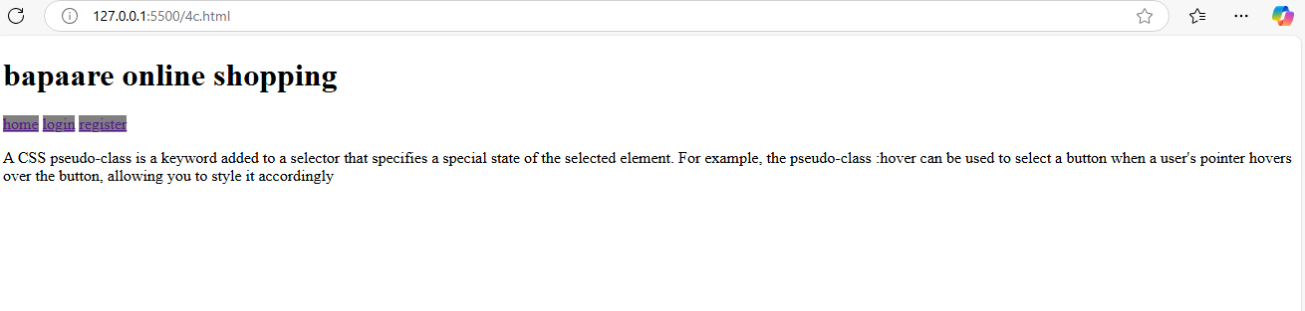

4d. Write a program to apply pseudo element selector

**Source code:**

 <!doctype html>

 <html>

    <head></head>

     <style>

    h1::first-letter{

        color:red;

        text-transform: uppercase;

    }

    pre::first-line{

        color:green;

    }

    h1::before{

       content:" adding text at begining ";

    }

    h1::after{

       content:" adding text at ending ";

    }

    p::selection{

        background-color:grey;

        color:white;

    }

    </style>

    <body>

        <h1>bapaare online shopping</h1>

        <a href="#" target="_parent">home</a>

        <a href="#" target="_parent">login</a>

        <a href="#" target="_parent">register</a>

        <pre>A CSS pseudo-element is used to style specific parts of an element.

            For example, it can be used to:

            Style the first letter or line, of an element

            Insert content before or after an element

            Style the markers of list items

            Style the viewbox behind a dialog box

            </pre>

    </body>

 </html>

Output:

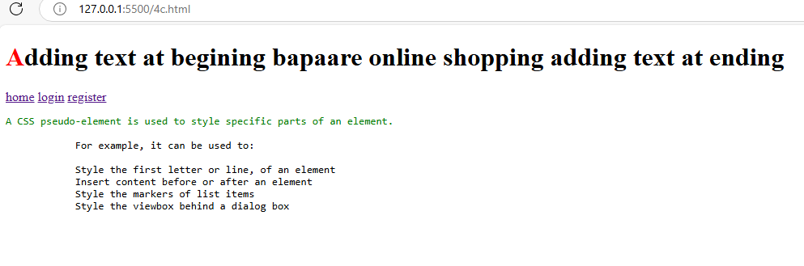

4e. Write a program to apply attribute selector

**Source code:**

 <!doctype html>

 <html>

    <head></head>

    <style>

        /* select all title attribute */

        [title]{

            border:5px solid yellow;

        }

        /* select exact value */

        [title='sacet cse dept']

        {

            color:white;

            background-color: aqua;

        }

        /* select any where matches the word */

        [title~="sacet"]

        {

            color:yellow;

            background-color: black;;

        }

        /* select when word comes at starting */

        [title^="sacp"]{

            color:green;

            background-color: blanchedalmond;

        }

        /* select word at end */

[title$="sacet"]{

    color:red;

    background-color: aqua;

}

    </style>

    <body>

        <img src="#" title="sacet cse dept" width="200" height="200">

        <br>

        <br>

        <img src="#" title="sacet ece dept" width="200" height="200">

        <img src="#" title="sacet eee dept" width="200" height="200">

        <img src="#" title="sacet mech dept" width="200" height="200">

        <img src="#" title="mech dept sacet" width="200" height="200">

        <img src="#" title="sacp pharma dept" width="200" height="200">

        <img src="#" title="sacp analysis dept" width="200" height="200">

    </body>

 </html>

**Output:**

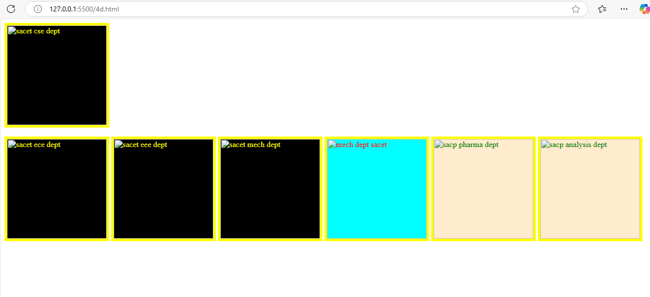

Experiment:5 CSS with Color, Background, Font, Text and CSS Box Model

5a. Write a program to demonstrate the various ways you can reference a color in CSS

**Source code:**

<!doctype html>

<html>

    <head></head>

    <style>

        #colorname{

            color:indianred;

            background-color: aqua;

        }

        #colorhex{

            color:#ffffff;

            background-color: #c24b90;

        }

        #colorrgb{

            color:rgb(10, 23, 50);

            background-color: rgb(55, 107, 107);

        }

        #colorrgba{

            color:rgb(29, 220, 39,1.0);

            background-color: rgb(242, 7, 117);

        }

        #colorothers{

            color:hwb(0 36% 20%);

            background-color: aqua;

        }

    </style>

    <body>

        <p id="colorname">to apply the colors in css we can use by their colorname</p>

        <p id="colorhex">to apply the colors to the content you can use hex decimal values</p>

        <p id="colorrgb">to aplly the colors to the content you can use the rgb values</p>

        <p id="colorrgba">to apply the colors to the content through the rgba</p>

        <p id="colorothers">to apply the coltrs to the content in otherways</p>

    </body>

</html>

Output:

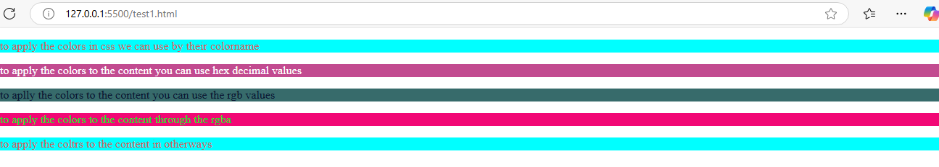

c. Write a program using the following terms related to CSS font and text: i. font-size ii. font-weight iii. font-style iv. text-decoration v. text-transformation vi. text-alignment

**source code:**

<!doctype html>

<html>

    <head></head>

    <style>

        #colorname{

            color:indianred;

            background-color: aqua;

        }

        #colorhex{

            color:#ffffff;

            background-color: #c24b90;

        }

        #colorrgb{

            color:rgb(10, 23, 50);

            background-color: rgb(55, 107, 107);

        }

        #colorrgba{

            color:rgb(29, 220, 39,1.0);

            background-color: rgb(242, 7, 117);

        }

        #colorothers{

            color:hwb(0 36% 20%);

            background-color: aqua;

        }

         p{

            font-size: 40px;

            font-weight: bold;

            font-style:italic;

            text-decoration: underline;

            text-transform: uppercase;

            text-align: center;

        }

    </style>

    <body>

        <p id="colorname">to apply the colors in css we can use by their colorname</p>

        <p id="colorhex">to apply the colors to the content you can use hex decimal values</p>

        <p id="colorrgb">to aplly the colors to the content you can use the rgb values</p>

        <p id="colorrgba">to apply the colors to the content through the rgba</p>

        <p id="colorothers">to apply the coltrs to the content in otherways</p>

    </body>

</html>

Output:

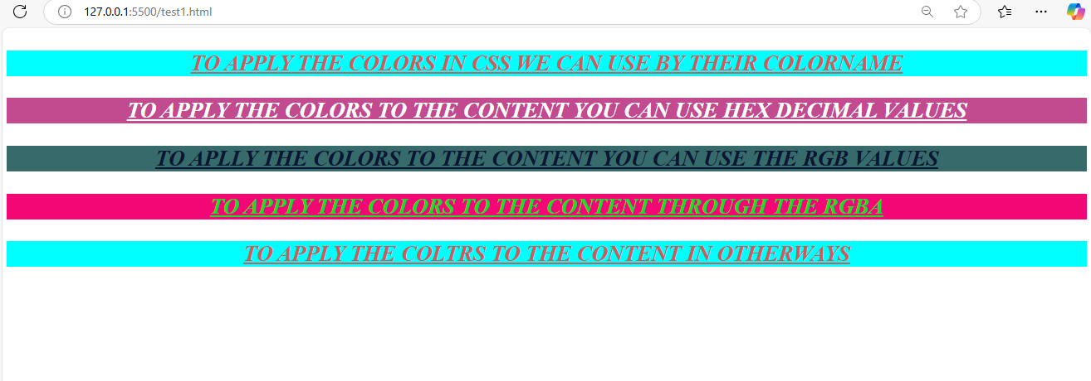

d. Write a program, to explain the importance of CSS Box model using

i. Content ii. Border iii. Margin iv. Padding

**source code:**

<!doctype html>

<html>

    <head></head>

    <style>

        #colorname{

            color:indianred;

            background-color: aqua;

        }

        #colorhex{

            color:#ffffff;

            background-color: #c24b90;

        }

        #colorrgb{

            color:rgb(10, 23, 50);

            background-color: rgb(55, 107, 107);

        }

        #colorrgba{

            color:rgb(29, 220, 39,1.0);

            background-color: rgb(242, 7, 117);

        }

        #colorothers{

            color:hwb(0 36% 20%);

            background-color: aqua;

        }

         p{

            padding:20px;

            margin:100px;

            border:2px solid red;

        }

    </style>

    <body>

        <p id="colorname">to apply the colors in css we can use by their colorname</p>

        <p id="colorhex">to apply the colors to the content you can use hex decimal values</p>

        <p id="colorrgb">to aplly the colors to the content you can use the rgb values</p>

        <p id="colorrgba">to apply the colors to the content through the rgba</p>

        <p id="colorothers">to apply the coltrs to the content in otherways</p>

    </body>

</html>

**Output:**

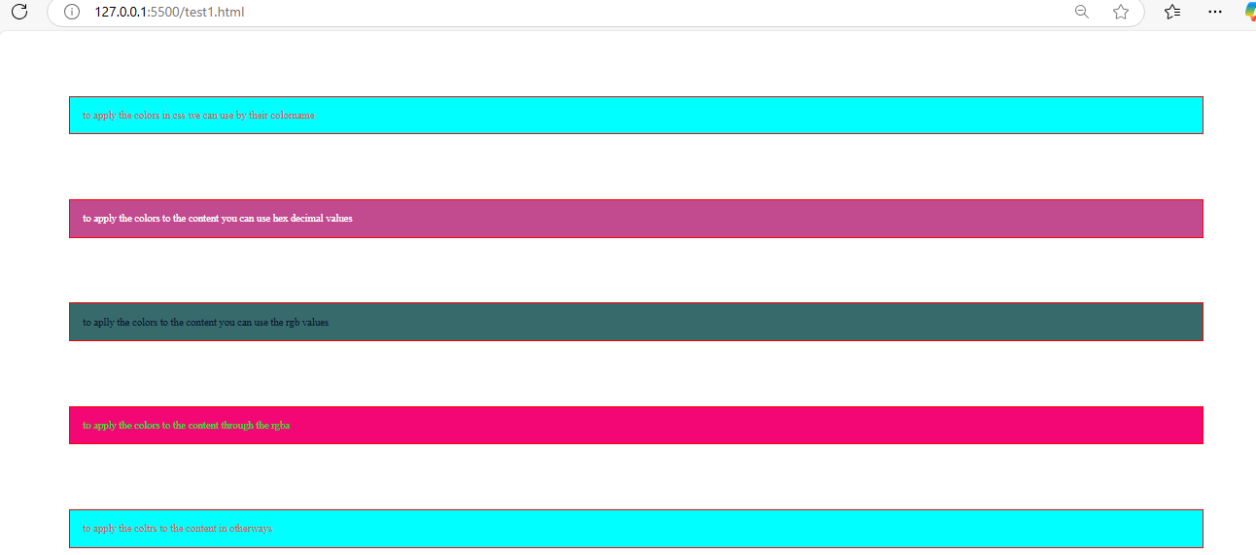

b. Write a CSS rule that places a background image halfway down the page, tilting it horizontally. The image should remain in place when the user scrolls up or down.

**Source code:**

<!doctype html>

<html>

    <head></head>

    <style>

        #colorname{

            color:indianred;

            background-color: aqua;

        }

        #colorhex{

            color:#ffffff;

            background-color: #c24b90;

        }

        #colorrgb{

            color:rgb(10, 23, 50);

            background-color: rgb(55, 107, 107);

        }

        #colorrgba{

            color:rgb(29, 220, 39,1.0);

            background-color: rgb(242, 7, 117);

        }

        #colorothers{

            color:hwb(0 36% 20%);

            background-color: aqua;

        }

         p{

            padding:20px;

            margin:100px;

            border:2px solid red;

            font-size: 40px;

            font-weight: bold;

            font-style:italic;

            text-decoration: underline;

            text-transform: uppercase;

            text-align: center;

        }

        body{

            background-image: url('gmg.jpg');

            background-repeat: no-repeat;

            background-size: cover;

            background-position: center 50%;

            background-attachment: fixed;

            transform: rotate(30deg);

        }

    </style>

    <body>

        <p id="colorname">to apply the colors in css we can use by their colorname</p>

        <p id="colorhex">to apply the colors to the content you can use hex decimal values</p>

        <p id="colorrgb">to aplly the colors to the content you can use the rgb values</p>

        <p id="colorrgba">to apply the colors to the content through the rgba</p>

        <p id="colorothers">to apply the coltrs to the content in otherways</p>

    </body></html>

**Output:**

