Milepost 2 Term 2 2026

This term we will begin by considering how the tectonic plates that form the Earth’s crust are always moving. Even the smallest movement can cause huge earthquakes, volcanoes and tsunamis that devastate communities across wide areas. If we can understand what is happening underground, we can learn to predict and protect ourselves in the future.

MATHS
In Year 4 we will be measure lengths, including area before moving on to developing strategies for multiplying and dividing.
In Year 3 we will continue to develop addition and subtraction strategies before moving on to multiplication and division and then a review of telling the time.

DATES FOR THE DIARY

November

Tues 3rd - photos
Friday 13th – Children in Need non-uniform day

December

Wed 9th – Christmas dinner and Christmas jumper day

Fri 18th – last day of term

January

Mon 4th – TD day (no school)

Tue 5th – first day of term 3

ENGLISH
In Year 4 we will look at the features of poetry and use them to write a poem inspired by volcanic eruptions. We will then write diaries about Pompeii and explanation texts to show how and why earthquakes happen.
In Year 3 we will study and write shape poems and also diaries to reflect the experience of the people of Pompeii during the eruption of Mount Vesuvius. We will then move on to a book study of Coming Home by Michael Morpurgo.

STEAM DAY
During the first week of term we will all take part in our first STEAM Day of this year. The day will have a focus on Science and we will be exploring how to make a getaway car using magnets to propel our vehicles forward.
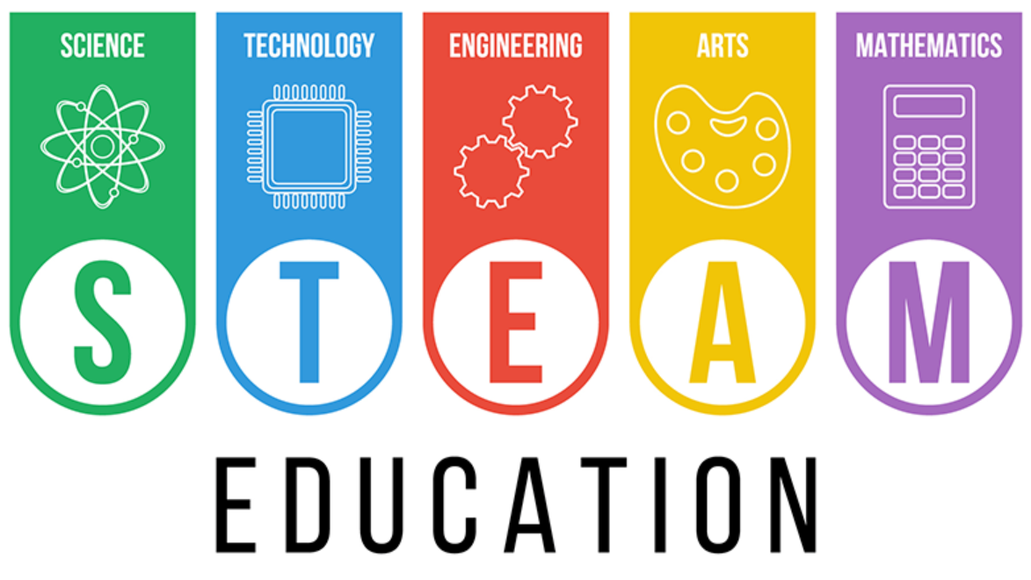

HISTORY/GEOGRAPHY
We will find out how the Earth was formed and use world maps to locate the position of volcanoes and earthquakes. We will also learn to use geographical terms, and discover what causes earthquakes and how they can be measured. In History we will find out about the devastation of Pompeii.

Milepost 2 Term 2 2026

PSHRE
In Years 3 and Year 4 we will cover the topic, ‘Connecting with Others’. We will learn about being respectful to ourselves and others, how to make friends, and how to fairly manage a friendship fall out. In addition to this, Year 4 will learn about stereotypes.

SCIENCE
We will learn about rocks and soils and try to identify different types and uses.
We will further our learning about solids liquids and gases in volcanoes and examine what happens when a volcano erupts.
We will continue to develop our science skills by carrying out simple investigations linked to volcanoes and predict
outcomes.

PE
In Year 3 we will develop dribbling and tracking skills in outdoor PE and work on their gymnastic skills during their indoor PE sessions.
In Year 4 we will complete a range of circuits to improve coordination and movement, as well as hand eye coordination with ball skills and tag rugby activities.

COMPUTING
In Year 3 and 4 we will build on coding skills by using the Scratch program to build and debug some instructions.

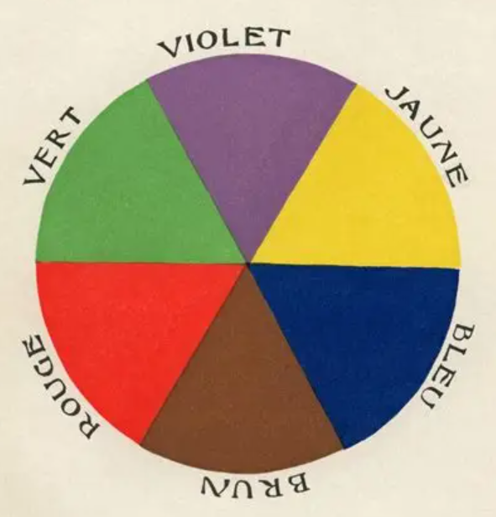

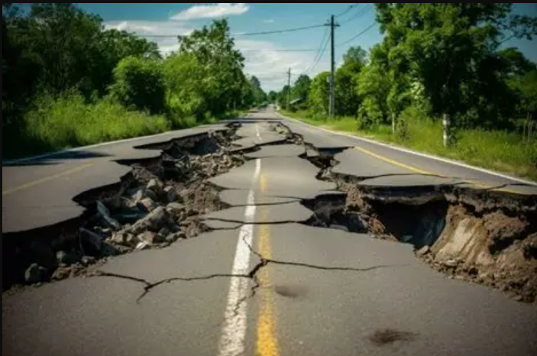
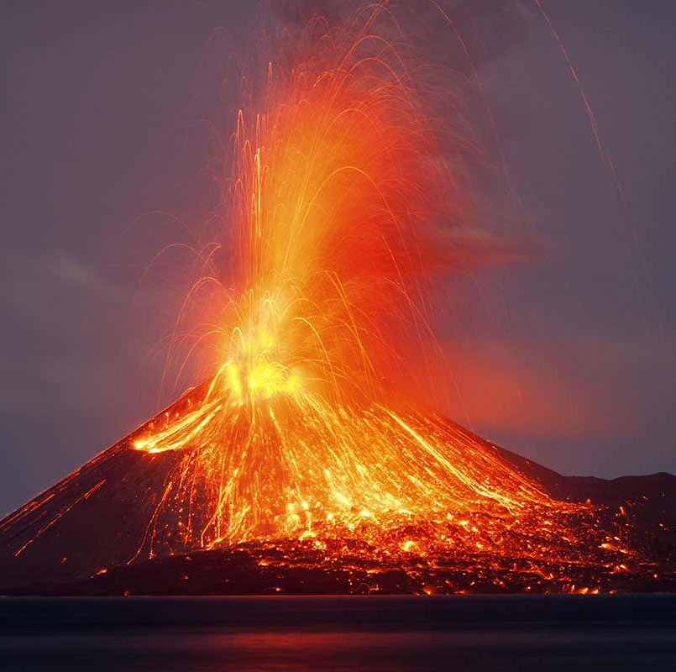
RE
In Years 3 and 4 we will be discussing how Christians believe that God is “Trinity; Father, Son and Holy Spirit” and make links to Christian baptism. This also leads to the idea of incarnation, God coming to Earth in Jesus, which Christians celebrate as Christmas. We will also make links to the concept of Gospel.

FRENCH
In Year 3 we will learn the names of ten colours and also how to count to ten.

