[*Wishful Thinking*](https://www.stevehemingway.com/) *is a few notes that blogger Steve Hemingway has used to keep track of what is going on in the markets mainly, but also about anything else that comes into his head. Read more informative articles today!*

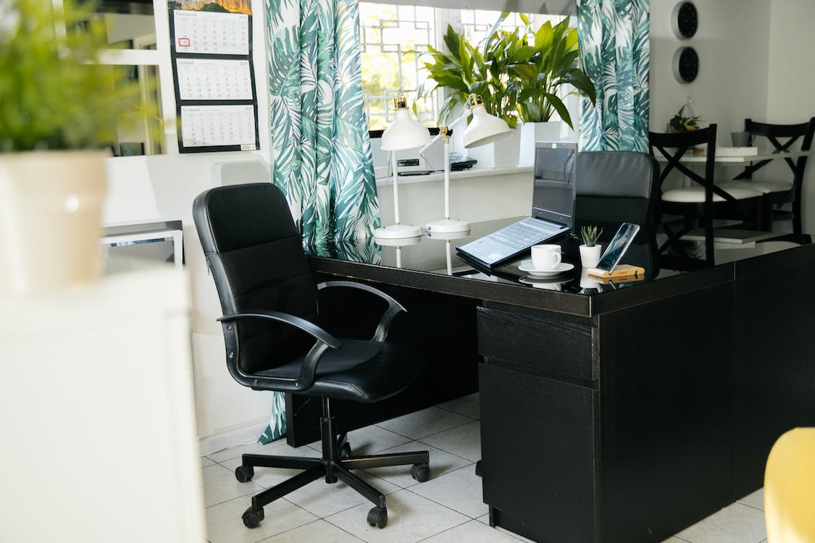

# How to Improve Your Home Workspace Without Robbing the Piggy Bank

With so many people working from home nowadays, it has become common practice to think of ways to upgrade a workspace without spending too much - assuming you’re thrifty at heart. Here are some tips on how to cut down on your expenditure in this regard, presented to you below [by Wishful Thinking](https://www.stevehemingway.com/).

## Finding the ideal space

If your current home lacks the proper facilities for a workspace, then you may need to find something more accommodating. Exploring online listings should indicate what's available regarding how big of a space you require to be able to work remotely - comfortably.

## Where to work?

If moving out of your current home is not an option, it would be in your best interest to find an existing area to work in peace and quiet. HomeServe notes that [the bedroom is a popular choice](https://www.homeserve.com/en-us/blog/how-to/home-office-ideas/) because it is usually quiet and private during the daytime hours, making it an ideal place to set up a desk and workstation for those who prefer to work there.

Wherever you decide to work, you should give some serious [consideration to the budget you have available](https://blog.fads.co.uk/inspiration/build-your-home-office-for-less-than-500/) and the design you have in mind for your home office. Keep in mind that such home [improvements and updates](https://www.redfin.com/guides/how-to-increase-your-home-appraisal-value-now) can pay off in time as your property value will certainly get a nice boost.

## Boost efficiency

With a few tweaks, you can be just as productive in a home office as you would in a traditional office. Fenesta points out that [exposure to natural light](https://www.fenesta.com/blog/importance-of-having-light-in-your-home-office) can keep you more alert - and you can save on your monthly energy costs. If you're looking for a change, consider painting the room or at least the walls around your workspace a shade of green for a calming effect on the psyche.

You can get a similar [effect from having plants](https://www.ambius.co.uk/benefits-of-indoor-plants/) around the office, and they'll even help you breathe better. Complementary lighting can help to enhance the ambiance of your homework space should clients come around. Your decor is really up to you at the end of the day and should be according to your personal taste.

[A work chair](https://www.tbsg.co.uk/blog/benefits-of-ergonomic-office-furniture-p6zd5) that is either too soft or too rigid can be a major source of pain and inefficiency in the workplace. The initial investment in a high-quality chair may be larger, but it will serve you well for many years by providing the necessary lumbar support at work. Other types of furniture that you might find to be useful in your workspace could include a sturdy desk, a desk lamp, a sofa for when clients come around, elegant mirrors, additional lampstands, and a coffee table.

However, expenses like these can tend to add up. [Click here for more information](https://safesmartfamily.com/) before committing to a significant purchase.

As you can see, there are many ways to set up a functional workplace without breaking the bank. Looking at rental options might just spark an idea to find bigger premises and could be an option if you don’t want to waste time upgrading an area that might not end up working to your advantage anyway.

Image via [Pexels](https://www.pexels.com/photo/interior-of-contemporary-workplace-with-chair-and-laptop-on-table-4138153/)