**BTCN07 – Hồ Ngọc Minh Đức – 19127368**

1. 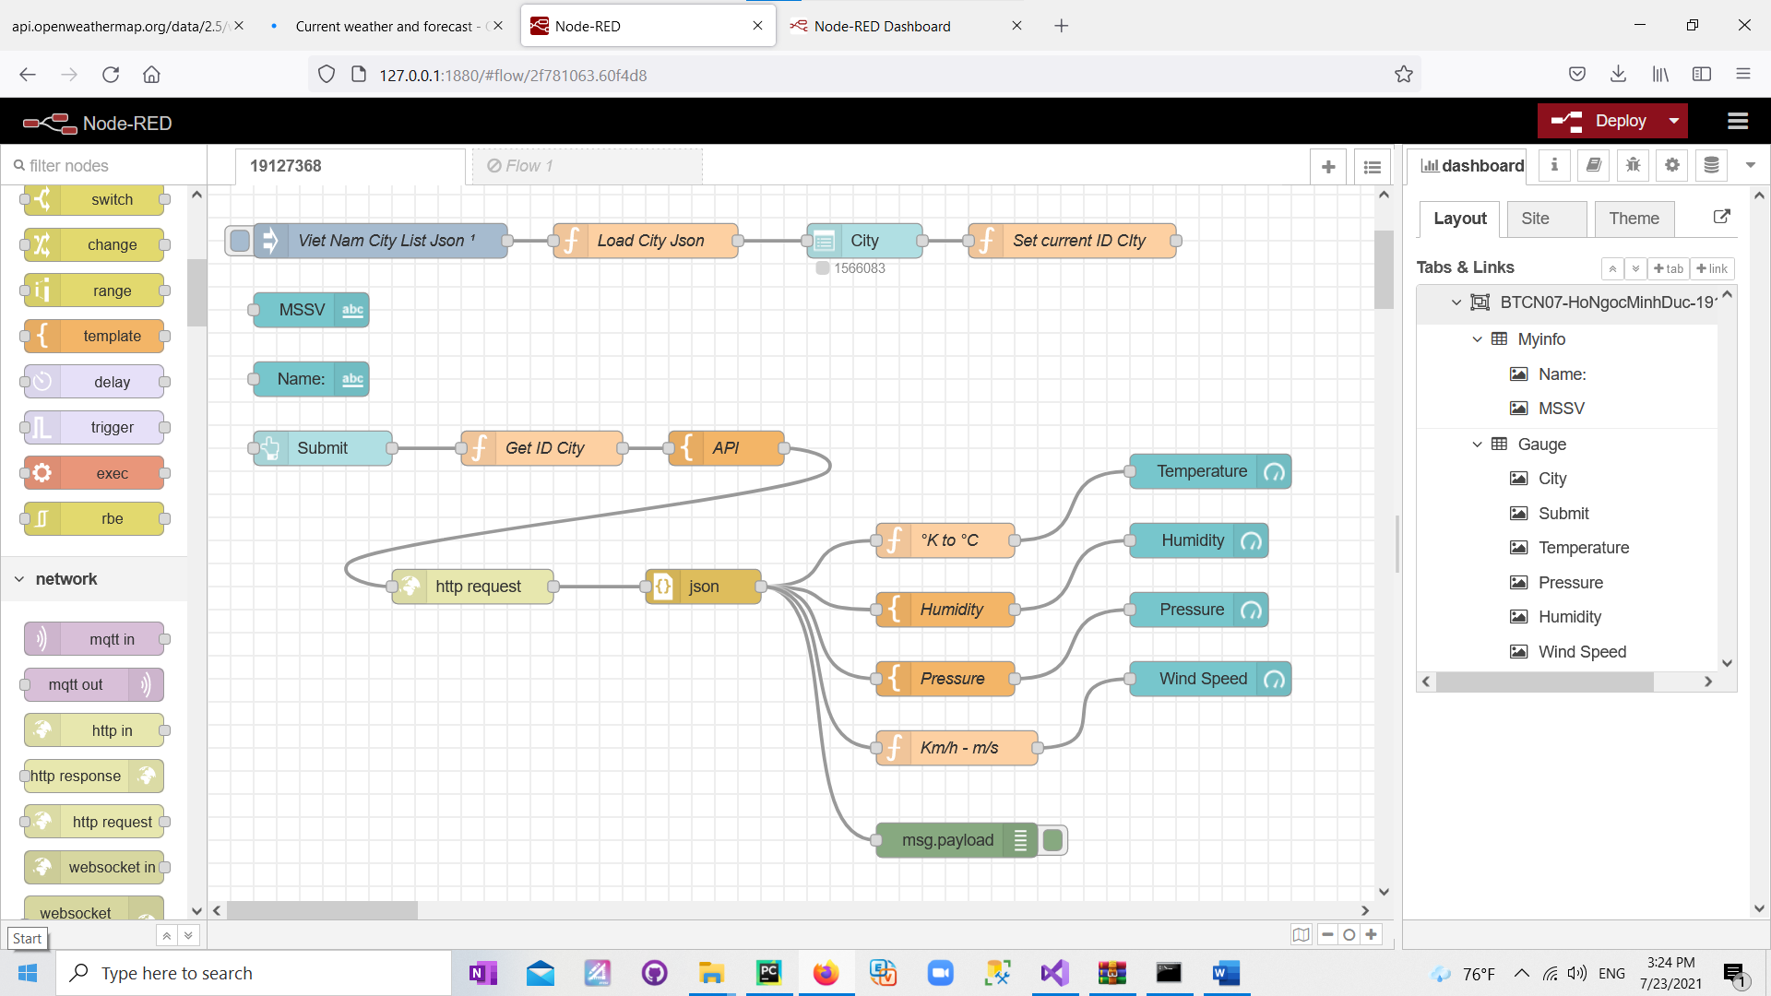 **Flow**
2. 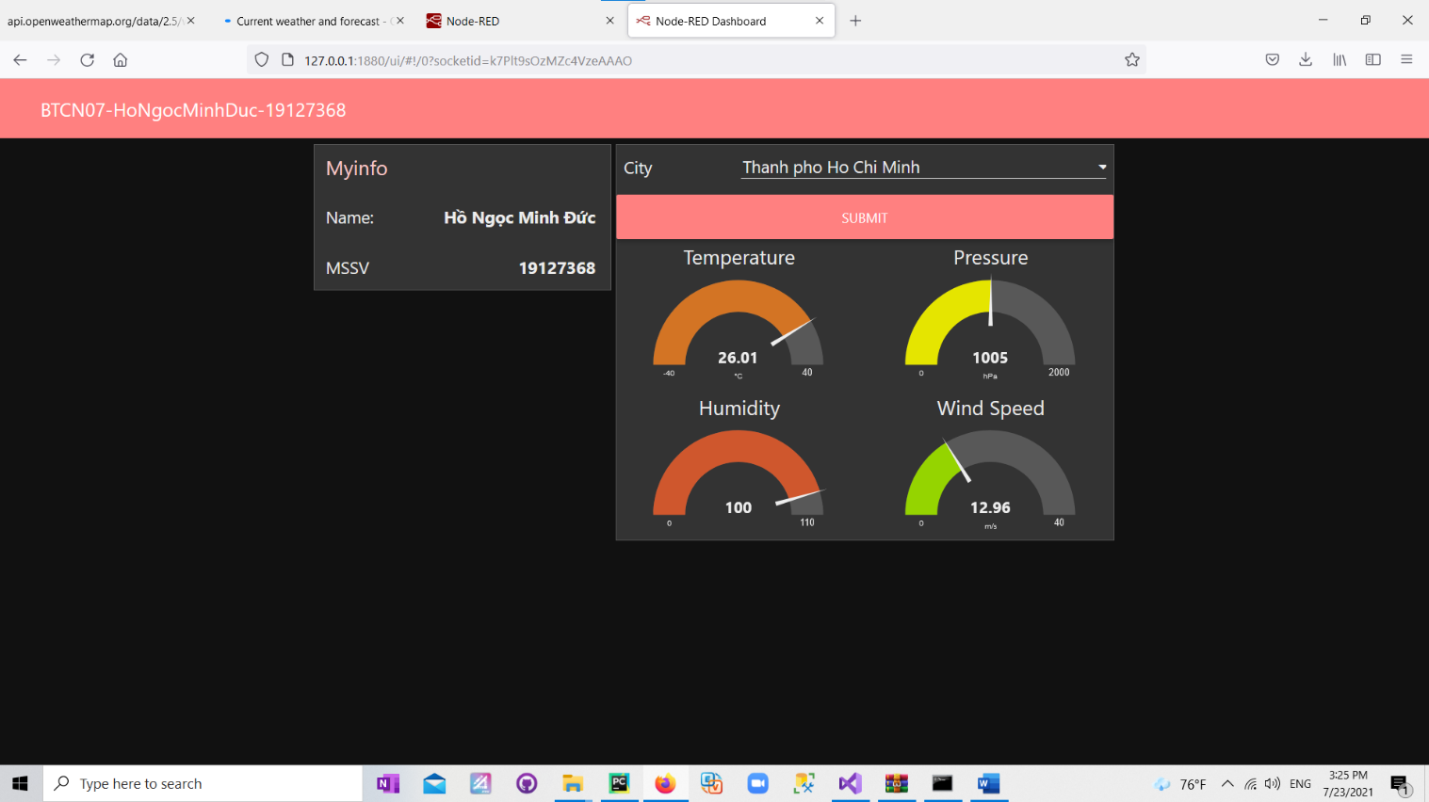**Web**