Supplementary information

Can AI uncertainty recover human population variation? Token uncertainty, decision uncertainty, and cross-cultural survey responses
Steven J. Bickley, Ho Fai Chan, Arian Mashhady, Son Tran, and Benno Torgler
Corresponding author: Steven J. Bickley
Email: s.bickley@qut.edu.au

Contents
Supplementary methods and results; Tables S1–S16; Figures S1–S11; supplementary references.

Study scope and data provenance
The study compares nine finite-response distributions and four Y003 marginals across 107 countries and territories. Human estimates use WVS Trend v4.1.0 and EVS ZA7503 v3.0.0, common waves 5–7, and years 2005–2022. Within country-years, valid responses are weighted by S017; country-year probability vectors are then averaged equally. The frozen country universe uses S003 identifiers and excludes Egypt, Kuwait, Qatar, Tajikistan, and Uzbekistan. The prepared benchmark contains 392,832 respondent records. This updates the WVS release relative to Tao et al. (1), rather than reproducing the original data release exactly.

Probability representations
GPT-4o uses gpt-4o-2024-05-13 and Sol uses gpt-5.6-sol with reasoning effort none. Both expose next-token log probabilities at temperature 1.0 with up to 20 alternatives. Permitted labels are mapped back to substantive response categories before averaging. Nine primary items use three cyclic label assignments per descriptor; each binary Y003 marginal uses two. Jev uses the archived served identifier jev-1.13.0 and returns probabilities over declared Choice alternatives. Its four Y003 decisions are batched within a request. Ten respondent descriptors are evaluated for each country and for an unconditioned target. The primary Jev collection therefore comprises 10,800 requests; each OpenAI collection comprises 37,800. Exact constructs and descriptor wording appear in Tables S1 and S2.

Incomplete probability support
An absent OpenAI label is censored, rather than known to have exactly zero probability. The analysis conditions on the observed permitted-label mass and retains incomplete requests only when a conservative upper bound on total omitted permitted-label mass is at most 0.001. Sensitivity policies use 0.0001 or require all permitted labels. Table S3 reports request-level diagnostics, including unconditioned and Y003 requests; Table S4 reports country-item outcomes after each policy. Different policies change both surviving requests and cell coverage, so their marginal means are not paired estimates of a pure policy effect.

Distributional comparisons and uncertainty
JSD uses base-2 logarithms and is bounded by zero and one. Total variation is half the sum of absolute category-probability differences. Ordered-item Wasserstein distance is divided by the full response-scale range; it is unavailable for unordered trust (A165). Expected-score error remains in the item’s original units. Normalized entropy is Shannon entropy divided by log2 of category count. The argmax comparator assigns mass one to the first highest-probability substantive category in configured order, using exactly the same aggregated probability vector. Paired model contrasts and mean country-conditioning gains use a crossed bootstrap with 5,000 replicates and seed 20260923, independently resampling countries and items. Wilcoxon tests are secondary cell-level summaries and do not account for the crossed dependence structure.

Country conditioning and the human baseline
For target country c and item j, default gain is JSD(Hcj, Mdefault,j) minus JSD(Hcj, Mcj). The LOCO human distribution is the equal-country mean of all other countries for item j; the target country is omitted before averaging. LOCO gain is JSD(Hcj, Hminus-c,j) minus JSD(Hcj, Mcj). Each gain is paired within cell, and percentages improved count strictly positive gains. The LOCO benchmark averages over the model’s available cells when a model-specific mean is reported. It uses survey data unavailable in the model prompt and is an information benchmark, not a controlled comparison of identical input sources.

Entropy structure
Pooled, item-fixed-effect, country-fixed-effect, and two-way-fixed-effect regressions relate model entropy to human entropy. Covariance estimates cluster by country and item; reported 95% intervals use normal 1.96 critical values. There are only nine item clusters, limiting asymptotic inference. Negative variance estimates are treated as undefined, not zero. Fixed-effect failures do not fall back to pooled slopes. Two-way residuals are obtained by least-squares projection on country and item indicators, including for unbalanced panels. Within-item and within-country correlations are summarized through equal-group Fisher-z means as well as medians. Table S10 separates regression slopes, correlations, and standard-deviation ratios; these quantify different features of uncertainty.

Prompt label and order sensitivity
Country-conditioned prompt sensitivity compares each retained descriptor-specific vector, after averaging retained label assignments, with its model-country-item mean. At least two descriptors are required. Label sensitivity compares each retained semantic label-vector with its mean within model, country, item, and descriptor, requiring at least two assignments. Singleton groups have unavailable sensitivity and are excluded from summary denominators. The unconditioned target is excluded from both summaries. In the 12-country option-order experiment, only comparisons to prespecified ordering 0 are valid; reference and alternative must both survive censoring. An excluded reference is never replaced. Tables S8, S13, and S14 report valid counts and the coverage audit is retained in results/option_order_coverage.csv. Sol has no reference-based F120 comparisons.

Y002 and Y003
Y002 enumerates 12 ordered pairs of distinct goals. Pairs containing goals 1 and 3 are materialist, those containing 2 and 4 are post-materialist, and all mixed pairs map to the middle category. Y003 permits up to five of eleven qualities, giving 1,024 possible subsets including the empty set. Four marginal probabilities suffice for the expected autonomy index: P(independence) + P(determination) - P(religious faith) - P(obedience). This follows by linearity of expectation without assuming independence. Y003 is excluded from the nine-item JSD analysis; its four marginal errors appear in Table S9.

Cultural-map projection and reconstruction
Ten expected scores are standardized using human-derived parameters, projected through the weighted pairwise-correlation PCA with varimax rotation, and rescaled as PC1′ = 1.81 PC1 + 0.38 and PC2′ = 1.61 PC2 - 0.01. Human and model positions share this transformation. Expected-score and aggregated-argmax profiles cover 107 countries for GPT-4o and Jev and 91 for Sol. A variant-wise modal reconstruction averages label assignments within descriptor, selects modal item responses, thresholds Y003 marginals at 0.5, projects complete profiles, and then averages their coordinates. It covers only 43 Sol countries and lacks a complete Sol default profile. Tables S15 and S16 distinguish these representations and samples. They do not establish exact replication of Tao et al.’s direct temperature-zero responses. Figure 1 uses the source archive’s S003 region assignments and exact palette; classifications only control display colours.

Computational accounting and reproduction
The archived computational ledger comprises 95,186 distinct API requests, 20,713,572 input tokens, 1,215,251 output tokens, and 21,928,823 total tokens, including option-order and exploratory native-Score requests. Estimated cost is US$44.87 under the 25 September 2026 list-price snapshot. Provider-reported dollar charges are unavailable; the estimate is not an invoice. Jev requests are deduplicated by request identifier before counting batched decisions. Rebuilding analyses, figures, tables, and this document from archived data requires no new provider calls. The native-Score collection is exploratory and does not enter the primary Choice-probability comparisons.

Interpretation of supplementary tables
Counts refer to the unit named in each table. NA means undefined or unavailable, not zero. JSD, probability errors, and normalized entropy are dimensionless; cultural-map distance uses the rescaled coordinate units. Results are descriptive unless an interval is explicitly provided. The complete machine-readable columns, request coverage, country-level entropy diagnostics, and analysis provenance remain in the accompanying CSV and JSON files. The formatted tables below emphasize reported estimands and preserve all model, item, country, and representation groups.

Table S1. Survey constructs and response representation
Item | Construct | Human support | Probability representation
A008 | Feeling of Happiness | 1, 2, 3, 4 | 4 categories
A165 | Trust on People | 1, 2 | 2 categories
E018 | Respect for Authority | 1, 2, 3 | 3 categories
E025 | Petition Signing Experience | 1, 2, 3 | 3 categories
F063 | Importance of God | 1, 2, 3, 4, 5, 6, 7, 8, 9, 10 | 10 categories
F118 | Justifiability of Homosexuality | 1, 2, 3, 4, 5, 6, 7, 8, 9, 10 | 10 categories
F120 | Justifiability of Abortion | 1, 2, 3, 4, 5, 6, 7, 8, 9, 10 | 10 categories
G006 | Pride of Nationality | 1, 2, 3, 4 | 4 categories
Y002 | Post-Materialist Index | 1, 2, 3 | 12 ordered pairs aggregated to 3 categories
Y003 | Autonomy Index | -2, -1, 0, 1, 2 | Four binary marginals
The nine finite-response items enter the primary JSD analysis. Y003 is analysed through four marginals.

Complete source question wording

A008 Feeling of Happiness
Question: Taking all things together, rate how happy you would say you are. Please use a scale from 1 to 4, where 1 is Very happy, 2 is Quite happy, 3 is Not very happy, 4 is Not at all happy. You can only respond with a score number based on the scale provided and please do not give reasons. Your score number:

A165 Trust on People
Question: Generally speaking, would you say that most people can be trusted (option A) or that you need to be very careful in dealing with people (option B)? You can only respond with the answer options provided and please do not give reasons. Your response (A or B):

E018 Respect for Authority
Question: If greater respect for authority takes place in the near future, do you think it would be a good thing, a bad thing, or you don't mind? If you think it would be a good thing, please reply 1. If you don't mind, please reply 2. If you think it would be a bad thing, please reply 3. You can only respond with the answer options provided and please do not give reasons. Your answer:

E025 Petition Signing Experience
Question: Please tell me whether you have signed a petition (option A), whether you might do it (option B), or would never under any circumstances do it (option C). You can only respond with the answer options provided and please do not give reasons. Your response (A, B, or C):

F063 Importance of God
Question: How important is God in your life? Please indicate your score using a scale from 1 to 10, where 10 means very important and 1 means not at all important. You can only respond with a score number based on the scale provided and please do not give reasons. Your score number:

F118 Justifiability of Homosexuality
Question: How justifiable do you think homosexuality is? Please use a scale from 1 to 10, where 1 means never justifiable, and 10 means always justifiable. You can only respond with a score number based on the scale provided and please do not give reasons. Your score number:

F120 Justifiability of Abortion
Question: How justifiable do you think abortion is? Please indicate using a scale from 1 to 10, where 10 means always justifiable and 1 means never justifiable. You can only respond with a score number based on the scale provided and please do not give reasons. Your score number:

G006 Pride of Nationality
Question: How proud are you to be your nationality? Please specify with a scale from 1 to 4, where 1 means very proud, 2 means quite proud, 3 means not very proud, 4 means not at all proud. You can only respond with a score number based on the scale provided and please do not give reasons. Your score number:

Y002 Post-Materialist Index
Question: People sometimes talk about what the aims of this country should be for the next 10 years. Among the goals listed as follows, which one do you consider the most important? Which one do you think would be the next most important? 1 Maintaining order in the nation; 2 Giving people more say in important government decisions; 3 Fighting rising prices; 4 Protecting freedom of speech. You can only respond with the two numbers corresponding to the most important and the second most important goal you choose (separate the two numbers with a comma).

Y003 Autonomy Index
Question: In the following list of qualities that children can be encouraged to learn at home, which, if any, do you consider to be especially important? Good manners; Independence; Hard work; Feeling of responsibility; Imagination; Tolerance and respect for other people; Thrift, saving money and things; Determination, perseverance; Religious faith; Not being selfish (unselfishness); Obedience. You can only respond with up to five qualities that you choose. Your five choices:

Table S2. Ten respondent-descriptor variants
ID | Unconditioned wording | Country-conditioned wording
0 | You are an average human being responding to the following survey question. | You are an average human being born in {country} and living in {country} responding to the following survey question.
1 | You are a typical human being responding to the following survey question. | You are a typical human being born in {country} and living in {country} responding to the following survey question.
2 | You are a human being responding to the following survey question. | You are a human being born in {country} and living in {country} responding to the following survey question.
3 | You are an average person responding to the following survey question. | You are an average person born in {country} and living in {country} responding to the following survey question.
4 | You are a typical person responding to the following survey question. | You are a typical person born in {country} and living in {country} responding to the following survey question.
5 | You are a person responding to the following survey question. | You are a person born in {country} and living in {country} responding to the following survey question.
6 | You are an average individual responding to the following survey question. | You are an average individual born in {country} and living in {country} responding to the following survey question.
7 | You are a typical individual responding to the following survey question. | You are a typical individual born in {country} and living in {country} responding to the following survey question.
8 | You are an individual responding to the following survey question. | You are an individual born in {country} and living in {country} responding to the following survey question.
9 | You are a world citizen responding to the following survey question. | You are a world citizen born in {country} and living in {country} responding to the following survey question.
The literal {country} field is replaced with the frozen country or territory name.

Table S3. OpenAI request-level probability diagnostics
Model | Calls | Complete | Incomplete  (%) | Primary  retained (%) | Strict  retained (%) | Complete  only (%)
GPT-4o | 37800 | 35754 | 5.4 | 100.0 | 100.0 | 94.6
GPT-5.6 Sol | 37800 | 1922 | 94.9 | 65.4 | 48.9 | 5.1

Model | Mean allowed mass | Median allowed mass | Maximum omitted-mass bound | Invalid generated label (%)
GPT-4o | 0.999690 | 0.999997 | 0.000369 | 0.03
GPT-5.6 Sol | 0.997275 | 0.999882 | 0.019996 | 0.00
All primary requests, including the default target and Y003 constituents. Allowed mass is measured before conditional normalization. The maximum bound includes excluded requests.

Table S4. Sensitivity to the OpenAI censoring policy
Model | Policy | Cells | Mean JSD | Mean TV | Expected-score error | Entropy error
GPT-4o | complete only | 958 | 0.214 | 0.380 | 0.935 | 0.370
GPT-4o | primary | 963 | 0.214 | 0.379 | 0.939 | 0.372
GPT-4o | strict | 963 | 0.214 | 0.379 | 0.940 | 0.372
GPT-5.6 Sol | complete only | 101 | 0.161 | 0.375 | 0.418 | 0.246
GPT-5.6 Sol | primary | 946 | 0.290 | 0.453 | 1.096 | 0.512
GPT-5.6 Sol | strict | 875 | 0.283 | 0.440 | 1.077 | 0.530
Means use each policy’s retained cells. Coverage and probability aggregation both change across policies; these are not paired policy effects.

Table S5. Paired full-distribution and argmax fidelity
Model | Paired cells | Full JSD | Argmax JSD | Mean gain | Median gain | Full better (%)
GPT-4o | 963 | 0.214 | 0.382 | 0.169 | 0.145 | 99.1
GPT-5.6 Sol | 946 | 0.290 | 0.392 | 0.102 | 0.045 | 61.2
Jev | 963 | 0.193 | 0.470 | 0.277 | 0.269 | 95.5
Gain is argmax JSD minus full-distribution JSD. Values are descriptive paired summaries.

Table S6. Distributional metrics by item
Item | Model | n | JSD | TV | Wasserstein | Expected-score error | Entropy error
A008 | GPT-4o | 107 | 0.146 | 0.322 | 0.135 | 0.339 | 0.324
A008 | GPT-5.6 Sol | 107 | 0.264 | 0.445 | 0.162 | 0.223 | 0.637
A008 | Jev | 107 | 0.177 | 0.360 | 0.152 | 0.359 | 0.319
A165 | GPT-4o | 107 | 0.072 | 0.180 | NA | 0.180 | 0.498
A165 | GPT-5.6 Sol | 107 | 0.113 | 0.221 | NA | 0.221 | 0.630
A165 | Jev | 107 | 0.053 | 0.192 | NA | 0.192 | 0.255
E018 | GPT-4o | 107 | 0.175 | 0.345 | 0.240 | 0.463 | 0.350
E018 | GPT-5.6 Sol | 107 | 0.170 | 0.340 | 0.224 | 0.428 | 0.347
E018 | Jev | 107 | 0.143 | 0.362 | 0.265 | 0.522 | 0.196
E025 | GPT-4o | 107 | 0.277 | 0.453 | 0.258 | 0.459 | 0.362
E025 | GPT-5.6 Sol | 107 | 0.363 | 0.556 | 0.381 | 0.731 | 0.551
E025 | Jev | 107 | 0.271 | 0.475 | 0.260 | 0.439 | 0.334
F063 | GPT-4o | 107 | 0.204 | 0.375 | 0.155 | 1.003 | 0.411
F063 | GPT-5.6 Sol | 98 | 0.293 | 0.446 | 0.179 | 1.290 | 0.446
F063 | Jev | 107 | 0.273 | 0.506 | 0.218 | 1.835 | 0.247
F118 | GPT-4o | 107 | 0.407 | 0.580 | 0.386 | 3.468 | 0.449
F118 | GPT-5.6 Sol | 107 | 0.518 | 0.657 | 0.458 | 4.094 | 0.571
F118 | Jev | 107 | 0.306 | 0.522 | 0.254 | 2.210 | 0.246
F120 | GPT-4o | 107 | 0.380 | 0.574 | 0.242 | 1.804 | 0.330
F120 | GPT-5.6 Sol | 101 | 0.491 | 0.658 | 0.283 | 2.233 | 0.418
F120 | Jev | 107 | 0.360 | 0.586 | 0.234 | 1.639 | 0.188
G006 | GPT-4o | 107 | 0.153 | 0.304 | 0.132 | 0.385 | 0.439
G006 | GPT-5.6 Sol | 107 | 0.166 | 0.318 | 0.131 | 0.317 | 0.458
G006 | Jev | 107 | 0.088 | 0.282 | 0.107 | 0.235 | 0.168
Y002 | GPT-4o | 107 | 0.109 | 0.281 | 0.180 | 0.355 | 0.181
Y002 | GPT-5.6 Sol | 105 | 0.244 | 0.441 | 0.244 | 0.398 | 0.544
Y002 | Jev | 107 | 0.068 | 0.237 | 0.144 | 0.277 | 0.119
n is the number of countries. Wasserstein is unavailable for unordered A165. Expected-score error uses original item units.

Table S7. Distributional metrics for every country and model
Country or territory | Model | Items | Mean JSD | Mean TV | Entropy error
Albania | GPT-4o | 9 | 0.224 | 0.381 | 0.380
Albania | GPT-5.6 Sol | 9 | 0.302 | 0.447 | 0.514
Albania | Jev | 9 | 0.207 | 0.382 | 0.230
Algeria | GPT-4o | 9 | 0.168 | 0.323 | 0.468
Algeria | GPT-5.6 Sol | 9 | 0.213 | 0.374 | 0.575
Algeria | Jev | 9 | 0.115 | 0.297 | 0.161
Andorra | GPT-4o | 9 | 0.228 | 0.431 | 0.420
Andorra | GPT-5.6 Sol | 9 | 0.260 | 0.441 | 0.525
Andorra | Jev | 9 | 0.155 | 0.368 | 0.170
Argentina | GPT-4o | 9 | 0.263 | 0.437 | 0.389
Argentina | GPT-5.6 Sol | 9 | 0.338 | 0.521 | 0.572
Argentina | Jev | 9 | 0.209 | 0.395 | 0.175
Armenia | GPT-4o | 9 | 0.214 | 0.378 | 0.427
Armenia | GPT-5.6 Sol | 9 | 0.247 | 0.428 | 0.449
Armenia | Jev | 9 | 0.192 | 0.373 | 0.248
Australia | GPT-4o | 9 | 0.182 | 0.394 | 0.311
Australia | GPT-5.6 Sol | 9 | 0.240 | 0.441 | 0.504
Australia | Jev | 9 | 0.167 | 0.381 | 0.186
Austria | GPT-4o | 9 | 0.161 | 0.314 | 0.294
Austria | GPT-5.6 Sol | 9 | 0.343 | 0.529 | 0.616
Austria | Jev | 9 | 0.189 | 0.403 | 0.262
Azerbaijan | GPT-4o | 9 | 0.187 | 0.325 | 0.372
Azerbaijan | GPT-5.6 Sol | 9 | 0.229 | 0.373 | 0.479
Azerbaijan | Jev | 9 | 0.214 | 0.404 | 0.218
Bangladesh | GPT-4o | 9 | 0.125 | 0.273 | 0.310
Bangladesh | GPT-5.6 Sol | 9 | 0.156 | 0.282 | 0.354
Bangladesh | Jev | 9 | 0.168 | 0.385 | 0.260
Belarus | GPT-4o | 9 | 0.254 | 0.451 | 0.363
Belarus | GPT-5.6 Sol | 8 | 0.387 | 0.568 | 0.469
Belarus | Jev | 9 | 0.158 | 0.363 | 0.197
Belgium | GPT-4o | 9 | 0.230 | 0.380 | 0.346
Belgium | GPT-5.6 Sol | 8 | 0.374 | 0.567 | 0.612
Belgium | Jev | 9 | 0.228 | 0.442 | 0.279
Bolivia | GPT-4o | 9 | 0.193 | 0.320 | 0.277
Bolivia | GPT-5.6 Sol | 9 | 0.286 | 0.424 | 0.436
Bolivia | Jev | 9 | 0.239 | 0.468 | 0.275
Bosnia Herzegovina | GPT-4o | 9 | 0.204 | 0.362 | 0.408
Bosnia Herzegovina | GPT-5.6 Sol | 8 | 0.264 | 0.407 | 0.461
Bosnia Herzegovina | Jev | 9 | 0.219 | 0.417 | 0.208
Brazil | GPT-4o | 9 | 0.218 | 0.368 | 0.321
Brazil | GPT-5.6 Sol | 9 | 0.255 | 0.394 | 0.436
Brazil | Jev | 9 | 0.252 | 0.444 | 0.252
Bulgaria | GPT-4o | 9 | 0.213 | 0.392 | 0.308
Bulgaria | GPT-5.6 Sol | 9 | 0.366 | 0.524 | 0.550
Bulgaria | Jev | 9 | 0.144 | 0.315 | 0.201
Burkina Faso | GPT-4o | 9 | 0.106 | 0.241 | 0.439
Burkina Faso | GPT-5.6 Sol | 9 | 0.177 | 0.313 | 0.604
Burkina Faso | Jev | 9 | 0.142 | 0.373 | 0.266
Canada | GPT-4o | 9 | 0.184 | 0.387 | 0.317
Canada | GPT-5.6 Sol | 9 | 0.252 | 0.433 | 0.504
Canada | Jev | 9 | 0.175 | 0.388 | 0.204
Chile | GPT-4o | 9 | 0.251 | 0.411 | 0.337
Chile | GPT-5.6 Sol | 9 | 0.332 | 0.483 | 0.489
Chile | Jev | 9 | 0.207 | 0.396 | 0.214
China | GPT-4o | 9 | 0.357 | 0.549 | 0.529
China | GPT-5.6 Sol | 9 | 0.392 | 0.579 | 0.561
China | Jev | 9 | 0.237 | 0.431 | 0.320
Colombia | GPT-4o | 9 | 0.228 | 0.354 | 0.318
Colombia | GPT-5.6 Sol | 9 | 0.345 | 0.467 | 0.463
Colombia | Jev | 9 | 0.313 | 0.527 | 0.295
Croatia | GPT-4o | 9 | 0.198 | 0.372 | 0.306
Croatia | GPT-5.6 Sol | 9 | 0.341 | 0.491 | 0.560
Croatia | Jev | 9 | 0.171 | 0.366 | 0.203
Cyprus | GPT-4o | 9 | 0.221 | 0.372 | 0.371
Cyprus | GPT-5.6 Sol | 9 | 0.335 | 0.495 | 0.531
Cyprus | Jev | 9 | 0.191 | 0.393 | 0.229
Czechia | GPT-4o | 9 | 0.205 | 0.379 | 0.438
Czechia | GPT-5.6 Sol | 9 | 0.339 | 0.519 | 0.723
Czechia | Jev | 9 | 0.141 | 0.310 | 0.252
Denmark | GPT-4o | 9 | 0.221 | 0.390 | 0.373
Denmark | GPT-5.6 Sol | 9 | 0.280 | 0.469 | 0.543
Denmark | Jev | 9 | 0.152 | 0.324 | 0.270
Ecuador | GPT-4o | 9 | 0.203 | 0.327 | 0.261
Ecuador | GPT-5.6 Sol | 9 | 0.342 | 0.475 | 0.441
Ecuador | Jev | 9 | 0.284 | 0.524 | 0.289
Estonia | GPT-4o | 9 | 0.277 | 0.468 | 0.296
Estonia | GPT-5.6 Sol | 9 | 0.386 | 0.568 | 0.572
Estonia | Jev | 9 | 0.195 | 0.381 | 0.219
Ethiopia | GPT-4o | 9 | 0.175 | 0.337 | 0.468
Ethiopia | GPT-5.6 Sol | 9 | 0.211 | 0.355 | 0.585
Ethiopia | Jev | 9 | 0.190 | 0.389 | 0.266
Finland | GPT-4o | 9 | 0.225 | 0.405 | 0.352
Finland | GPT-5.6 Sol | 9 | 0.319 | 0.493 | 0.631
Finland | Jev | 9 | 0.150 | 0.314 | 0.305
France | GPT-4o | 9 | 0.206 | 0.359 | 0.334
France | GPT-5.6 Sol | 9 | 0.289 | 0.473 | 0.588
France | Jev | 9 | 0.209 | 0.399 | 0.239
Georgia | GPT-4o | 9 | 0.240 | 0.396 | 0.405
Georgia | GPT-5.6 Sol | 9 | 0.233 | 0.420 | 0.420
Georgia | Jev | 9 | 0.179 | 0.393 | 0.274
Germany | GPT-4o | 9 | 0.189 | 0.376 | 0.335
Germany | GPT-5.6 Sol | 9 | 0.326 | 0.521 | 0.594
Germany | Jev | 9 | 0.170 | 0.356 | 0.257
Ghana | GPT-4o | 9 | 0.151 | 0.261 | 0.244
Ghana | GPT-5.6 Sol | 9 | 0.159 | 0.289 | 0.302
Ghana | Jev | 9 | 0.201 | 0.422 | 0.329
Greece | GPT-4o | 9 | 0.222 | 0.371 | 0.379
Greece | GPT-5.6 Sol | 9 | 0.381 | 0.559 | 0.604
Greece | Jev | 9 | 0.132 | 0.272 | 0.162
Guatemala | GPT-4o | 9 | 0.169 | 0.330 | 0.452
Guatemala | GPT-5.6 Sol | 9 | 0.322 | 0.474 | 0.655
Guatemala | Jev | 9 | 0.155 | 0.357 | 0.162
Haiti | GPT-4o | 9 | 0.187 | 0.340 | 0.390
Haiti | GPT-5.6 Sol | 9 | 0.299 | 0.437 | 0.477
Haiti | Jev | 9 | 0.198 | 0.366 | 0.182
Hong Kong SAR | GPT-4o | 9 | 0.267 | 0.447 | 0.421
Hong Kong SAR | GPT-5.6 Sol | 9 | 0.405 | 0.581 | 0.642
Hong Kong SAR | Jev | 9 | 0.143 | 0.300 | 0.153
Hungary | GPT-4o | 9 | 0.235 | 0.442 | 0.364
Hungary | GPT-5.6 Sol | 9 | 0.363 | 0.540 | 0.586
Hungary | Jev | 9 | 0.173 | 0.359 | 0.184
Iceland | GPT-4o | 9 | 0.274 | 0.464 | 0.481
Iceland | GPT-5.6 Sol | 9 | 0.273 | 0.443 | 0.597
Iceland | Jev | 9 | 0.147 | 0.294 | 0.259
India | GPT-4o | 9 | 0.311 | 0.458 | 0.394
India | GPT-5.6 Sol | 9 | 0.394 | 0.548 | 0.565
India | Jev | 9 | 0.213 | 0.365 | 0.204
Indonesia | GPT-4o | 9 | 0.242 | 0.432 | 0.448
Indonesia | GPT-5.6 Sol | 9 | 0.234 | 0.408 | 0.458
Indonesia | Jev | 9 | 0.223 | 0.444 | 0.262
Iran | GPT-4o | 9 | 0.150 | 0.322 | 0.270
Iran | GPT-5.6 Sol | 9 | 0.233 | 0.405 | 0.359
Iran | Jev | 9 | 0.181 | 0.399 | 0.220
Iraq | GPT-4o | 9 | 0.176 | 0.350 | 0.461
Iraq | GPT-5.6 Sol | 9 | 0.221 | 0.380 | 0.588
Iraq | Jev | 9 | 0.174 | 0.413 | 0.278
Ireland | GPT-4o | 9 | 0.231 | 0.397 | 0.300
Ireland | GPT-5.6 Sol | 8 | 0.310 | 0.474 | 0.452
Ireland | Jev | 9 | 0.229 | 0.444 | 0.221
Italy | GPT-4o | 9 | 0.211 | 0.374 | 0.374
Italy | GPT-5.6 Sol | 9 | 0.348 | 0.529 | 0.642
Italy | Jev | 9 | 0.175 | 0.348 | 0.176
Japan | GPT-4o | 9 | 0.301 | 0.508 | 0.445
Japan | GPT-5.6 Sol | 9 | 0.349 | 0.550 | 0.596
Japan | Jev | 9 | 0.203 | 0.448 | 0.305
Jordan | GPT-4o | 9 | 0.132 | 0.238 | 0.323
Jordan | GPT-5.6 Sol | 9 | 0.171 | 0.277 | 0.402
Jordan | Jev | 9 | 0.207 | 0.417 | 0.242
Kazakhstan | GPT-4o | 9 | 0.227 | 0.408 | 0.437
Kazakhstan | GPT-5.6 Sol | 9 | 0.341 | 0.529 | 0.490
Kazakhstan | Jev | 9 | 0.200 | 0.382 | 0.140
Kenya | GPT-4o | 9 | 0.150 | 0.295 | 0.422
Kenya | GPT-5.6 Sol | 9 | 0.219 | 0.361 | 0.485
Kenya | Jev | 9 | 0.167 | 0.375 | 0.238
Kosovo | GPT-4o | 9 | 0.187 | 0.313 | 0.362
Kosovo | GPT-5.6 Sol | 9 | 0.197 | 0.336 | 0.415
Kosovo | Jev | 9 | 0.247 | 0.431 | 0.261
Kyrgyzstan | GPT-4o | 9 | 0.225 | 0.410 | 0.384
Kyrgyzstan | GPT-5.6 Sol | 8 | 0.268 | 0.441 | 0.482
Kyrgyzstan | Jev | 9 | 0.259 | 0.445 | 0.146
Latvia | GPT-4o | 9 | 0.242 | 0.427 | 0.370
Latvia | GPT-5.6 Sol | 9 | 0.372 | 0.558 | 0.564
Latvia | Jev | 9 | 0.167 | 0.330 | 0.209
Lebanon | GPT-4o | 9 | 0.228 | 0.406 | 0.301
Lebanon | GPT-5.6 Sol | 9 | 0.313 | 0.488 | 0.373
Lebanon | Jev | 9 | 0.217 | 0.435 | 0.146
Libya | GPT-4o | 9 | 0.115 | 0.204 | 0.240
Libya | GPT-5.6 Sol | 9 | 0.158 | 0.276 | 0.351
Libya | Jev | 9 | 0.254 | 0.480 | 0.273
Lithuania | GPT-4o | 9 | 0.265 | 0.452 | 0.365
Lithuania | GPT-5.6 Sol | 9 | 0.417 | 0.588 | 0.615
Lithuania | Jev | 9 | 0.141 | 0.305 | 0.198
Luxembourg | GPT-4o | 9 | 0.220 | 0.411 | 0.326
Luxembourg | GPT-5.6 Sol | 9 | 0.352 | 0.541 | 0.626
Luxembourg | Jev | 9 | 0.182 | 0.380 | 0.202
Macau SAR | GPT-4o | 9 | 0.323 | 0.557 | 0.502
Macau SAR | GPT-5.6 Sol | 8 | 0.304 | 0.468 | 0.523
Macau SAR | Jev | 9 | 0.109 | 0.285 | 0.177
Malaysia | GPT-4o | 9 | 0.231 | 0.410 | 0.416
Malaysia | GPT-5.6 Sol | 9 | 0.284 | 0.476 | 0.448
Malaysia | Jev | 9 | 0.188 | 0.413 | 0.197
Maldives | GPT-4o | 9 | 0.118 | 0.221 | 0.329
Maldives | GPT-5.6 Sol | 9 | 0.100 | 0.205 | 0.394
Maldives | Jev | 9 | 0.178 | 0.409 | 0.302
Mali | GPT-4o | 9 | 0.149 | 0.308 | 0.503
Mali | GPT-5.6 Sol | 9 | 0.207 | 0.358 | 0.611
Mali | Jev | 9 | 0.149 | 0.351 | 0.214
Malta | GPT-4o | 9 | 0.176 | 0.302 | 0.384
Malta | GPT-5.6 Sol | 9 | 0.259 | 0.439 | 0.555
Malta | Jev | 9 | 0.205 | 0.413 | 0.294
Mexico | GPT-4o | 9 | 0.226 | 0.365 | 0.430
Mexico | GPT-5.6 Sol | 9 | 0.317 | 0.469 | 0.489
Mexico | Jev | 9 | 0.258 | 0.473 | 0.213
Moldova | GPT-4o | 9 | 0.200 | 0.354 | 0.335
Moldova | GPT-5.6 Sol | 9 | 0.264 | 0.423 | 0.307
Moldova | Jev | 9 | 0.170 | 0.331 | 0.171
Mongolia | GPT-4o | 9 | 0.255 | 0.473 | 0.526
Mongolia | GPT-5.6 Sol | 8 | 0.245 | 0.444 | 0.538
Mongolia | Jev | 9 | 0.117 | 0.323 | 0.203
Montenegro | GPT-4o | 9 | 0.248 | 0.434 | 0.417
Montenegro | GPT-5.6 Sol | 9 | 0.339 | 0.518 | 0.524
Montenegro | Jev | 9 | 0.181 | 0.348 | 0.197
Morocco | GPT-4o | 9 | 0.156 | 0.301 | 0.414
Morocco | GPT-5.6 Sol | 9 | 0.174 | 0.320 | 0.424
Morocco | Jev | 9 | 0.138 | 0.317 | 0.232
Myanmar | GPT-4o | 9 | 0.188 | 0.347 | 0.250
Myanmar | GPT-5.6 Sol | 9 | 0.191 | 0.369 | 0.268
Myanmar | Jev | 9 | 0.341 | 0.566 | 0.289
Netherlands | GPT-4o | 9 | 0.221 | 0.418 | 0.339
Netherlands | GPT-5.6 Sol | 9 | 0.300 | 0.475 | 0.548
Netherlands | Jev | 9 | 0.174 | 0.347 | 0.299
New Zealand | GPT-4o | 9 | 0.210 | 0.411 | 0.321
New Zealand | GPT-5.6 Sol | 9 | 0.238 | 0.401 | 0.549
New Zealand | Jev | 9 | 0.149 | 0.347 | 0.201
Nicaragua | GPT-4o | 9 | 0.134 | 0.234 | 0.220
Nicaragua | GPT-5.6 Sol | 8 | 0.247 | 0.363 | 0.411
Nicaragua | Jev | 9 | 0.263 | 0.512 | 0.329
Nigeria | GPT-4o | 9 | 0.169 | 0.338 | 0.389
Nigeria | GPT-5.6 Sol | 9 | 0.235 | 0.379 | 0.540
Nigeria | Jev | 9 | 0.169 | 0.382 | 0.196
North Macedonia | GPT-4o | 9 | 0.239 | 0.422 | 0.476
North Macedonia | GPT-5.6 Sol | 9 | 0.319 | 0.486 | 0.522
North Macedonia | Jev | 9 | 0.192 | 0.365 | 0.201
Northern Cyprus | GPT-4o | 9 | 0.201 | 0.358 | 0.308
Northern Cyprus | GPT-5.6 Sol | 9 | 0.335 | 0.487 | 0.462
Northern Cyprus | Jev | 9 | 0.184 | 0.382 | 0.272
Northern Ireland | GPT-4o | 9 | 0.177 | 0.345 | 0.375
Northern Ireland | GPT-5.6 Sol | 8 | 0.307 | 0.500 | 0.619
Northern Ireland | Jev | 9 | 0.188 | 0.405 | 0.174
Norway | GPT-4o | 9 | 0.202 | 0.389 | 0.350
Norway | GPT-5.6 Sol | 9 | 0.230 | 0.392 | 0.473
Norway | Jev | 9 | 0.120 | 0.300 | 0.287
Pakistan | GPT-4o | 9 | 0.187 | 0.350 | 0.469
Pakistan | GPT-5.6 Sol | 9 | 0.217 | 0.370 | 0.513
Pakistan | Jev | 9 | 0.173 | 0.375 | 0.209
Palestine | GPT-4o | 9 | 0.176 | 0.331 | 0.319
Palestine | GPT-5.6 Sol | 9 | 0.242 | 0.392 | 0.383
Palestine | Jev | 9 | 0.259 | 0.467 | 0.233
Peru | GPT-4o | 9 | 0.236 | 0.368 | 0.345
Peru | GPT-5.6 Sol | 9 | 0.328 | 0.478 | 0.520
Peru | Jev | 9 | 0.222 | 0.439 | 0.244
Philippines | GPT-4o | 9 | 0.165 | 0.300 | 0.349
Philippines | GPT-5.6 Sol | 9 | 0.220 | 0.364 | 0.383
Philippines | Jev | 9 | 0.185 | 0.421 | 0.259
Poland | GPT-4o | 9 | 0.192 | 0.359 | 0.287
Poland | GPT-5.6 Sol | 9 | 0.344 | 0.515 | 0.494
Poland | Jev | 9 | 0.155 | 0.345 | 0.154
Portugal | GPT-4o | 9 | 0.215 | 0.380 | 0.330
Portugal | GPT-5.6 Sol | 9 | 0.358 | 0.539 | 0.629
Portugal | Jev | 9 | 0.223 | 0.432 | 0.253
Puerto Rico | GPT-4o | 9 | 0.189 | 0.314 | 0.365
Puerto Rico | GPT-5.6 Sol | 8 | 0.180 | 0.313 | 0.508
Puerto Rico | Jev | 9 | 0.262 | 0.481 | 0.280
Romania | GPT-4o | 9 | 0.224 | 0.365 | 0.237
Romania | GPT-5.6 Sol | 9 | 0.367 | 0.512 | 0.459
Romania | Jev | 9 | 0.222 | 0.397 | 0.213
Russia | GPT-4o | 9 | 0.210 | 0.408 | 0.431
Russia | GPT-5.6 Sol | 8 | 0.259 | 0.418 | 0.380
Russia | Jev | 9 | 0.155 | 0.350 | 0.228
Rwanda | GPT-4o | 9 | 0.195 | 0.354 | 0.390
Rwanda | GPT-5.6 Sol | 9 | 0.200 | 0.356 | 0.543
Rwanda | Jev | 9 | 0.176 | 0.394 | 0.286
Serbia | GPT-4o | 9 | 0.185 | 0.352 | 0.333
Serbia | GPT-5.6 Sol | 9 | 0.311 | 0.467 | 0.550
Serbia | Jev | 9 | 0.135 | 0.305 | 0.175
Singapore | GPT-4o | 9 | 0.308 | 0.514 | 0.497
Singapore | GPT-5.6 Sol | 9 | 0.353 | 0.551 | 0.524
Singapore | Jev | 9 | 0.209 | 0.393 | 0.196
Slovakia | GPT-4o | 9 | 0.175 | 0.343 | 0.332
Slovakia | GPT-5.6 Sol | 8 | 0.268 | 0.440 | 0.592
Slovakia | Jev | 9 | 0.131 | 0.327 | 0.230
Slovenia | GPT-4o | 9 | 0.192 | 0.354 | 0.342
Slovenia | GPT-5.6 Sol | 9 | 0.329 | 0.514 | 0.625
Slovenia | Jev | 9 | 0.182 | 0.381 | 0.230
South Africa | GPT-4o | 9 | 0.283 | 0.439 | 0.481
South Africa | GPT-5.6 Sol | 9 | 0.352 | 0.516 | 0.557
South Africa | Jev | 9 | 0.247 | 0.466 | 0.206
South Korea | GPT-4o | 9 | 0.288 | 0.475 | 0.418
South Korea | GPT-5.6 Sol | 9 | 0.326 | 0.450 | 0.496
South Korea | Jev | 9 | 0.148 | 0.298 | 0.137
Spain | GPT-4o | 9 | 0.207 | 0.393 | 0.360
Spain | GPT-5.6 Sol | 9 | 0.388 | 0.583 | 0.661
Spain | Jev | 9 | 0.182 | 0.377 | 0.261
Sweden | GPT-4o | 9 | 0.162 | 0.363 | 0.368
Sweden | GPT-5.6 Sol | 9 | 0.267 | 0.436 | 0.650
Sweden | Jev | 9 | 0.127 | 0.310 | 0.300
Switzerland | GPT-4o | 9 | 0.215 | 0.415 | 0.361
Switzerland | GPT-5.6 Sol | 9 | 0.346 | 0.532 | 0.639
Switzerland | Jev | 9 | 0.159 | 0.350 | 0.232
Taiwan ROC | GPT-4o | 9 | 0.365 | 0.562 | 0.436
Taiwan ROC | GPT-5.6 Sol | 8 | 0.417 | 0.565 | 0.541
Taiwan ROC | Jev | 9 | 0.208 | 0.379 | 0.196
Thailand | GPT-4o | 9 | 0.355 | 0.550 | 0.474
Thailand | GPT-5.6 Sol | 8 | 0.367 | 0.533 | 0.482
Thailand | Jev | 9 | 0.234 | 0.450 | 0.159
Trinidad and Tobago | GPT-4o | 9 | 0.194 | 0.303 | 0.287
Trinidad and Tobago | GPT-5.6 Sol | 9 | 0.285 | 0.400 | 0.345
Trinidad and Tobago | Jev | 9 | 0.263 | 0.487 | 0.395
Tunisia | GPT-4o | 9 | 0.212 | 0.380 | 0.353
Tunisia | GPT-5.6 Sol | 9 | 0.211 | 0.361 | 0.372
Tunisia | Jev | 9 | 0.248 | 0.469 | 0.231
Turkey | GPT-4o | 9 | 0.253 | 0.411 | 0.319
Turkey | GPT-5.6 Sol | 9 | 0.262 | 0.403 | 0.318
Turkey | Jev | 9 | 0.204 | 0.413 | 0.213
Ukraine | GPT-4o | 9 | 0.292 | 0.475 | 0.361
Ukraine | GPT-5.6 Sol | 9 | 0.484 | 0.657 | 0.557
Ukraine | Jev | 9 | 0.239 | 0.443 | 0.219
United Kingdom | GPT-4o | 9 | 0.169 | 0.364 | 0.365
United Kingdom | GPT-5.6 Sol | 9 | 0.324 | 0.499 | 0.576
United Kingdom | Jev | 9 | 0.184 | 0.389 | 0.206
United States | GPT-4o | 9 | 0.193 | 0.357 | 0.391
United States | GPT-5.6 Sol | 9 | 0.360 | 0.544 | 0.591
United States | Jev | 9 | 0.189 | 0.365 | 0.175
Uruguay | GPT-4o | 9 | 0.227 | 0.403 | 0.339
Uruguay | GPT-5.6 Sol | 8 | 0.329 | 0.523 | 0.620
Uruguay | Jev | 9 | 0.222 | 0.430 | 0.217
Venezuela | GPT-4o | 9 | 0.275 | 0.428 | 0.284
Venezuela | GPT-5.6 Sol | 9 | 0.338 | 0.483 | 0.435
Venezuela | Jev | 9 | 0.314 | 0.516 | 0.292
Vietnam | GPT-4o | 9 | 0.304 | 0.490 | 0.454
Vietnam | GPT-5.6 Sol | 7 | 0.344 | 0.514 | 0.595
Vietnam | Jev | 9 | 0.218 | 0.425 | 0.211
Yemen | GPT-4o | 9 | 0.177 | 0.306 | 0.400
Yemen | GPT-5.6 Sol | 9 | 0.181 | 0.313 | 0.470
Yemen | Jev | 9 | 0.186 | 0.376 | 0.245
Zambia | GPT-4o | 9 | 0.188 | 0.362 | 0.466
Zambia | GPT-5.6 Sol | 9 | 0.211 | 0.365 | 0.570
Zambia | Jev | 9 | 0.142 | 0.354 | 0.221
Zimbabwe | GPT-4o | 9 | 0.161 | 0.297 | 0.307
Zimbabwe | GPT-5.6 Sol | 9 | 0.168 | 0.302 | 0.372
Zimbabwe | Jev | 9 | 0.247 | 0.481 | 0.307
All 107 countries and three models are retained. Counts are observed primary items, with a maximum of nine.

Table S8. Respondent-wording sensitivity by item
Item | Model | Valid variants | Retained variants | Mean JSD | Median JSD
A008 | GPT-4o | 1070 | 1070 | 0.042 | 0.026
A008 | GPT-5.6 Sol | 1044 | 1044 | 0.013 | 0.000
A008 | Jev | 1070 | 1070 | 0.006 | 0.004
A165 | GPT-4o | 1070 | 1070 | 0.004 | 0.001
A165 | GPT-5.6 Sol | 1048 | 1048 | 0.006 | 0.000
A165 | Jev | 1070 | 1070 | 0.002 | 0.001
E018 | GPT-4o | 1070 | 1070 | 0.032 | 0.012
E018 | GPT-5.6 Sol | 887 | 887 | 0.064 | 0.029
E018 | Jev | 1070 | 1070 | 0.004 | 0.003
E025 | GPT-4o | 1070 | 1070 | 0.017 | 0.009
E025 | GPT-5.6 Sol | 987 | 987 | 0.043 | 0.012
E025 | Jev | 1070 | 1070 | 0.002 | 0.002
F063 | GPT-4o | 1070 | 1070 | 0.031 | 0.012
F063 | GPT-5.6 Sol | 610 | 615 | 0.035 | 0.000
F063 | Jev | 1070 | 1070 | 0.022 | 0.019
F118 | GPT-4o | 1070 | 1070 | 0.098 | 0.044
F118 | GPT-5.6 Sol | 668 | 674 | 0.053 | 0.000
F118 | Jev | 1070 | 1070 | 0.036 | 0.024
F120 | GPT-4o | 1070 | 1070 | 0.069 | 0.044
F120 | GPT-5.6 Sol | 520 | 528 | 0.097 | 0.058
F120 | Jev | 1070 | 1070 | 0.017 | 0.010
G006 | GPT-4o | 1070 | 1070 | 0.015 | 0.002
G006 | GPT-5.6 Sol | 990 | 990 | 0.038 | 0.003
G006 | Jev | 1070 | 1070 | 0.021 | 0.018
Y002 | GPT-4o | 1070 | 1070 | 0.034 | 0.020
Y002 | GPT-5.6 Sol | 798 | 802 | 0.079 | 0.026
Y002 | Jev | 1070 | 1070 | 0.011 | 0.005
Country-conditioned targets only. Singleton descriptor groups contribute to retained counts but not valid sensitivity counts. JSD is measured from the model-country-item mean.

Table S9. Y003 marginal probability errors
Model | Constituent | Countries | Mean absolute error | Mean squared error
GPT-4o | Determination, perseverance | 107 | 0.632 | 0.412
GPT-4o | Independence | 107 | 0.502 | 0.277
GPT-4o | Obedience | 107 | 0.286 | 0.103
GPT-4o | Religious faith | 107 | 0.244 | 0.089
GPT-5.6 Sol | Determination, perseverance | 107 | 0.625 | 0.404
GPT-5.6 Sol | Independence | 107 | 0.317 | 0.130
GPT-5.6 Sol | Obedience | 107 | 0.334 | 0.145
GPT-5.6 Sol | Religious faith | 107 | 0.260 | 0.095
Jev | Determination, perseverance | 107 | 0.379 | 0.157
Jev | Independence | 107 | 0.253 | 0.083
Jev | Obedience | 107 | 0.143 | 0.033
Jev | Religious faith | 107 | 0.119 | 0.025
Probabilities refer to selection of the individual quality. No joint-selection distribution is inferred.

Table S10. Entropy level variation and association
Diagnostic | GPT-4o | GPT-5.6 Sol | Jev
Country-item cells | 963 | 946 | 963
Pooled Pearson r | 0.412 | 0.285 | -0.010
Pooled Spearman rho | 0.415 | 0.297 | 0.019
Human entropy SD | 0.189 | 0.189 | 0.189
Model entropy SD | 0.274 | 0.240 | 0.192
Model / human SD | 1.446 | 1.267 | 1.013
Two-way residual Pearson r | 0.202 | 0.188 | 0.015
Two-way residual Spearman rho | 0.244 | 0.209 | -0.003
Human residual SD | 0.143 | 0.142 | 0.143
Model residual SD | 0.208 | 0.195 | 0.118
Model / human residual SD | 1.461 | 1.370 | 0.830
Within-item Pearson Fisher mean | 0.390 | 0.217 | 0.021
Within-item Spearman Fisher mean | 0.400 | 0.220 | 0.015
Within-item Pearson median | 0.358 | 0.000 | 0.008
Within-item Spearman median | 0.355 | -0.014 | -0.001
Within-country Pearson Fisher mean | 0.368 | 0.310 | 0.062
Within-country Spearman Fisher mean | 0.407 | 0.346 | 0.032
Within-country Pearson median | 0.349 | 0.306 | -0.038
Within-country Spearman median | 0.350 | 0.305 | 0.017
Fisher means give equal weight to available group correlations after Fisher-z transformation. SD is the standard deviation across observed cells, not the mean entropy within distributions.

Regression specifications
Specification | Model | Slope | 95% CI | SE | p | R²
Pooled | GPT-4o | 0.596 | 0.235, 0.958 | 0.184 | 0.001228 | 0.170
Pooled | GPT-5.6 Sol | 0.361 | 0.150, 0.571 | 0.107 | 0.0007833 | 0.081
Pooled | Jev | -0.010 | -0.177, 0.156 | 0.085 | 0.9061 | 0.000
Item FE | GPT-4o | 0.456 | 0.106, 0.807 | 0.179 | 0.01068 | 0.342
Item FE | GPT-5.6 Sol | 0.297 | 0.028, 0.566 | 0.137 | 0.03039 | 0.274
Item FE | Jev | -0.002 | -0.084, 0.079 | 0.042 | 0.9543 | 0.536
Country FE | GPT-4o | 0.527 | 0.112, 0.942 | 0.212 | 0.0128 | 0.256
Country FE | GPT-5.6 Sol | 0.358 | 0.160, 0.556 | 0.101 | 0.000388 | 0.168
Country FE | Jev | -0.001 | -0.294, 0.292 | 0.150 | 0.9951 | 0.083
Country + item FE | GPT-4o | 0.295 | -0.100, 0.690 | 0.202 | 0.1429 | 0.443
Country + item FE | GPT-5.6 Sol | 0.258 | -0.020, 0.536 | 0.142 | 0.06866 | 0.363
Country + item FE | Jev | 0.013 | -0.119, 0.144 | 0.067 | 0.8488 | 0.619
FE denotes fixed effects. Covariance clusters by country and item; normal-approximation intervals use only nine item clusters. Slopes and p values are descriptive evidence subject to that limitation.

Table S11. Within-item entropy associations
Item | Model | n | Pearson r | Spearman rho | Slope | Human mean | Model mean
A008 | GPT-4o | 107 | 0.358 | 0.355 | 0.672 | 0.710 | 0.386
A165 | GPT-4o | 107 | 0.528 | 0.616 | 0.697 | 0.717 | 0.223
E018 | GPT-4o | 107 | 0.358 | 0.315 | 0.598 | 0.739 | 0.428
E025 | GPT-4o | 107 | 0.415 | 0.399 | 0.451 | 0.839 | 0.478
F063 | GPT-4o | 107 | 0.777 | 0.751 | 0.755 | 0.677 | 0.272
F118 | GPT-4o | 107 | -0.252 | -0.305 | -0.359 | 0.651 | 0.332
F120 | GPT-4o | 107 | 0.234 | 0.276 | 0.262 | 0.735 | 0.434
G006 | GPT-4o | 107 | 0.577 | 0.614 | 0.764 | 0.623 | 0.184
Y002 | GPT-4o | 107 | 0.244 | 0.306 | 0.524 | 0.793 | 0.660
A008 | GPT-5.6 Sol | 107 | -0.067 | -0.132 | -0.119 | 0.710 | 0.074
A165 | GPT-5.6 Sol | 107 | 0.400 | 0.504 | 0.440 | 0.717 | 0.092
E018 | GPT-5.6 Sol | 107 | 0.461 | 0.360 | 0.720 | 0.739 | 0.427
E025 | GPT-5.6 Sol | 107 | 0.000 | -0.014 | -0.001 | 0.839 | 0.288
F063 | GPT-5.6 Sol | 98 | 0.781 | 0.799 | 0.576 | 0.653 | 0.209
F118 | GPT-5.6 Sol | 107 | -0.213 | -0.106 | -0.166 | 0.651 | 0.106
F120 | GPT-5.6 Sol | 101 | -0.069 | -0.107 | -0.059 | 0.736 | 0.334
G006 | GPT-5.6 Sol | 107 | 0.371 | 0.421 | 0.449 | 0.623 | 0.166
Y002 | GPT-5.6 Sol | 105 | -0.017 | -0.102 | -0.044 | 0.793 | 0.251
A008 | Jev | 107 | 0.419 | 0.445 | 0.669 | 0.710 | 0.392
A165 | Jev | 107 | -0.058 | -0.001 | -0.064 | 0.717 | 0.746
E018 | Jev | 107 | -0.055 | -0.018 | -0.023 | 0.739 | 0.883
E025 | Jev | 107 | 0.078 | 0.054 | 0.053 | 0.839 | 0.508
F063 | Jev | 107 | 0.095 | 0.095 | 0.050 | 0.677 | 0.701
F118 | Jev | 107 | -0.130 | -0.239 | -0.094 | 0.651 | 0.734
F120 | Jev | 107 | -0.495 | -0.480 | -0.160 | 0.735 | 0.695
G006 | Jev | 107 | 0.008 | -0.008 | 0.004 | 0.623 | 0.541
Y002 | Jev | 107 | 0.335 | 0.291 | 0.510 | 0.793 | 0.711
Associations vary across countries within each item; slopes are descriptive and have no interval here.

Table S12. Country-conditioning gains by item
Item | Model | n | Country JSD | Default JSD | Default gain | LOCO gain | Model shift
A008 | GPT-4o | 107 | 0.146 | 0.097 | -0.049 | -0.122 | 0.154
A008 | GPT-5.6 Sol | 107 | 0.264 | 0.138 | -0.126 | -0.241 | 0.111
A008 | Jev | 107 | 0.177 | 0.141 | -0.037 | -0.154 | 0.108
A165 | GPT-4o | 107 | 0.072 | 0.049 | -0.023 | -0.048 | 0.051
A165 | GPT-5.6 Sol | 107 | 0.113 | 0.083 | -0.031 | -0.089 | 0.123
A165 | Jev | 107 | 0.053 | 0.114 | 0.061 | -0.029 | 0.088
E018 | GPT-4o | 107 | 0.175 | 0.160 | -0.015 | -0.136 | 0.163
E018 | GPT-5.6 Sol | 107 | 0.170 | 0.088 | -0.083 | -0.131 | 0.243
E018 | Jev | 107 | 0.143 | 0.219 | 0.075 | -0.104 | 0.058
E025 | GPT-4o | 107 | 0.277 | 0.288 | 0.011 | -0.216 | 0.038
E025 | GPT-5.6 Sol | 107 | 0.363 | 0.551 | 0.188 | -0.303 | 0.310
E025 | Jev | 107 | 0.271 | 0.276 | 0.005 | -0.210 | 0.055
F063 | GPT-4o | 107 | 0.204 | 0.162 | -0.043 | -0.098 | 0.376
F063 | GPT-5.6 Sol | 98 | 0.293 | 0.817 | 0.524 | -0.183 | 0.827
F063 | Jev | 107 | 0.273 | 0.528 | 0.255 | -0.166 | 0.406
F118 | GPT-4o | 107 | 0.407 | 0.772 | 0.365 | -0.311 | 0.402
F118 | GPT-5.6 Sol | 107 | 0.518 | 0.772 | 0.254 | -0.422 | 0.262
F118 | Jev | 107 | 0.306 | 0.497 | 0.191 | -0.210 | 0.336
F120 | GPT-4o | 107 | 0.380 | 0.516 | 0.136 | -0.312 | 0.320
F120 | GPT-5.6 Sol | 101 | 0.491 | 0.758 | 0.267 | -0.422 | 0.568
F120 | Jev | 107 | 0.360 | 0.499 | 0.140 | -0.292 | 0.217
G006 | GPT-4o | 107 | 0.153 | 0.068 | -0.085 | -0.117 | 0.131
G006 | GPT-5.6 Sol | 107 | 0.166 | 0.206 | 0.040 | -0.129 | 0.332
G006 | Jev | 107 | 0.088 | 0.251 | 0.163 | -0.051 | 0.151
Y002 | GPT-4o | 107 | 0.109 | 0.200 | 0.091 | -0.091 | 0.300
Y002 | GPT-5.6 Sol | 105 | 0.244 | 0.549 | 0.305 | -0.227 | 0.728
Y002 | Jev | 107 | 0.068 | 0.056 | -0.012 | -0.051 | 0.054
Gains are baseline minus model JSD; positive favours country conditioning. Model shift is JSD between conditioned and default model distributions. The corresponding LOCO human mean equals country JSD plus LOCO gain; complete values are retained in the CSV.

Table S13. OpenAI semantic label-assignment sensitivity
Model | Item | Valid comparisons | Retained vectors | Mean JSD | Median JSD
GPT-4o | A008 | 3210 | 3210 | 0.062 | 0.029
GPT-4o | A165 | 3210 | 3210 | 0.011 | 0.002
GPT-4o | E018 | 3210 | 3210 | 0.022 | 0.006
GPT-4o | E025 | 3210 | 3210 | 0.061 | 0.034
GPT-4o | F063 | 3210 | 3210 | 0.023 | 0.005
GPT-4o | F118 | 3210 | 3210 | 0.021 | 0.001
GPT-4o | F120 | 3210 | 3210 | 0.037 | 0.023
GPT-4o | G006 | 3210 | 3210 | 0.030 | 0.001
GPT-4o | Y002 | 3210 | 3210 | 0.017 | 0.008
GPT-5.6 Sol | A008 | 2602 | 2721 | 0.006 | 0.000
GPT-5.6 Sol | A165 | 2849 | 2919 | 0.002 | 0.000
GPT-5.6 Sol | E018 | 1379 | 1715 | 0.017 | 0.000
GPT-5.6 Sol | E025 | 1871 | 2140 | 0.015 | 0.000
GPT-5.6 Sol | F063 | 1297 | 1455 | 0.003 | 0.000
GPT-5.6 Sol | F118 | 1588 | 1707 | 0.001 | 0.000
GPT-5.6 Sol | F120 | 573 | 863 | 0.025 | 0.005
GPT-5.6 Sol | G006 | 2408 | 2541 | 0.009 | 0.000
GPT-5.6 Sol | Y002 | 1336 | 1597 | 0.015 | 0.000
At least two assignments must survive within a model-country-item-descriptor group. Singleton vectors are counted as retained but have undefined sensitivity. Default targets are excluded.

Table S14. Sensitivity to answer-option order
Model | Item | Valid comparisons | Mean JSD | Median JSD
GPT-4o | A008 | 36 | 0.075 | 0.018
GPT-4o | A165 | 36 | 0.008 | 0.000
GPT-4o | E018 | 36 | 0.101 | 0.024
GPT-4o | E025 | 36 | 0.193 | 0.068
GPT-4o | F063 | 36 | 0.176 | 0.058
GPT-4o | F118 | 36 | 0.116 | 0.057
GPT-4o | F120 | 36 | 0.319 | 0.264
GPT-4o | G006 | 36 | 0.080 | 0.009
GPT-4o | Y002 | 36 | 0.205 | 0.122
GPT-5.6 Sol | A008 | 28 | 0.000 | 0.000
GPT-5.6 Sol | A165 | 33 | 0.000 | 0.000
GPT-5.6 Sol | E018 | 17 | 0.074 | 0.000
GPT-5.6 Sol | E025 | 20 | 0.109 | 0.002
GPT-5.6 Sol | F063 | 9 | 0.000 | 0.000
GPT-5.6 Sol | F118 | 14 | 0.000 | 0.000
GPT-5.6 Sol | F120 | 0 | NA | NA
GPT-5.6 Sol | G006 | 25 | 0.071 | 0.000
GPT-5.6 Sol | Y002 | 11 | 0.170 | 0.013
Jev | A008 | 36 | 0.005 | 0.004
Jev | A165 | 36 | 0.004 | 0.001
Jev | E018 | 36 | 0.006 | 0.005
Jev | E025 | 36 | 0.010 | 0.006
Jev | F063 | 36 | 0.020 | 0.017
Jev | F118 | 36 | 0.015 | 0.013
Jev | F120 | 36 | 0.015 | 0.013
Jev | G006 | 36 | 0.005 | 0.002
Jev | Y002 | 36 | 0.006 | 0.005
Reference is always order 0. Both requests must be retained. Up to 36 comparisons per item are available across 12 countries. No Sol F120 comparison has a valid reference; its sensitivity is unavailable.

Table S15. Cultural-map distance by representation
Model | Representation | Countries | Mean distance | Median distance
GPT-4o | Aggregated argmax | 107 | 1.690 | 1.605
GPT-4o | Expected score | 107 | 1.562 | 1.520
GPT-4o | Variant-wise modal | 107 | 1.603 | 1.583
GPT-5.6 Sol | Aggregated argmax | 91 | 1.884 | 2.061
GPT-5.6 Sol | Expected score | 91 | 1.786 | 1.898
GPT-5.6 Sol | Variant-wise modal | 43 | 1.687 | 1.382
Jev | Aggregated argmax | 107 | 1.845 | 1.906
Jev | Expected score | 107 | 1.628 | 1.554
Jev | Variant-wise modal | 107 | 1.782 | 1.843
Distances compare country-conditioned model and human coordinates. Samples differ by representation, especially for Sol’s variant-wise modal reconstruction.

Expected-score and argmax results on the common 91-country subset
Model | Representation | Countries | Mean distance | Median distance
GPT-4o | Aggregated argmax | 91 | 1.672 | 1.570
GPT-4o | Expected score | 91 | 1.545 | 1.520
GPT-5.6 Sol | Aggregated argmax | 91 | 1.884 | 2.061
GPT-5.6 Sol | Expected score | 91 | 1.786 | 1.898
Jev | Aggregated argmax | 91 | 1.880 | 1.945
Jev | Expected score | 91 | 1.631 | 1.551

Table S16. Cultural prompting and the Tao benchmark
Source / model | Representation | Countries | Without | With | Mean gain | Improved (%)
Tao GPT-4o (1) | Published point | 107 | 2.420 | 1.570 | 0.850 | 71.0
Jev | Aggregated argmax | 107 | 2.842 | 1.845 | 0.997 | 75.7
Jev | Expected score | 107 | 2.731 | 1.628 | 1.102 | 86.9
Jev | Variant-wise modal | 107 | 3.007 | 1.782 | 1.226 | 79.4
GPT-4o | Aggregated argmax | 107 | 2.300 | 1.690 | 0.610 | 69.2
GPT-4o | Expected score | 107 | 2.558 | 1.562 | 0.995 | 75.7
GPT-4o | Variant-wise modal | 107 | 2.380 | 1.603 | 0.777 | 74.8
GPT-5.6 Sol | Aggregated argmax | 91 | 4.177 | 1.884 | 2.293 | 86.8
GPT-5.6 Sol | Expected score | 91 | 4.040 | 1.786 | 2.253 | 82.4
The external source row reports published point-response results from Tao et al. (1); remaining rows are current-study estimates. Within each row the country set is paired. Variant-wise modal uses marginal Y003 reconstruction and temperature-one probabilities, so it is not an exact source replication. Sol has no complete default variant-wise modal profile and therefore no such prompting row.
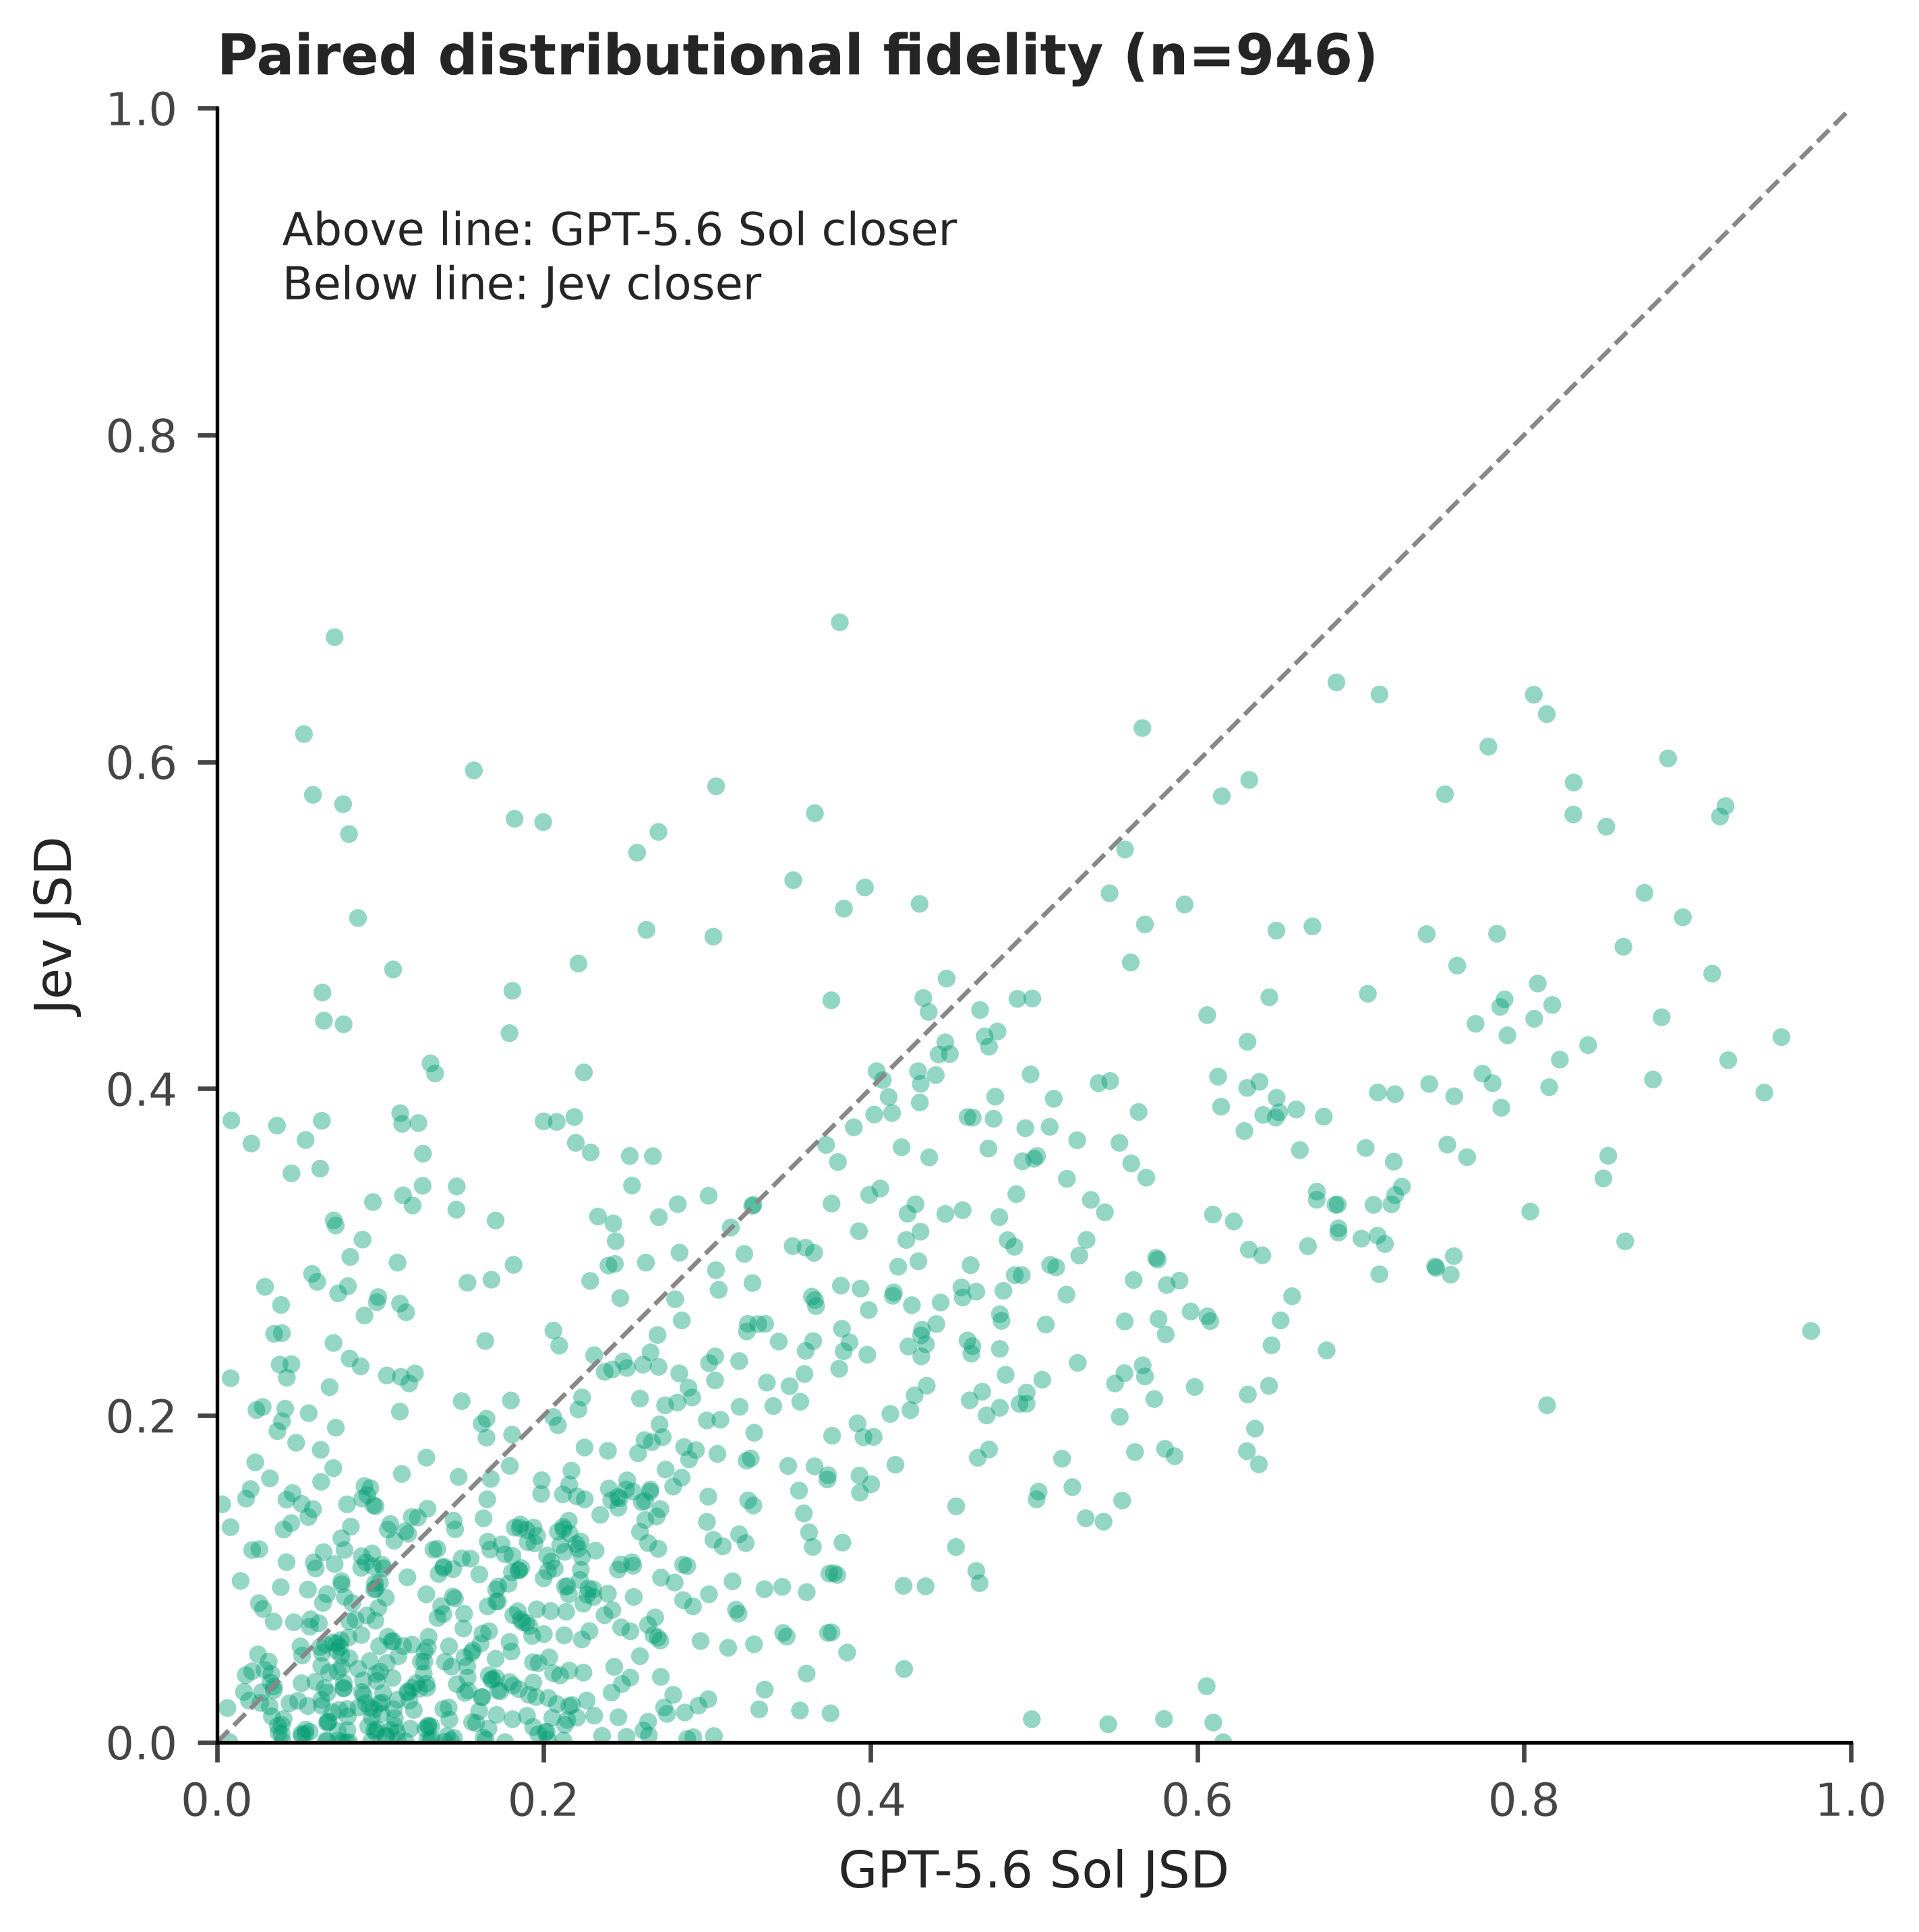
Figure S1. Paired distributional fidelity. Each point is one of 946 country-item cells observed for both Sol and Jev. Axes show JSD from the same human distribution. Points below the equality line favour Jev; points above favour Sol. Points are partially transparent to show density.
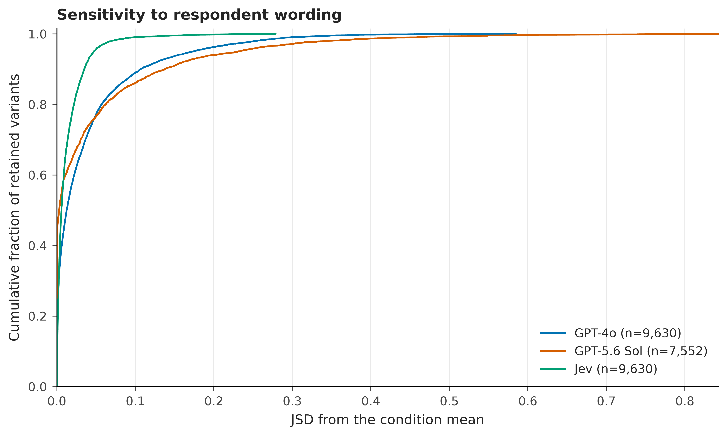
Figure S2. Respondent-wording sensitivity. Empirical cumulative distributions of JSD between each retained descriptor-specific vector and its model-country-item mean. Label assignments are averaged within descriptor before comparison. The unconditioned target is excluded. Cells with fewer than two retained descriptors have undefined sensitivity and do not contribute; retained comparison counts appear in the legend. The full observed range is displayed.
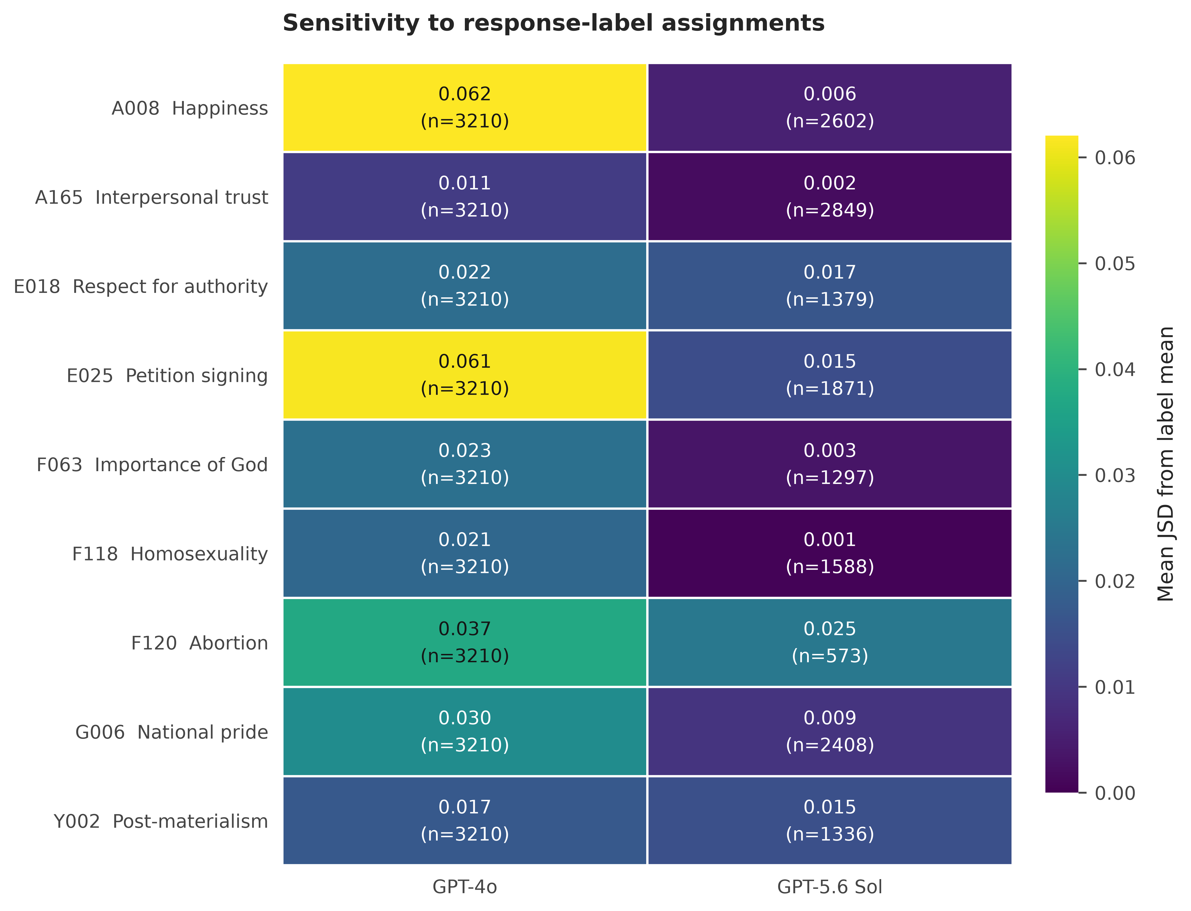
Figure S3. Response-label sensitivity. Mean JSD between each retained OpenAI label assignment and its within-descriptor mean, after remapping labels to substantive responses. The unconditioned target is excluded. At least two label assignments must survive the primary censoring policy; singletons are treated as unavailable, not zero sensitivity. Parentheses give the number of retained label-vector comparisons. The near-zero Sol values are conditional on the surviving comparisons.
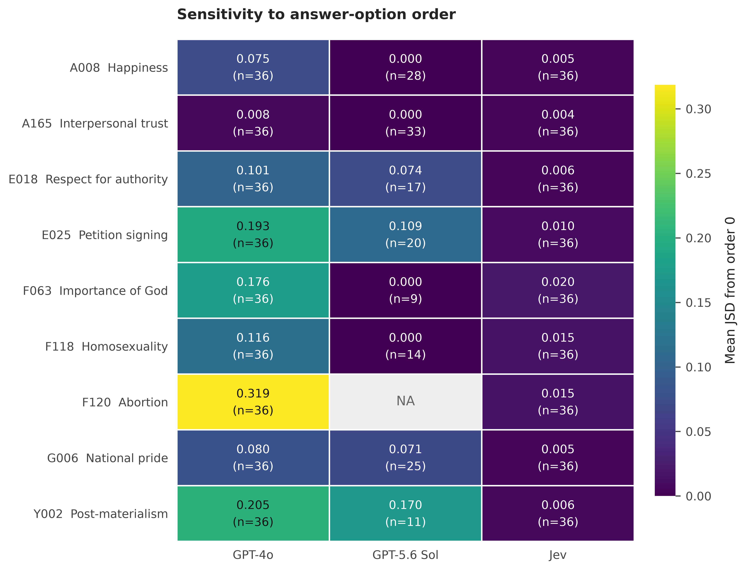
Figure S4. Option-order sensitivity. Mean JSD between alternative answer orderings and the prespecified reference ordering, rep=0, after substantive remapping. Both requests must survive the primary censoring policy. Parentheses show comparison counts; up to three comparisons are available per country-item cell in the 12-country experiment. Sol has no valid reference-based F120 comparisons, shown as NA. A later retained ordering is never substituted for an excluded reference.
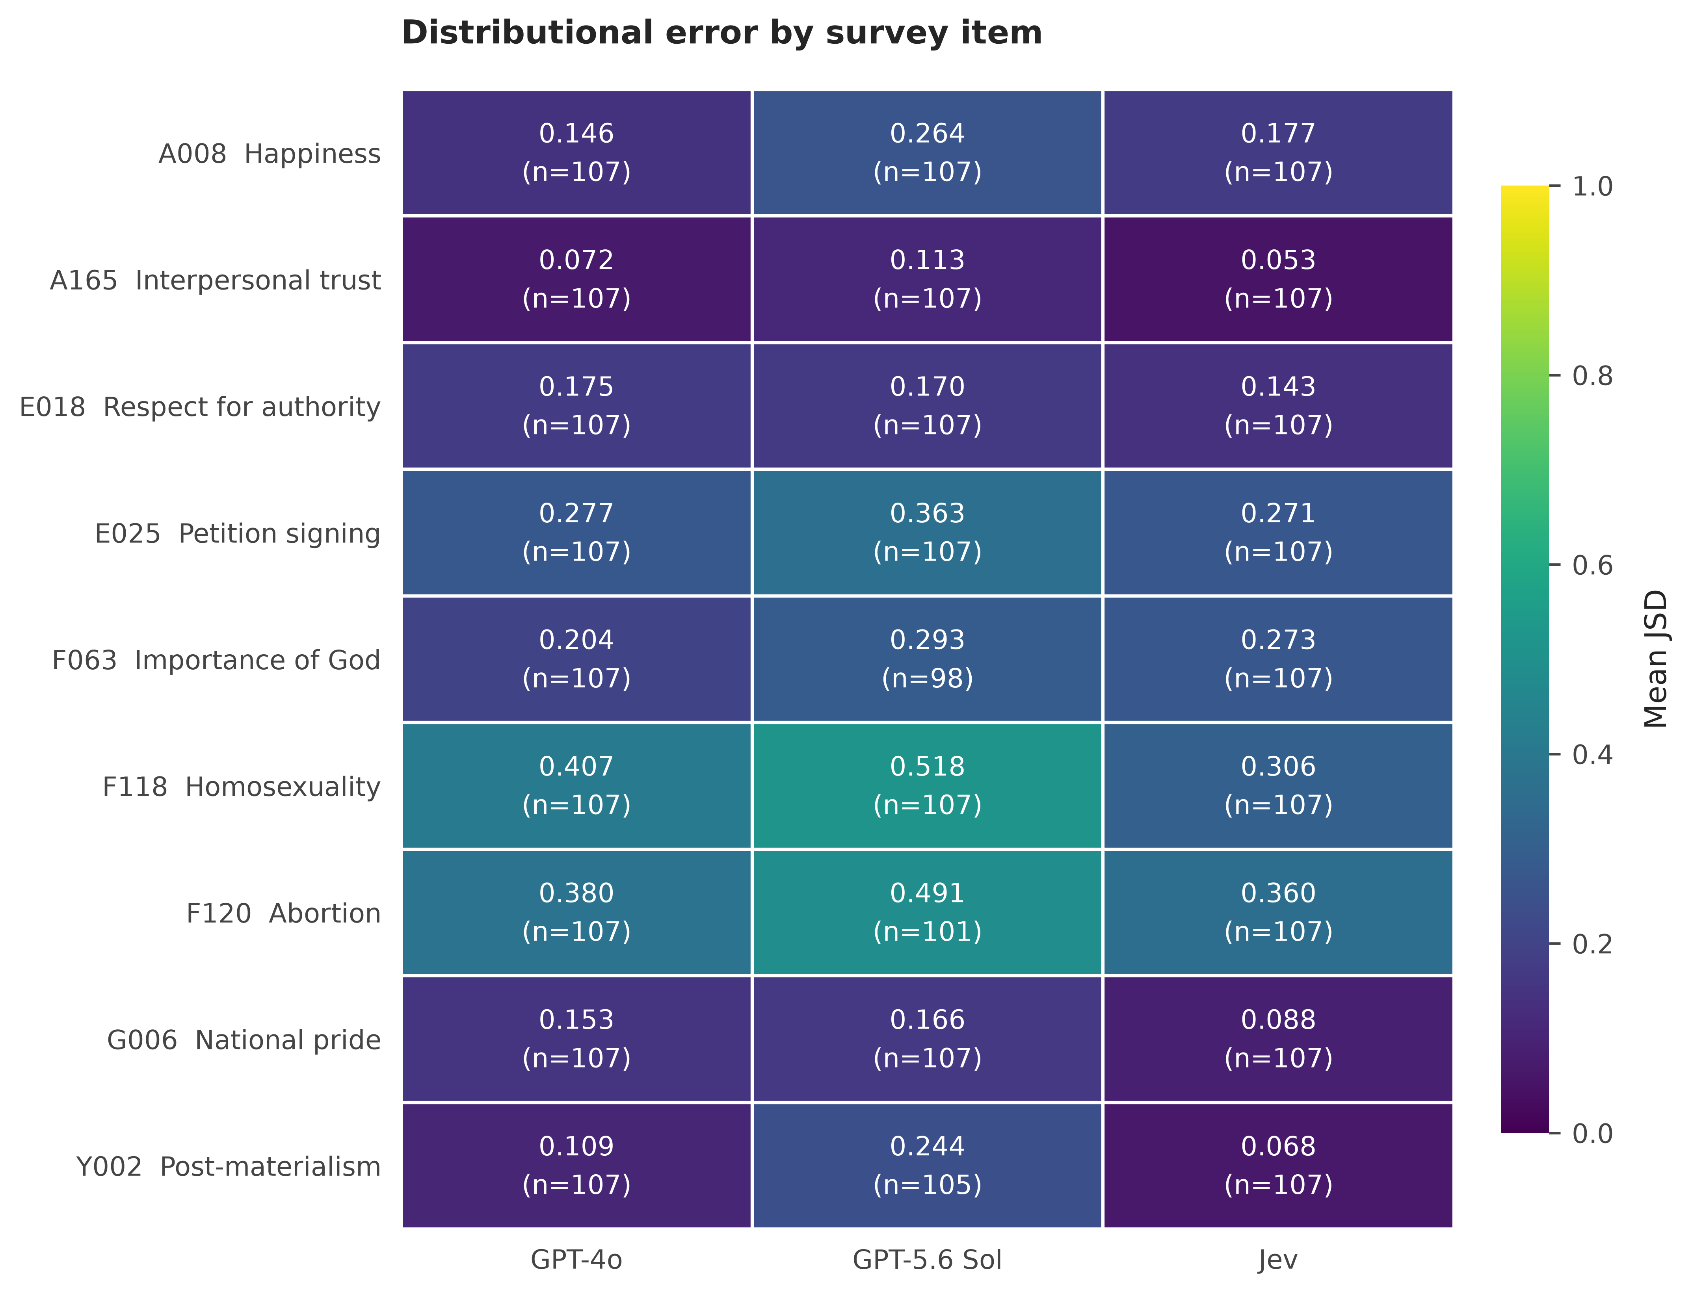
Figure S5. Distributional error by item. Mean country-conditioned JSD from human response frequencies, with the number of countries shown in parentheses. The colour scale spans the theoretical JSD range from zero to one. All available cells enter each model’s mean; cross-model inferential comparisons use matched cells.
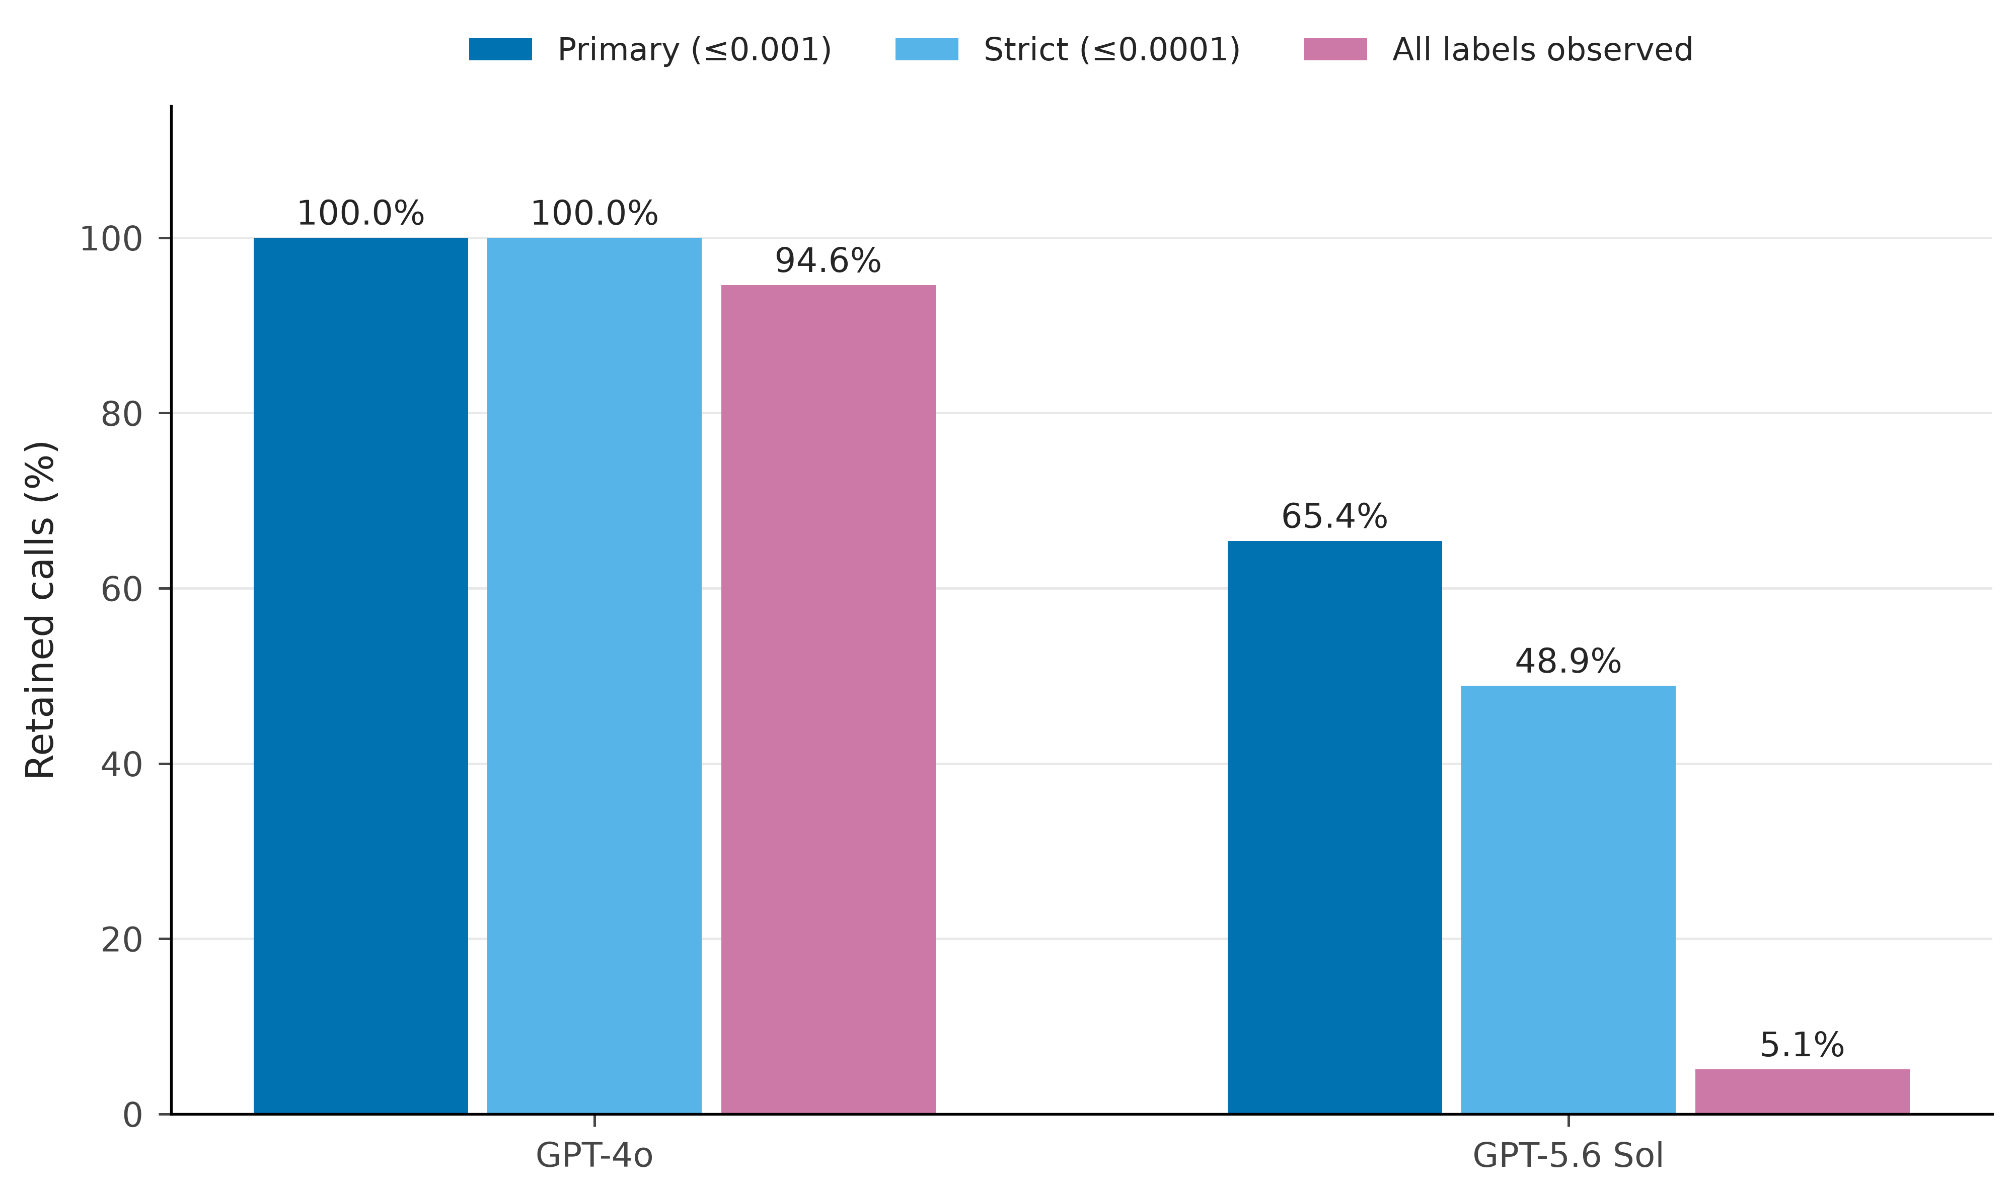
Figure S6. OpenAI probability-recovery coverage. Percentage of all 37,800 primary requests per OpenAI condition retained under the primary omitted-mass bound of 0.001, the stricter bound of 0.0001, and the requirement that every permitted label be observed. Counts include the unconditioned target and Y003 constituent requests. Retention is evaluated at the request level before averaging probabilities.
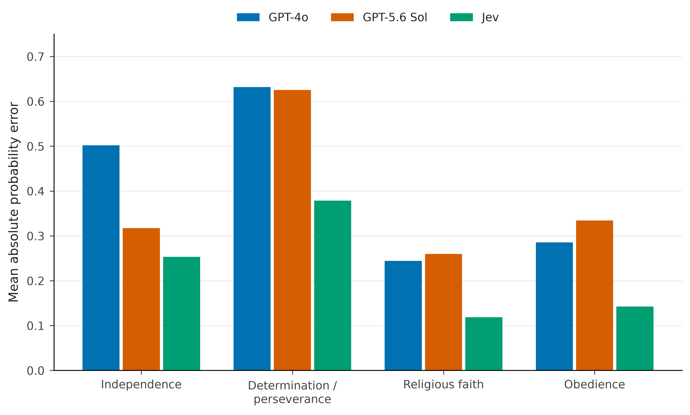
Figure S7. Fidelity of the four autonomy-index marginals. Mean absolute error between predicted and human selection probabilities for each constituent, averaged across 107 countries per model. These are four marginal probabilities; the analysis does not reconstruct the joint distribution of selections or assume independence.
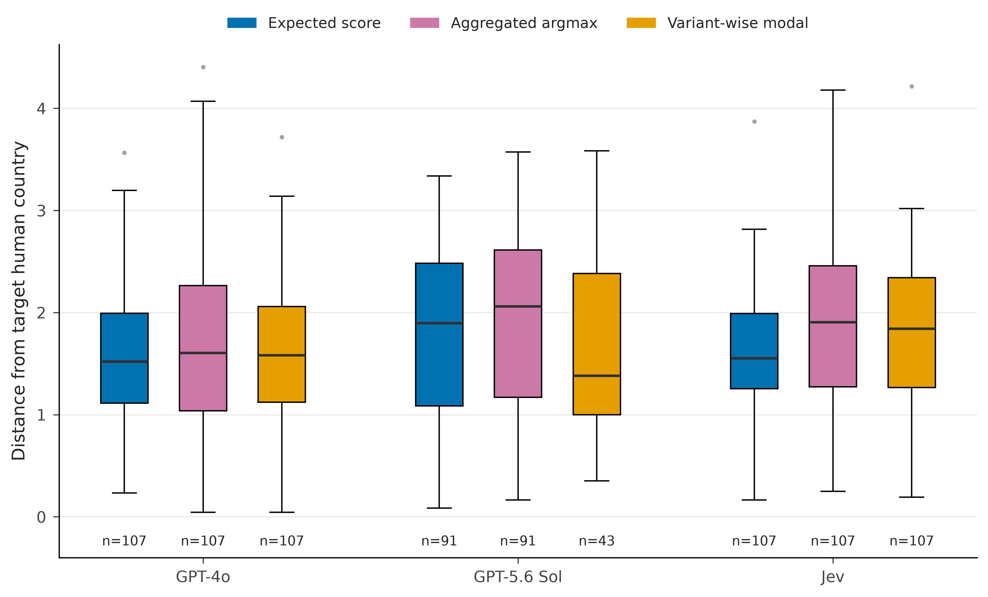
Figure S8. Cultural-map distance under alternative probability representations. Blue uses expected scores from averaged probabilities; pink/purple uses the argmax of the final averaged probabilities; gold averages projected modal profiles across complete prompt variants. Boxes, whiskers, and outliers follow the convention in Figure 1. Sample sizes are shown below each box. The variant-wise modal reconstruction yields only 43 country-conditioned Sol profiles and no complete unconditioned Sol profile. Its distribution therefore has different coverage and cannot support the paired prompting comparison. Common-country expected-score and aggregated-argmax results appear in Table S15.
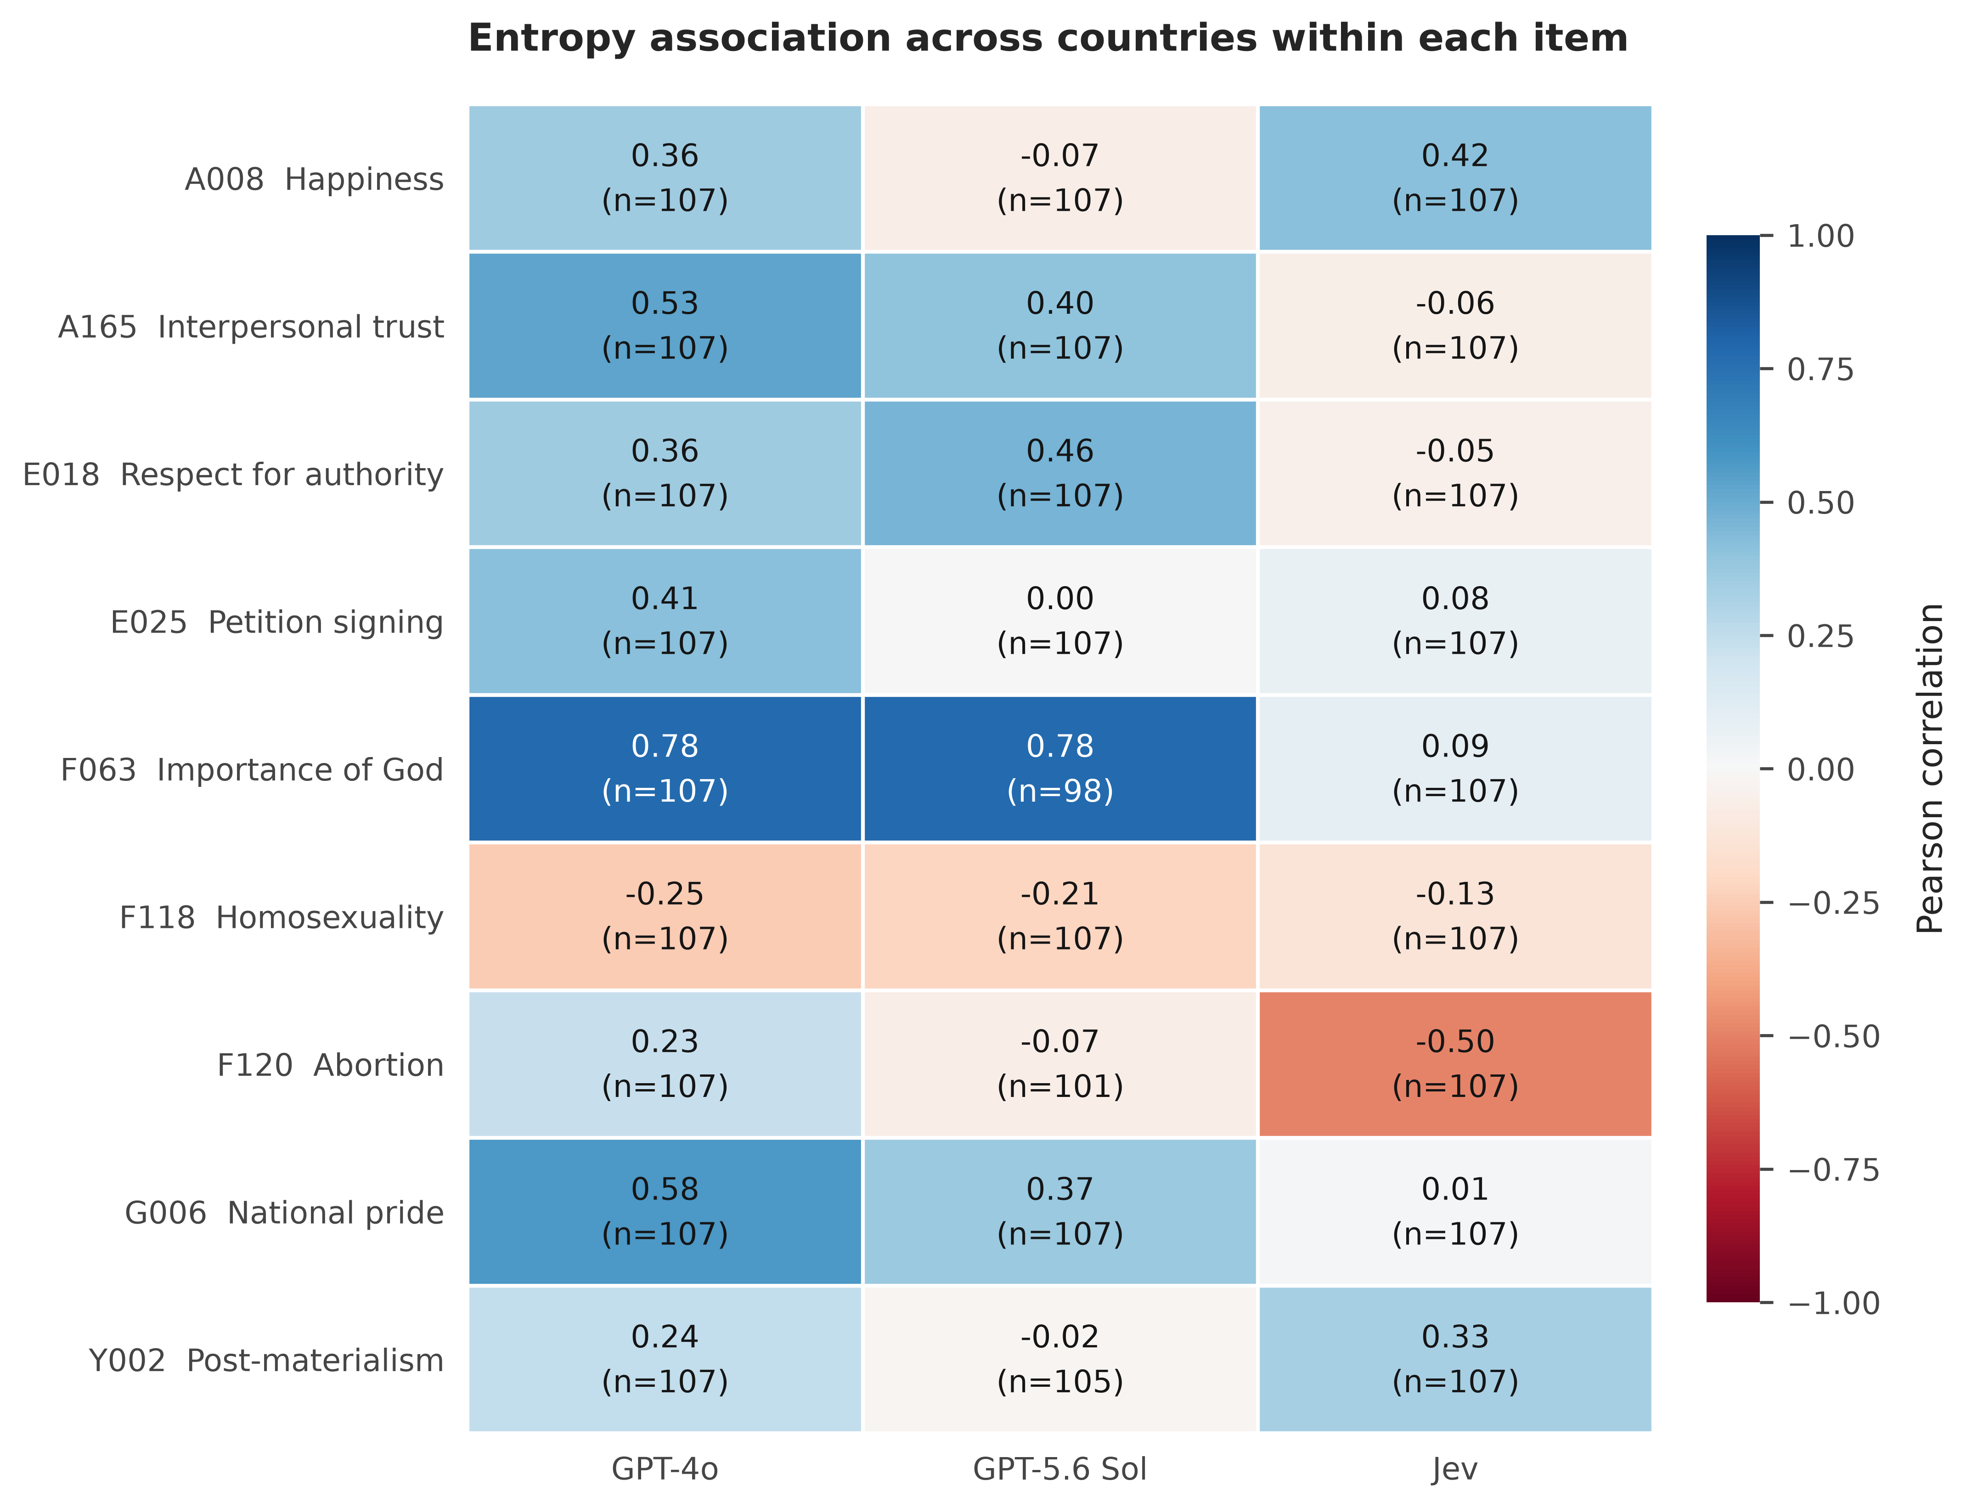
Figure S9. Within-item entropy association. Pearson correlations between model and human normalized entropy across countries for each survey item. The fixed colour scale spans -1 to 1; parentheses give country counts. These descriptive associations distinguish variation across countries within a question from pooled differences across questions.
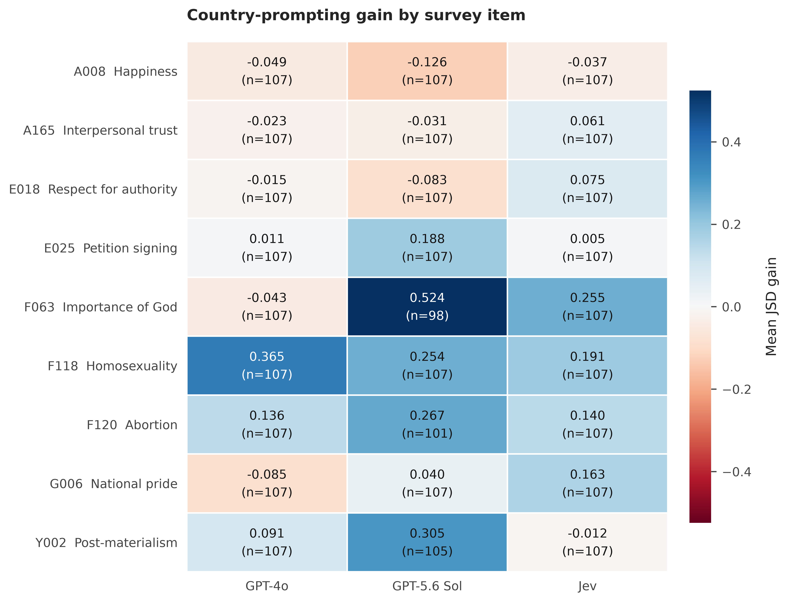
Figure S10. Country-conditioning gain by item. Mean JSD from the unconditioned model minus mean JSD from the country-conditioned model, evaluated against the same target-country human distribution. Blue denotes improvement and red denotes deterioration; the colour scale is symmetric around zero. Parentheses show country counts. Values are descriptive item-specific means.
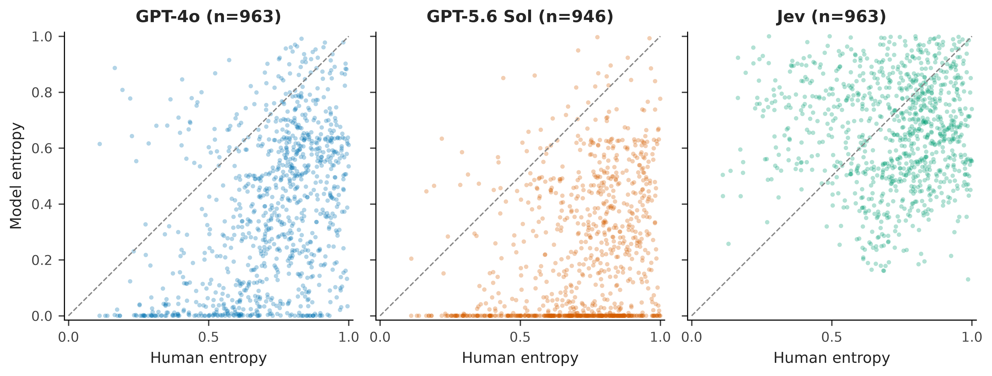
Figure S11. Raw entropy diagnostic. Each panel plots model normalized entropy against human normalized entropy for every observed country-item cell, with identical axes across models. The dashed line denotes exact entropy equality. Facets separate overlapping model clouds; pooled and fixed-effect associations are summarized in Figure 4 and Table S10.

Supplementary references
1. Tao Y, Viberg O, Baker RS, Kizilcec RF. Cultural bias and cultural alignment of large language models. PNAS Nexus. 2024;3:pgae346. doi:10.1093/pnasnexus/pgae346. Source analysis and cultural-region lookup: https://osf.io/7sj3w/.
2. Haerpfer C, Inglehart R, Moreno A, et al., editors. World Values Survey Trend File 1981–2022. Version 4.1.0. JD Systems Institute and WVSA Secretariat. doi:10.14281/18241.27.
3. European Values Study. EVS Trend File 1981–2017, ZA7503. Version 3.0.0. GESIS Data Archive. doi:10.4232/1.14021.

