
Main Manuscript for
Can AI uncertainty recover human population variation? Token uncertainty, decision uncertainty, and cross-cultural survey responses
Steven J. Bickley^{1,2,3}, Ho Fai Chan^{1,2,3}, Arian Mashhady^{1,2}, Son Tran³, & Benno Torgler^{1,2,3,4,5}
¹ School of Economics and Finance, Queensland University of Technology, Gardens Point, 2 George Street, Brisbane, QLD 4001, Australia
² ARC Industrial Transformation Training Centre for Behavioural Insights for Technology Adoption, Queensland University of Technology, Brisbane, Australia
³ Panalogy Lab Pty Ltd, Brisbane, Australia
⁴ Institut für Schweizer Wirtschaftspolitik an der Universität Luzern (IWP), Switzerland
⁵ CREMA—Centre for Research in Economics, Management, and the Arts, Zürich, Switzerland
Corresponding author: Steven J. Bickley
Email: s.bickley@qut.edu.au
Author Contributions: SJB, HFC and AM conceived the study. SJB developed the conceptual framework and study methodology. SJB conducted computational analyses, statistical modelling, validation, and reproducibility checks. SJB curated and harmonized the survey and model-generated data. SJB developed visualizations. SJB, HFC, AM and BT interpreted the findings and developed the theoretical implications. SJB wrote the original manuscript. All authors contributed to critical revision of the manuscript and approved the final version.
Competing Interest Statement: SJB, HFC and BT hold dual roles in Queensland University of Technology and Panalogy Lab Pty Ltd. This relationship is managed under QUT’s approved Conflict of Interest Management Plan. The authors declare no other competing interests.
Classification: Social Sciences — Psychological and Cognitive Sciences
Keywords: human values; artificial intelligence; cultural alignment; synthetic respondents; survey research

This PDF file includes:
Abstract
Significance Statement
Main Text
Acknowledgements
Data and code availability
References
Figures 1 to XX
Tables 1 to XX

Abstract
Human populations contain disagreement, yet artificial intelligence is increasingly used to summarize or simulate them through a single model. Modern AI systems expose probability distributions over possible answers, raising an intriguing possibility: can uncertainty within one model recover variation across many people? These quantities share a mathematical form but not necessarily a statistical meaning. Building on the cross-cultural benchmark of Tao et al. (2024), we compare survey-weighted human response distributions across 107 countries/territories with next-token probabilities from GPT-4o and GPT-5.6 Sol and direct decision probabilities from TypeSafe Jev. Full probability distributions were substantially closer to human responses than their modal answers. Mean Jensen–Shannon divergence was 0.214 for GPT-4o, 0.290 for GPT-5.6 Sol, and 0.193 for Jev. On 946 matched Sol–Jev country-item cells, the mean Sol-minus-Jev difference was 0.099 (95% CI 0.057–0.145). Yet different notions of uncertainty preserved different aspects of human variation. Jev most closely matched average human response entropy, but its entropy scarcely tracked which country–item populations were more divided, whereas GPT-4o and Sol were systematically under-dispersed but covaried more with human heterogeneity. Model uncertainty therefore contains population-level signal without being equivalent to population disagreement. The results distinguish uncertainty over words, uncertainty over decisions, and heterogeneity across people—and show why synthetic-population research should test rather than assume that one can stand in for another.
Significance Statement
A population distribution describes differences among people. A model probability describes uncertainty within one artificial system. Because both can be represented as probability distributions, synthetic-population research can easily treat them as interchangeable. We test that assumption across 107 countries and nine cultural-value constructs. Retaining full AI probability distributions preserves substantially more human variation than retaining only modal answers, but different probability interfaces capture different aspects of disagreement. Jev closely matches the average amount of human response diversity while poorly identifying where that diversity is greatest; GPT models are more concentrated but track some cross-population changes in disagreement. A single model’s uncertainty can therefore contain useful information about a population without constituting a synthetic population by itself.

Main Text

Introduction
Populations disagree. People who share a country, institution, demographic category, or cultural environment can nevertheless give different answers to the same question. For social research, this variation is not simply noise to be averaged away. The amount and structure of disagreement can reveal contested norms, minority positions, polarized judgments, and differences in the experiences and commitments that people bring to collective life.

Artificial intelligence is increasingly used to simulate those populations. Researchers ask large language models (LLMs) to answer surveys, emulate experimental participants, approximate subgroup attitudes, and anticipate aggregate behavioral outcomes (2–5,15). Much of this work begins with a single artificial system and asks it to stand in for many heterogeneous humans. That creates a basic statistical question: when one model is uncertain between several answers, can that uncertainty substitute for disagreement across many people?

The temptation is understandable. A human survey distribution and a model probability distribution can have exactly the same mathematical form. If 20%, 50%, and 30% of respondents choose three alternatives, the population can be represented by the vector $p=\left(0.20 , 0.50 , 0.30\right)$. If a model assigns probabilities 0.20, 0.50, and 0.30 to the same alternatives, the two vectors are numerically identical. But identical numbers need not describe identical processes. Survey frequencies arise because different people select different responses. A language-model distribution arises because one model assigns different probabilities to possible textual continuations. A decision model may instead express uncertainty directly over a predefined set of alternatives.

The distinction matters because most synthetic respondent research has historically observed point answers. A model receives a persona or population descriptor, generates one response, and repeated generations are treated analogously to repeated observations from people. Yet variation over repeated model generations is not automatically variation across humans. Human disagreement reflects differences in biography, institutions, beliefs, values, information, and interpretation, together with within-person uncertainty and measurement processes. Sampling the same artificial system repeatedly instead samples a generative mechanism whose stochasticity need not preserve those sources of human variation (2,3,15).

Recent research has therefore begun to move from answers to distributions. First-token probabilities can be compared directly with empirical response frequencies, models can be specialized to predict group-level survey distributions, and model probabilities can be evaluated against distributions of human disagreement (5,6). This shift is promising because a complete probability vector retains information discarded by a modal prediction. It also introduces a deeper measurement problem. A vector of model probabilities may look like a population distribution without having the same interpretation.

Several adjacent literatures address pieces of this problem. Lee et al. (6) compare sampling- and log-probability-based model distributions with human disagreement in natural-language inference. Cao et al. (5) specialize LLMs using first-token probabilities to reproduce country-level survey response distributions. Xie et al. (3) evaluate population-level statistical realism more broadly and show that synthetic data often collapse toward overly typical profiles. Survey-method studies additionally show that model responses can change substantially with response-generation procedure, wording, labels, and option order (7,16–18). What remains less clear is whether uncertainty within a single model can be interpreted as between-person heterogeneity, whether this correspondence differs between lexical and explicitly typed decision probabilities, and whether matching average dispersion implies tracking where human disagreement actually occurs. We test those distinctions directly.

We call the implicit assumption behind such use the uncertainty substitution hypothesis: uncertainty within one model can serve as a statistical proxy for heterogeneity across people. The hypothesis does not require the two probability objects to arise from the same mechanism. It requires only that they coincide closely enough, across populations and questions, for model uncertainty to recover substantively important properties of the human distribution. This is ultimately an empirical proposition.

Formally, let a human population in country or territory $c$ contain heterogeneous latent states $θ$ distributed according to $F_{c}\left(θ\right)$. For survey item $q$ and response $Y$, the population distribution is
$$H\left(y , ∣cq\right)=\int{P}\left(y , ∣θq\right) dF_{c}\left(θ\right).$$

This probability integrates variation across people. An autoregressive language model instead exposes a conditional distribution over textual continuations,
$$O\left(t∣prompt\right),$$
which can be mapped to substantive survey responses through controlled output labels. A decision-native model exposes a probability directly over declared alternatives,
$$J\left(y , ∣stateA\right).$$
These three objects can be placed on the same response support and compared numerically. Their semantics nevertheless remain distinct: $H$is between-person population heterogeneity, $O$is generative or lexical uncertainty within a language model, and $J$is decision uncertainty within a structured choice interface. Whether $O$or $J$approximates $H$is the empirical question.

This problem is related to, but distinct from, conventional probability calibration. Calibration asks whether events assigned a given probability occur with the corresponding long-run frequency (13,14). Here the target is not repeated realization of one uncertain event. It is the distribution of responses across different people. A model can therefore be well behaved as a probabilistic predictor while still failing to reproduce the social distribution it is being used to simulate.

The distinction also changes how synthetic populations should be evaluated. Matching a population mean is only one criterion. Two distributions can share the same expected response while differing markedly in concentration, tails, minority support, or multimodality. Likewise, a model could reproduce the average amount of disagreement across a dataset without identifying which particular populations and questions are consensual and which are divided. We therefore distinguish three increasingly demanding targets: (i) location, whether the model places expected responses appropriately; (ii) distributional shape, whether its full response probabilities resemble population frequencies; and (iii) heterogeneity structure, whether its uncertainty rises and falls across populations and questions in the same places that human disagreement does.

We test these distinctions using the cross-cultural benchmark developed by Tao et al. (1). Their study projected responses from several GPT generations into the Inglehart–Welzel World Cultural Map using ten constructs from the Integrated Values Surveys (IVS). Country-specific prompting often moved GPT point responses toward the corresponding national survey coordinates, demonstrating that model responses contain culturally patterned information. The source study evaluated 107 countries/territories and repeated each question under ten semantically similar respondent descriptors to reduce dependence on exact wording (1). We preserve that basic design but change the principal unit of analysis from which response the model selects to how probability is distributed over all permitted responses.

The cultural-values setting provides a demanding test. The benchmark spans happiness, interpersonal trust, authority, political participation, religion, moral judgments, national pride, materialist/post-materialist priorities, and child-rearing autonomy (1,10). Countries differ systematically on these measures, while substantial variation also remains within countries. The same model must therefore recover both geographic structure and population disagreement across questions that vary greatly in response cardinality and substantive content.

We compare three principal model conditions. GPT-4o provides a historical-generation anchor close to the most recent OpenAI model in Tao et al. (1). GPT-5.6 Sol provides a contemporary autoregressive comparison using the same probability-extraction procedure. TypeSafe Jev provides a contrasting decision interface in which probabilities are returned over explicitly declared alternatives rather than reconstructed from next-token probabilities (8,9). The comparison is not intended as an architectural horse race: training data, post-training, capacity, objectives, and serving infrastructure differ across systems. Instead, the three conditions let us observe how the uncertainty-substitution hypothesis behaves across model generations and probability interfaces.

The study makes three contributions. First, it distinguishes between-person heterogeneity, next-token uncertainty, and decision uncertainty, three mathematically comparable but generatively different probability objects that synthetic population research can easily conflate. Second, it measures the information gained by retaining uncertainty rather than reducing each model to its modal response. Third, it separates matching the average amount of human disagreement from recovering the social structure of disagreement across countries and questions. This latter distinction is especially important: knowing how uncertain a population is on average is not the same as knowing where disagreement actually occurs.

We organize the analysis around four questions. RQ1, distributional substitution: how closely do machine probability distributions reproduce survey-weighted human response distributions? RQ2, heterogeneity recovery: do machine probabilities reproduce not only the average level but also the cross-population structure of human disagreement? RQ3, population specificity: does conditioning a model on a country improve distributional fidelity relative to its unconditioned distribution and simple population-level baselines? RQ4, measurement robustness: how sensitive are inferred distributions to respondent wording, arbitrary response labels, option ordering, and incomplete top-$K$ probability support? As a secondary extension of Tao et al. (1), we also test whether retaining complete probability information changes cultural-map alignment. Together, these analyses ask whether uncertainty inside one artificial system can recover variation across many humans—and whether that uncertainty is genuinely population-specific rather than merely generically diffuse.

Results
A cross-cultural test of uncertainty substitution
The merged EVS/WVS file contained 666,907 historical observations. Restricting the reconstructed IVS benchmark to common waves 5–7 and calendar years 2005–2022 yielded 392,832 respondent records. The harmonized data contained 112 countries/territories before the five exclusions used in the source cultural-map study—Egypt, Kuwait, Qatar, Tajikistan, and Uzbekistan—leaving 107 analysis targets. The nine finite-response constructs therefore contributed 963 possible human country–item cells.

The empirical run used WVS Trend v4.1 together with EVS ZA7503 v3.0.0. Tao et al. used an earlier WVS release and reported 393,536 observations for their corresponding analysis period (1). Our human benchmark should therefore be interpreted as a release-updated replication and extension, rather than as an exact numerical reproduction of their IVS dataset.

Probability recovery differed sharply across the two autoregressive models. GPT-4o returned every permitted label in 35,754 of 37,800 primary calls (94.6%), whereas GPT-5.6 Sol did so in only 1,922 calls (5.1%). This difference primarily reflected Sol’s highly concentrated next-token distributions, for which low-probability permitted alternatives often fell outside the returned top-$K$ set.

An absent label was treated as censored rather than as having exact probability zero. The primary policy retained a vector if all unseen permitted alternatives together could carry at most 0.001 probability mass. Under this rule, all 37,800 GPT-4o calls and 24,723 Sol calls (65.4%) were retained, yielding 963 GPT-4o and 946 Sol country–item distributions after aggregation. Mean pre-renormalization probability mass assigned to permitted labels was 0.9997 for GPT-4o and 0.9973 for Sol. Jev returned a probability for every declared alternative by construction; 10,800 primary Jev requests covered the same targets and respondent descriptors. Full diagnostics are reported in Tables S3 and S4.

Do AI probabilities recover human response distributions?
Across the nine finite-response constructs, mean Jensen–Shannon divergence (JSD) from human frequencies was 0.214 for GPT-4o, 0.290 for GPT-5.6 Sol, and 0.193 for Jev (Table 2).

The primary contemporary comparison used 946 country–item cells observed for both Sol and Jev. Sol’s JSD exceeded Jev’s by 0.099 on average (95% crossed-bootstrap CI 0.057 to 0.145; paired Wilcoxon $P=2.05×{10}^{-61}$). The corresponding mean total-variation difference was 0.063 (95% CI 0.008 to 0.117). For ordered response scales, the mean normalized Wasserstein difference was 0.055, although its crossed-bootstrap interval narrowly included zero (95% CI −0.0004 to 0.113).

The comparison with GPT-4o was less one-sided. GPT-4o’s mean JSD exceeded Jev’s by only 0.020 across 963 matched cells, with a crossed-bootstrap interval that included zero (95% CI −0.016 to 0.053), despite a small paired-rank $P$value. GPT-4o also produced slightly lower mean total variation than Jev (0.379 versus 0.391). Thus, Jev’s advantage over Sol should not be interpreted as a general provider ordering.

Model recency was likewise not associated monotonically with population fidelity. On the 946 cells shared by GPT-4o and Sol, GPT-4o had JSD lower by 0.079 on average (95% CI −0.113 to −0.045), total variation lower by 0.077 (95% CI −0.114 to −0.042), and normalized Wasserstein distance lower by 0.043 (95% CI −0.076 to −0.014). A newer and more capable general-purpose model therefore did not automatically produce a better synthetic population distribution.

Item-level differences were substantial (Table S6). For justifiability of homosexuality (F118), mean JSD was 0.407 for GPT-4o, 0.518 for Sol, and 0.306 for Jev. For the post-materialist index (Y002), the corresponding values were 0.109, 0.244, and 0.068. Respect for authority (E018) showed much less separation at 0.175, 0.170, and 0.143. The success of uncertainty substitution therefore depended materially on the judgment being represented.
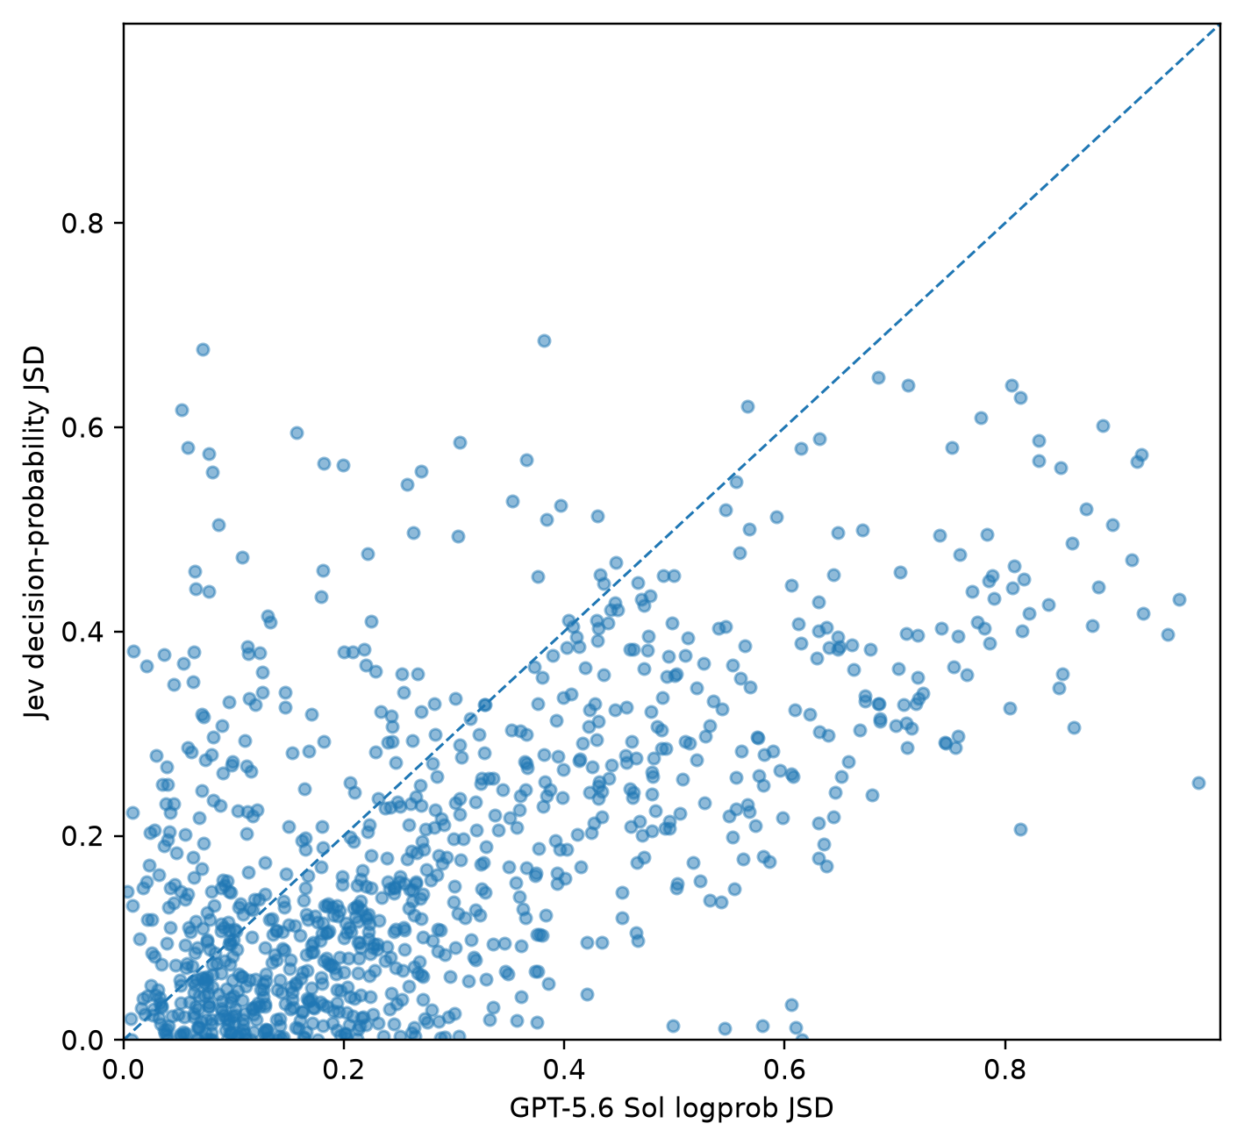
Figure 2. Distributional fidelity for the primary contemporary comparison. Each point represents one matched country × item cell. The x-axis shows Jensen–Shannon divergence between the survey-weighted human distribution and GPT-5.6 Sol’s conditional next-token distribution; the y-axis shows the corresponding divergence for Jev decision probabilities. The dashed 45-degree line denotes equal error. Points below the line indicate lower divergence for Jev and points above indicate lower divergence for Sol. The plot contains the 946 cells retained for Sol under the primary top-$K$ censoring policy and observed for Jev.

Collapsing uncertainty to a modal answer loses population-level information
The same probability vectors can be converted deterministically to conventional point predictions by assigning all probability to the highest-probability response. This creates a direct within-model test of whether the remaining probability mass contains useful information about population variation.

For every model condition, collapsing the distribution to its argmax substantially worsened agreement with human response frequencies. Mean JSD increased from 0.214 to 0.382 for GPT-4o, from 0.290 to 0.392 for Sol, and from 0.193 to 0.470 for Jev. The corresponding argmax-minus-full differences were 0.169, 0.102, and 0.277 (Fig. S3; Table S5).

The result is important because the modal response itself does not change: the only difference is whether nonmodal probability mass is retained. Model uncertainty therefore contained information about population responses that was systematically destroyed by reducing the model to one answer. The effect was largest for Jev, whose complete decision distributions were relatively diffuse even when their most likely choice alone poorly represented population frequencies.

Matching average disagreement is not the same as locating disagreement
Human response distributions had mean normalized entropy of 0.721. GPT-4o had mean entropy 0.378 and Sol 0.215, indicating substantial concentration relative to the survey populations. Jev’s mean entropy was 0.657 and therefore much closer to the human mean. Consistent with this, mean absolute entropy error was 0.372 for GPT-4o, 0.512 for Sol, and 0.230 for Jev.

Average dispersion, however, answers only part of the heterogeneity question. We additionally asked whether model entropy increased and decreased across the same country–item cells as human entropy. Regressing model entropy on human entropy yielded a slope of 0.596 for GPT-4o (two-way cluster-robust 95% CI 0.235 to 0.958), 0.361 for Sol (0.150 to 0.571), and −0.010 for Jev (−0.177 to 0.156).

GPT-4o and Sol therefore compressed human variation: they tended to be too certain, but their uncertainty still increased somewhat in the cells where human respondents were more divided. Jev showed the opposite pattern. Its typical distribution had approximately the right degree of dispersion, but that dispersion changed very little with observed human disagreement.

Thus matching how much populations disagree on average is not the same as knowing which populations disagree. Average heterogeneity and structured heterogeneity are distinct empirical targets.

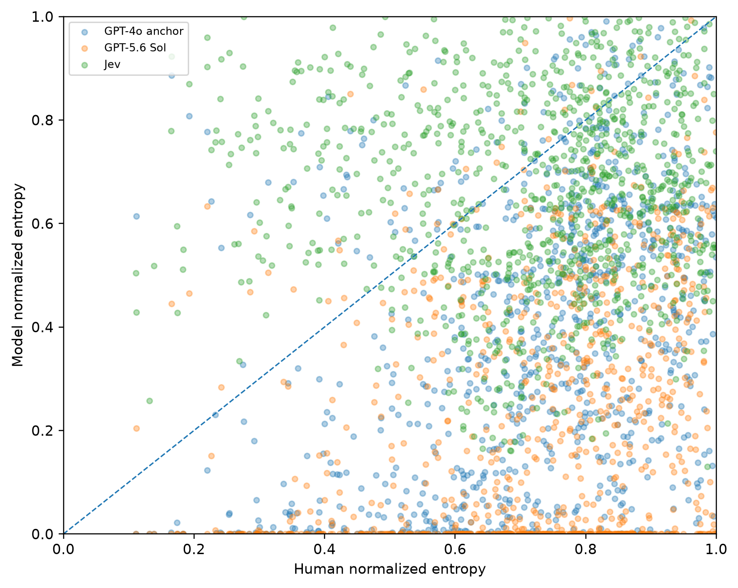
Figure 3. Recovery of human response heterogeneity. Normalized entropy of the survey-weighted human response distribution is plotted against normalized entropy of each model distribution for country–item cells. The dashed 45-degree line represents exact entropy recovery. GPT-4o and GPT-5.6 Sol are systematically under-dispersed but exhibit positive association between model and human entropy. Jev is much closer to the human average entropy level but shows little cross-cell covariation with human entropy.

Estimated population distributions depend on the elicitation interface
A probability distribution is partly a property of the measurement procedure used to obtain it. Across the ten respondent-descriptor variants, mean within-condition JSD from each country–item mean was 0.038 for GPT-4o, 0.043 for Sol, and 0.014 for Jev. Minor wording changes therefore altered all three systems, although Jev was least sensitive on average.

Rotating the arbitrary alphabetical labels used to extract OpenAI probabilities produced mean semantic JSD of 0.032 for GPT-4o and 0.008 for Sol after probabilities were mapped back to the same substantive responses. Label-token identity therefore contributed measurable variation, particularly for GPT-4o.

Randomized option-order perturbations produced larger changes for GPT-4o than for the other systems. Mean within-prompt JSD was 0.141 for GPT-4o, 0.052 for Sol among 175 retained comparisons, and 0.010 for Jev. Apparent population distributions are therefore partly reactive to the elicitation instrument rather than being fixed outputs of a population descriptor alone.

The top-$K$ sensitivity analysis illustrates a second measurement problem. Tightening the maximum tolerated unseen mass for Sol from 0.001 to 0.0001 changed mean JSD only from 0.290 to 0.283, across 875 retained country–item cells. By contrast, requiring every permitted response label to appear in the returned alternatives reduced the usable sample to only 101 country–item cells and lowered mean JSD to 0.161. Complete-case filtering therefore selects an atypically diffuse subset of Sol outputs rather than providing a neutral solution to missing tail probabilities (Table S4).

Probability information improves mean cultural alignment without guaranteeing distributional recovery
We next asked whether retaining uncertainty changes conclusions under the original cultural-map style of evaluation. Expected item scores were projected through the same human-fitted two-dimensional transformation used for the release-updated IVS benchmark.

For GPT-4o, mean Euclidean distance from the corresponding human country coordinates declined from 1.690 using modal responses to 1.562 using expected scores. Jev declined from 1.845 to 1.628. For Sol, the corresponding distance declined from 1.884 to 1.786 among the 91 countries for which all ten expected-score inputs were available under the primary censoring policy.
On this common 91-country set, mean expected-score distance was 1.545 for GPT-4o, 1.786 for Sol, and 1.631 for Jev. Retaining the probability vector therefore improved cultural-map alignment for all three systems.

However, cultural-map coordinates summarize each country through ten expected scores and ultimately two dimensions. They can therefore improve even when the underlying response distribution remains imperfect. Mean-location alignment and distributional recovery are complementary rather than interchangeable evaluation targets.

The autonomy index Y003 required separate treatment because respondents can select up to five of eleven qualities, creating 1,024 possible subsets. We therefore evaluated the four marginal probabilities that determine the index: Independence, Determination/perseverance, Religious faith, and Obedience. Mean absolute error across these four marginals was 0.416 for GPT-4o, 0.384 for Sol, and 0.223 for Jev. Jev had the lowest mean absolute error for each of the four constituent selections (Table S9; Fig. S6).

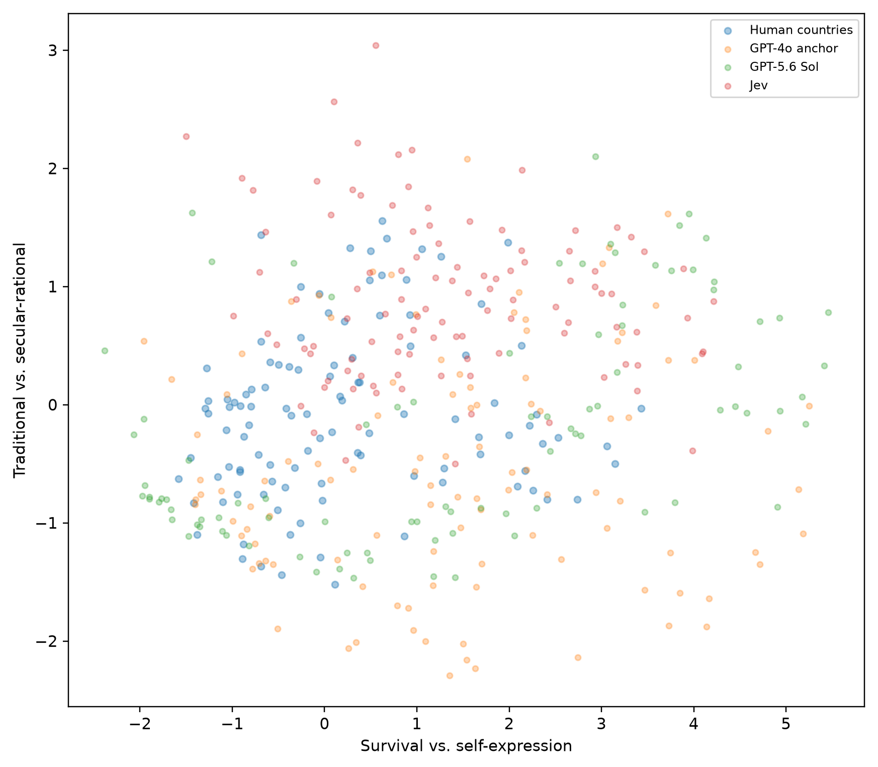
Figure 4. Cultural-map alignment using expected model responses. Human country/territory coordinates are obtained from the release-updated IVS benchmark. Country-conditioned GPT-4o, GPT-5.6 Sol, and Jev responses are converted to expected item scores and projected through the same human-derived cultural-map transformation. GPT-4o and Jev have complete expected-score inputs for 107 countries; GPT-5.6 Sol has complete ten-construct inputs for 91 countries under the primary top-$K$ censoring rule. Retaining complete probability information reduces mean cultural-map distance relative to the corresponding argmax representation for all three systems.

Table 1. Probability objects compared in the study.
Source | Probability object | Variation represented | Output support | Interpretation in this study
Human IVS | Survey-weighted response frequency | Differences among people within a country/territory | Substantive survey-response categories | Between-person population heterogeneity
GPT-4o | Conditional next-token probability | Uncertainty within one autoregressive model conditional on prompt | Controlled single-token labels mapped to substantive responses | Historical-generation lexical/generative uncertainty
GPT-5.6 Sol | Conditional next-token probability | Uncertainty within one autoregressive model conditional on prompt | Controlled single-token labels mapped to substantive responses | Contemporary lexical/generative uncertainty
Jev | Direct typed Choice probability | Uncertainty within one decision model conditional on state and declared alternatives | Substantive declared alternatives | Decision uncertainty
Note: The use of a common probability-vector representation permits empirical comparison but does not imply that the four probability objects have identical statistical meaning.

Table 2. Primary distributional fidelity
Metric | GPT-4o anchor | GPT-5.6 Sol | Jev | Sol − Jev difference (95% CI)
Jensen–Shannon divergence | 0.214 | 0.290 | 0.193 | 0.099 (0.057, 0.145)
Total variation distance | 0.379 | 0.453 | 0.391 | 0.063 (0.008, 0.117)
Normalized Wasserstein distance | 0.216 | 0.258 | 0.204 | 0.055 (-0.000, 0.113)
Absolute expected-score error | 0.939 | 1.096 | 0.856 | 0.260 (-0.098, 0.758)
Absolute normalized-entropy error | 0.372 | 0.512 | 0.230 | 0.281 (0.220, 0.342)
Note: Lower values indicate closer agreement with the human distribution. Condition means use each model’s retained full-distribution cells; Sol–Jev differences use the 946 matched cells. Wasserstein distance is defined only for ordered response items. Confidence intervals are based on the crossed country × item bootstrap.

Table 3. Cultural-map alignment
Condition | Representation | Mean distance | Median distance | N countries
GPT-4o anchor | Argmax/modal | 1.690 | 1.605 | 107
GPT-4o anchor | Expected-score probability | 1.562 | 1.520 | 107
GPT-5.6 Sol | Argmax/modal | 1.884 | 2.061 | 91
GPT-5.6 Sol | Expected-score probability | 1.786 | 1.898 | 91
Jev | Argmax/modal | 1.845 | 1.906 | 107
Jev | Expected-score probability | 1.628 | 1.554 | 107
Note: Distances are Euclidean distances from the corresponding human country coordinate in the release-updated cultural map. GPT-5.6 Sol uses the 91 countries with complete expected-score inputs for all ten constructs under the primary censoring rule; direct cross-condition comparisons should therefore use the common-country subset described in the text.

Discussion
Can uncertainty inside one artificial system recover variation across a population of humans? Our results suggest a qualified answer. Machine probability distributions contain substantial information about population responses, and retaining that information is consistently better than discarding it in favor of a modal answer. Yet the correspondence is incomplete, model-dependent, and multidimensional. Within-model uncertainty and between-person heterogeneity are related empirical objects, not interchangeable ones.

The clearest positive result is the value of retaining uncertainty. For every system, the complete probability vector was substantially closer to human response frequencies than the same vector collapsed to its argmax. The reduction in mean JSD was 0.169 for GPT-4o, 0.102 for Sol, and 0.277 for Jev. Nonmodal probability mass therefore contains population-level information that point prediction systematically removes.

This matters for how synthetic respondents are conceptualized. A point predictor answers, in effect, “which response is most plausible?” A synthetic population asks a different question: “how are responses distributed across people?” The first objective can be useful without satisfying the second. Our results show that even when only one artificial model is available, its complete uncertainty distribution can recover some of the information lost by forcing it to return a single answer. But the improvement should not be confused with proof that model uncertainty is human heterogeneity.

The comparison among systems makes that distinction visible. Jev had the lowest overall JSD and expected-score error and clearly outperformed GPT-5.6 Sol on the primary matched comparison. But GPT-4o was close to Jev in mean JSD, slightly better in mean total variation, and better than Sol on each major distributional metric. The contemporary OpenAI model was therefore not a uniformly better population simulator than its historical-generation counterpart. Model recency and general capability should not be assumed to imply better synthetic-population fidelity.

Nor should the Jev result be treated as establishing a general advantage of decision-native architecture. GPT-4o, Sol, and Jev differ in many unobserved ways, including pretraining, post-training, model scale, objectives, and serving infrastructure. Our comparisons therefore describe complete systems. They show that probability semantics and model generation matter empirically; they do not isolate a causal architectural mechanism.

The entropy results reveal a deeper distinction between average and structured heterogeneity. Jev’s mean entropy was close to the human mean and its mean absolute entropy error was substantially smaller than either GPT model. If evaluation stopped there, one might conclude that Jev had recovered human disagreement particularly well.

Yet its cell-level entropy told a different story. Jev entropy was essentially unrelated to human entropy across country–item cells. It tended to produce moderately diffuse distributions regardless of whether the corresponding human population was relatively consensual or deeply divided. GPT-4o and Sol had the opposite weakness. Their distributions were systematically too concentrated, but their uncertainty increased at least somewhat where human heterogeneity increased.

These are substantively different failures. A model can understate disagreement while still recognizing where disagreement changes. Another can reproduce the global amount of disagreement while allocating it to the wrong populations and questions. For synthetic polling, market segmentation, deliberative simulations, or social-science experiments, the second distinction may be as important as the first. Matching how much people disagree is not the same as knowing where they disagree.

This motivates a stronger version of the uncertainty-substitution hypothesis. A useful synthetic distribution should not merely resemble the pooled human distribution. Its uncertainty should respond appropriately to the social conditions indexed by the prompt. If one population is empirically more divided than another on a question, a model being used as a probabilistic proxy should ideally express greater uncertainty there as well. The near-zero Jev entropy slope shows why average distributional similarity is insufficient to establish this stronger form of substitution.

The interface analyses add another complication: model uncertainty is partly measured rather than merely revealed. Semantically minor respondent-descriptor changes altered distributions for every system. Alphabetical label assignment affected OpenAI probabilities. Option order produced particularly large changes for GPT-4o. These effects parallel familiar measurement concerns in human survey research: the instrument itself can affect the response being measured.

GPT-5.6 Sol exposed a different interface problem because its next-token distribution was often highly concentrated. Low-probability permitted responses frequently fell outside the API’s returned top-logprob alternatives. Assigning those unobserved labels probability zero would overstate certainty. Dropping every incomplete call would produce a different problem, because complete cases are not randomly selected: they disproportionately occur when the model is diffuse enough that all alternatives enter the returned set.

The censoring results demonstrate this selection directly. A stricter residual-mass threshold produced a Sol estimate close to the primary result, whereas complete-case restriction reduced the data from 946 to only 101 country–item cells and produced a dramatically smaller mean JSD. The apparent improvement was largely an artifact of conditioning on a small subset of unusually diffuse outputs. Probability extraction therefore requires explicit treatment of what the interface does not reveal.

The cultural-map results illustrate why distributional and mean-based evaluations should coexist. Using expected scores from the full probabilities moved all three model conditions closer to the corresponding human cultural coordinates than using argmax answers. Probability information therefore improves the point-based alignment framework introduced by Tao et al. (1).

But cultural maps necessarily compress. Each national response distribution becomes a set of expected item scores and ultimately a two-dimensional coordinate. Two models can occupy similar positions while differing substantially in the shape or entropy of their underlying response distributions. A cultural coordinate can therefore answer whether the location of model-implied values resembles the human population while leaving open whether the model preserves the population’s internal disagreement. The present distributional tests make this hidden dimension observable.

The GPT-4o versus Sol comparison also raises a temporal issue for synthetic-population research. Model development can alter uncertainty even when the elicitation procedure is held approximately constant. Sol was much more concentrated, suffered much more top-$K$ censoring, and had higher mean distributional error than GPT-4o on this benchmark. Synthetic-population findings should therefore be treated as model-snapshot results rather than stable properties of a provider or model family.

Several limitations bound the interpretation. First, country labels are coarse descriptors of internally heterogeneous populations. The benchmark assesses country-level response distributions and does not claim that nationality is sufficient to characterize individual preferences. Second, all model prompts were in English. Language itself can alter cultural expression and model behavior. Third, the empirical run used WVS Trend v4.1 rather than the earlier WVS release used by Tao et al., so the cultural benchmark is a release-updated replication and extension rather than an exact numerical reproduction.

Fourth, OpenAI exposes only a finite top-$K$ view of the next-token distribution. The residual-mass rule bounds rather than observes probabilities for missing permitted labels. Fifth, all three models are externally developed systems whose training data and post-training procedures are only partially observable. Sixth, Y003 cannot be compared through a complete joint distribution and is therefore evaluated through four marginals. Seventh, model probability distributions may have been influenced by survey material or related cultural data present in unknown training corpora. Finally, model APIs evolve, making frozen model identifiers and archived outputs essential for reproducibility.

The study also leaves open the relationship between probability distributions and richer synthetic-agent approaches. A single country-conditioned model has no explicit collection of individuals with different histories or latent traits. Its probability vector may nevertheless encode statistical regularities learned from heterogeneous human text and data. Future work can compare this compressed uncertainty with distributions generated by explicit synthetic populations whose agents differ in demographics, experiences, or latent preferences. Such comparisons could determine when one probabilistic model is sufficient and when population structure must be represented explicitly.

A second direction concerns joint distributions. The present study asks whether each survey item’s marginal response distribution is recovered. A convincing synthetic population may require more: relationships among attitudes, correlations across questions, subgroup differences, and the coexistence of minority positions within individuals. Marginal fidelity is therefore necessary for many applications but not sufficient for reconstructing a population’s complete social structure.

A third direction concerns the decomposition of uncertainty itself. Human survey frequencies combine stable between-person differences, within-person ambivalence, framing effects, and measurement error. Model probabilities likewise combine learned statistical regularities and uncertainty induced by context and representation. Future experiments with repeated human judgments, richer personal information, and controlled ambiguity could begin to separate these components rather than treating either side as a single undifferentiated probability.

The broader methodological lesson is that synthetic-population research should distinguish at least three objectives. A system may produce a plausible answer, approximate a population distribution, or reproduce the structure of variation across populations and questions. Success at one does not guarantee success at the others.

Model probabilities are therefore neither meaningless for social science nor automatically equivalent to human frequencies. They occupy an intermediate position. Their nonmodal mass clearly contains information about population variation; in some settings, it can materially improve synthetic distributions and cultural-map alignment. Yet the pattern of uncertainty can diverge from the pattern of disagreement among people.

The practical question is consequently not whether a model “has uncertainty,” but what that uncertainty tracks. When AI is used to simulate a population, the relevant test is not simply whether its probabilities sum to one or look appropriately diffuse. It is whether uncertainty within the model rises, falls, and redistributes itself in the same places that heterogeneity appears among the humans the model is intended to approximate.

Materials and Methods
Human data and analysis universe
The human benchmark was constructed from the European Values Study (EVS) Trend File 1981–2017, ZA7503 version 3.0.0, and the World Values Survey (WVS) Trend File 1981–2022 version 4.1.0 (11,12). The source files were harmonized using the common EVS/WVS variable dictionary and official merge logic supplied with the Integrated Values Surveys materials.

The resulting historical IVS file contained 666,907 respondent observations and 838 harmonized variables. The analysis retained common survey-wave codes 5, 6, and 7 and restricted observations to calendar years 2005–2022, leaving 392,832 respondent records.

Country identity was defined using the numeric IVS identifier S003 rather than alpha-label strings, because some survey releases use multiple alpha aliases for the same survey-defined country unit. After harmonization, 112 country/territory entities were present. Following Tao et al. (1), Egypt, Kuwait, Qatar, Tajikistan, and Uzbekistan were excluded from the strict cultural benchmark because at least one required construct lacked valid observations. The final analysis universe therefore contained 107 countries/territories.

The source study used an earlier WVS Trend release. The present analysis consequently preserves the substantive benchmark and wave logic but uses an updated WVS release. We treat this as a release-updated replication and extension.

Human response distributions
The primary finite-response items were: A008 Feeling of Happiness; A165 Trust on People; E018 Respect for Authority; E025, Petition Signing Experience; F063, Importance of God; F118, Justifiability of Homosexuality; F120, Justifiability of Abortion; G006, Pride of Nationality; and Y002, Post-Materialist Index.

For each country, year, item, and valid response category, survey-weighted response frequencies were calculated using IVS weight S017. Values outside the documented substantive response set were treated as missing.

Country-year distributions were calculated first. Where a country contributed observations in multiple retained years/waves, its country-level distribution was obtained by averaging the available country-year distributions equally rather than pooling all respondents across years. This preserves the source study’s treatment of repeated national observations while avoiding mechanical overweighting of years with larger samples.

The nine primary constructs yield a maximum of $107×9=963$ country–item distributions.

Cultural-map construction

The cultural-map replication used the nine finite-response items plus Y003, the Autonomy Index. Human item scores were standardized using the reconstructed IVS benchmark. A weighted pairwise correlation matrix was calculated, two components were extracted, and varimax rotation was applied. Component signs were oriented so that the first dimension increased from survival toward self-expression values and the second from traditional toward secular-rational values.

Following the source study, the resulting coordinates were rescaled as
$$PC1^{'}=1.81PC1+0.38$$
and
$$PC2^{'}=1.61PC2-0.01.$$
Expected model scores were standardized and projected using the corresponding human-derived transformation. Because the current human benchmark uses WVS v4.1 rather than the earlier source-study release, these map coordinates are interpreted internally against the release-updated human benchmark rather than asserted to reproduce the published source coordinates exactly.

Respondent descriptors and country conditioning
We retained the ten respondent-descriptor variants used by Tao et al. (1), including “average human being,” “typical human being,” “human being,” “average person,” “typical person,” “person,” “average individual,” “typical individual,” “individual,” and “world citizen.”

For the country-conditioned analysis, the descriptor additionally stated that the respondent was born in and living in the named country/territory. A separate unconditioned __DEFAULT__ target omitted country information.

The model received no individual respondent profiles, demographics, or observed attitudes. Any within-country probability structure therefore arose from the model’s conditional uncertainty under the country descriptor rather than explicit simulation of observed individual respondents.

OpenAI model conditions
Two OpenAI conditions were evaluated. The historical-generation anchor used gpt-4o-2024-05-13, providing continuity with the GPT-4o generation evaluated by Tao et al. (1). The contemporary condition used gpt-5.6-sol with reasoning effort set to none.

Both OpenAI conditions used temperature 1.0. This deliberately differs from the temperature-zero point-response procedure used in the source study. Tao et al. sought a near-deterministic selected answer; the present estimand is the probability distribution itself. Temperature 1.0 avoids deliberately sharpening that distribution before extracting next-token probabilities.

For every request, the replication package records the requested model identifier, model identifier returned by the provider, response ID, exact prompt, response-label mapping, usage metadata, and probability diagnostics.

Controlled-label probability extraction
Each substantive response category was mapped to a short alphabetical output label. The user instruction required the model to return exactly one permitted label and no explanation.

The OpenAI Responses API was queried with top_logprobs = 20 and max_output_tokens = 16. The first generated token and alternative token log probabilities were collected. Returned raw token strings were normalized for surrounding whitespace before label matching. If multiple raw token forms mapped to the same semantic label—for example A and A—their probabilities were summed.

For permitted label set $A$, the observed pre-renormalization permitted-label mass is
$$m_{A}=\sum_{a∈A_{observed}}{P}\left(a∣prompt\right).$$
When every permitted label is returned, the substantive response distribution is
$$P\left(y , =k∣y∈Aprompt\right)=\frac{P\left(a_{k}∣prompt\right)}{\sum_{a∈A}{P}\left(a∣prompt\right)}.$$
Thus, the OpenAI probability object analyzed here is explicitly a conditional next-token distribution over the permitted response labels. The original permitted-label mass was retained separately as a diagnostic indicating how much model probability was assigned outside the imposed survey-answer vocabulary.

Label rotation
Because token probabilities can depend on arbitrary token identity, the association between substantive responses and alphabetical labels was rotated. Each of the nine primary items was queried under three cyclic label assignments for every respondent descriptor. After collection, probabilities were mapped back to the same substantive response coding before aggregation. The four binary Y003 constituent questions used two label assignments.

This yields, for each OpenAI model, target, and primary item,
$$10\text{ descriptors}×3\text{ label assignments}=30$$probability vectors before aggregation. Across the 107 country targets plus the unconditioned default target, the complete primary OpenAI collection contained 37,800 requests per model condition.

Top-$K$ censoring
OpenAI may return fewer than 20 alternative token probabilities, particularly for highly concentrated outputs. A permitted response label absent from the returned alternatives is not known to have exact probability zero and was therefore treated as censored.

Let $m_{A}$denote observed permitted-label mass after clamping negligible numerical overshoot to the interval $\left[0 , 1\right]$. The total probability assigned to all unobserved tokens is bounded by
$$1-m_{A}.$$
Because any missing permitted labels form a subset of the unobserved vocabulary, their combined probability mass cannot exceed this residual. The primary analysis retained: (i) calls in which every permitted label was observed; and (ii) censored calls for which the residual upper bound was no greater than 0.001. A strict sensitivity analysis used an upper bound of 0.0001. A complete-only analysis retained only calls in which every permitted label appeared in the returned top-logprob set. Missing permitted labels were never silently assigned exact probability zero.

Jev model and probability elicitation
The decision-native condition used TypeSafe’s Jev System One API with the model pinned as jev-1.13.0.
The respondent descriptor was supplied as shared state. Each primary finite-response item was represented as a typed Choice question with substantive alternatives matching the human response categories used in the OpenAI condition.
The API returned a probability dictionary over the declared alternatives. Probabilities were mapped directly to the human response support and normalized defensively to one for numerical analysis.
Choice rather than an ordered Score abstraction was used for the primary comparison so that OpenAI and Jev received the same substantive response alternatives without giving Jev additional information about ordinal structure. Exploratory native-Score requests were included in the computational audit but are not part of the reported primary results.
Jev’s Y003 constituents were issued jointly as four Noul questions sharing the same respondent state. Each returned a probability for the corresponding yes/no decision without allowing one constituent response to alter the state presented to the next.
The principal Jev collection contained 10,800 API requests.

Post-Materialist Index, Y002
Y002 asks respondents to select the most important and second-most-important goal from four alternatives. The model response space therefore contains 12 ordered pairs of distinct goals.
OpenAI received one controlled label for each ordered pair, and Jev received the corresponding 12 declared Choice alternatives.
Pairs containing goals 1 and 3, in either order, were aggregated to the materialist class; pairs containing goals 2 and 4 were aggregated to the post-materialist class; all cross-group pairs were aggregated to the mixed class. The resulting three-category probability vector was compared with the human Y002 distribution.

Autonomy Index, Y003
Y003 asks respondents to select up to five important child qualities from eleven alternatives. Including the empty set, the complete response space up to size five contains 1,024 possible subsets and is therefore unsuitable for a common exhaustive OpenAI/Jev probability-vector comparison.
The WVS autonomy index depends on four binary indicators:
- Independence, A029;
- Determination/perseverance, A039;
- Religious faith, A040; and
- Obedience, A042.
The index is
$$Y003=A029+A039-A040-A042.$$
We therefore estimated each constituent’s marginal selection probability directly.
Expected Y003 can then be calculated as
$$E\left(Y003\right)=P\left(A029=1\right)+P\left(A039=1\right)-P\left(A040=1\right)-P\left(A042=1\right),$$
which follows by linearity of expectation and requires no assumption that constituent selections are independent.
Y003 was excluded from the primary nine-item full-distribution divergence analysis.

Aggregation of model distributions
For each condition, target, and primary item, retained probability vectors were mapped to common substantive response categories and averaged across respondent-descriptor variants and, for OpenAI, cyclic label assignments.
The resulting country–item vector represents the condition’s mean predicted response distribution for that population and item.
The unconditioned default target was retained for descriptive diagnostics but was not treated as one of the 107 national observations in country-level paired inference.

Distributional metrics
The primary metric was Jensen–Shannon divergence with base-2 logarithms:
$$JSD\left(P , Q\right)=\frac{1}{2}KL\left(P∥M\right)+\frac{1}{2}KL\left(Q∥M\right), M=\frac{P+Q}{2}.$$
JSD is symmetric, finite for discrete distributions containing zero probabilities, and bounded between 0 and 1.
Secondary distributional metrics included total variation distance,
$$TV\left(P , Q\right)=\frac{1}{2}\sum_{k}{∣}P_{k}-Q_{k}∣,$$
and 1-Wasserstein distance for ordered items. Wasserstein distances were divided by the full response-scale range so that transport errors were comparable across items with different numbers of ordered categories.
Expected-score error was
$$∣\sum_{k}{v_{k}}P_{k}-\sum_{k}{v_{k}}H_{k}∣,$$
where $v_{k}$denotes the numeric score attached to response category $k$.

Entropy and heterogeneity
Shannon entropy was calculated as
$$H\left(P\right)=-\sum_{k}{P_{k}}\log{P_{k}}.$$
To permit comparison across response spaces of different sizes, entropy was normalized by its maximum value:
$$H_{N}\left(P\right)=\frac{H\left(P\right)}{\log{K}},$$
where $K$is the number of response categories.
We report absolute normalized-entropy error,
$$∣H_{N}\left(P_{model}\right)-H_{N}\left(P_{human}\right)∣,$$
and signed entropy difference.
To distinguish average dispersion from tracking of cell-level heterogeneity, model normalized entropy was regressed on human normalized entropy. Standard errors used two-way clustering by country and survey item.
A slope of one is consistent with one-for-one variation in model and human entropy; a slope below one indicates compressed variation; and a slope near zero indicates little relationship between the amount of model uncertainty and observed human disagreement across cells.

Full-distribution versus argmax comparison
For every machine probability vector, an argmax representation was generated deterministically by assigning probability one to the highest-probability substantive response and zero to all others.
No second API request was made.
Distributional metrics were then recalculated against the human response distribution. The resulting argmax-minus-full difference isolates the value of retaining probability information while holding the underlying model, prompt, and probability vector fixed.

Pairwise inference
Pairwise model comparisons were based on country–item cells observed for both relevant conditions.
For each metric, the principal interval for the average difference used a crossed bootstrap with 5,000 replicates. Each replicate independently resampled countries with replacement and items with replacement and evaluated the corresponding Cartesian set of observed paired cells.
This procedure treats country and item as two dimensions over which the result should generalize rather than treating all country–item observations as independently and identically distributed.
Paired Wilcoxon signed-rank tests across observed matched cells were reported as complementary robustness statistics. Because the rank test and crossed bootstrap target different aspects of the paired distribution, disagreement between a rank-test $P$value and a confidence interval for the mean difference was not treated as contradictory.

Prompt sensitivity
For each respondent descriptor, the corresponding probability vector was compared with the model condition’s mean distribution for that country and item using JSD.
Mean descriptor-level JSD therefore measures sensitivity to semantically minor variations in how the simulated respondent is described.

Label sensitivity
OpenAI label sensitivity was calculated after mapping each cyclic alphabetical label assignment back to the same substantive response categories.
JSD among these semantically aligned vectors measures dependence on arbitrary token labels rather than substantive survey content.

Option-order robustness
A supplementary option-order experiment sampled 12 countries across the analysis universe and included all nine primary items.
For each model condition and country–item cell, four answer-order configurations were queried. The first served as the reference configuration, and alternative outputs were remapped into the same substantive category order before comparison.
The design generated 432 option-order requests per provider/model condition. Mean within-cell JSD quantified distributional sensitivity to option ordering.

Cultural-map comparison
For each finite-response item, expected model score was calculated from the complete probability vector rather than selecting its argmax.
Expected Y003 was constructed from the four constituent marginal probabilities.
These ten expected scores were standardized and projected through the human-fitted cultural-map transformation.
For each country, cultural distance was defined as Euclidean distance between model and human coordinates.
The same procedure was repeated with argmax responses, permitting direct comparison of expected-score probability representations with modal point responses.

Computational audit
The complete computational audit included the primary GPT-4o, GPT-5.6 Sol, and Jev collections, option-order robustness requests, and exploratory Jev native-Score collection.
Across providers, the archived records contained 95,186 distinct API requests, 20,713,572 input tokens, 1,215,251 output tokens, and 21,928,823 total provider-reported tokens.
Using the dated standard list-price configuration frozen on 25 September 2026, estimated API expenditure was US$44.87. These values are reproducibility estimates rather than invoices; provider billing records are authoritative.
Raw request identifiers, model identifiers, usage objects, flattened token counts, and dated pricing assumptions are retained in the replication package where provider terms permit.

Acknowledgments
This research was supported by the Australian Research Council through the ARC Training Centre for Behavioural Insights for Technology Adoption (IC210100008). Any opinions, findings, conclusions, or recommendations expressed in this material are those of the authors and do not necessarily reflect the views of the Australian Research Council, the funding organizations, or the authors’ affiliated institutions. According to the GAIDeT taxonomy, the following tasks were delegated to generative AI tools under full human supervision: literature search and systematization; quality assessment, including assessment of arguments and proposed derivations; code optimization; visualization; and proofreading and editing. The generative AI tools used were ChatGPT (GPT-6 Astra and GPT-5.6 Sol) and Claude (Opus 5). Responsibility for the final manuscript, references, analyses, and conclusions lies entirely with the authors.

Data and Code Availability
The human reference data and documentation are available from the World Values Survey Association and the European Values Study as the Joint EVS/WVS 2017–2022 dataset, version 5.0.0, at https://www.worldvaluessurvey.org/WVSEVSjoint2017.jsp (36–38). Data and code required to reproduce the reported analyses are archived at XXXX.
References
- Tao Y, Viberg O, Baker RS, Kizilcec RF. Cultural bias and cultural alignment of large language models. PNAS Nexus. 2024;3:pgae346. doi:10.1093/pnasnexus/pgae346.
- Buttrick N. Studying large language models as compression algorithms for human culture. Trends Cogn Sci. 2024;28:187–189.
- Xie Y, Liang L, Li S, et al. Evaluating the statistical realism of LLM-generated social science data. Proc Natl Acad Sci USA. 2026;123:e2538145123. doi:10.1073/pnas.2538145123.
- Ashokkumar A, Hewitt L, Ghezae I, Willer R. Large language models can predict the results of social science experiments. Nature. 2026;656:115–122. doi:10.1038/s41586-026-10742-x.
- Cao Y, Liu H, Arora A, Augenstein I, Röttger P, Hershcovich D. Specializing large language models to simulate survey response distributions for global populations. Proc NAACL-HLT. 2025:3141–3154. doi:10.18653/v1/2025.naacl-long.162.
- Lee N, An NM, Thorne J. Can large language models capture dissenting human voices? Proc EMNLP. 2023:4569–4585. doi:10.18653/v1/2023.emnlp-main.278.
- Dominguez-Olmedo R, Hardt M, Mendler-Dünner C. Questioning the survey responses of large language models. Adv Neural Inf Process Syst. 2024.
- OpenAI. Responses API reference and model documentation. Accessed September 2026.
- TypeSafe AI. System One models and Jev; System One API documentation. Accessed September 2026.
- Inglehart R, Welzel C. Modernization, Cultural Change, and Democracy: The Human Development Sequence. Cambridge University Press; 2005.
- Haerpfer C, Inglehart R, Moreno A, et al., eds. World Values Survey Trend File (1981–2022) Cross-National Data-Set. Data File Version 4.1.0. JD Systems Institute & WVSA Secretariat; 2022. doi:10.14281/18241.27.
- European Values Study. EVS Trend File 1981–2017, ZA7503. Data File Version 3.0.0. GESIS Data Archive; 2022. doi:10.4232/1.14021.
- Gneiting T, Raftery AE. Strictly proper scoring rules, prediction, and estimation. J Am Stat Assoc. 2007;102:359–378.
- Guo C, Pleiss G, Sun Y, Weinberger KQ. On calibration of modern neural networks. Proc ICML. 2017.
- Abdurahman S, et al. Perils and opportunities in using large language models in psychological research. PNAS Nexus. 2024;3:pgae245.
- Argyle LP, Busby EC, Fulda N, Gubler J, Rytting C, Wingate D. Out of one, many: Using language models to simulate human samples. Political Analysis. 2023;31(3):337–351. doi:10.1017/pan.2023.2.
- Rupprecht J, Ahnert G, Strohmaier M. Prompt perturbations reveal human-like biases in large language model survey responses. Proceedings of the Seventh Workshop on NLP and Computational Social Science. 2026:1–21. doi:10.18653/v1/2026.nlpcss-1.1.
- Ahnert G, Haensch A-C, Plank B, Strohmaier M. Survey response generation: Generating closed-ended survey responses in-silico with large language models. Proceedings of ACL 2026. 2026:41554–41577. doi:10.18653/v1/2026.acl-long.1927.
- Cummins J. The threat of analytic flexibility in using large language models to simulate human data. Adv Methods Pract Psychol Sci. 2026;9(3). doi:10.1177/25152459261461505.

Figures and Tables

Figure 1. Type or paste legend here. Paste figure above the legend.

<insert page break here>

Figure 2. Type or paste legend here. Paste figure above the legend.

<insert page break here>

Table 1. Type or paste table title here. Paste table below the title.

<insert page break here>

Table 2. Type or paste table title here. Paste table below the title.

